St. Clair County Natural Hazard
Mitigation Plan

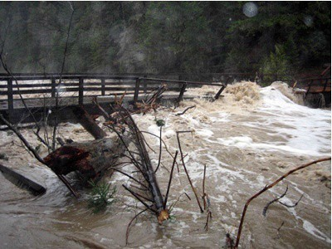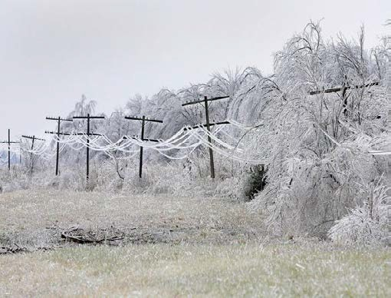

January 2015

Prepared by
Kaysinger Basin Regional Planning Commission

Table of Contents
Executive Summary 4
Prerequisites 5
Introduction 10
Assurance Statements of Compliance with FEMA 11
Basis for Planning Authority 11
Adoption by Local Governing Bodies 11
Acknowledgements and Special Thanks 12
Planning Process 12
Participants and Jurisdictions Represented 13
Time Frame for Preparation 13
Section 1 – Community Profiles 14
St. Clair County Profile 14
Climate 15
Rivers and Lakes 16
Land Use 17
Soils 20
Government 27
Population 28
Economy, Employment and Industry 33
Codes/Regulations 35
Environment 38
Community Plans 39
Critical Facilities 42
Community Profiles 51
Section 2- Identified Hazards 74
Tornado 77
Severe Thunderstorms, Hail, and Straight-Line Winds 84
Flood and Levee Failure 92
Severe Winter Weather 109
Drought 115
Heat Wave 119
Earthquakes 123
Dam Failure 134
Wildfires 149
Sinkholes 165
Profile Worksheets 172
Vulnerability Assessment 183
Section 3-Capability and Vulnerability Assessment 197
Section 4-Mitigation Strategy 211

Appendix A: Signed Adoption Resolutions Appendix B: Websites
Appendix C: Acronyms Appendix D: Definitions Appendix E: Maps
Appendix F: Public Participation Documentation

Appendix G: Data Limitations

List of Figures
Figures

Figure 1 Average Annual Precipitation Figure 2 Topographic Release Map Figure 3 Land Use Map
Figure 4 Groundcover Map
Figure 5 Barden-Deepwater-Hartwell Soil Figure 6 Barden-Collinsville Association Figure 7 Hector Boliver Association Figure 8 Goss – Gasconade Association Figure 9 Population Trend
Figure 10 Population Density Figure 11 Average Employed Figure 12 Employment Sector Figure 13 Average Annual Wages Figure 14 Environmental Sites
Figure 15-26 Appleton City through Vista City and School District Maps Figure 27-36 Firmettes and Flood Maps
Figure 37 Wind Chill Figure 38 Drought Severity Figure 39 Heat Index
Figure 40 Mercalli Map Index Figure 41 County Dams Figure 42-50 Dam Failure Maps Figure 51 Fire Danger Class Figure 52 Wildfire Progression
Figure 53-63 Wildfire Urban Interface Maps Figure 64 Sinkholes
Figure 65 Sinkholes in St. Clair County Figure 66 Cross Section of Sinkhole

List of Tables

Tables

Table 1 Hazard Mitigation Participation by Jurisdiction Table 2 Revisions and Updates
Table 3 County Government
Table 4 Community Service Facilities Table 5 Area Hospitals
Table 6 Hospice Senior Centers Table 7 Area Mental Health Facilities Table 8 Day Care Centers
Table 9 Schools
Table 10 Government Facilities
Table 11 Inventory of Housing Structures Table 12 Cascading Hazards
Table 13 Fujita Tornado Damage Scale Table 14 Tornado Occurrences
Table 15 Hail Occurrences Table 16 Lightning Occurrences Table 17 Flood Occurrences
Table 18 Severe Winter Weather Occurrences Table 19 Drought Occurrences
Table 20 Extreme Heat Occurrences Table 21 Dams in St. Clair County Table 22 Fires by Ignition
Table 23 Fire Danger Categories Table 24 Wildfire Occurrences Table 25 Vulnerability by Jurisdiction Table 26 Base Count Vulnerability Table 27 Tornado Vulnerability Table 28 Thunderstorm Vulnerability Table 29 Flood Vulnerability
Table 30 Winter Weather Vulnerability Table 31 Drought Vulnerability
Table 32 Heat Vulnerability
Table 33 Earthquake Vulnerability Table 34 Dam Failure Vulnerability Table 35 Wildfire Vulnerability Table 36 Sinkhole Vulnerability Table 37 Jurisdictional Ordinances Table 38 Goals/Objectives Update
Table 39 Goals/Objectives by Jurisdiction Table 40 Five-Year Action Matrix

Executive Summary
Located at the eastern edge of the Great Plains near the center of the North American continent,
St. Clair County, Missouri, has been fortunate to avoid many of the natural disasters that impact other areas of North America. The county is virtually unknown to hurricanes, tsunamis, tidal surges, landslides, and forest fires. Furthermore, the geology of the region reduces the risk of an earthquake to a minimal threat. However, St. Clair County is susceptible to other natural hazards. Tornadoes and severe thunderstorms, severe winter storms, drought, flooding, sinkholes, and heat waves are all hazards that can impact the county, endangering both lives and property.

St. Clair County is an inland-border county. Inland, in that it is two counties east of Kansas and four south of the Missouri River, border, in that it lies at the point where prairie lands adjoin the foothills of the Ozark. North of the river lies land in prairie stretches or long sloping hills; south of the river in precipitous bluffs, timber covered hills and mountain flat woods. St. Clair has a total area of 448,838 acres, or 702 square miles. Osceola, the county seat, is in the central part of the county. According to the 2010 census, it has a population of 947. The population of the county is 9,805. Other communities in the county are Appleton City, Collins, Lowry City, Iconium, and Roscoe Gerster and Vista.

Section One of this plan provides general background data for St. Clair County. This includes population statistics, identification of critical facilities, and general information regarding the county’s infrastructure. Understanding “where you are” is a fundamental component of the planning process. It is hoped this section provides a snapshot of St. Clair County that will serve to assist in the implementation of this plan.

Section Two identifies and explores the types and likelihood of a hazard occurring in St. Clair County. It provides a general overview of each of the identified natural hazards; in addition to explaining the impact upon St. Clair County should such a hazard occur.

Section Three provides a capability assessment of St. Clair County should one of the identified disasters occur. It outlines the county’s disaster response capabilities and seeks to identify those areas in which the county may improve in disaster mitigation. Specifically, it identifies key personnel, organizational leaders, and existing plans regarding emergency planning. Also, it provides a brief assessment of each municipality’s readiness regarding hazard mitigation.

Section Four provides mitigation goals, objectives, and mitigation plans in response to each identified natural disaster. Each disaster has specific problems identified with its respective occurrence, overall goals to reduce a disaster’s effect, specific objectives towards achieving those goals, and implementation plans for the county to pursue.

The overall goals of this and any mitigation plan are to 1) protect the lives, property, and livelihood of all citizens; 2) ensure uninterrupted government and emergency function during a natural hazard event; and 3) manage growth through sustainable principles and practices to limit development in hazard-prone areas. These goals, and the other information contained within this plan, will be reviewed every five years under the coordination of St. Clair County.

The St. Clair County Mitigation Plan is a multijurisdictional plan that represents several local governments and entities within the county. The following local governments participated in both the original plan development as well as the plan update. They are represented by the plan through formal adoption:

- City of Appleton City
- Village of Collins
- City of Lowry City
- City of Osceola
- Village of Roscoe
- Village of Vista
- County of St. Clair

The following jurisdictions are new participants with the 2015 plan update. They are also represented by the plan through formal adoption:

- Appleton City R-II School District
- Lakeland R-III School District
- Osceola School District
- Roscoe C-I School District

The following Jurisdictions are no longer participating in the plan for reasons described below:

- The Village of Gerster (Estimated Population of 30), did not participate in the 2010 St. Clair County Natural Hazard Mitigation Plan update per the requirements set forth in this plan. Through public meetings and discussions with county officials it was determined that Gerster does not have an organized government structure as of the plan date which prevents them from participating in the plan update process.

Prerequisites
Requirement For multi-jurisdictional plans, each jurisdiction requesting
§201.6(c)(5) approval of the plan must document that it has been formally adopted.

Note to Reviewers: When this plan has been reviewed and approved pending adoption by
FEMA Region VII, adoption resolutions will be signed by participating jurisdictions and added to Appendix A.

The following jurisdictions participated in the plan update process and have formally adopted the updated Hazard Mitigation Plan. Adoption resolutions are included in Appendix A.

- City of Appleton City *Lakeland R-III School District
*Village of Collins *Osceola School District
*Roscoe C-I School District *City of Lowry City
*City of Osceola *Village of Roscoe
*Village of Vista *Appleton City R-II School District
*County of St. Clair

Requirement Multi-Jurisdictional plans may be accepted, as appropriate,
§201.6(c)(5) as long as each jurisdiction has participated in the process.

Kaysinger Basin Regional Planning Commission (KBRPC), on behalf of St. Clair County, invited incorporated cities, school districts, and private non-profit entities in the County to participate in the St. Clair County Multi-Jurisdictional Hazard Mitigation Plan update. DMA 2000 requires that jurisdictions represented by a multi-jurisdictional plan participate in the planning process and formally adopt the plan. Each participating jurisdiction was required to meet plan participation requirements as defined by KBRPC at the beginning of the planning process.

Minimum participation requirements are defined as follows:

  - Provide information to support plan update through at least one of the following methods:
    - Completion of worksheets;
    - Attendance at public meetings;
    - Executed letters of authorization
    - Alternately scheduled meetings with KBRPC staff for data collection; or
    - Communicate with KBRPC staff through email concerning data collection.
  - Formal adoption of the mitigation plan update.

All of the jurisdictions listed as participants in the plan update met the minimum participation requirements as indicated in the table below. Documentation in the form of sign-in sheets for attendance at group meetings as well as time sheets for meetings with KBRPC staff is included in Appendix F: Documentation of Public Participation.

 | Hazard Mitigation Participation by Jurisdiction
Participant | Worksheets | Meetings | Email | Formal plan adoption | Meetings with KBRPC  staff
St. Clair County |  | X |  | X | X
City of Appleton City |  | X |  | X
Village of Collins |  | X |  | X
City of Lowry City |  | X |  | X
City of Osceola |  | X |  | X | X
Village of Roscoe |  | X |  | X
Village of Vista |  | X |  | X
Appleton City R-II Schools |  | X |  | X
Lakeland R-III Schools |  | X |  | X
Osceola Schools |  | X |  | X
Roscoe C-I Schools |  | X |  | X
Table 1 – Hazard Mitigation Participation

Public participation was a key element in obtaining information for the plan update. A series of public meetings was held between January 2015 and November of 2015. The purpose of these meetings was:

- To educate the public on what hazard mitigation planning is and why it is important
- To gain valuable local insight into past disasters and the threats communities face

- To understand the capabilities of communities
- To develop mitigation action plans, goals and objectives
- Formally adopt the draft and final version of the plan

Meetings took place throughout the County at various locations and times to allow for maximum public participation.

Beginning in January 2015 and continuing through November 2015, KBRPC and the public worked to update the St. Clair County Hazard Mitigation Plan.

The meeting schedule was as follows:

St. Clair County Courthouse September 23, 2009 Appleton City City Hall September 29, 2009
Lowry City City Hall October 27, 2009 St. Clair County Courthouse October 29, 2009 Baer House, Osceola, MO November 20, 2009

The public meetings involved stakeholders from all jurisdictions participating in the plan. The meetings allowed for the public to review hazard and vulnerability data as well as review and analyze mitigation goals, objectives and actions.

Revisions and Updates

Plan Section | Update Review and Analysis
Executive Summary | Updated the participants list to include new and deleted participating jurisdictions. The new meeting dates for the update process as well as the planning process, participation standards and time frame were added as well.
Section 1- Community Profiles | The list of critical facilities was brought up to date. All relevant community plans were addressed and reviewed by the public and hazard mitigation plan stakeholders. Listings of media relations and infrastructure were all made current and all city maps were updated.
Section 2 - Identified Hazards | Add Levee and sinkholes to the list of natural disasters that could affect the county. All data pertaining to hazard occurrences brought up to 2015 events. Hazard profile worksheets were updated to reflect current vulnerability. Vulnerability assessment calculations were also updated using HAZUS-MH data to reflect potential building and population damages.
Section 3 - Capability and Vulnerability Assessment | Review of existing plans, particularly the County Master Plan and Emergency Operations Plan. County capabilities were reviewed for accuracy and relevance. Mitigation funding sources were also revised to reflect the main federal mitigation grants available. Jurisdictional development trends were also reviewed and made current on their status.
Section 4 - Mitigation Strategy | Categories of mitigation reviewed and brought up to current categorization measures. All goals and actions were reviewed by the public, elected officials and emergency personnel to determine the best and most cost effective mitigation priorities in the County. Goals were analyzed and either remained, were deleted, revised or new goals were added. Jurisdictional specific goals and actions were also identified.
Appendices | Additional St. Clair County official websites were added as resources. Maps were updated with current data.
Table 2 – Revisions and Updates

St. Clair County Hazard Mitigation Plan Update Notes

The hazard mitigation plan update for St. Clair County was completed by Kaysinger Basin Regional Planning Commission. This work included several one on one meetings with each jurisdiction participating as well as two county wide public meetings to review hazards data and analysis of goals and mitigation action items.

Some difficulties were encountered in completion of the plan. Participation from jurisdictions, key stakeholders, and the general public was heavily solicited via local newspapers, various social media outlets, email and personal invitations. Public meetings held by KBRPC had lower than expected public attendance. Individual meetings were then scheduled with county officials to gather the remaining data necessary to complete the plan.

INTRODUCTION

Following the severe weather, tornado, and flood disaster that was declared in the spring of 2002 (DR- 1412), Missouri’s State Emergency Management Agency (SEMA) received flood buyout project proposals from 23 communities across the state. Fortunately, they were able to help some of these communities with federal mitigation grant funding provided through the Federal Emergency Management Agency (FEMA). After November 1, 2004, communities like these will still be eligible for federal disaster public assistance and individual assistance, but will not be eligible for mitigation assistance unless they have an approved hazard mitigation plan on file. For the nearly 1,000 cities and 114 counties in Missouri, mitigation plans will be required for all federally declared disasters such as flood, earthquake, ice storm, tornado, and fire. Under the new rules for federal mitigation funding, local governments will be required to have FEMA-approved hazard mitigation plans in place as a condition to receiving federal mitigation grant funding as of the 2004 deadline.

Under the initiative set forth by SEMA, the Missouri Association of Councils of
Government (MACOG) agreed to meet the challenge of developing county and municipal plans throughout the state. The 19 regional planning commissions of MACOG provide an effective way for local governments to work together to share technical staff and address common problems in need of an area-wide approach. They also can effectively deliver programs that might be beyond the resources of an individual county or municipal government. The intent of the regional planning commissions in Missouri is to be of service to their member counties and municipalities and to bring an organized approach to addressing a broad cross-section of area-wide issues. They also are available to assist their member entities in coordinating the needs of the area with state and federal agencies or with private companies or other public bodies. SEMA’s initiative further states that, due to time and funding limitations, the plans developed by Missouri’s regional planning commissions should cover natural hazards only. Manmade and/or technological hazards are not addressed in this plan, except in the context of cascading damages.

Citizens and public organizations have participated in the process. This effort will be sustainable over the long term because it enjoys grassroots support that stems from a sense of local and individual ownership. Through SEMA’s Scope of Work, St. Clair County contracted with Kaysinger Basin Regional Planning Commission and participated fully in the preparation of the plan. Once this plan is approved, St. Clair County and cities within the county will be eligible for future mitigation assistance from FEMA and will be able to more effectively carry out mitigation activities to lessen the adverse impact of future disasters within the county.

Most of the rural regional planning commissions in Missouri were formed under Chapter 251 of the Revised Statutes of the State of Missouri. All regional councils in Missouri operate as “quasi- governmental” entities. In Missouri, regional planning commissions are advisory in nature, and county and municipal governments hold membership on a voluntary basis.

The role of a regional planning commission varies across the state, depending upon the desires of the member counties and municipalities and their representatives.

Nonetheless, the primary role of the regional planning commission is to provide a technical staff capable of providing sound advice to its membership and working for coordination of various planning and infrastructure needs among the various counties and municipalities, as appropriate.

The St. Clair County hazard mitigation plan was prepared by the staff of the Kaysinger Basin Regional Planning Commission. KBRPC, a member of MACOG, and was created October 14, 1968 by Governor Warren E. Hearnes. The commission serves the seven county area of Bates, Benton, Cedar, Henry, Hickory, St. Clair, and Vernon counties.

Assurance statements of compliance with FEMA

This city/county mitigation plan complies with SEMA’s and FEMA’s planning guidance; FEMA regulations, rules, guidelines, and checklists; Code of Federal Regulations; and existing Federal and State laws; and such other reasonable criterion as the President/Governor, Federal/State congresses and SEMA/FEMA may establish in consultation with City/County governments while the plan is being developed. This plan also meets the minimum planning requirements for all FEMA mitigation programs, such as:

- Flood Mitigation Assistance (FMA) Program
- Pre-Disaster Mitigation (PDM) Program
- Hazard Mitigation Grant Program (HMGP)
- National Earthquake Hazards Reduction Program (NEHRP)
- National Flood Insurance Program (NFIP)
- Community Rating System (CRS)

Basis for planning authority

The basis for authority to create a natural hazard mitigation plan lies in Section 322 of the Robert T. Stafford Disaster Relief and Emergency Assistance Act (Stafford Act), 42 U.S.C. 5165. This act was enacted under Section 104 of the Disaster Mitigation Act of 2000 (DMA 2000), P.L. 106-390. Section 104 is the legal basis for FEMA’s Interim Final Rule for 44 CFR Parts 201 and 206, published in the Federal Register on February 26, 2002.

Adoption by local governing bodies

Participation of local governing bodies as stakeholders is critical to successful mitigation implementation. As former SEMA Deputy Director Beaufort C. “Buck” Katt writes,

“One thing we have learned over the years is that mitigation programs crumble unless locals, both private and public, have a stake in the process; they simply must feel a sense of ownership for the program to be successful. We strongly believe that this effort will be successful and sustainable over the long term only if it enjoys grassroots support that stems from a sense of local and individual ownership. For this reason, SEMA Headquarters staff and Area Coordinators will support this initiative by providing training and technical assistance to the RPCs, but the grant funding will go to the participating counties/cities. The participating counties/cities will use SEMA’s Scope of Work to contract with the RPCs and must participate fully in the preparation of the Mitigation Plan. Once the Mitigation Plans are completed and approved, these counties/cities will be eligible for future Mitigation Assistance and will be able to more effectively carry out mitigation activities to lessen the adverse impact of future disasters in those communities. “

KBRPC has collaborated with each local government to assure participation and sense of ownership among local government officials.

Acknowledgements and Special Thanks

Several county and city officials provided valuable assistance throughout the plan development process, from data sources to defining mitigation needs. Appreciation goes to John Christiansen, Emergency Management Director. Also, thanks go to, Presiding Commissioner Billy Wood; Northern Commissioner Leroy Strope; and Southern Commissioner Gerald Williams.

Planning Process

Data for this plan was created through a series of public meetings held within St. Clair County. The planning process for the St. Clair County Hazard Mitigation Plan began during the
Fall of 2009, with presentations to elected officials, community members, and other interested parties. These individuals were invited to attend these meetings, with a special effort to invite participants representing various business and service interests throughout St. Clair County communities.
Participants were asked to identify critical infrastructure, ranking the likelihood of disaster occurrence, perform a susceptibility analysis based on these factors, and determine appropriate mitigation strategies for each individual disaster. This data was recorded and assimilated into this plan by KBRPC staff.

Background and statistical data for this plan were collected from a variety of sources, including the United States Census Bureau, the United States Geological Society, the United States Corps of Engineers, the Missouri Department of Natural Resources, the Missouri Department of Conservation, the Center for Agricultural, Resources and Environmental Systems at the University of Missouri- Columbia, and the National Climatic Data Center. The Missouri State Hazard Mitigation Plan was last updated in 2007 and provided information regarding tornado, earthquake, and flood hazards affecting St. Clair County. The last flood insurance study for St. Clair County was conducted in 1980 and, at this time, there is no activity pertaining to DFIRM production for St. Clair County. Other sources of information include Zoning Ordinances, Building Codes and Emergency Operations Plans were reviewed for applicability to the plan and are summarized in Section 3 – Capability Assessment.

Many of the following recommendations should not be considered final solutions, but rather short- term efforts that will ultimately have long-term strategic implications once implemented. To be sure, this process should be an ongoing effort that is periodically reviewed to insure that they are still relevant and that maximum impact is achieved. The following plan contains goals, broad implementation strategies, possible partners, and time frames for completion.

Participants and Jurisdictions Represented

Kaysinger Basin Regional Planning Commission, in conjunction with Pioneer Trails RPC, SEMA and FEMA, produced this document. Participants providing the data for this project included the county commission, emergency planning coordinator, and interested members of the public from within St.
Clair County. In addition, officials from each municipality within the county were directly invited to participate in these meetings.

In accordance to Missouri’s “sunshine law” (RSMo 610.010, 610.020, 610.023, and 610.024), the public was notified each time the plan, or sections of the plan, was presented for review. Input from each public official (city and county) was solicited by mailing an explanatory letter and copy of the particular draft. These mailings were disbursed on a schedule that allowed officials sufficient time to review the draft prior to the next public County Commission or City Council meeting. Participation was solicited from each of the following jurisdictions:

- St. Clair County
- City of Appleton City
- Village of Collins
- Village of Gerster
- City of Lowry City
- City of Osceola
- Village of Roscoe
- Village of Vista
- Appleton City R-II Schools
- Lakeland R-III Schools
- Osceola Schools
- Roscoe C-I Schools

Public participation was also encouraged through press releases in three local newspapers, the Appleton City Journal, St. Clair Courier and The Little Apple, which serve all of St. Clair County.

Finally, city and county officials were encouraged to invite others from any state or federal agency as well as local businesses that had interest in contributing to the planning process. Input from the general public was solicited through reminders at public gatherings and press releases. Numerous citizens, public organizations, and elected officials have participated in this process.

Time Frame for Preparation

The data and results in this plan represent more than a year-long effort. County officials were contacted in the middle part of the year and plans were made regarding how and when to gather the necessary information for the formation of this plan. A series of meetings was held throughout 2009 and 2010 in various public domains throughout St. Clair County to gather public input. This input resulted in the data utilized herein.

SECTION 1: COMMUNITY PROFILES

Why Plan for Natural Hazards in St. Clair County?

Natural hazards impact citizens, property, the environment, and the economy of St. Clair County. Flooding, wild fires, droughts, severe storms, tornadoes, and even earthquakes have exposed St. Clair County residents and businesses to the financial and emotional costs of recovering after natural disaster. St. Clair County has experienced over 299 weather related natural disasters in the last 50 years. The inevitability of natural hazards, and the growing population and activity within the county create an urgent need to develop strategies, coordinate resources, and increase public awareness to reduce risk and prevent loss from future natural hazard events. Identifying risks posed by natural hazards, and developing strategies to reduce the impact of hazard event can assist in protecting life and property of citizens and communities. Local residents and businesses can work together with the county to create a natural hazards mitigation plan that addresses the potential impacts of hazard events.

Geography and the Environment

In what was once the hunting ground of the Osage and other Indian tribes, in the valley of the Osage River, St. Clair County is situated in the southwestern part of the state and is bordered by Henry County on the north, Benton and Hickory counties on the east and Bates and Vernon on the west. To the south lie Cedar and Polk counties.

St. Clair County originally included portions of what are now Benton, Hickory and Cedar counties. St. Clair County was established in February 1841 from Rives County (later Henry County.) The county was named for Gen. Arthur St. Clair, of Revolutionary War fame and the county seat is Osceola. The county's present boundaries were established in 1845.

St. Clair County is an inland-border county. Inland, in that it is two counties east of Kansas and four south of the Missouri River, border, in that it lies at the point where prairie lands adjoin the foothills of the Ozark. Osage River divides it in twain. North of the river lies land in prairie stretches or long sloping hills; south of the river in precipitous bluffs, timber covered hills and mountain flat woods. St. Clair has a total area of 448,838 acres, or 702 square miles. Osceola, the county seat, is in the central part of the county. According to the 2000 census, it has a population of 835. The population of the county is 9,652. Other communities in the county are Appleton City, Collins, Lowry City, Iconium, and Roscoe, Gerster and Vista.

Soybeans, grain sorghum, and wheat are the principal cash crops grown in the county. Beef cattle, dairy cattle, and hogs are the dominant livestock. The prairie region, in the northwestern part of the county, is used for both livestock and cash-grain farming. The southwestern part of the county is rolling cropland and pasture, and the eastern part is a mixture of rolling pasture and wooded Ozark highlands.

Climate

St. Clair County is hot in summer, especially at low elevations. It is moderately cool in winter. Rainfall is fairly heavy and well distributed throughout the year. Snow falls nearly every winter, but the snow cover lasts only a few days. In winter the average temperature is 34 degrees F, and the average daily minimum temperature is 23 degrees. The lowest temperature on record, which occurred at Appleton City on February 9, 1979, is -19 degrees. In summer the average temperature is 77 degrees, and the average daily maximum temperature is 90 degrees. The highest recorded temperature, which occurred on July 14, 1954, is 116 degrees.

The total annual average precipitation is 38.29 inches. Of this, about 25 inches, or 65 percent, usually falls in April through September. The growing season for most crops falls within this period. In 2 years out of 10, the rainfall in April through September is less than 18 inches. The heaviest 1-day rainfall during the period of record was 5.78 inches at Appleton City on September 13, 1961.
Thunderstorms occur on about 49 days each year. The average seasonal snowfall is about 18 inches. The greatest snow depth at any one time during the period of record was 14 inches. On the average, 15 days of the year have at least 1 inch of snow on the ground. The number of such days varies greatly from year to year.

The average relative humidity in mid-afternoon is about 55 percent. Humidity is higher at night, and the average at dawn is about 70 percent. The sun shines 70 percent of the time possible in summer and 50 percent in winter. The prevailing wind is from the south. Average wind speed is highest, 12 miles per hour, in spring.

Figure 1: Average Annual Precipitation

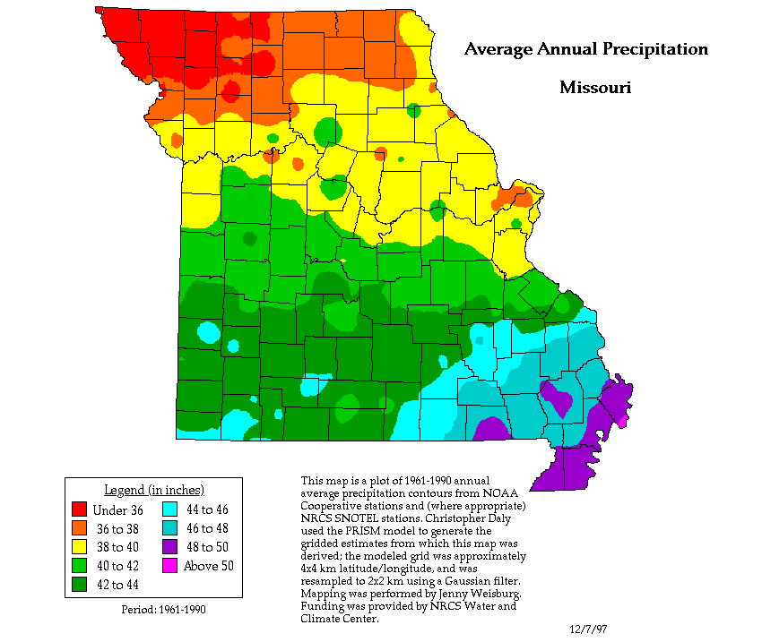

Rivers, Lakes, and Drainage Relief and Drainage
St. Clair County is characterized by three major physiographic areas. These are the flood plains along the Osage and Sac Rivers, the prairie areas in the northern and central parts of the county, and the Ozark highlands in the eastern part. Elevation ranges from the normal level of the Harry S. Truman Reservoir, which is 706 feet above sea level, to 1,060 feet on the highest ridges.

The Osage River and its tributaries, which include the Sac River, drain about 90 percent of the county. The northern 10 percent is drained by Deepwater Creek.

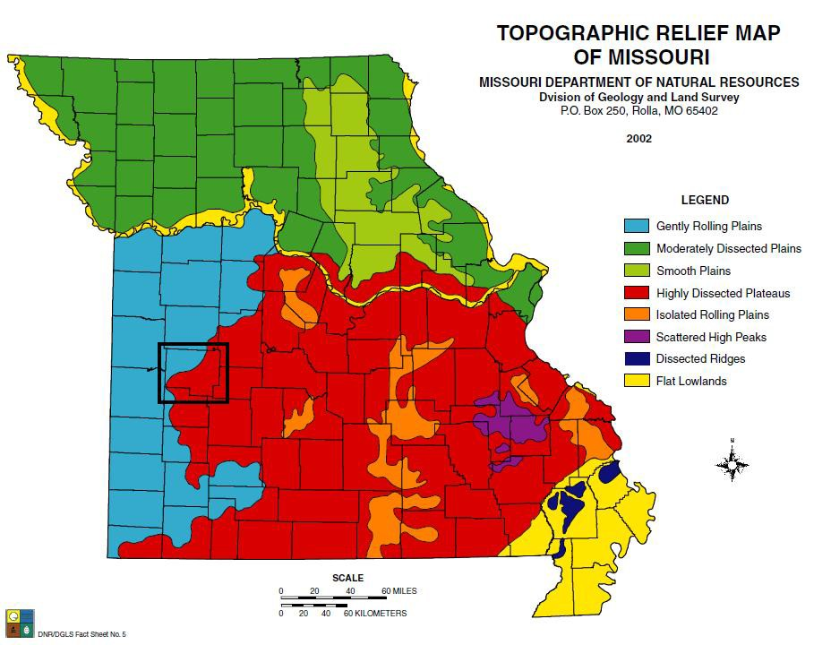

Harry S. Truman Lake
Figure 2 – Topographic Release Map

The Flood Control Act of 1954 authorized the construction of Kaysinger Bluff Dam and Reservoir (now known as Harry S Truman Dam and Reservoir) on the Osage River. The plans were modified in 1962 to add hydroelectric power and recreation to the list of purposes for the dam. The resulting 55,600-acre Truman Lake created a diverse wildlife area rich in the history of Osage Indians, explorers, fur trappers, traders and white settlers.

Truman Reservoir is the largest flood control reservoir in Missouri, with a storage capacity of more than 5 million acre-feet (an acre-foot = 325,000 gal.). At normal pool (706 m.s.l.) the reservoir has a

surface area of about 55,600 acres – this surface area can grow to over 200,000 acres at the top of the flood control pool. During periods of flooding, Truman Reservoir, operating in conjunction with other reservoirs helps protect the lower Osage, Missouri and Mississippi River floodplains.

The Truman Power Plant contains six turbine generators and has a rated capacity of 160,000 kilowatts. This electrical energy is used to meet peak electrical demands when conventional power plants cannot fulfill the public’s demand for electrical energy. Power plant operators are on duty around the clock to control the flow of water through Truman Dam. Additionally the power plants located at Stockton and Mark Twain lakes are remotely controlled from Truman Dam.

The lake and more than 100,000 acres of land surrounding the lake is managed for fish and wildlife. Agricultural leases, controlled burning, wetland developments, food plot establishment, and native grass re-introduction are a few of the land management techniques used at Truman Reservoir. Over 55,000 acres are licensed to the Missouri Department of Conservation for fish and wildlife management and approximately 8,800 acres of timber was left standing in the lake to improve fisheries habitat.

Recreational development is extensive. Park areas at Truman Reservoir offer a wide variety of recreation facilities including boat launching ramps, campgrounds, full service marinas, picnic areas, sand swimming beaches, and a regional visitor center. Many routine maintenance items are contracted to the private sector. Mowing, refuse collection, and facility cleanup are just a few of the activities that are performed by private contractors for the Corp of Engineers.

Land Use Trends For St. Clair County

There has been significant change in land use in the county as a result of the construction of the Harry
- Truman Dam. Inundated lands have been removed from cultivation and because of the relatively short distance between the lake and metropolitan Kansas City; recreational use of the lands adjacent to the lake has increased. The increase in the area used for recreation has been accompanied by an increase in area used for wildlife and game hunters.

Figure 3 – St. Clair County Land Use

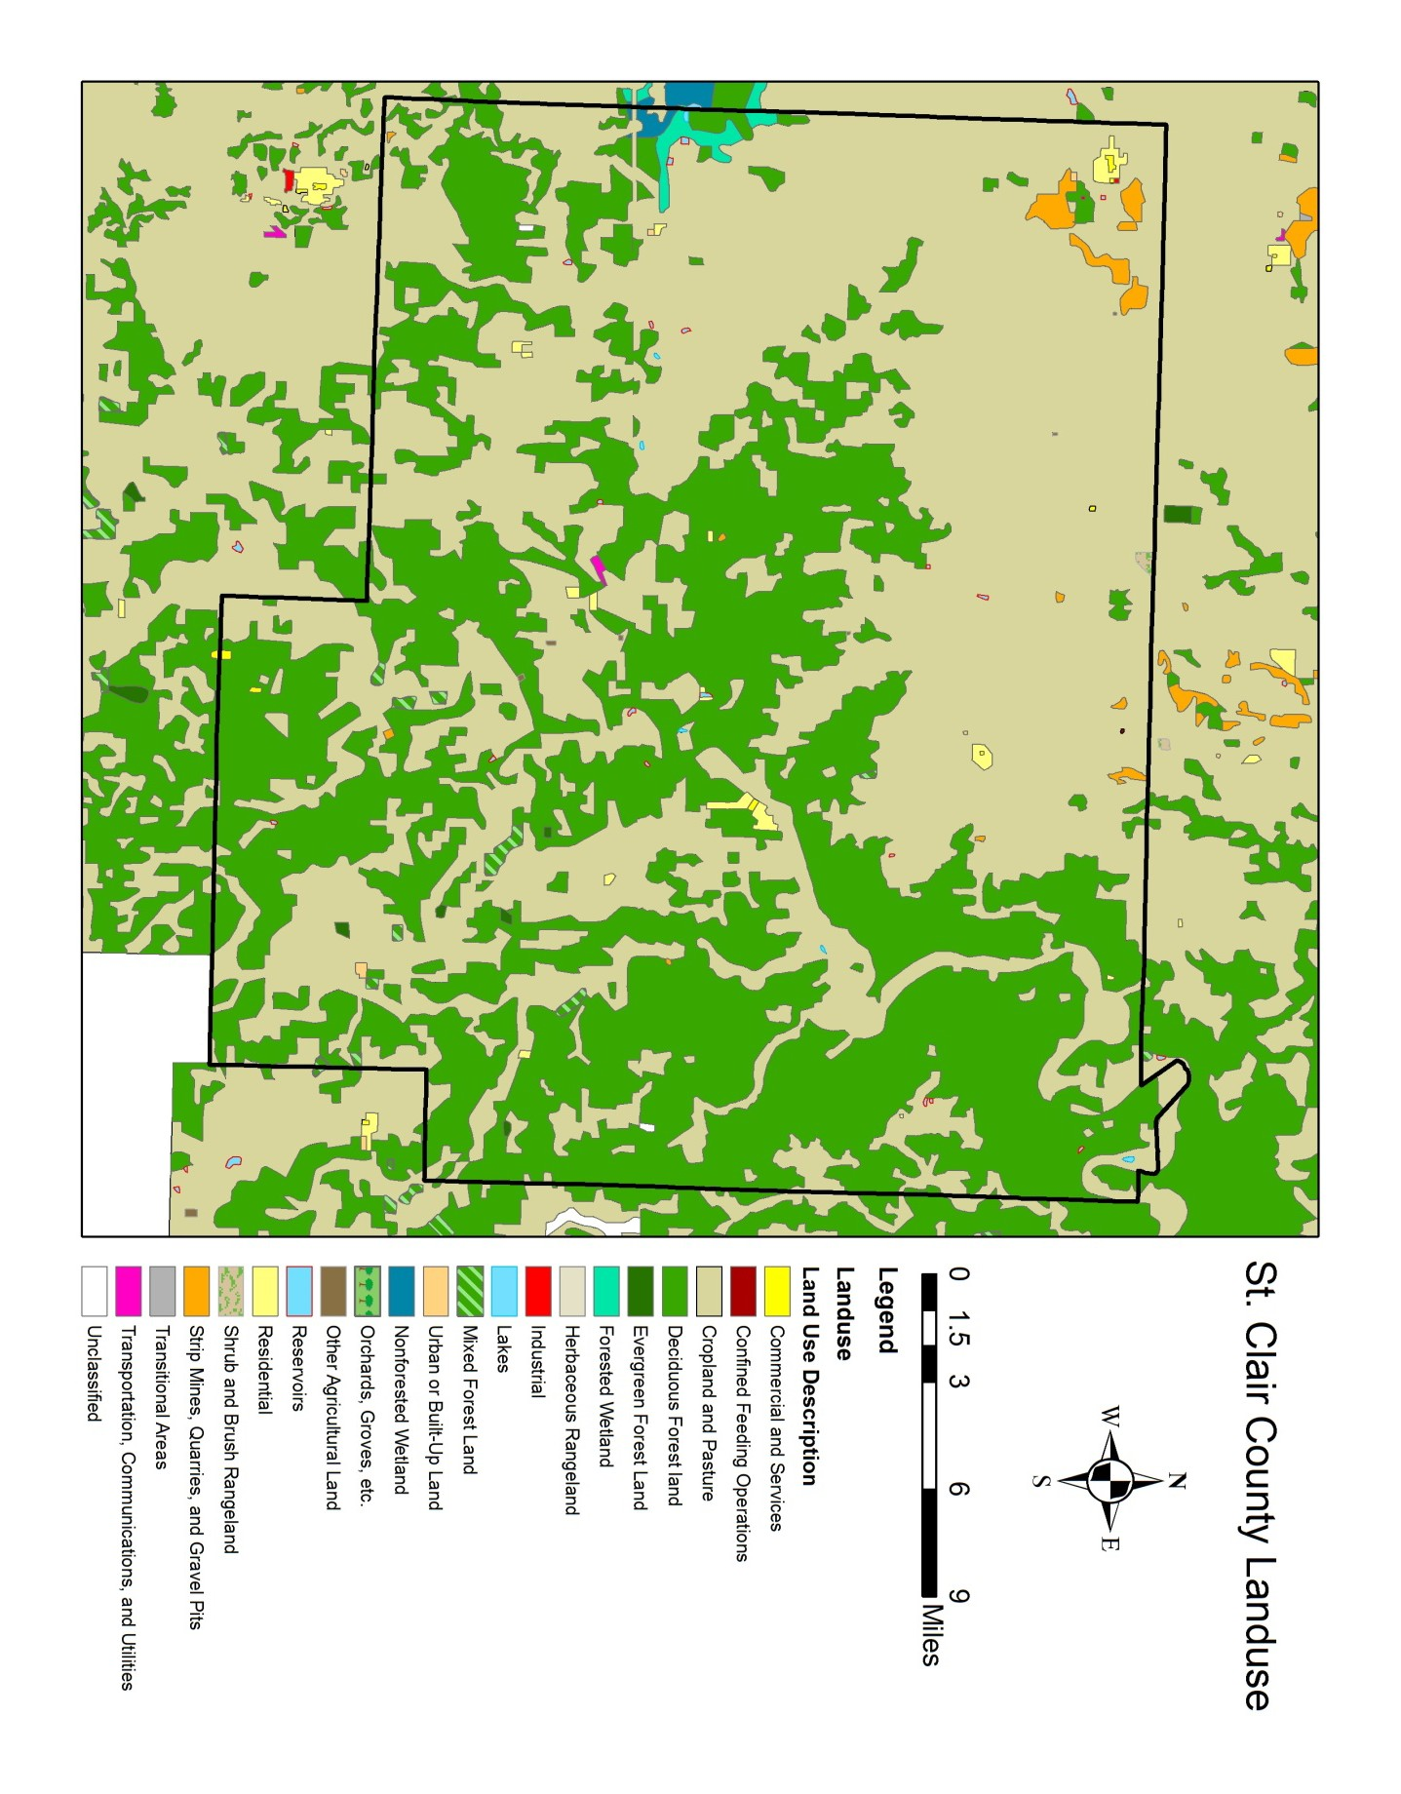

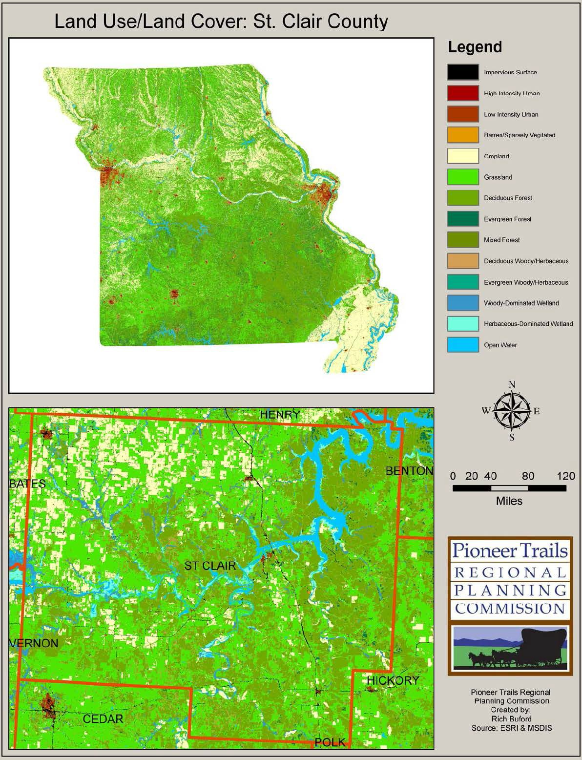

Figure 4 – Ground Cover

Soils

  - Barden-Deepwater-Hartwell Association
Deep, nearly level to moderately sloping, moderately well drained and somewhat poorly drained soils formed in a thin mantle of loess or silty sediments and in shale residuum; on uplands

This association is in the northwestern part of the county. It is mainly on high, wide divides, which separate watersheds. A few areas are adjacent to the flood plains and terraces along the major streams. This association makes up about 12 percent of the county. It is about 37 percent Barden soils, 28 percent Deepwater soils, 17 percent Hartwell soils, and 18 percent minor soils (fig. 2).

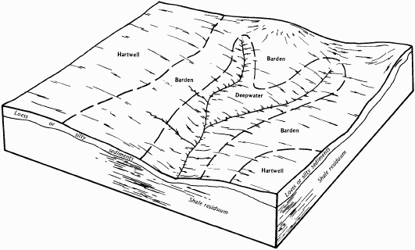
Figure 5. Typical pattern of soils and parent material in the Barden-Deepwater-Hartwell association.

Barden soils are gently sloping and moderately well drained. They are in areas between the Hartwell and Deepwater soils. Typically, the surface layer is dark brown silt loam. The subsoil is dark brown silty clay loam in the upper part; dark brown and dark grayish brown, mottled silty clay in the next part; and grayish brown, mottled silty clay loam in the lower part. The substratum is mottled light brownish gray, yellowish brown, and strong brown silty clay loam.

Deepwater soils are gently sloping and moderately sloping and are moderately well drained. They are on narrow ridgetops and side slopes below the Barden and Hartwell soils. Typically, the surface layer is very dark grayish brown silt loam. The subsurface layer is dark brown silt loam. The subsoil is dark yellowish brown and yellowish brown, mottled silty clay loam in the upper part; strong brown, mottled silty clay in the next part; and mottled light brownish gray, brown, and strong brown silty clay loam in the lower part.

Hartwell soils are nearly level and somewhat poorly drained. They are on the divides above the Barden and Deepwater soils. Typically, the surface layer is very dark grayish brown silt loam. The subsurface layer is grayish brown silt loam. The subsoil is very dark grayish brown and dark grayish

brown, mottled silty clay in the upper part; dark brown, mottled silty clay in the next part; and strong brown, mottled silty clay loam in the lower part.

The minor soils in this association are the Barco, Collinsville, Kanima, Quarles, and Verdigris soils. The moderately deep Barco and shallow Collinsville soils are on ridgetops and side slopes. The strongly sloping to steep Kanima soils is in areas that formerly were strip-mined for coal. The poorly drained Quarles soils are on terraces. The well-drained Verdigris soils are on flood plains.

About 80 percent of the acreage is cleared and is used for row crops. Corn, grain sorghum, soybeans, and wheat are the main crops. Some areas are used for pasture and hay. The uncleared acreage consists of uneven, moderately steep and steep areas of minor soils that generally support hardwoods.

The soils in this association are suited to cultivated crops, small grain, and grasses and legumes. Controlling water erosion and improving and maintaining fertility and tilth are the main concerns in managing the areas used for row crops. The main concerns in managing pasture are water erosion during seedbed preparation and overgrazing. The seasonal wetness of the Hartwell soils also is a concern in row cropped or pastured areas. In areas that do not have flowing water, ponds provide water for livestock.

These soils are suitable as sites for buildings and sanitary facilities. The high shrink-swell potential in the clayey subsoil and the wetness are the main limitations on sites for dwellings and septic tank absorption fields. Also, the slow permeability of the Barden and Hartwell soils is a limitation on sites for septic tank absorption fields. These two soils generally are better suited to sewage lagoons.

Barden-Barco-Collinsville Association
Deep to shallow, gently sloping to moderately steep, moderately well drained to somewhat excessively drained soils formed in a thin mantle of loess or silty sediments and in shale or sandstone residuum; on uplands

This association is on wide divides, benches, ridgetops, and knobs and on side slopes and breaks along drainage ways. It makes up about 28 percent of the county. It is about 39 percent Barden and similar soils, 36 percent Barco soils, 12 percent Collinsville soils, and 13 percent minor soils (fig. 3).

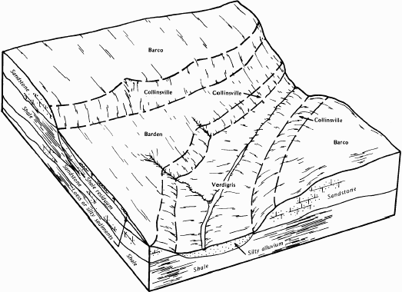
Figure 6. Typical pattern of soils and parent material in the Barden-Barco-Collinsville association.

The deep, gently sloping, moderately well drained Barden soils are on divides and side slopes. Typically, the surface layer is dark brown silt loam. The subsoil is dark brown silty clay loam in the upper part; dark brown and dark grayish brown, mottled silty clay in the next part; and grayish brown, mottled silty clay loam in the lower part. The substratum is mottled light brownish gray, yellowish brown, and strong brown silty clay loam.

The moderately deep, gently sloping and moderately sloping, well drained Barco soils are on ridgetops, knobs, and side slopes. Typically, the surface layer is dark brown fine sandy loam. The subsoil is brown fine sandy loam in the upper part and dark yellowish brown, mottled sandy clay loam in the lower part. It is underlain by multicolored, soft sandstone bedrock. Below this is hard sandstone bedrock.

The shallow, gently sloping to moderately steep, somewhat excessively drained Collinsville soils are on narrow ridgetops, on knobs, and on side slopes and breaks along drainage ways. Typically, the surface layer is very dark brown fine sandy loam. The subsoil is dark brown loam. It is underlain by hard sandstone bedrock. The minor soils in this association are the Deepwater, Quarles, and Verdigris soils. Deepwater soils are deep and have less clay than the Barden soils. They are on the lower side slopes. The poorly drained Quarles soils are on terraces. Verdigris soils are silty throughout. They are on flood plains.

About 70 percent of the acreage is cleared and is used mostly for pasture, hay, small grain, or grain sorghum. Corn and soybeans are grown in some of the gently sloping areas. The uncleared acreage

consists mainly of steep, uneven areas that support mixed hardwoods. The Barden and Barco soils are suited to row crops. The Collinsville soils are best suited to pasture. Controlling water erosion and improving and maintaining fertility and tilth are the main concerns in managing the areas used for row crops. Gullying is a problem in some areas.

All the major soils are suited to grasses and legumes. Erosion during seedbed preparation and overgrazing are concerns in managing pasture. Droughtiness is a concern in areas of the Barco and Collinsville soils during the hot summer months. In areas that do not have flowing water, ponds provide water for livestock. The Barden and Barco soils are suitable as sites for buildings and sanitary facilities. The shrink-swell potential in the clayey subsoil and restricted permeability are limitations.
The wetness in the Barden soils and the moderate depth to bedrock in the Barco soils also are limitations. The Collinsville soils generally are unsuitable as building sites because of the shallow depth to bedrock.

Verdigris-Moniteau-Osage Association
Deep, nearly level, well drained and poorly drained soils formed in silty or clayey alluvium on flood plains and terraces

This association is on the flood plains and terraces along medium and large streams throughout the county. The width of the flood plains ranges from about 200 feet to 2 miles. This association makes up about 5 percent of the county. It is about 36 percent Verdigris soils, 18 percent Moniteau soils, 13 percent Osage soils, and 33 percent minor soils.

Verdigris soils are well drained. They are on low flood plains adjacent to streams. Typically, the surface layer is very dark grayish brown silt loam. The subsurface layer also is very dark grayish brown silt loam. Below this is a transition layer of dark brown silt loam. The substratum is brown silt loam.

Moniteau soils are poorly drained. They are on terraces adjacent to the flood plains. Typically, the surface layer is dark grayish brown silt loam. The subsurface layer is grayish brown, mottled silt loam. The subsoil is dark grayish brown, mottled silty clay loam.

Osage soils are poorly drained. They are on flood plains adjacent to the uplands. Typically, the surface layer is black silty clay. The subsurface layer is very dark gray silty clay. Below this is a buried layer of dark gray, mottled silty clay loam. The subsoil is dark grayish brown, mottled silty clay.

The minor soils in this association are the Cedargap, Cotter, Hartville, and Quarles soils. Cedargap soils have chert in the lower part. They are on narrow flood plains. Cotter, Hartville, and Quarles soils are on terraces. Cotter soils have more clay in the subsoil than the Verdigris soils, and Hartville and Quarles have less clay in the surface layer. Also, Hartville soils are gently sloping and have chert in the subsoil.

The soils in this association are used mainly for row crops, pasture, or hay. They are suited to small grain, soybeans, grain sorghum, and grasses and legumes. Occasional flooding, wetness, and maintenance of fertility and tilth are the main concerns in managing the areas used for cultivated crops. Overgrazing and the wetness are the main concerns in managing pasture.

The soils in this association are suitable for trees. Many areas that are too small for farming remain wooded. Existing stands are dominantly oak and hickory. The equipment limitation, seedling

mortality, and the wind throw hazard are the main management concerns. The wind throw hazard is caused by the wetness.

These soils generally are unsuitable as sites for buildings and sanitary facilities. Overcoming the occasional flooding and the wetness is difficult.

Hector-Bolivar Association
Shallow and moderately deep, gently sloping to steep, well drained soils formed in sandstone residuum on uplands

This association is on ridgetops, foot slopes, and the somewhat broken and stony parts of side slopes. Scattered rock outcrop is on the side slopes. This association makes up about 21 percent of the county. It is about 54 percent Hector soils, 35 percent Bolivar soils, and 11 percent minor soils (fig. 4).

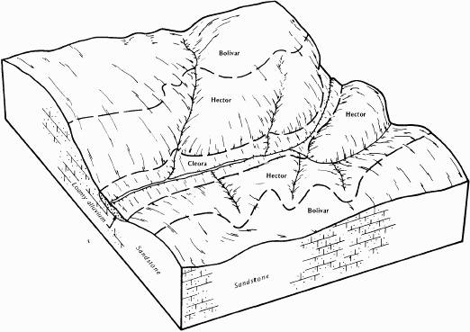
Figure 7. Typical pattern of soils and parent material in the Hector-Bolivar association.

Hector soils are shallow and are moderately sloping to steep. They are on ridge tops and side slopes. Typically, the surface layer is dark brown fine sandy loam. The subsoil is yellowish brown gravelly fine sandy loam. It is underlain by hard sandstone bedrock.

Bolivar soils are moderately deep and are gently sloping and moderately sloping. They are on ridgetops and side slopes above the Hector soils. Typically, the surface layer is dark brown fine sandy loam. The subsurface layer is yellowish brown fine sandy loam. The subsoil is sandy clay loam. The upper part is strong brown, the next part is yellowish brown and mottled, and the lower part is grayish brown, strong brown and dark red and is mottled. Sandstone bedrock underlies the subsoil.

The minor soils in this association are the Cleora, Liberal, and Verdigris soils. The deep, nearly level Cleora and Verdigris soils are on flood plains. The moderately well drained Liberal soils are higher on the ridges than the Bolivar soils.

More than 50 percent of this association is used for pasture or hay, and about 40 percent supports trees or brush. Most of the remaining acreage is cultivated. The Bolivar soils are suited to small grain and grain sorghum, which are the major cultivated crops. Controlling water erosion, overcoming droughtiness, and improving fertility are the main concerns in managing the cultivated areas. Erosion, droughtiness, and overgrazing are the major concerns in managing pasture. In areas that do not have flowing water, ponds provide water for livestock.

The soils in this association are suitable for trees. The erosion hazard, the equipment limitation, seedling mortality, and the wind throw hazard are the major management concerns.

The Bolivar soils are suitable as sites for buildings. The shrink-swell potential, the depth to bedrock, and moderate permeability are the main limitations. The Hector soils generally are unsuitable as building sites because of the shallow depth to bedrock and the slope.

Goss-Gasconade Association
Deep and shallow, gently sloping to very steep, well-drained and somewhat excessively drained soils formed in limestone residuum on uplands

This association is on highly dissected ridges separated by very narrow drainage ways. Flagstones and scattered rock outcrop are on the lower side slopes. This association makes up 28 percent of the county. It is about 51 percent Goss soils, 22 percent Gasconade soils, and 27 percent minor soils (fig. 5).

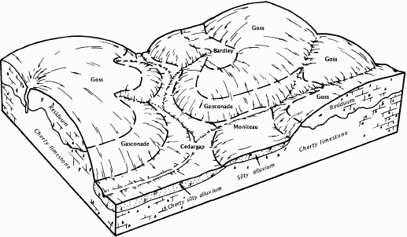
Figure 8. Typical pattern of soils and parent material in the Goss-Gasconade association.

The deep, well drained, gently sloping to steep Goss soils are on ridgetops and side slopes. Typically, the surface layer is very dark grayish brown cherty silt loam. The subsurface layer is yellowish brown very cherty silt loam. The subsoil is yellowish red very cherty silty clay loam in the upper part, red and dark red cherty and very cherty silty clay in the next part, and red silty clay in the lower part.

The shallow, somewhat excessively drained, gently sloping to very steep Gasconade soils are in glades on ridgetops and side slopes. Typically, the surface layer is very dark brown flaggy silty clay loam.
The subsoil is dark brown very flaggy silty clay. It is underlain by hard limestone bedrock.

The minor soils in this association are the Bardley, Bucklick, Cedargap, Hartville, and Moniteau soils. The moderately deep Bardley soils are on side slopes. Bucklick, Hartville, and Moniteau soils are on terraces. Bucklick soils have no chert. Hartville soils are somewhat poorly drained. Moniteau soils are poorly drained. Cedargap soils formed in alluvium that has a high content of chert. They are on flood plains.

About 80 percent of this association is native hardwood forest, dominantly of oak and hickory. The cleared areas, which are mainly on ridgetops, foot slopes, and narrow flood plains, are used for cultivated crops or for hay and pasture. The Goss soils are suited to trees. Water erosion, the slope, and seedling mortality are the main management concerns. Because of the slope, the use of logging equipment is restricted and erosion is a hazard along logging roads and skid trails. The shallow Gasconade soils are not suited to commercial timber production because of their low productivity.

Livestock production is the major farm enterprise. The less sloping areas generally are cleared and are suitable as pasture. The slope, droughtiness, and the hazard of erosion are the main concerns in managing pasture.

The Goss soils generally are suitable as sites for buildings and sanitary facilities. The slope and the content of chert are the main limitations. The Gasconade soils are generally unsuited to building site development and onsite waste disposal because they are shallow over bedrock.

Eldorado-Newtonia Association
Deep, gently sloping to strongly sloping, well drained soils formed in material weathered from cherty limestone or in silty sediments; on uplands

This association is on broad ridgetops and long side slopes adjacent to narrow flood plains and terraces. It makes up about 6 percent of the county. It is about 65 percent Eldorado soils, 10 percent Newtonia soils, and 25 percent minor soils.

Eldorado soils are gently sloping to strongly sloping. They are on ridgetops and side slopes below the Newtonia soils. Typically, the surface layer is dark brown cherty silt loam. The subsoil is dark reddish brown and reddish brown extremely cherty silty clay loam in the upper part, yellowish red extremely cherty silty clay loam in the next part, and red very cherty silty clay in the lower part.

Newtonia soils are gently sloping. They are on broad divides. Typically, the surface layer is dark brown silt loam. The subsoil is dark brown silt loam and dark reddish brown silty clay loam in the upper part, dark red silty clay loam in the next part, and red silty clay loam in the lower part.

The minor soils in this association are the Bucklick, Cedargap, Hartville, and Moniteau soils. The moderately deep Bucklick soils, the somewhat poorly drained Hartville soils, and the poorly drained Moniteau soils are on terraces. Cedargap soils are cherty and have less clay than the Eldorado soils. They are on flood plains.

About 75 percent of this association is used for pasture and hay. About 10 percent is second growth woodland. The rest is mainly gently sloping areas on the ridgetops. These areas are used for small

grain or row crops. The forage crops and most of the grain crops are fed to beef and dairy cattle. Wheat, soybeans, and grain sorghum are sold as cash crops. Controlling water erosion and improving and maintaining fertility and tilth are the main concerns in managing most of the cultivated areas.
Some areas have long, smooth slopes that can be terraced and farmed on the contour. These soils generally are suited to pasture and hay. Controlling water erosion during periods when the pasture is seeded and overgrazing are the main management concerns.

The major soils are suited to building site development and sanitary facilities. The major limitations are the moderate permeability and moderate shrink-swell potential of both soils and the content of chert and slope in areas of the Eldorado soils

County Government

St. Clair County has a local county government of publicly elected officials. The county government primarily consists of the County Commission.

Elected County Officials
Name | Position
Robert Salmon | Presiding Commissioner
Leroy Strope | Commissioner
Gerald Williams | Commissioner
Joleene Wood | Prosecuting Attorney
Laurie Stinnett | Public Administrator
Randy Sheldon | Coroner
Ron Snodgrass | Sheriff
Rhonda Shelby | County Treasurer
Gladys Smith | County Assessor
Sharon Foster | County Collector Of Revenue
Debbie Peden | County Clerk
Karen Hubbard | Circuit Clerk
Pat Terry | Recorder

Table 3 – St. Clair County, MO Officials

Population and Demographics

St. Clair is one of 115 counties in Missouri. It is not part of a Metropolitan Area and its 2000 population was 9,652. In 2002 it was ranked 90th in the State among population counties. The following table shows population statistics for St. Clair County from the 2000 Census with projected population figures (in blue).

TABLE: HISTORICAL POPULATION CENSUS AND PROJECTIONS
20,000

18,000

16,000

14,000

12,000

10,000

8,000

6,000

4,000

2,000

-

YEAR
POPULATION

Figure 9 – St. Clair County Population
1900
1920
1930
1940
1950
1960
1970
1980
1990
2000
2010
2020
2030

St. Clair County has a population density of 14.3 persons per square mile, being well below the state average of 81.2, and has five incorporated communities: Appleton City, Collins, Lowry City, Roscoe, and Osceola.

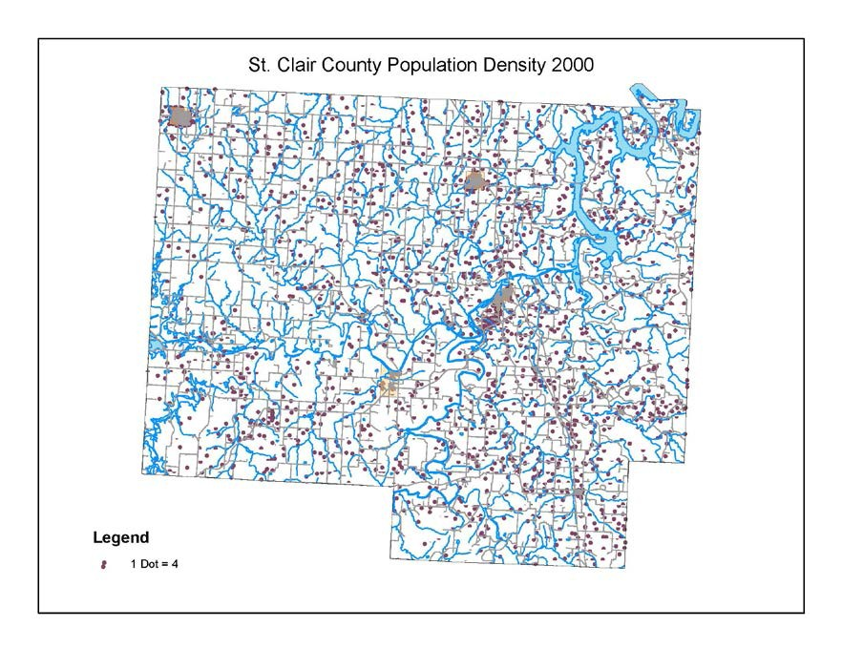
Figure 10 – St. Clair Population Density

The increase of people living in St. Clair County creates more community exposure, and changes how agencies prepare for and respond to natural hazards. For example, more people living in a rural area can increase risk of fire. Wildfire has an increased chance of starting due to human activities in this area, and has the potential to injure more people and cause more property damage. Furthermore, increased density can affect risk. For example, narrower streets are more difficult for emergency service vehicles to navigate; the higher ration of residents to emergency responders affects response times.

Natural hazards do not discriminate, but the impacts in terms of vulnerability and the ability to recover vary greatly among the population. According to Peggy Stahl of the Federal Emergency Management Agency (FEMA) preparedness, training, and exercise directorate, 80% of the disaster burden falls on the public, and within that number, a disproportionate burden is placed upon special needs groups: women, children, minorities, disabled, and the poor.

According to the 2000 census, 1.0% of the population of St. Clair County is of Hispanic or Latino origin. .1% of the population is Asian. .7% is of American Indian or Alaskan Native origin, and 0.7% of the population is of African American descent. The ethnic and cultural diversity suggest a need to address multi-cultural needs and services.

In St. Clair County the poverty percentage is 19.6% of the population, much more than the 11.7% in the state of Missouri. The vulnerable populations including seniors, disabled citizens, women, and children, as well as those people living in poverty, may be disproportionately impacted by natural hazards. Examining the reach of hazard mitigation policies to special needs populations may assist in increasing access to services and programs. FEMA’s Office of Equal Rights addresses this need by

suggesting that agencies and organizations planning for natural disasters identify special needs populations, make recovery centers more accessible, and review practices and procedures to remedy any discrimination in relief application or assistance.

The cost of natural hazards recovery can place an unequal financial responsibility on the general population when only a small proportion may benefit from governmental funds used to rebuild private structures. Discussions about natural hazards that include local citizen groups, insurance companies, and other public and private sector organizations can help ensure that all members of the population are a part of the decision-making processes.

The following is the demographic information of St. Clair County compared to the State of Missouri.

People Quick Facts | St. Clair County | Missouri
Population, 2000 | 9,652 | 5,595,211
Population, percent change, 1990 to 2000 | 14.1% | 9.3%
Female persons, percent, 2000 | 50.4% | 51.4%
Black or African American persons, percent, 2000 (a) | 0.2% | 11.2%
American Indian and Alaska Native persons, percent, 2000 (a) | 0.7% | 0.4%
Asian persons, percent, 2000 (a) | 0.1% | 1.1%
Native Hawaiian and Other Pacific Islander, percent, 2000 (a) | Z | 0.1%
Persons reporting some other race, percent, 2000 (a) | 0.3% | 0.8%
Persons reporting two or more races, percent, 2000 | 1.2% | 1.5%
Persons of Hispanic or Latino origin, percent, 2000 | 1.0% | 2.1%
White persons, not of Hispanic/Latino origin, percent, 2000 | 96.7% | 83.8%
High school graduates, percent of persons age 25+, 2000 | 73.1% | 81.3%
Bachelor's degree or higher, pct of persons age 25+, 2000 | 9.0% | 21.6%
Persons with a disability, age 5+, 2000 | 2,248 | 973,637
Mean travel time to work, workers age 16+ (minutes), 2000 | 32.3 | 23.8
Housing units, 2000 | 5,205 | 2,442,017

Homeownership rate, 2000 | 79.4% | 70.3%
Housing units in multi-unit structures, percent, 2000 | 4.9% | 20.0%
Median value of owner-occupied housing units, 2000 | $48,500 | $89,900
Households, 2000 | 4,040 | 2,194,594
Persons per household, 2000 | 2.34 | 2.48
Median household money income, 1999 | $25,321 | $37,934
Per capita money income, 1999 | $14,025 | $19,936
Persons below poverty, percent, 1999 | 19.6% | 11.7%
Private non-farm establishments, 1999 | 184 | 144,874
Private non-farm employment, 1999 | 1,478 | 2,350,965
Private non-farm employment, percent change 1990- 1999 | 41.3% | 16.8%
Non-employer establishments, 1999 | 599 | 310,678
Retail sales, 1997 ($1000) | 42,527 | 51,269,88  1
Retail sales per capita, 1997 | $8,393 | $9,482
Housing units authorized by building permits, 2000 | n/a | 24,321
Federal funds and grants, 2001 ($1000) | 74,213 | 39,190,88  1
Local government employment - full-time equivalent, 1997 | 505 | 201,609
Land area, 2000 (square miles) | 677 | 68,886
Persons per square mile, 2000 | 14.3 | 81.2

Jobs

Economy, Employment, and Industry

Since 1995 and 2002, employment in St. Clair County has increased by 229 jobs to 1,541, a 14.86% increase over the last 7 years. Statewide employment increased 14.82% to 2.677.226 over the decade.

Figure 11 & 12 – Average Employed and Employment Sector
Average Employed
1600
1550
1500
1450
1400
1350
1300
1250
1200
1150
1529
1541
1496
1383
1358
1312
1302
1305
95
96
97
98
99
OO
O1
O2
Year

St. Clair Employment Sector (2002)
 |  | 11% |  | Agriculture
 |  |  |  | Construction
 | 32% |  | 8% | Manufacturing
 |  |  | 3% | Transportation & Utilities
 |  |  | 9% | Wholesale Trade
 |  |  |  | Retail Trade
4% |  |  | 5% | Fire
 |  | 28% |  | Services

The following chart shows the average annual wages paid for St. Clair County each year.

Figure 13 – Average Annual Wages
Average Annual Wages 1995-2002
$18,000
$15,864
$16,110
$16,422 $16,617
$16,000
$14,000
$12,000
$10,000
$8,000
$6,000
$4,000
$2,000
$-
$15,114
$13,040
$13,536
$14,367
95 96 97 98 99 OO O1
O2
Year
Jobs

Services, Retail trade, and Agriculture trade are St. Clair County’s principle employment and industrial activities. Leading the full-time employment comes from services with 485 employees, retail trade with 425 employees, and agriculture with 165 employees.

Mitigation activities are needed at the business level to ensure the safety and welfare of workers and limit damage to industrial infrastructure. Employees are highly mobile, commuting to and from the surrounding areas. This creates a greater dependency on roads, communications, accessibility and emergency plans to reunite people with their families. Before a natural hazard event, large and small businesses can develop strategies to prepare for natural hazards, respond efficiently, and prevent loss of life and property.

Codes/Regulations (i.e. building, storm water, fire, zoning)

Missouri state law dictates the powers and structure of county governments. St. Clair County operates as a third-class county and administers county structures, infrastructures, and floodplain regulations. Zoning codes as well as building and storm water regulations are needed to implement mitigation measures such as site plan review of drainage, flood hazard, soil, slope, and street connectivity issues.

Community Partnerships

St. Clair County and its cities collaborate on numerous issues, such as infrastructure, law enforcement, and emergency services. Missouri Department of Transportation (MoDOT), the Kaysinger Basin Regional Planning Commission, the county, and cities collaborate concerning transportation issues.
The Missouri Department of Conservation and local firefighters work together to safeguard the county’s forested areas.

Media Relations

There are three newspapers published in St. Clair County. The Appleton City Journal, the
St. Clair County Courier, and the Little Apple are all weekly papers.
There are a number of regional news and/or public radio stations nearby that cover St. Clair County events. A list of stations is provided below:

AM
    - WHB (810 AM; 50 kW; KANSAS CITY, MO; Owner: UNION BROADCASTING, INC.)
    - KRMS (1150 AM; 10 kW; OSAGE BEACH, MO; Owner: VIPER COMMUNICATIONS, INC)
    - KKHK (1250 AM; 25 kW; KANSAS CITY, KS)
    - KKOW (860 AM; 10 kW; PITTSBURG, KS; Owner: AMERICAN MEDIA INVESTMENTS)
    - KBNN (750 AM; daytime; 5 kW; LEBANON, MO; Owner: OZARK BROADCASTING, INC.)
    - KRMG (740 AM; 50 kW; TULSA, OK; Owner: CXR HOLDINGS, INC.)
    - KCMO (710 AM; 10 kW; KANSAS CITY, MO; Owner: SUSQUEHANNA KANSAS CITY PARTNERSHIP)
    - KFAQ (1170 AM; 50 kW; TULSA, OK; Owner: JOURNAL BROADCAST CORPORATION)
    - KDKD (1280 AM; 1 kW; CLINTON, MO; Owner: CLINTON RADIO COMPANY)
    - KWTO (560 AM; 5 kW; SPRINGFIELD, MO; Owner: KWTO, INC.)
    - KSGF (1260 AM; 5 kW; SPRINGFIELD, MO; Owner: JOURNAL BROADCAST CORPORATION)
    - KXEN (1010 AM; 50 kW; FESTUS-ST. LOUIS, MO; Owner: BDJ RADIO ENTERPRISES, LLC)
    - KCCV (760 AM; daytime; 6 kW; OVERLAND PARK, KS; Owner: BOTT BROADCASTING COMPANY)

FM

    - KCVJ (92.3 FM; OSCEOLA, MO; Owner: LAKE AREA EDUCATIONAL BROADCASTING FOUNDATION)
    - KLRQ (96.1 FM; CLINTON, MO; Owner: B & F BROADCASTING, INC.)
    - KWKJ (98.5 FM; WINDSOR, MO; Owner: D & H MEDIA, LLC)
    - KDKD-FM (95.3 FM; CLINTON, MO; Owner: CLINTON RADIO COMPANY, INC.)
    - KWND (88.3 FM; Springfield, MO)
    - KWFC (89.1 FM; Springfield, MO)
    - KSCV (90.1 FM; Springfield, MO)
    - KSMU (91.1 FM; Springfield, MO)
    - KXUS (97.3 FM; Springfield, MO)
    - KWTO (98.7 FM; Springfield, MO

There is no television station located in St. Clair Country, but a number of Kansas City and Springfield stations provide St. Clair County residents with news and weather updates. A list of stations is provided below:

    - KMBC, ABC, Kansas City
    - KCTV, CBS, Kansas City
    - WDAF, FOX, Kansas City
    - KSHB, NBC, Kansas City
    - KCPT, PBS, Kansas City
    - KCWE, UPN, Kansas City
    - KPXE, PAX, Kansas City
    - KMCI, NBC, Kansas City
    - KMOS, PBS, Sedalia
    - KYTV, NBC, Springfield
    - KOLR, CBS, Springfield
    - KSPR, ABC, Springfield
    - KOZK, PBS, Springfield
    - KSFX-TV, FOX, Springfield

The media plan for increasing hazard mitigation awareness will be initiated through the appropriate local agencies as specific hazard seasons occur. At these times, residents are more attuned to receiving prevention information. Various prevention instructions from the FEMA website are also a source of information to be distributed through the media.

Endangered Species

Under the Endangered Species Act of 1973 "the term 'endangered species' means any species which is in danger of extinction throughout all or a significant portion of its range other than a species of the Class Insecta determined by the Secretary to constitute a pest whose protection under the provisions of this Act would present an overwhelming and overriding risk to man. ”A threatened species "means any species which is likely to become an endangered species within the foreseeable future throughout all or a significant portion of its range."

More than 600 kinds of plants and 325 different animals in Missouri are of concern to conservationists because they are uncommon or because their numbers are low or declining. Our species of conservation concern (our "rare" and "endangered" species) represent 18 percent of our native vascular plants and 28 percent of our vertebrate animals.

St. Clair County is home to 5 species of plant and animal listed on the federal registry of endangered species. They are the: Bald Eagle (Haliaeetus Leucocephalus), Pink Mucket (Lampsilis Abrupta), Geocarpon (Geocarpon minimum), Mead’s Milkweed (Asclepias Meadii), Niangua Darter (Etheostoma Nianguae). These all need to be considered when making changes or planning for St. Clair County.

Historic Properties and Archaeological Sites

St. Clair County has one listing on the National Register of Historic Places. According to the Archaeological Survey of Missouri (ASM) there are a reported 641 other recorded archaeological sites located in St. Clair County. The exact locations cannot be shown in order to protect the individual resources.

Osceola Public School Building (added 1999 - Building - #98001638) Also known as Osceola High School Building
HWY WW

Floodplain Management

There are no floodplain management practices in place for St. Clair County.

Wetland Issues

No issues or concerns were found at this time with regards to area wetlands.

Environmental Concerns

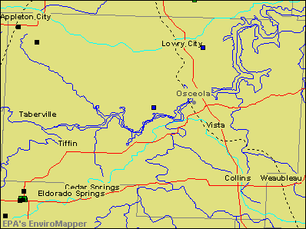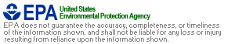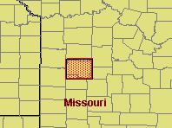
LEGEND
4/19/04 2:51:52 PM
EnviroMapper
(http://maps.epa.gov/enviromapper)

St. Clair Environmental Concerns
Superfund
Hazardous waste Toxic releases Air emissions BRS
Multi-activities Major Roads Railroads Rivers Watersheds Counties
States
2.6 mi

Figure 14 – Environmental Sites
AIR -- Facilities that produce and release air pollutants: 0 TOXICS -- Facilities that have reported toxic releases: 0
WASTE -- Facilities that have reported hazardous waste activities: 0
      - Number of Large Quantity Generators: 0
      - Number of Small Quantity Generators: 0
      - Number of Transporters: 0

Potential hazardous waste sites that are part of Superfund that exist: 1
      - Sites Not on the NPL: 1

Facilities that generate hazardous waste from large quantity generators: 0

Existing Community Plans

St. Clair County Emergency Operations Plan: Revised in 2008 and continuously being updated, the purpose of the St. Clair County Emergency Operations Plan (EOP) is “to save lives, minimize injuries, protect property, preserve functioning civil government, and maintain economic activities essential to St. Clair County.” The chief elected official is ultimately responsible for emergency management activities within the boundaries of the jurisdiction. The Presiding Commissioner of St. Clair County is responsible for those activities in the unincorporated areas of the county and in those incorporated communities that do not have a local emergency management organization (See Title XI, Division 10, Chapter 11, of the Missouri Code of Regulations). The chief elected official of each municipality (i.e., Mayor) has a similar responsibility within their corporate boundaries. These officials can delegate their authority but never their responsibility.
St. Clair County emergency management is set up along the following functional lines: direction and control; communications and warning; emergency public information; damage assessment; law enforcement; fire and rescue; civil disorder, hazardous material response, public works; evacuation; in-place shelter; reception and care; health and medical, terrorism response, and resource and supply. The plan also defines lines of succession for continuity of government during a disaster as well as preservation of records and the logistics of administrative functions such as procedures for obtaining temporary use of facilities. The EOP is reviewed annually and revised as needed.
St. Clair County Master Plan: Created in 2001, the Master Plan is intended to provide a long range plan for sustainable development. The plan has not been updated since 2001.

Comprehensive Economic Development Strategy CEDS: The November 2001 CEDS plan provides demographic, economic and environmental analysis of Benton, Bates, Cedar, Henry, Hickory, St.
Clair, and Vernon counties. It also includes detailed information on infrastructures and resources available.

State Transportation Improvement Plan (STIP): St. Clair County is part of a regional STIP encompassing the eleven counties that comprise the Missouri Department of Transportation (MoDOT), District 7, or the Southwest District. The STIP provides regional planning for transportation interests in the St. Clair County area, including maintenance of State Highways.

Inventory of Infrastructures

Identified Assets (existing, proposed, planned, approved, or included in land use plan)

Roadways -- There are basically 3 main highways (13, 82, and 54) that run through various parts of St. Clair County. MO highway 13 runs in a north/south direction through the middle part of the county. MO highway 82 runs in a west/northeast direction through the middle part of the county. MO highway 54 runs in an east/west direction just to the south from the center of the county.

Railroads -- The Missouri Kansas & Texas Railroad passes through St. Clair County at Appleton City.

Airports -- The Osceola Memorial Airport is the only public airport located in St. Clair County and is located about 2 miles south of Osceola. It has two gravel runways (18/36), with the largest dimensions of 2,430 feet long by 74 feet wide.

Public Transportation -- St. Clair County has no public transportation.

County Media -- St. Clair County, being a rural county, has 4 different, locally distributed newspapers: The St. Clair County Courier, The Appleton City Journal, and the Little Apple. The county also relies on surrounding areas for most other media including TV, Radio, and print.

Telecommunications -- Four wireless companies and one home service company serve St. Clair County: T-Mobile, Verizon, CenturyTel, and Sprint.

Sewer and Water Facilities -- The four major cities in St. Clair County: Appleton City, Collins, Lowry City, and Osceola have municipal sewer and water facilities. In the outlying areas, there are community wells. The remaining areas operate on private wells and septic or lagoon systems.

Electricity and Natural Gas -- There are currently three electric companies that serve St. Clair County: KCP&L, The City of Osceola, and Sac-Osage Valley Electric COOP. While one gas company serves St. Clair County: Missouri Gas Energy.

Solid Waste Disposal -- There is No Solid Waste Disposal Facilities in St. Clair County

Law Enforcement –
St. Clair County Sheriff’s Department – Osceola; Appleton City Police
Department – Appleton City; Lowry City Police Department – Lowry City; Osceola Police Department – Osceola; Missouri State Water Patrol District 1 – Jefferson City
Missouri State Highway Patrol – Troop D – Springfield

Emergency Medical Services -- Ellett Memorial Hospital – Appleton City; Sac-Osage Hospital -- Osceola

Fire Protection -- Iconium Fire Protection District; Lowry City Fire Department; Appleton City Fire Department; Collins Fire Department; Taberville Fire Department; Roscoe Fire Department
Sac-Osage Fire District

Emergency Management -- The incorporated cities and villages in the county all operate under and support the St. Clair County Emergency Operations Plan. The County has a volunteer part time Emergency Management Director who also serves as the LEPC Chairman and the County Floodplain Manager.

Information Restrictions

Due to homeland security concerns, underground utilities are not mapped in this plan. According to the Missouri One Call System, Inc. as of January 5, 2010, the following companies maintain underground utility lines within St. Clair County. The Missouri One Call utility location telephone

number is 800-344-7483. Listings of utility lines posing a possibly disastrous hazard include a contact telephone number for emergency personnel:

CENTURYTEL – 1-800-201-4099

CITY OF APPLETON CITY – 1-660-476-2631 CITY OF LOWRY CITY – 1-417-644-2338 CITY OF OSCEOLA – 1-417-646-8421
KANSAS CITY POWER & LIGHT – 1-888-471-5275 MAGELLAN MIDSTREAM PARTNERS – 1-913-624-3603 MEDIACOM – 1-800-234-2157
MODOT DISTRICT 7 – 1-417-621-6500

SAC OSAGE ELECTRIC COOP – 1-800-876-2701 TRUMAN WATER 2 – 1-660-693-4551
VERNON COUNTY CPWSD 1 – 1-417-667-8512 VILLAGE OF COLLINS – 1-417-275-4546 WINDSTREAM COMMUNICATIONS – 1-866-445-3402

Inventory of Critical/Key/Essential Facilities

Relevant facilities include medical facilities, schools, long-term care facilities, day care centers, and government structures. These facilities represent resources for care and shelter as well as populations requiring a higher level of care and installations critical to community services.

Community Services
Agency Name | Address | Phone
Department of Revenue - License Bureau | 285 SE 467 Rd., Osceola, MO  64776 | (417) 646-  8454
Ministerial Alliance | Grace United Methodist Church, Osceola, MO 64776 | (417) 646-  2254
Ministerial Alliance | Christian Church, 100 S. Chestnut, Appleton City, MO 64724 | (660) 476-  5612
Missouri Veterans Commission |  | (866) 838-  4636
On My Own Independent Living Center | 1301 De La Porte, PO Box 211, Collins, MO 64738 | (877) 275-  2815
Pathyways | 1800 Community Dr., Clinton, MO 64735 | (660) 885-  8131
Speacial Health Care Needs - Henry County Health Center | 306 S. 2nd St., Clinton, MO 64753 | (660) 885-  8193
St. Clair County Food Bank | 5th and Market, Osceola, MO 64776 | (417) 646-  8305
University of Missouri Extension Center | 655 Second St. 1st Floor Courthouse, Osceola, MO 64776 | (427) 646-  2419
West Central Missouri Community Action Agency | 106 W. 4th St., Appleton City, MO 64724 | (660) 476-  2185
OECSEP (Older American Community Service Employment Program - Care Connection for Agin Services
Job Division of Workforce Development | 1661 N. 2nd Street, Clinton, MO 64735 | (660) 885-  5541

Table 4 – Community Service Facilities

Hospitals
Agency Name | Address | Phone
Cedar County Memorial Hospital | Butler, MO | (417) 876-  2511
Golden Valley Memorial Hospital | Clinton, MO 64735 | (660) 885-  5511
Ellett Memorial Hospital | 610 N. Ohio, Appleton City, MO 64724 | (660) 476-  2111
Citizens Memorial Hospital | Bolivar, MO | (417) 326-  6000
Sac-Osage Hospital | Jct. HWY 13 and BUS 13, Osceola, MO 64776 | (417) 646-  8181

Table 5 – Area Hospitals

Hospice/Nursing Homes/Senior Center
Agency | Address | Phone
Appleton City Manor | 600 N. Ohio, Box 98, Appleton  City, MO 64724 | (660) 476-  2128
Countryside Estates | 500 N. Ohio, Box 98, Aplleton  City, MO 64724 | (660) 476-  2311
Truman Lake Manor | 600 E. Seventh, PO Box 188, Lowry City, MO 64763 | (417) 644-  2248
Hospice Compassus | 270 Chestnut, PO Box 554,  Osceola, MO 64776 | (417) 646-  2650
Evelyn Brown Laney Hospice | 610 N. Ohio Ave., Appleton City, MO 64724 | (660) 476-  2111
Four Season In Home Services | 207 S. Washington St., Clinton, MO 64735 | (660) 826-  2600
Homemaker Plus | 113 E. Broadway, Bolivar, MO 65613 | (417) 326-  4357
Premier Home Care | 1309 Parry, Lamar, MO 64759 | (417) 682-  3399
St. Clair County Health Center | 530 Arduser Drive, Osceola, MO 64776 | (417) 646-  8332
Heartland Hospice Services | Butler, MO | (660) 679-  4300
Transitions Hospice | 315 A S. Main, PO Box 1077,  Bolivar, MO 65613 | (417) 777-  2703
St. Clair County Senior Center | 100 Pine, Osceola, MO 64776 | (417) 646-  8292

Table 6 – Hospice/Senior Centers

Mental Health
Agency | Address | Phone
Pathways | 1800 Community Drive, Clinton, MO 64735 | (660) 885-  8131
Royal Oaks Hospital | 307 N. Main, Windsor, MO 65360 | (660) 647-  2182
Citizens Memorial Hospital | 1500 N. Oakland, Bolivar MO | (417) 328-  6306

Table 7 – Area Mental Health Facilities

Day Care Centers
Agency | Address | Phone
Clearview Day Care | Business HWY 13, Osceola, MO 64776 | (417) 646-  8560
West Central Missouri Community Action Agency | 214 S. Beech, Appleton City, MO 64724 | (660) 476-  5877
Little Apple Day Care | 409 E. Dover, Appleton City, MO 64724 | (660) 476-  2252
SE St. Clair County Head Start Center | 8515 NW HWY 13, Lowry City,  MO 64763 | (800) 293-  3581

Table 8 – Day Care Centers

SCHOOLS
SCHOOL | ADDRESS | ENROLLMENT
Appleton City High | 408 W 4th St., Appleton City, MO 64724 | 198
Appleton City Elementary | 409 W 4th St., Appleton City, MO 64724 | 146
Lakeland High | 12530 Lakeland School Dr., Deepwater, MO 64740 | 216
Lakeland Elementary | 12531 Lakeland School Dr., Deepwater, MO 64740 | 247
Osceola Jr./Sr. High | 76 SE HWY WW, Osceola, MO 64776 | 270
Osceola Elementary | 77 SE HWY WW, Osceola, MO 64776 | 288
Roscoe Elementary | 1515 SW 300 RD., Roscoe, MO 64781 | 61
Table 9 – St. Clair County, MO Schools

Government-Owned Structures

County build include county and city government centers, police stations, fire stations, ambulance bases, and the county’s 911 Emergency Operations Center. The following table details these facilities.

Government Owned Structures
Location | Structure
Appleton City | City Hall
Appleton City | Fire Department
Appleton City | Public Library
Appleton City | MoDOT Maintenance Bldg.
Appleton City | Police Department
Appleton City | Water Department
Appleton | Post Office

City
Appleton City | Hospital
Appleton City | School
Collins | City Hall
Collins | Fire Department
Collins | Storm Shelter
Iconium | Fire Department (3 Stations)
Lowry City | Fire Department
Lowry City | City Hall/Police Department
Lowry City | School
Osceola | City Hall
Osceola | Swimming Pool
Osceola | St. Clair County Health Center
Osceola | Municipal Utilities Department
Osceola | RV Park
Osceola | Family Services Division
Osceola | Fire Department
Osceola | Post Office
Osceola | Library
Osceola | MoDOT
Osceola | USDA Offices
Osceola | Hospital
Osceola | School

Roscoe | Fire Department
Roscoe | School
Roscoe | Post Office

Table 10 – Government Facilities

Inventory of large employment, commercial, and recreation centers Large Industrial and Commercial Centers
Recreation Facilities

The H. Roe Bartle Scout Reservation is located in the Iconium area of the county. During the months of June, July and August This facility has a daily population that averages 3,000 people. On weekend and Sundays this can swell to over 8,000 people. This is also in the lake area (Truman Lake and Lake of the Ozarks) and a great deal of the economy is based on the tourist trade. Each of the major cities hosts at least one special event day per year, which draws thousands of visitors into the area. There are many boat launching facilities and campgrounds. Each of the major cities has their own park systems. Osceola and Appleton City also have a swimming pool and several baseball diamonds.

Inventory of Housing Structures Total Inventory of Structures
Total housing units | 5,205
YEAR STRUCTURE BUILT
1999 to March 2000 | 143
1995 to 1998 | 436
1990 to 1994 | 319
1980 to 1989 | 715
1970 to 1979 | 1,023
1960 to 1969 | 654
1940 to 1959 | 806
1939 or earlier | 1,109
VALUE
Less than 50,000 | 645
50,000 to 99,000 | 464
100,000 to 149,000 | 86
150,000 to 199,000 | 29
200,000 to 299,000 | 13
300,000 or more | 7
GROSS RENT
Less than 200 | 141
200 to 299 | 172
300 to 499 | 234
500 to 749 | 36
750 to 999 | 5

1000 or more | 6
No cash rent | 116
OCCUPIED HOUSING UNITS | 9,133
HOUSE HEATING FUEL
Utility gas | 343
Bottled, tank, or LP gas | 2,092
Electricity | 998
Fuel oil, kerosene, etc. | 40
Coal or coke | 0
Wood | 534
Solar energy | 0
Other fuel | 22
No fuel used | 11
UNITS IN STRUCTURE
1-unit detached | 3,495
1-unit attached | 34
2 units | 65
3 or 4 units | 139
5 to 9 units | 12
10 to 19 units | 27
20 or more units | 14
Mobile home | 1,371
Table 11 – Inventory of Housing Structures

City/Town/Village Profiles

The following tables provide a comparison of characteristics within St. Clair County’s incorporated areas.

Appleton City

Total population 1,314
Classification 4th Class
Median household income $23,674
Total housing units 639
Median gross rent $253
Median owner-occupied housing value $47,000 Master plan NO
Emergency Operations Plan County Wide
Zoning regulations NO
Building regulations NO
Subdivision regulations NO
Storm water regulations NO
Floodplain regulations NO
Water service Yes
Sewer service Yes
Fire service Yes
Ambulance service Yes

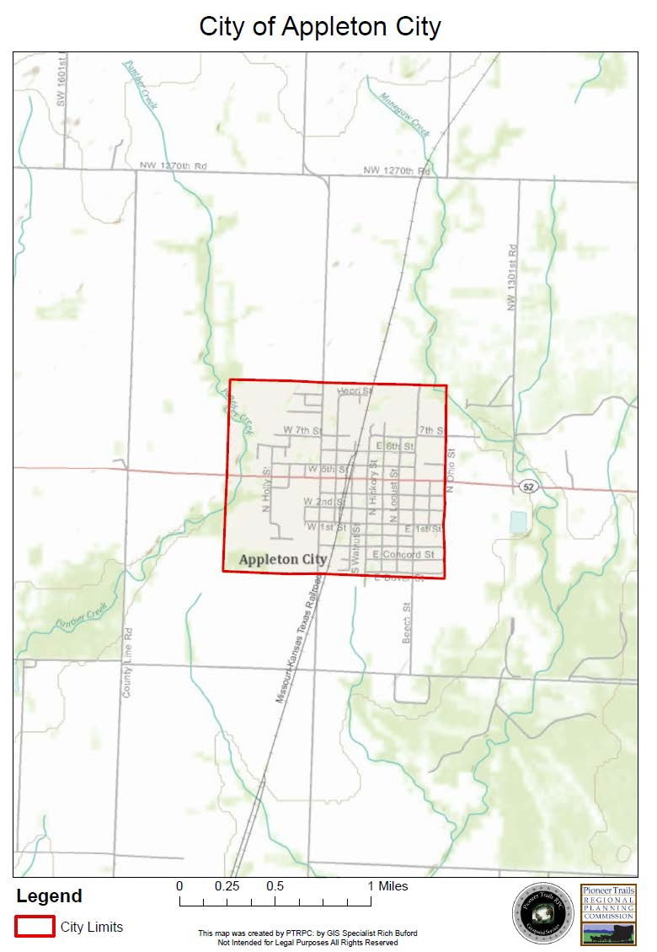

Collins
Total population 176
Classification Village
Median household income $22,292
Total housing units 88
Median gross rent $296
Median owner-occupied housing value $42,500 Master plan NO
Emergency Operations Plan County Wide
Zoning regulations NO
Building regulations NO
Subdivision regulations NO
Storm water regulations NO
Floodplain regulations NO
Water service Yes
Sewer service Yes
Fire service Yes
Ambulance service Yes

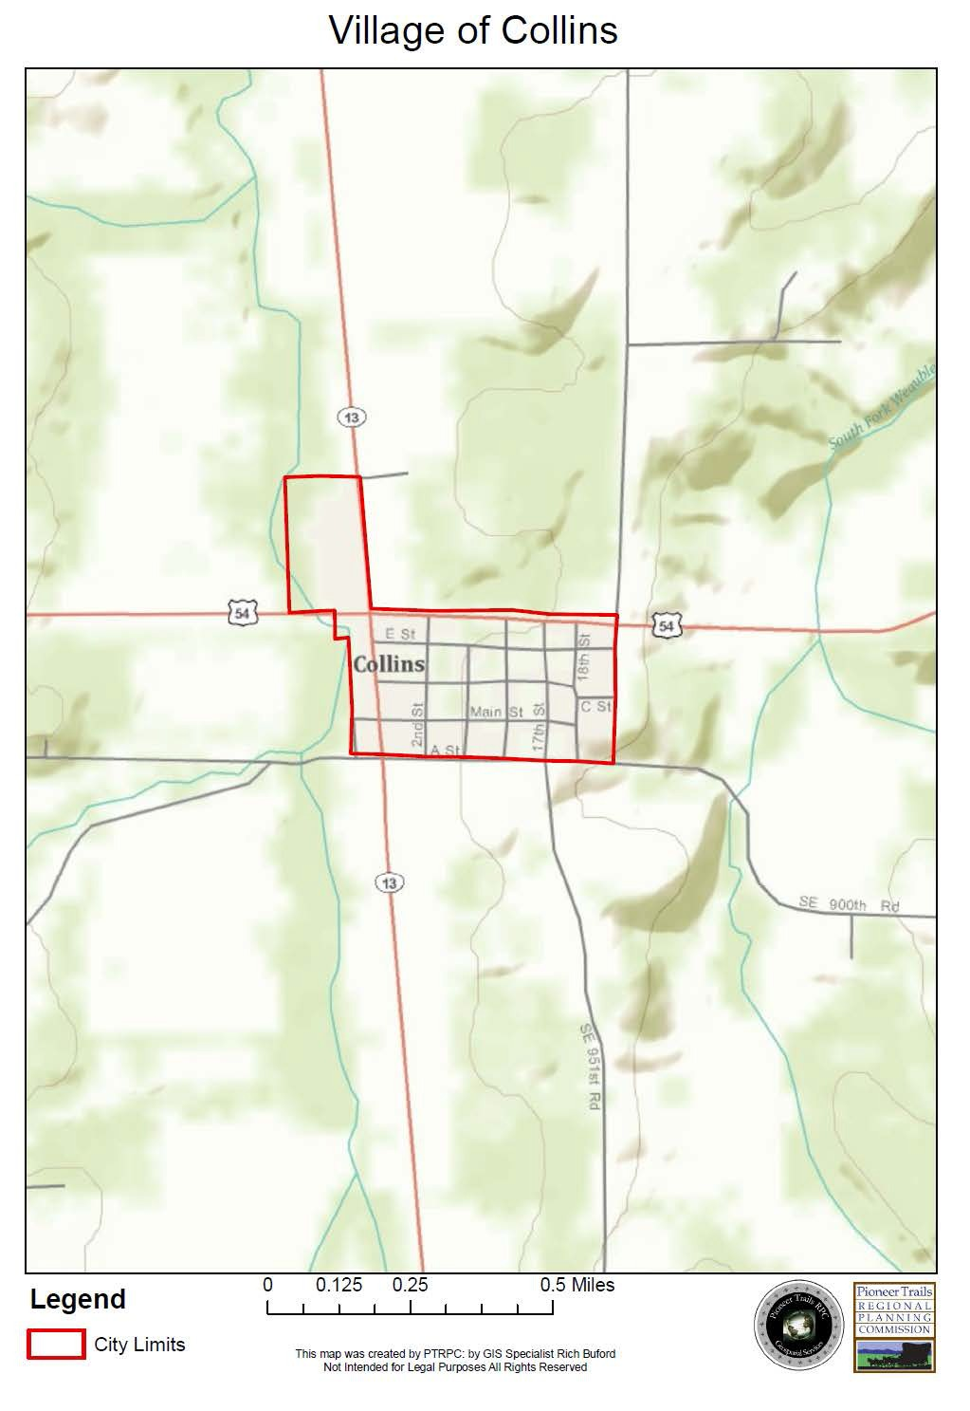

Lowry City
Total population 728
Classification 4th Class
Median household income $19,437
Total housing units 352
Median gross rent $319
Median owner-occupied housing value $38,500 Master plan NO
Emergency Operations Plan County Wide
Zoning regulations NO
Building regulations NO
Subdivision regulations NO
Storm water regulations NO
Floodplain regulations NO
Water service Yes
Sewer service Yes
Fire service Yes
Ambulance service Yes

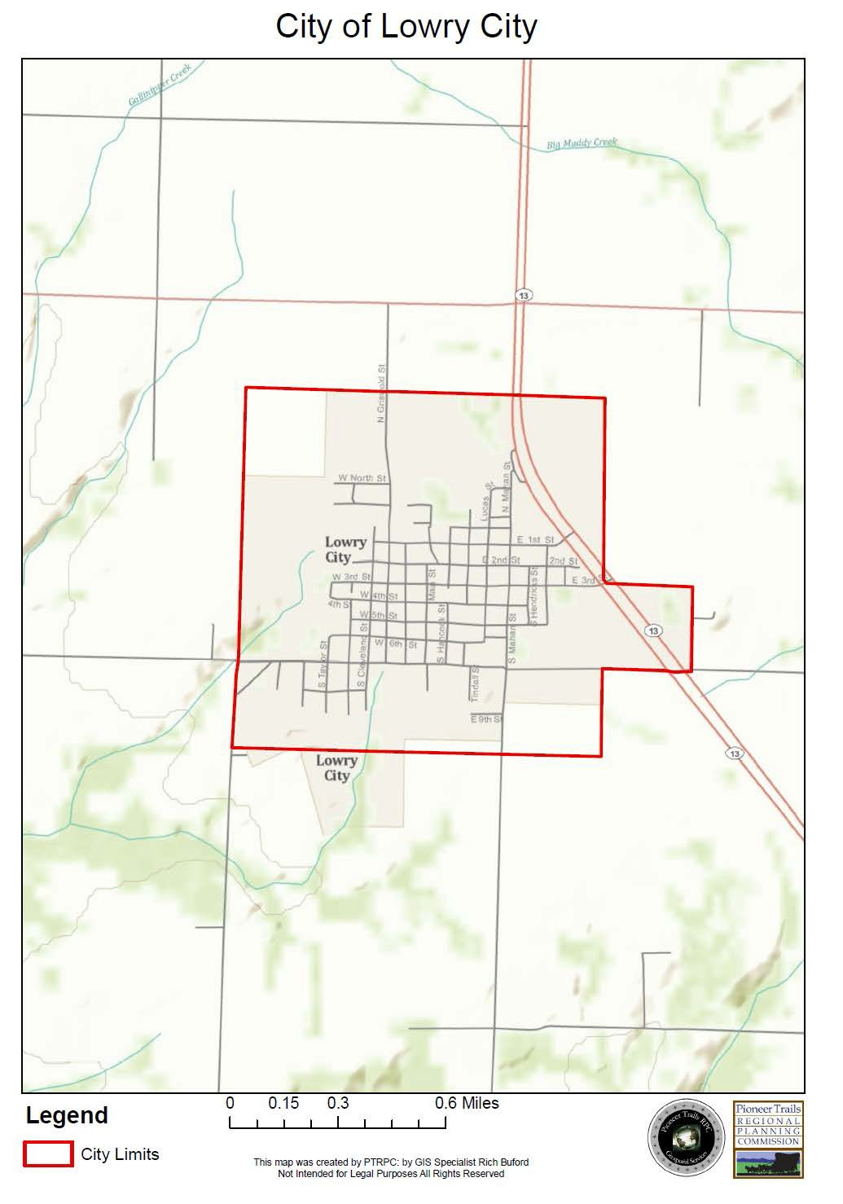

Osceola
Total population 835
Classification 4th Class
Median household income $21,563
Total housing units 474
Median gross rent $226
Median owner-occupied housing value $44,800 Master plan NO
Emergency Operations Plan County Wide
Zoning regulations Yes
Building regulations Yes
Subdivision regulations Yes
Storm water regulations Yes
Floodplain regulations NO
Water service Yes
Sewer service Yes
Fire service Yes
Ambulance service Yes

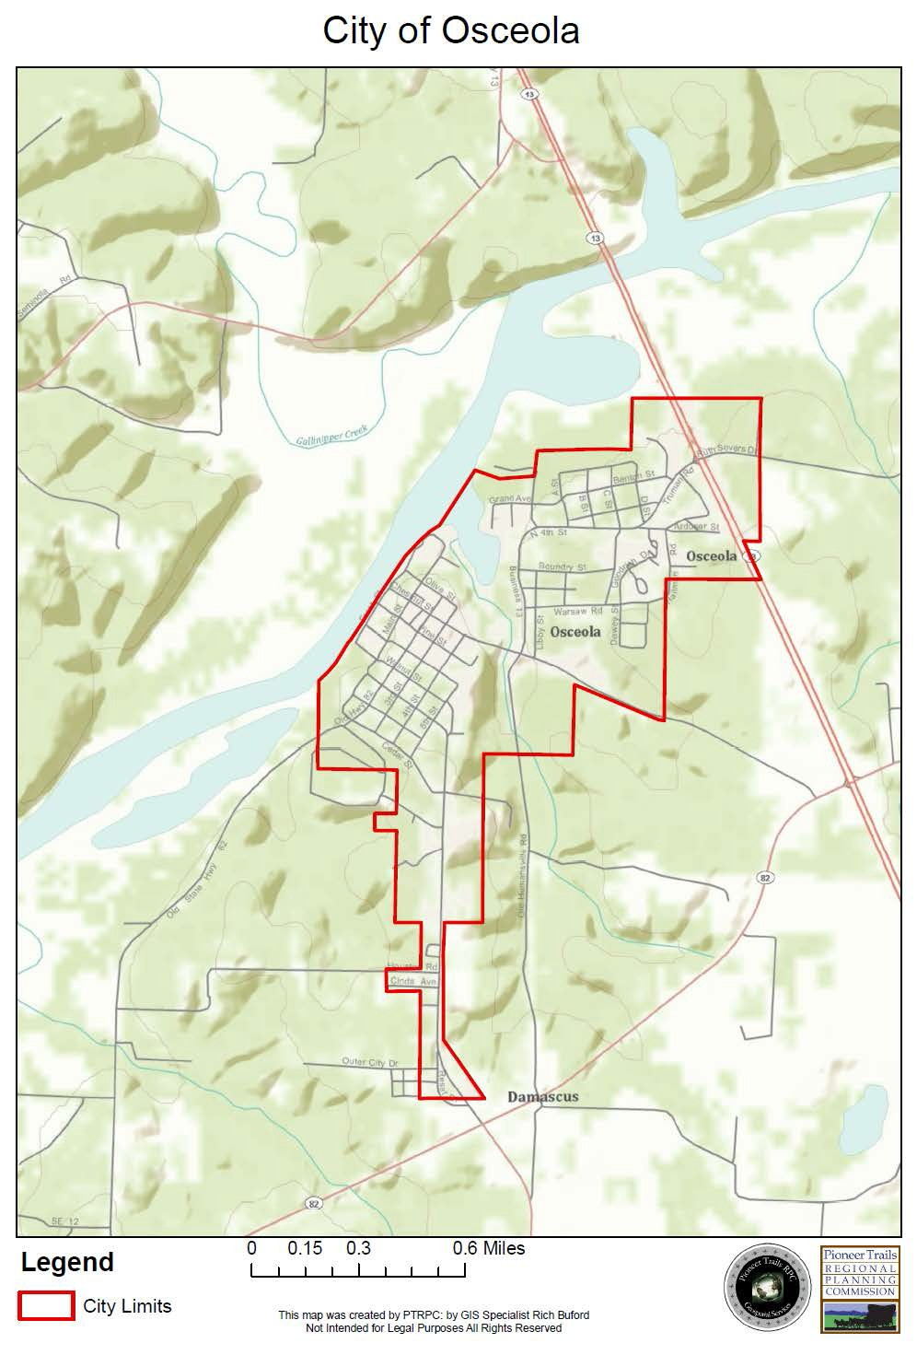

Roscoe
Total population 112
Classification Village
Median household income $30,278
Total housing units 97
Median gross rent $225
Median owner-occupied housing value $37,800 Master plan NO
Emergency Operations Plan County Wide
Zoning regulations NO
Building regulations NO
Subdivision regulations NO
Storm water regulations NO
Floodplain regulations NO
Water service NO
Sewer service NO
Fire service Yes
Ambulance service Yes

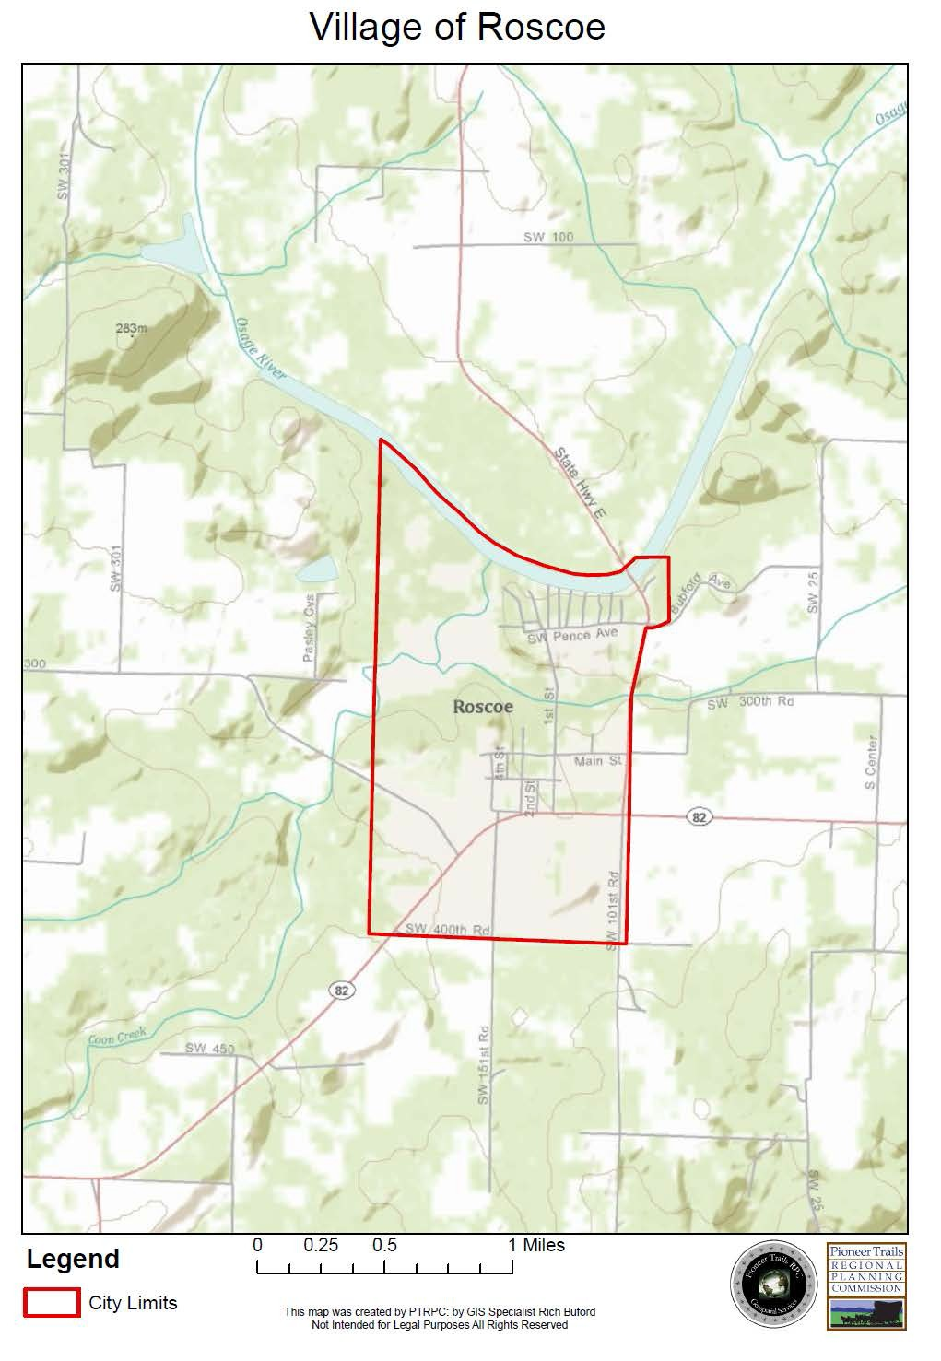

Vista
Total population 55
Classification Village
Median household income $30,000
Total housing units 24
Median gross rent Not Included Median owner-occupied housing value $27,500 Master plan NO
Emergency Operations Plan County Wide
Zoning regulations NO
Building regulations NO
Subdivision regulations NO
Storm water regulations NO
Floodplain regulations NO
Water service NO
Sewer service NO
Fire service Yes
Ambulance service Yes

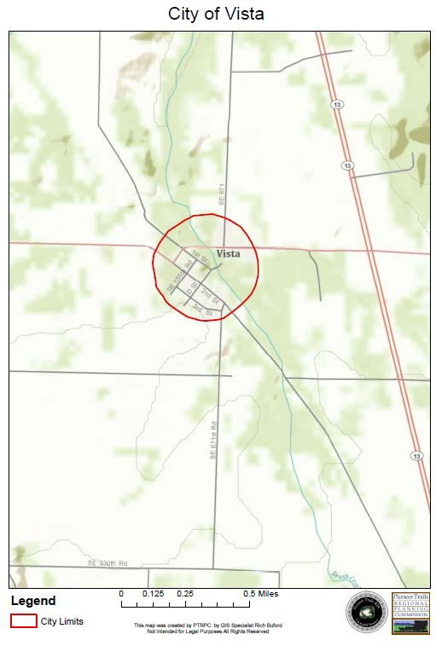

St. Clair County

Total population 9,652
Classification 3rd Class
Median household income $25,321
Total housing units 5205
Median gross rent 290
Median owner-occupied housing value $ 48,500 Master plan NO
Emergency Operations Plan Yes
Zoning regulations NO
Building regulations NO
Subdivision regulations NO
Storm water regulations NO
Floodplain regulations NO
Water service NO
Sewer service NO
Fire service Yes
Ambulance service Yes

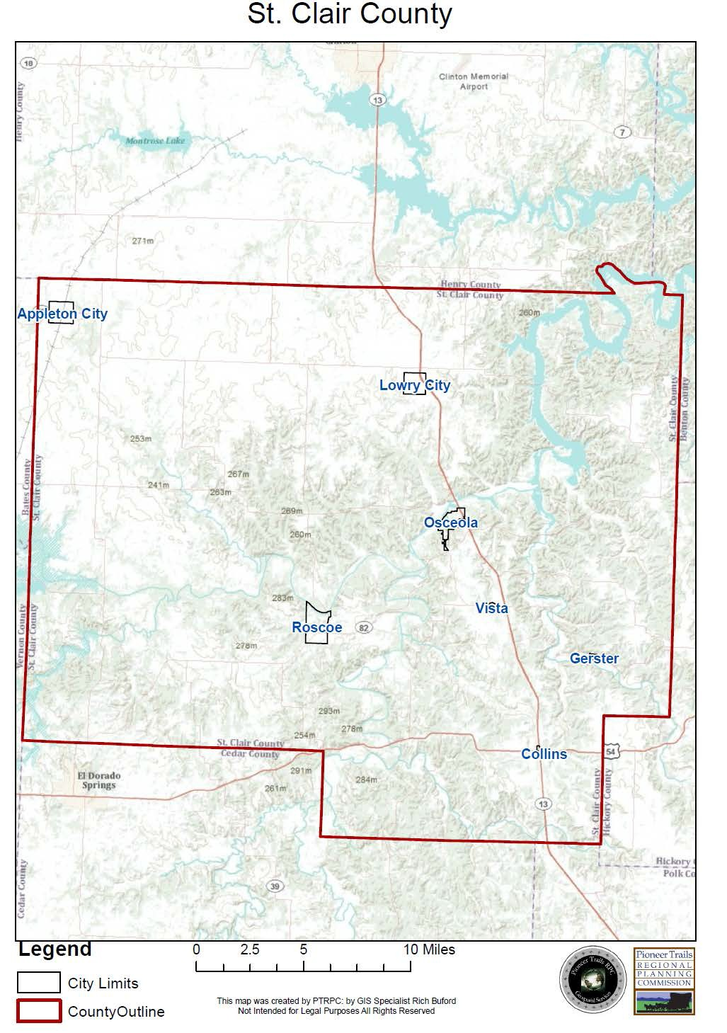

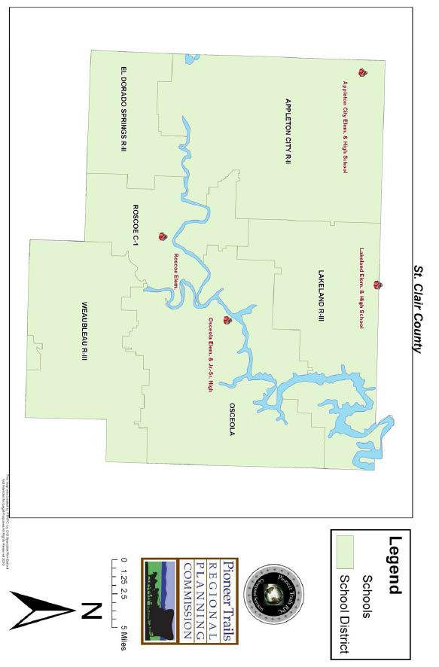

Appleton City R-II  Students | 449
District Population | 2,592
Housing Units | 1,074
Household Size | 2.35
Median Home Value | $56,800
Per Capita Income (1999) | $13,507
Teachers | 37
District Revenue | $3,172,000

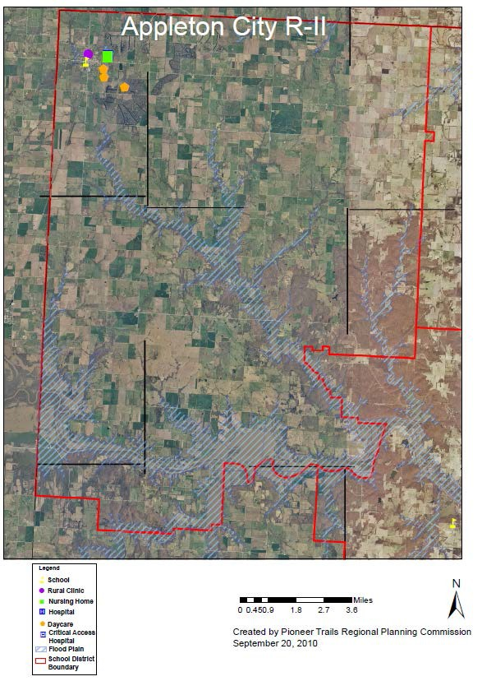

Roscoe C-1  Students | 61
District Population
Housing Units
Household Size
Median Home Value
Per Capita Income (1999)
Teachers | 9
District Revenue

*Data Limitation – No data available or provided.

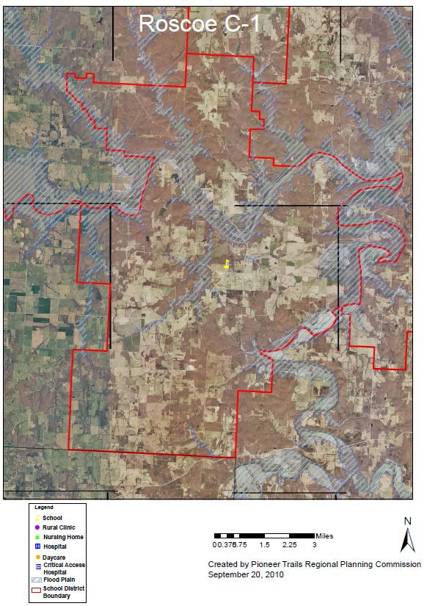

Osceola School District  Students | 495
District Population | 2,883
Housing Units | 1,245
Household Size | 2.28
Median Home Value | $57,600
Per Capita Income (1999) | $15,205
Teachers | 43
District Revenue | $4,307,000

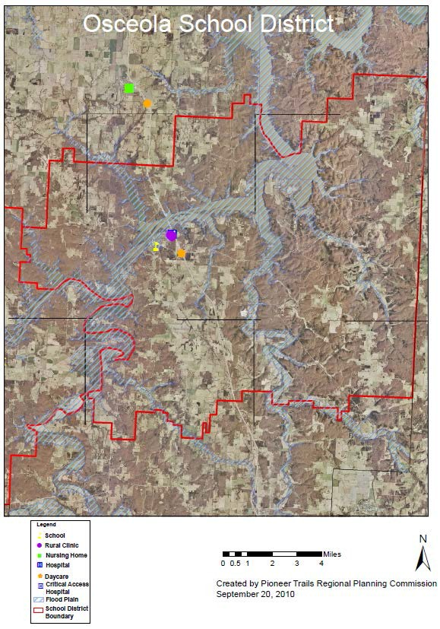

Lakeland R-III  Students | 541
District Population | 3,232
Housing Units | 1,351
Household Size | 2.34
Median Home Value | $53,300
Per Capita Income (1999) | $14,502
Teachers | 37
District Revenue | $4,035,000

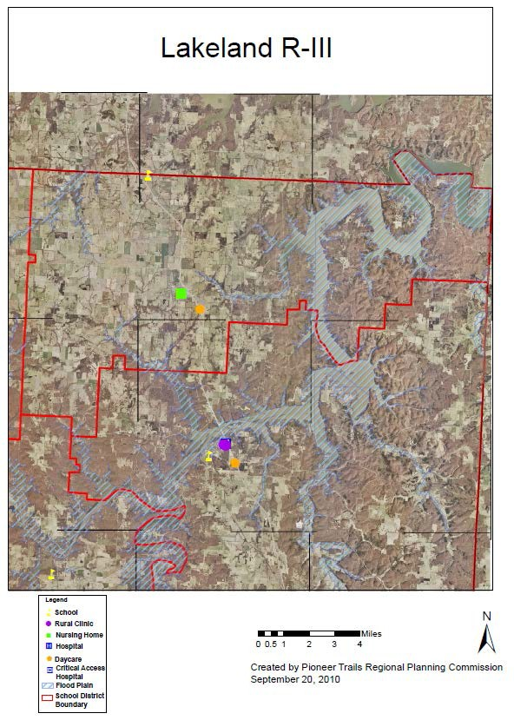

Section 2
Natural hazard identification/elimination process

Natural hazards in west-central Missouri vary dramatically with regard to intensity, frequency, and the scope of impact. Some hazards, like earthquakes, happen without warning and do not provide any opportunity to warn the general public. Other hazards, such as tornadoes, flooding, or severe winter storms, provide a period of warning which allows for public preparation prior to their occurrence. The following natural hazards have been identified as potential threats for St.
Clair County:

- Tornadoes
- Severe Thunderstorms, Hail, and High Winds
- Flood and levee failure*
- Severe Winter Weather
- Drought
- Heat Wave
- Earthquakes
- Dam Failure
- Wildfire
- Sinkholes
*Levee failure and Sinkholes added with the 2010 update.

Several resources were investigated for the accumulated data relating to natural hazards. The primary sources utilized by the Kaysinger Basin Regional Planning Commission to compile this data include the Federal Emergency Management Agency (FEMA), the Missouri State Emergency Management Agency (SEMA), National Climatic Data Center (NCDC) and National Oceanic and Atmospheric Administration (NOAA) websites and databases. United States Geological Survey (USGS) and the Center for Earthquake Research and Information (CERI) were the primary sources for earthquake information. Other sources included county officials, existing county, regional and state plans, reports on the floods, and information from local officials and residents. This plan utilizes compiled data through December 2009.

Community-wide hazard profile and list of hazards identified

As noted, St. Clair County is located in west-central Missouri. This location precludes many natural hazards from occurring or having a significant impact. The natural hazards not included in this hazard mitigation plan include landslides and severe land subsidence. According to the USGS, this is not a serious threat in that the soil types and elevations do not lend themselves to such activity. Other risks that are not included in this plan are coastal storms, tsunamis, hurricanes, avalanche, volcanic activity, and tropical storms. These do not occur in the area due to soil substructure, location, climate, and geological structure. Though these natural hazards do not affect St. Clair County, the region has potential susceptibility to other natural hazards – namely tornadoes and severe thunderstorms, and floods and levee failure, severe winter weather, drought, heat wave, earthquake, dam failure, sinkholes and wildfire. Levee failure and sinkholes

were added as a natural hazard through the 2009-2010 update process. The previously identified natural disaster list was not altered with this exception. All disasters can precipitate cascading hazards, those secondary hazards caused as a result of a primary natural disaster. Cascading hazards could include interruption of power supply, water supply, business, and transportation. Natural disasters can also cause civil unrest, computer failure, and environmental health hazards. Any of these, in combination, could possibly impact emergency response activities. Table 2.1 shows the relationships between St. Clair County’s natural disasters and categories of possible cascading disasters. Examples of specific disasters include nuclear power plant damage, hazardous materials release, mass transportation accidents, and disease outbreak due to unsanitary conditions.

(Land Subsidence is included in the excluded hazards list because subsidence is caused by the removal of ground water or other resources from the ground. The difference between subsidence and sinkholes is that subsidence is a manmade hazard, while sinkholes are natural hazards caused by erosion underground. The United States Geological Survey explains that sinkholes are a characteristic of karst topography, which results from dissolution and collapse of carbonate rocks, such as limestone and dolomite, and is characterized by closed depressions or sinkholes, caves, and underground drainage. While St. Clair County can be assessed for sinkholes, land subsidence does not occur in the county and in fact is a man-made hazard which this plan does not address.)

Cascading Hazards Resulting from Natural Disasters
Disaster | Health and/or Environmental Hazards | Water Supply Interruption | Power Interruption | Transportation Interruption | Civil Unrest | Business Interruption | Computer Failure and/or Loss of Records
Tornado / Severe Storm | X | X | X | X | X | X | X
Flood / Levee Failure | X | X | X | X |  | X | X
Severe Winter Weather | X | X | X | X |  | X
Drought | X | X | X
Heat Wave | X | X | X |  | X
Earthquake | X | X | X | X | X | X | X
Dam Failure | X | X | X | X |  | X
Wildfire | X | X |  |  |  |  | X
Sinkhole | X | X | X | X |  | X
X = More than 50% chance of cascading effect in instance of disaster
Table 12 – Cascading Hazards

Throughout the Section, potential severity is defined as either: negligible, limited, critical or catastrophic. The scaling definitions are as follows:

Catastrophic - More than 50% of area will be affected by hazard Critical - 25% to 50 % of area will be affected by hazard Limited - 10% to 25% of area will be affected by hazard Negligible - Less than 10%

Hazard Identification Tornadoes
Although tornadoes may occur in many parts of the world, they are most common in the United States. An area covering portions of Texas, Oklahoma, Arkansas, Missouri, and Kansas is known as “Tornado Alley”, where the annual average number of tornadoes is highest in the United States. In an average year in the United States, almost 800 tornadoes are reported. These result in an average of almost 90 deaths, over 1,500 injuries, and over $436 million in damage.

Tornadoes are cyclical windstorms often associated with the mid-western areas of the United States. Weather conditions, which are conducive to tornadoes often, produce a wide range of other dangerous storm activities, including severe thunderstorms, downbursts, straight line winds, lightning, hail, and heavy rains. Essentially, tornadoes are a vortex storm with two components of winds. The first is the rotational winds that can measure up to 500 miles an hour and the second is an uplifting current of great strength. The dynamic strength of both these currents can cause vacuums that can overpressure structures from the inside. Although tornadoes have been documented in all fifty states, most of them occur in the central United States. The unique geography of the central United States allows for the development of the thunderstorms that spawn tornadoes. The jet stream, which is a high velocity stream of air, determines which are of the central United States will be prone to tornado development. The jet stream normally separates the cold of the north from the warm of the south. During the winter, the jet stream flows west to east over Texas to the Carolina coast. As the sun “moves” north, so does the jet stream, which at summer solstice moves from Canada across Lake Superior to Maine. During its move north in the spring and its recession south during the fall, it crosses Missouri causing the large thunderstorms that breed tornadoes.

Tornadoes spawn from the largest thunderstorms. These cumulonimbus clouds can reach heights of up to 55,000 feet above ground level, and are commonly formed when solar heating warms gulf air. The dry cool air provided by the jet stream overrides the moist warm air. This cold air presses down on the warm air preventing it from rising, but only temporarily. Soon, the warm air forces its way through the cool air and the cool air moves downward past the rising warm air. Adding to all this is the deflection of the earth’s surface, and the air masses will start rotating.
This rotational movement around the location of the breakthrough forms a vortex, or funnel. If the newly created funnel stays in the sky it is referred to as a funnel cloud. However, if it touches the ground, the funnel officially becomes a tornado.

A typical tornado can be described as a funnel shaped cloud that is “anchored” to a cloud, usually a cumulonimbus, which is also in contact with the earth’s surface. This contact is, on the average, for 30 minutes and covers an average distance of 15 miles. The width of the tornado (and its path of destruction) is usually about 300 yards wide. However, tornadoes can stay on the

ground for upward of 300 miles and can be up to a mile wide. The National Weather Service, in reviewing tornadoes occurring in Missouri between 1950 and 1996, calculated the mean path length was 2.27 miles and the mean path area was 0.14 square miles.

The average forward speed of a tornado is 30 miles per hour but may vary from nearly stationary to 70 miles per hour. The average tornado moves from southwest to northeast, but tornadoes have been known to move in any direction. Tornadoes are most likely to occur between 3 and 9 in the afternoon and evening, but have been known to occur at all hours of the day or night.

Table 13 |  | The Enhanced Fujita Tornado Damage
EF-Scale Number | Wind Speed (mph) | Relative frequency
EF0 | 65-85 | 47.0%
EF1 | 86-110 | 29.4%
EF2 | 111-135 | 11.8%
EF3 | 136-165 | 11.1%
EF4 | 166-200 | 0.6%

Tornadoes are classified according to the F-Scale (developed by Dr. Theodore Fujita, a renowned severe storm researcher). The F-Scale attempts to rank tornadoes according to wind speed based on the damage caused.

The National Weather Service (NWS) Severe Storms Forecast Center in Springfield, MO, provides information on severe thunderstorms and tornadoes to emergency managers, news media, law enforcement personnel, and the general public. The Center uses the latest Doppler radar (NEXRAD), wind profilers, and networks of automated surface observing systems (ASOS) across the United States to assist in the prediction and identification process for severe thunderstorm and tornado watches and warnings.

When a tornado watch (favorable conditions for tornado) or warning (tornado is imminent or occurring) is issued, local tornado spotters, emergency response organizations, and ham radio operators are placed on alert to assist in identifying and locating possible tornadoes. When a tornado is detected, emergency operations personnel and law enforcement agencies are alerted immediately. Warnings are broadcast to the public on NOAA weather radio, television stations,

cable television, and alarm systems. Emergency managers and local law enforcement officials sound sirens to notify those who have not already received information by other means.
Compared with other States, Missouri ranks number 8 for frequency of Tornadoes, 12 for number of deaths, 15 for injuries and 9 for cost of damages. When we compare these statistics to other States by the frequency per square mile, Missouri ranks number 13 for the frequency of tornadoes, number 14 for fatalities, number 19 for injuries per area and number 15 for costs per area. Based on data from 1950 - 1995.

Missouri, in 2000, had a population of 5,987,580 and between 1950 and 1995 had 1,201 tornadoes. This ranks the State number 8 in tornadoes by State. The population in 2000 divided by the number of tornadoes equals 4,985. This ranks Missouri number 17 in the ratio of tornadoes to population. Missouri had 155 fatalities between 1950 and 1995. Compared to other states it ranked 12 The risk of death in any one year is 1 in 1,358,020 This ranks Missouri as number 12 for the risk of death by tornado. Between 1950 and 1995 the state had 2,272 injuries involving tornadoes. This ranks the state number 15 among the States for injury. The risk of injury in any one year is one in 92,647 When we divide the population by the number of injuries, the State ranks number 12 The total cost of tornadoes between 1950 and 1995 was
$752,658,432.00 This ranks the state number 9 The cost per person for tornadoes, in the state per year, is $ 3.58 This ranks the State number 14 In costs for tornadoes per person.
Between 1962 and 2008, St. Clair County has experienced at least 17 different tornadoes. Out of these 17 tornadoes there have been no deaths, 3 serious injuries and have caused a total damage of 26.103 million dollars.

Tornadoes may occur in any part of Missouri, the entire population (over 5.5 million people), as well as buildings and infrastructure, are subject to its effects. Those parts of the state with large populations, high property value, and high tornado frequency have the greatest exposure to tornado damage, injury, and loss of life.

Tornadoes and other extreme wind events can cause several kinds of damage to buildings. Tornadoes have been known to lift and move objects weighing more than 300 tons a distance of 30 ft, toss homes more than 300 ft from their foundations, and siphon millions of tons of water from water bodies. However, the less spectacular damage is much more common. Houses and other obstructions in the path of the wind cause the wind to change direction. This change in wind direction increases pressure on parts of the building. Rapid changes in wind speeds are also known to be common during tornadoes. The combination of increased pressures and fluctuating wind speeds creates stress on the building that frequently causes connections between building components (e.g., roof, siding, windows, etc.) to fail. The common misconception that windows should be open during an extreme wind event to “equalize pressure” is a myth that will actually increase the risk of building failure.

Tornadoes also generate a tremendous amount of flying debris or “missiles”, which often becomes airborne shrapnel that causes additional damage. If wind speeds are high enough, missiles can be thrown at a building with enough force to penetrate windows, roofs, and walls.

For example, a 15 pound 2” x 4” wood stud carried by a 250 mph (F4) wind will penetrate most common building materials used today, including reinforced masonry walls.

Historical Statistics

Since 1962, according to the NCDC, tornadoes in St. Clair County have:

- occurred between April and July;
- caused no reported deaths;
- created unknown employment impacts; and
- damaged property valued at $26,103,000.

Of the seventeen St. Clair County tornadoes since 1962, the Storm Prediction Center (SPC) lists nine as being countywide and the other eight as being area specific. There seems that there are some major gaps in time between some of the tornados on record. While statistically possible, it is more likely that tornadoes did touch down between these gaps, but were not recorded, due to low population density in the county. The historical data since 1962 is shown in the following table.

Location or County | Date | Time | Type | Mag |  | Dth | Inj | PrD | CrD
1 ST. CLAIR | 05/26/1962 | 2230 | Tornado | F1 |  | 0 | 0 | 25K | 0
2 ST. CLAIR | 04/13/1972 | 2100 | Tornado | F1 |  | 0 | 0 | 25K | 0
3 ST. CLAIR | 07/27/1972 | 1910 | Tornado | F1 |  | 0 | 1 | 25K | 0
4 ST. CLAIR | 04/20/1973 | 1300 | Tornado | F0 |  | 0 | 0 | 3K | 0
5 ST. CLAIR | 04/20/1973 | 1308 | Tornado | F1 |  | 0 | 0 | 250K | 0
6 ST. CLAIR | 04/20/1973 | 1310 | Tornado | F2 |  | 0 | 0 | 25K | 0
7 ST. CLAIR | 04/20/1973 | 1705 | Tornado | F1 |  | 0 | 0 | 25K | 0
8 ST. CLAIR | 03/15/1982 | 2050 | Tornado | F3 |  | 0 | 0 | 25.0M | 0
9 ST. CLAIR | 04/02/1982 | 1507 | Tornado | F0 |  | 0 | 0 | 0K | 0
10 Appleton City | 05/25/1997 | 23:20 | Tornado | F0 |  | 0 | 0 | 1K | 0K
11 Tiffin | 05/04/1999 | 12:49 | Tornado | F3 |  | 0 | 1 | 50K | 0
12 Harper | 05/06/2003 | 15:25 | Tornado | F0 |  | 0 | 0 | 0K | 0K
13 Gerster | 05/06/2003 | 09:10 | Tornado | F0 |  | 0 | 0 | 0K | 0K
14 Roscoe | 05/26/2004 | 21:20 | Tornado | F2 |  | 0 | 1 | 500K | 0
15 Roscoe | 03/12/2006 | 21:17 | Tornado | F0 |  | 0 | 0 | 150K | 0
16 Lowry City | 01/07/2008 | 14:22 | Tornado | F0 |  | 0 | 0 | 0K | 0K
17 Taberville | 06/02/2008 | 13:07 | Tornado | F0 |  | 0 | 0 | 25K | 0K
 |  |  | TOTALS: |  |  | 0 | 3 | 26.103M | 0
Table 14 – Tornoado Occurances

Statement of Future Probable Severity

The level of tornado impact is generally predictable in regard to F-scale and distance from the path of the storm. Based on the seventeen previous tornado events, the future probable severity is shown below.

Future Probable Severity By F-Scale:

EF0 negligible EF1 limited
EF2 limited
EF3 critical
EF4 catastrophic EF5 catastrophic

Statement of Probable Risk

Generally, the risk of tornadoes is relatively minimal in St. Clair County. Of 114 Missouri counties, St. Clair County experienced only 17 tornadoes between 1962 and 2008. Another 49 counties have 16 or fewer tornadoes. Therefore, St. Clair County falls within the lower 47% of tornado-affected counties. In the last ten years, a tornado outbreak across Missouri and the Midwest was record-setting and St. Clair County received approximately $675,000 in damage while being surrounded by numerous tornado, wind damage, and large hail events. The probable risk is calculated by dividing the number of events by the number of years, multiplying by 100 to create a risk percentage.

EF# Events Risk Probable Risk of Occurrence, By F-Scale

EF0 | 8 | 17.4% highly likely
EF1 | 5 | 10.9% highly likely
EF2 | 2 | 4.3% likely
EF4 | 2 | 4.3% possible
EF0-5 | 17 | 36.9% highly likely

Statement of Next Disaster’s Likely Adverse Impact on the Community

The enormous power and destructive ability of tornadoes are beyond humankind’s capabilities to control. Severity, risk of death, injuries, and property damages will continue to be high.
However, technological advances will facilitate earlier warnings than previously available. This, combined with a vigorous public education program and improved construction techniques, provides the potential for significant reductions in the number of deaths and injuries, as well as a reduction in property damage. Based on the 46-year history, the likely adverse impact of future St. Clair County tornado and thunderstorm events is shown below.

Without mitigation measures:
Life: critical Property: critical Emotional: critical Financial: critical Comments: none

With mitigation measures:
Life: negligible Property: limited Emotional: limited Financial: limited

Comments: An effective mitigation program could reduce the adverse impact on life and emotional stress from critical to limited or better.

Statement of Next Disaster’s Likely Adverse Impact by Jurisdiction

All jurisdictions within the county are equally susceptible to damage stemming from tornadic activity. Vulnerable structures, including critical facilities and mobile homes, exist in each jurisdiction. In the event of a tornado, 50-100% of any given jurisdiction may be at risk for damage. Since the passage of the original plan in 2004, no significant changes concerning building development or population shifts have taken place.

Recommendation

Recommend that the County:

- continues to encourage acquisition of the infrastructure to mitigate possible damage and help reduce the loss of life caused by tornadoes;
- continues to provide emergency preparedness information and resources related to all natural disasters to the public through active education and outreach programs.

Severe Thunderstorms, Hail, and Straight-line Winds

As defined by the National Weather Service, a thunderstorm is a storm with hail equal to or greater than ¾ of an inch in diameter or convective wind gusts greater than or equal to 58 miles per hour. Thunderstorms develop when moisture, a rising unstable air mass, and updraft combine. Four types of thunderstorms may impact St. Clair County:

- Single cell storm: The single cell storm lasts approximately 20-30 minutes and is not usually considered to be severe.

- Multi-cell cluster: Multi-cell clusters are the most common type of thunderstorms. They consist of a group of storm cells which move as a single unit. Multi-cell storms may produce moderate size hail, flash flooding, and relatively weak tornadoes.

- Multi-cell line: Also known as a squall line, the multi-cell line storm is comprised of a long line of storms with a well-developed updraft at its leading edge. These storms may produce golf-ball sized hail, heavy rainfall, and tornadoes, but most often cause significant damage from associated winds.

- Supercell: Rare but highly organized, supercells pose a significant risk to life and property in St. Clair County. With a strong rotating updraft reaching speeds of 150-175 miles per hour, the supercell is capable of producing hail more than two inches in diameter, strong downbursts of more than 80 miles per hour, torrential rain, and strong tornadoes.

Lightning may be produced by any of the four storm types, but is most prevalent multi-cell and super-cell storms. Lightning can cause significant injury and death as well as property damage from cascading effects such as fire. Thunderstorms and their associated hazards occur, for the most part, on a regional basis. Therefore all jurisdictions within St. Clair County are equally susceptible.

Historical Statistics

Since 1955, St. Clair County has experienced 108 hail events as well as 83 thunderstorms and high wind events, and 2 lightening storms. None of these types of events created any serious impact within the county. The following table lists thunderstorms, hail, and high wind events within the county from 1955 to 2009 which resulted in property and crop damage. These events generated $596,000 in general property damage and $562,000 in crop damage and caused seven injuries.

ST. CLAIR HAIL OCCURENCES: 1955 - 2010
Location or County | Date | Magnitude | Deaths | Injuries | Property Damage | Crop Damage
ST. CLAIR | 6/21/1955 | 1.00 in. | 0 | 0 | 0 | 0
ST. CLAIR | 9/23/1961 | 0.75 in. | 0 | 0 | 0 | 0
ST. CLAIR | 5/13/1967 | 1.50 in. | 0 | 0 | 0 | 0
ST. CLAIR | 6/11/1968 | 1.75 in. | 0 | 0 | 0 | 0
ST. CLAIR | 4/20/1974 | 1.75 in. | 0 | 0 | 0 | 0
ST. CLAIR | 4/21/1974 | 1.75 in. | 0 | 0 | 0 | 0
ST. CLAIR | 4/2/1982 | 1.75 in. | 0 | 0 | 0 | 0

ST. CLAIR | 4/16/1982 | 1.75 in. | 0 | 0 | 0 | 0
ST. CLAIR | 5/14/1982 | 1.75 in. | 0 | 0 | 0 | 0
ST. CLAIR | 5/18/1983 | 0.75 in. | 0 | 0 | 0 | 0
ST. CLAIR | 5/13/1991 | 1.25 in. | 0 | 0 | 0 | 0
ST. CLAIR | 5/13/1991 | 1.25 in. | 0 | 0 | 0 | 0
ST. CLAIR | 5/13/1991 | 1.75 in. | 0 | 0 | 0 | 0
ST. CLAIR | 9/9/1992 | 1.75 in. | 0 | 0 | 0 | 0
LOWRY CITY | 3/30/1993 | 2.75 in. | 0 | 0 | 1K | 0
APPLETON CITY | 4/27/1994 | 0.75 in. | 0 | 0 | 0 | 0
COLLINS | 6/8/1994 | 0.75 in. | 0 | 0 | 0 | 0
OSCEOLA | 10/27/1995 | 1.75 in. | 0 | 0 | 0 | 0
LOWRY CITY | 10/27/1995 | 1.00 in. | 0 | 0 | 0 | 0
COLLINS | 3/14/1996 | 1.00 in. | 0 | 0 | 0 | 0
COLLINS | 3/30/1996 | 0.75 in. | 0 | 0 | 0 | 0
COLLINS | 5/2/1996 | 0.75 in. | 0 | 0 | 0 | 0
APPLETON CITY | 5/4/1996 | 1.00 in. | 0 | 0 | 0 | 0
LOWRY CITY | 5/4/1996 | 0.75 in. | 0 | 0 | 0 | 0
OSCEOLA | 4/20/1997 | 1.00 in. | 0 | 0 | 0 | 0
LOWRY CITY | 4/20/1997 | 0.75 in. | 0 | 0 | 0 | 0
APPLETON CITY | 5/2/1997 | 0.88 in. | 0 | 0 | 0 | 0
OSCEOLA | 5/26/1997 | 1.00 in. | 0 | 0 | 0 | 0
OSCEOLA | 7/3/1997 | 1.00 in. | 0 | 0 | 0 | 0
COLLINS | 4/15/1998 | 1.00 in. | 0 | 0 | 0 | 0
VISTA | 5/5/1998 | 0.75 in. | 0 | 0 | 0 | 0
TIFFIN | 6/13/1998 | 0 kts. | 0 | 0 | 2K | 0
TIFFIN | 6/18/1998 | 1.00 in. | 0 | 0 | 0 | 0
COLLINS | 6/18/1998 | 1.00 in. | 0 | 0 | 0 | 0
LOWRY CITY | 6/19/1998 | 0.75 in. | 0 | 0 | 0 | 0
OSCEOLA | 6/20/1998 | 0.75 in. | 0 | 0 | 0 | 0
APPLETON CITY | 10/4/1998 | 0.88 in. | 0 | 0 | 0 | 0
COLLINS | 3/26/2000 | 0.75 in. | 0 | 0 | 0 | 0
OSCEOLA | 3/26/2000 | 0.75 in. | 0 | 0 | 0 | 0
APPLETON CITY | 5/8/2000 | 2.75 in. | 0 | 0 | 0 | 0
LOWRY CITY | 5/8/2000 | 2.75 in. | 0 | 0 | 0 | 0
LOWRY CITY | 6/4/2000 | 1.75 in. | 0 | 0 | 0 | 0
LOWRY CITY | 6/4/2000 | 0.88 in. | 0 | 0 | 0 | 0
OSCEOLA | 9/11/2000 | 0.75 in. | 0 | 0 | 0K | 0
OHIO | 4/14/2001 | 1.00 in. | 0 | 0 | 0K | 0

OSCEOLA | 5/17/2001 | 1.75 in. | 0 | 0 | 0K | 0
GERSTER | 5/17/2001 | 0.88 in. | 0 | 0 | 0K | 0
ROSCOE | 6/27/2001 | 0.75 in. | 0 | 0 | 0K | 0
APPLETON CITY | 7/5/2001 | 1.00 in. | 0 | 0 | 0K | 0
COLLINS | 4/30/2002 | 0.75 in. | 0 | 0 | 0K | 0
COLLINS | 4/30/2002 | 0.88 in. | 0 | 0 | 0K | 0
COLLINS | 5/12/2002 | 0.75 in. | 0 | 0 | 0K | 0
COLLINS | 7/18/2002 | 1.75 in. | 0 | 0 | 0K | 0
LOWRY CITY | 7/19/2002 | 1.75 in. | 0 | 0 | 10K | 0
APPLETON CITY | 12/18/2002 | 0.88 in. | 0 | 0 | 0 | 0
COLLINS | 4/6/2003 | 0.88 in. | 0 | 0 | 0 | 0
OSCEOLA | 4/6/2003 | 0.88 in. | 0 | 0 | 0 | 0
APPLETON CITY | 4/24/2003 | 0.75 in. | 0 | 0 | 0 | 0
ICONIUM | 4/24/2003 | 1.00 in. | 0 | 0 | 0 | 0
COLLINS | 4/24/2003 | 0.75 in. | 0 | 0 | 0 | 0
COLLINS | 5/4/2003 | 1.25 in. | 0 | 0 | 0 | 0
APPLETON CITY | 5/4/2003 | 0.88 in. | 0 | 0 | 0 | 0
LOWRY CITY | 5/6/2003 | 2.75 in. | 0 | 0 | 0 | 0
APPLETON CITY | 5/6/2003 | 1.00 in. | 0 | 0 | 0 | 0
LOWRY CITY | 5/6/2003 | 0.75 in. | 0 | 0 | 0 | 0
OSCEOLA | 5/6/2003 | 1.00 in. | 0 | 0 | 0 | 0
ICONIUM | 5/6/2003 | 1.75 in. | 0 | 0 | 0 | 0
LOWRY CITY | 5/6/2003 | 0.75 in. | 0 | 0 | 0 | 0
TABERVILLE | 5/6/2003 | 1.75 in. | 0 | 0 | 0 | 0
OSCEOLA | 5/6/2003 | 1.00 in. | 0 | 0 | 0 | 0
OSCEOLA | 5/6/2003 | 0.75 in. | 0 | 0 | 0 | 0
OSCEOLA | 6/10/2003 | 0.88 in. | 0 | 0 | 0 | 0
OSCEOLA | 6/10/2003 | 0.88 in. | 0 | 0 | 0 | 0
LOWRY CITY | 7/11/2003 | 1.75 in. | 0 | 0 | 0 | 0
APPLETON CITY | 9/26/2003 | 0.75 in. | 0 | 0 | 0 | 0
APPLETON CITY | 5/13/2004 | 0.75 in. | 0 | 0 | 0 | 0
COLLINS | 5/13/2004 | 0.75 in. | 0 | 0 | 0 | 0
LOWRY CITY | 5/26/2004 | 1.00 in. | 0 | 0 | 0 | 0
OSCEOLA | 5/26/2004 | 1.00 in. | 0 | 0 | 0 | 0
APPLETON CITY | 3/3/2005 | 0.75 in. | 0 | 0 | 0 | 0
COLLINS | 6/30/2005 | 0.75 in. | 0 | 0 | 0 | 0
TABERVILLE | 6/30/2005 | 0.75 in. | 0 | 0 | 0 | 0

OSCEOLA | 6/30/2005 | 0.88 in. | 0 | 0 | 0 | 0
COLLINS | 9/13/2005 | 1.00 in. | 0 | 0 | 0 | 0
ICONIUM | 4/2/2006 | 1.00 in. | 0 | 0 | 0 | 0
GERSTER | 3/1/2007 | 1.00 in. | 0 | 0 | 0K | 0K
DAMASCUS | 3/22/2007 | 1.00 in. | 0 | 0 | 0K | 0K
TABERVILLE | 3/30/2007 | 1.00 in. | 0 | 0 | 0K | 0K
TABERVILLE | 3/30/2007 | 1.00 in. | 0 | 0 | 0K | 0K
OSCEOLA | 2/4/2008 | 0.88 in. | 0 | 0 | 0K | 0K
COLLINS | 3/27/2008 | 1.00 in. | 0 | 0 | 0K | 0K
OHIO | 4/23/2008 | 1.75 in. | 0 | 0 | 0K | 0K
ICONIUM | 5/10/2008 | 0.75 in. | 0 | 0 | 0K | 0K
ROSCOE | 6/2/2008 | 1.75 in. | 0 | 0 | 0K | 0K
TIFFIN | 6/2/2008 | 0.75 in. | 0 | 0 | 0K | 0K
TIFFIN | 6/2/2008 | 0.75 in. | 0 | 0 | 0K | 0K
TIFFIN | 6/2/2008 | 0.75 in. | 0 | 0 | 0K | 0K
OSCEOLA | 6/2/2008 | 0.75 in. | 0 | 0 | 0K | 0K
OSCEOLA | 6/15/2008 | 0.88 in. | 0 | 0 | 0K | 0K
CHLOE | 2/26/2009 | 0.88 in. | 0 | 0 | 0K | 0K
LOWRY CITY | 2/26/2009 | 0.88 in. | 0 | 0 | 0K | 0K
COLLINS | 2/26/2009 | 1.00 in. | 0 | 0 | 0K | 0K
DAMASCUS | 3/24/2009 | 0.75 in. | 0 | 0 | 0K | 0K
APPLETON CITY | 6/9/2009 | 0.88 in. | 0 | 0 | 0K | 0K
TABERVILLE | 6/10/2009 | 1.50 in. | 0 | 0 | 0K | 0K
APPLETON CITY | 6/16/2009 | 1.75 in. | 0 | 0 | 0K | 0K
APPLETON CITY | 6/16/2009 | 1.00 in. | 0 | 0 | 0K | 0K
ICONIUM | 6/16/2009 | 0.75 in. | 0 | 0 | 0K | 0K
ICONIUM | 3/10/2010 | 0.75 in. | 0 | 0 | 0K | 0K
OSCEOLA | 5/10/2010 | 1.00 in. | 0 | 0 | 0K | 0K
 | TOTALS: |  | 0 | 0 | 13K | 0
Table 15 – Hail Occurrences

St. Clair County Lightning Occurrences: 1950 - 2010
Location or County | Date | Time | Deaths | Injuries | Property Damage | Crop Damage
APPLETON  CITY | 4/21/1999 | 2:30  AM | 0 | 0 | 8K | 0
OSCEOLA | 6/1/2001 | 10:00  PM | 0 | 0 | 10K | 0
 | TOTALS: |  | 0 | 0 | 18K | 0
Table 16 – Lightning Occurrences

ST. CLAIR COUNTY T-STORM WIND OCCURANCES: 1950 - 2010
Location or County | Date | Magnitude | Deaths | Injuries | Property Damage | Crop Damage
ST. CLAIR | 11/17/1958 | 0 kts. | 0 | 0 | 0 | 0
ST. CLAIR | 5/25/1963 | 53 kts. | 0 | 0 | 0 | 0
ST. CLAIR | 7/5/1969 | 61 kts. | 0 | 0 | 0 | 0
ST. CLAIR | 5/1/1973 | 55 kts. | 0 | 0 | 0 | 0
ST. CLAIR | 7/23/1973 | 0 kts. | 0 | 0 | 0 | 0
ST. CLAIR | 4/18/1975 | 0 kts. | 0 | 0 | 0 | 0
ST. CLAIR | 5/22/1978 | 0 kts. | 0 | 0 | 0 | 0
ST. CLAIR | 7/14/1978 | 0 kts. | 0 | 0 | 0 | 0
ST. CLAIR | 6/4/1980 | 0 kts. | 0 | 0 | 0 | 0
ST. CLAIR | 8/20/1980 | 0 kts. | 0 | 0 | 0 | 0
ST. CLAIR | 4/8/1981 | 0 kts. | 0 | 0 | 0 | 0
ST. CLAIR | 7/20/1981 | 0 kts. | 0 | 0 | 0 | 0
ST. CLAIR | 9/13/1982 | 0 kts. | 0 | 0 | 0 | 0
ST. CLAIR | 8/21/1984 | 0 kts. | 0 | 0 | 0 | 0
ST. CLAIR | 8/19/1987 | 52 kts. | 0 | 0 | 0 | 0
ST. CLAIR | 9/14/1987 | 0 kts. | 0 | 0 | 0 | 0
ST. CLAIR | 7/10/1992 | 0 kts. | 0 | 0 | 0 | 0
LOWRY CITY | 3/30/1993 | 61 kts. | 0 | 0 | 0 | 0
APPLETON CITY | 4/15/1994 | 0 kts. | 0 | 0 | 5K | 0
COLLINS | 6/8/1994 | 0 kts. | 0 | 0 | 0 | 0
OSCEOLA | 5/7/1995 | 0 kts. | 0 | 0 | 1K | 0
COLLINS | 5/7/1995 | 0 kts. | 0 | 0 | 30K | 0
COLLINS | 5/7/1995 | 0 kts. | 0 | 0 | 50K | 0
OSCEOLA | 5/17/1995 | 0 kts. | 0 | 0 | 2K | 0
OSCEOLA | 5/17/1995 | 52 kts. | 0 | 0 | 0 | 0
OSCEOLA | 6/8/1995 | 0 kts. | 0 | 0 | 1K | 0
TIFFIN | 7/22/1996 | 0 kts. | 0 | 0 | 0 | 0
APPLETON CITY | 4/20/1997 | 0 kts. | 0 | 0 | 10K | 0K
TIFFIN | 6/13/1997 | 0 kts. | 0 | 0 | 2K | 0K
TIFFIN | 6/13/1998 | 0 kts. | 0 | 0 | 2K | 0
VISTA | 6/18/1998 | 0 kts. | 0 | 0 | 5K | 0
VISTA | 4/5/1999 | 0 kts. | 0 | 0 | 0 | 0
LOWRY CITY | 4/8/1999 | 0 kts. | 0 | 0 | 0 | 0
OSCEOLA | 5/4/1999 | 0 kts. | 0 | 0 | 0 | 0
COLLINS | 3/26/2000 | 0 kts. | 0 | 0 | 0K | 0

OSCEOLA | 4/20/2000 | 52 kts. | 0 | 0 | 0 | 0
LOWRY CITY | 6/4/2000 | 0 kts. | 0 | 0 | 0K | 0
APPLETON CITY | 7/26/2000 | 60 kts. | 0 | 0 | 0K | 0
BLACKJACK | 4/11/2001 | 0 kts. | 0 | 0 | 0K | 0
OSCEOLA | 6/27/2001 | 52 kts. | 0 | 0 | 5K | 0
COLLINS | 7/5/2001 | 52 kts. | 0 | 0 | 15K | 0
LOWRY CITY | 7/10/2001 | 62 kts. | 0 | 0 | 50K | 0
OSCEOLA | 9/7/2001 | 52 kts. | 0 | 0 | 0K | 0
TIFFIN | 5/7/2002 | 52 kts. | 0 | 0 | 0K | 0
COLLINS | 5/7/2002 | 52 kts. | 0 | 0 | 0K | 0
LOWRY CITY | 10/3/2002 | 50 kts. | 0 | 0 | 2K | 0
COLLINS | 12/18/2002 | 65 kts. | 0 | 0 | 0 | 0
LOWRY CITY | 5/6/2003 | 60 kts. | 0 | 0 | 0 | 0
OSCEOLA | 5/6/2003 | 65 kts. | 0 | 0 | 0 | 0
LOWRY CITY | 5/6/2003 | 65 kts. | 0 | 0 | 0 | 0
APPLETON CITY | 7/9/2003 | 65 kts. | 0 | 0 | 0 | 0
LOWRY CITY | 8/18/2003 | 65 kts. | 0 | 0 | 0 | 0
LOWRY CITY | 8/21/2003 | 60 kts. | 0 | 0 | 0 | 0
COLLINS | 8/26/2003 | 60 kts. | 0 | 0 | 0 | 0
APPLETON CITY | 8/26/2003 | 60 kts. | 0 | 0 | 0 | 0
ST. CLAIR | 7/5/2004 | 65 kts. | 0 | 0 | 125K | 0
LOWRY CITY | 6/7/2005 | 50 kts. | 0 | 0 | 0 | 0
COLLINS | 6/7/2005 | 50 kts. | 0 | 0 | 0 | 0
COLLINS | 6/10/2005 | 55 kts. | 0 | 0 | 5K | 0K
LOWRY CITY | 7/23/2005 | 50 kts. | 0 | 0 | 0 | 0
APPLETON CITY | 8/13/2005 | 50 kts. | 0 | 0 | 5K | 0
ICONIUM | 9/13/2005 | 50 kts. | 0 | 0 | 5K | 0
OSCEOLA | 3/12/2006 | 60 kts. | 0 | 0 | 0 | 0
APPLETON CITY | 8/25/2006 | 50 kts. | 0 | 0 | 0 | 0
APPLETON CITY | 5/6/2007 | 60 kts. | 0 | 0 | 10K | 0K
GERSTER | 5/7/2007 | 50 kts. | 0 | 0 | 0K | 0K

GERSTER | 6/3/2008 | 50 kts. | 0 | 0 | 0K | 0K
OHIO | 3/8/2009 | 50 kts. | 0 | 0 | 0K | 0K
OSCEOLA | 5/15/2009 | 52 kts. | 0 | 0 | 20K | 0K
TABERVILLE | 6/10/2009 | 60 kts. | 0 | 0 | 0K | 0K
ICONIUM | 6/10/2009 | 61 kts. | 0 | 0 | 0K | 0K
VISTA | 6/10/2009 | 56 kts. | 0 | 0 | 0K | 0K
ICONIUM | 6/15/2009 | 52 kts. | 0 | 0 | 0K | 0K
HARPER | 6/15/2009 | 52 kts. | 0 | 0 | 0K | 0K
APPLETON CITY | 6/16/2009 | 61 kts. | 0 | 0 | 0K | 0K
DAMASCUS | 6/16/2009 | 52 kts. | 0 | 0 | 0K | 0K
OSCEOLA | 6/19/2009 | 52 kts. | 0 | 0 | 0K | 0K
COLLINS | 6/19/2009 | 52 kts. | 0 | 0 | 0K | 0K
APPLETON CITY | 7/11/2009 | 50 kts. | 0 | 0 | 7K | 0K
ICONIUM | 9/21/2009 | 50 kts. | 0 | 0 | 2K | 0K
OSCEOLA | 5/10/2010 | 60 kts. | 0 | 0 | 0K | 0K
 | TOTALS: |  | 0 | 0 | 359K | 0
Table 17 – Thunderstorm Winds

Statement of Future Probable Severity

Severe wind and hail events are a common occurrence in St. Clair County. According to the NOAA, severe criteria for wind events constitutes winds over 58 mph and hail larger than ¾ inches in diameter. Non-severe criteria constitutes heavy rainfall, which may cause flash flooding, and lightning occurrences. With most residents having knowledge and experience in thunderstorm and hail occurrences the severity to population remains fairly low. Using NOAA standards most hail occurrences in the county are classified as severe and almost all thunderstorm events are classified as not severe. Future high wind and hail events will likely have a critical impact on the county

Statement of Probable Risk

Thunderstorms, hail, and straight-line winds are a fairly regular occurrence in St. Clair County. Severity of these storms varies greatly. Of 81 thunderstorms and high wind events from 1950- 2010, 22 storms caused $359,000 in property damage, $0 in crop damage, and no injuries. 3 of 110 hail events were responsible for over $13,000 in property damage and $0 in crop damage. These statistics suggest a significant probable risk for St. Clair County. The probable risk is calculated by dividing the number of events by the number of years, multiplying by 100 to create a risk percentage. 81 thunderstorm and high wind events occurred in St. Clair County between 1950 and 2010, resulting in a probable risk percentage of 135%. 110 hail events occurred between 1950 and 2010, yielding a 183% probable risk percentage of one hail event in any given year.

Statement of Next Disaster’s Likely Adverse Impact on the Community

Thunderstorms, hail, and straight-line winds may cause significant property damage, crop damage, injury, and even death. Improvements in meteorological forecasting and warning systems for such storms have increased the potential for advance public preparation. These improvements, however, may or may not provide sufficient warning time depending upon the speed of storm development. The use of advanced forecasting, warning systems, vigorous public education, and improved construction techniques may reduce property damage as well as the number of deaths and injuries. Based on the 54-year history, the likely adverse impact of future St. Clair County thunderstorm, straight-line wind, and hail events is shown below.

Without mitigation measures:
Life: critical Property: critical Emotional: critical Financial: critical Comments: none

With mitigation measures:
Life: negligible Property: limited Emotional: negligible Financial: limited
Comments: An effective mitigation program could reduce the adverse impact on life and emotional stress from critical to limited or better.

Statement of Next Disaster’s Likely Adverse Impact by Jurisdiction

All jurisdictions within the county are equally susceptible to damage stemming from thunderstorms, wind, and hail events. Vulnerable structures, including critical facilities and mobile homes, exist in each jurisdiction. In the event of a severe storm or high winds, 50-100% of any given jurisdiction may be at risk for damage. Since the passage of the original plan in 2004, no significant changes concerning building development or population shifts have taken place.

Recommendation

Recommend that the County Hazard Mitigation Planning Committee continues to provide emergency preparedness information and resources related to all natural disasters to the public through active education and outreach programs.

Flood and Levee Failure

A flood is a partial or complete inundation of normally dry land areas. Riverine flooding is defined as the overflow of rivers, streams, drains, and lakes due to excessive rainfall, rapid snowmelt or ice. There are several types of riverine floods including headwater, backwater, interior drainage, and flash flooding.

Flash flooding is characterized by rapid accumulation or runoff of surface waters from any source. This type of flooding can occur within six hours of a rain event, after a dam or levee failure, or following a sudden release of water held by an ice or debris jam. Flash floods can catch people unprepared. Because flash floods can develop in just a matter of hours, most flood related deaths result from this type of flooding event.

Several factors contribute to flooding. Two key elements are rainfall intensity and duration. Intensity is the rate of rainfall and duration is how long the precipitation lasts. Topography, soil conditions, and ground cover also play important roles. Most flash flooding is caused by slow- moving thunderstorms or heavy rains. Widespread floods, on the other hand, can be fast-rising, but generally develop over a period of hours or days.

Urbanization further aggravates the flooding potential by increasing runoff two to six times over what would occur on natural terrain. As land is converted from fields or woodlands to buildings and pavement, it loses its ability to efficiently absorb rainfall. During periods of urban flooding, streets can become swift moving rivers, while basements and viaducts can fill with water, creating potentially dangerous situations.

The areas adjacent to rivers and stream banks that serve to carry excess floodwater during rapid runoff are called floodplains. A floodplain is defined as the lowlands and relatively flat areas adjoining rivers and streams. The term “base flood,” or 100-year flood, is the area in the floodplain that is subject to a one percent or greater chance of flooding in any given year, based upon historical records.

Floodplains are a vital part of a larger entity called a basin, or watershed. A basin is defined as all the land drained by a river and its branches. In some cases, flooding may not necessarily be directly attributable to a river, stream or lake. Rather, it may be the combination of excessive rainfall/snowmelt, saturated ground, and inadequate drainage within a given basin. Levee failure also falls within the scope of potential flooding events. FEMA has defined a levee as “a man- made structure, usually an earthen embankment, designed and constructed in accordance with sound engineering practices to contain, control, or divert the flow of water so as to provide protection from temporary flooding.” The primary function of levees is flood protection, with most levees built to the 100 year flood standard. Levees are constructed by piling earth on a cleared, level surface and forming the earth into a structure with a broad base and tapered level top. Earthen levees are highly susceptible to erosion due to the increased height and speed of water flow. In order to mitigate this erosion, levees are often planted with vegetation to help bind the soil together, subsequently reinforcing the stability of the levee. Failsafe spillways may also be installed to serve as pressure-relief valves for the levees.

Levee failure occurs in two basic categories, breeches and overtopping. A breech occurs when part of the levee breaks away, resulting in a large opening for water to flood protected land.
Breeches can occur suddenly or gradually over time, caused by surface erosion or subsurface failure. Sand boils, a volcano-like structure, often accompany levee failure. Water seeps through soil pores under the levee, causing water pressure to build significantly. As the upward water pressure grows to exceed the pressure exerted by the weight of the soil, the water resurfaces on the levee’s landside in a volcano-like cone structure. Sand boils demonstrate levee instability and may be followed by a complete breech. Overtopping occurs when flood waters exceed the lower crest of the levee. A subsequent breech of the levee is possible when overtopped due to the increased erosion speed. Levees are often reinforced with rock or concrete to prevent such erosion and possible breech. Flooding associated with levee failure is significantly different than standard riverine flooding. It tends to occur more rapidly, inundating the area in a shorter amount of time, while its impact area can be limited by additional levee systems in place.

There is a data limitation in the location of levees in St. Clair County. The limitation is begin addressed and coordinated with the United States Army Corps of Engineers to obtain the locations of both Federal and Non-Federal levee locations within the County.

Historical Statistics

The largest disaster to impact St. Clair County in recent years was in 1994, 1995, and 2002. Loss of agricultural lands, homes, businesses, and infrastructures, as well as the temporary closing of some local businesses, contributed to economic losses. The FEMA repetitive loss list shows no repetitive loss properties for St. Clair County as of June 16, 2009. Between 1994 and 2009, property damages as a result of flooding total $23.6 million, crop damages total $7.2 million, and 4 deaths have occurred.

The Harry S. Truman Dam and Reservoir is designed to hold back large amounts of water during flooding conditions. However, St. Clair County faces other flooding problems from various creeks that wind through the county, as well as flash flooding. County flood plain maps are kept on file at the County Clerk’s office, while Osceola flood plain maps are kept on file at the City Clerk’s office.

St. Clair County Flood Occurrences: 1994 - 2010
Location or County | Date | Time | Type | Dth | Inj | PrD | CrD
St. Clair | 4/11/1994 | 0 | River Flood | 0 | 0 | 5,000,000 | 5,000,000
St. Clair | 4/11/1994 | 30 | Flood/flash Flood | 0 | 0 | 500,000 | 0
St. Clair | 4/11/1994 | 1610 | Flash Flood | 0 | 0 | 0 | 0
Osceola | 4/27/1994 | 1700 | Flash Flood | 0 | 0 | 0 | 0
St. Clair | 4/28/1994 | 136 | Flash Flood | 0 | 0 | 50,000 | 0
St. Clair | 5/7/1995 | 1800 | River Flood | 0 | 0 | 2,800,000 | 2,000,000
Osceola | 9/23/1996 | 5:50 PM | Flash Flood | 0 | 0 | 0 | 0
Vista | 5/26/1997 | 12:42  AM | Flash Flood | 0 | 0 | 0 | 0
Taberville | 6/13/1997 | 6:00 AM | Flash Flood | 0 | 0 | 0 | 0
Taberville | 8/19/1997 | 6:00 AM | Flash Flood | 0 | 0 | 0 | 0
St. Clair | 9/14/1998 | 6:00 AM | Flood | 0 | 0 | 0 | 0
St. Clair | 10/4/1998 | 11:20  AM | Flash Flood | 0 | 0 | 50,000 | 0
St. Clair | 10/5/1998 | 3:00 AM | Flood | 0 | 0 | 0 | 0
St. Clair | 10/17/1998 | 4:30 PM | Flash Flood | 0 | 0 | 0 | 0
St. Clair | 5/4/1999 | 12:00  PM | Flash Flood | 0 | 0 | 0 | 0
St. Clair | 6/28/1999 | 4:00 AM | Flash Flood | 0 | 0 | 0 | 0
St. Clair | 6/20/2000 | 8:10 PM | Flash Flood | 0 | 0 | 0 | 0
Appleton City | 7/28/2000 | 9:00 PM | Flash Flood | 0 | 0 | 0 | 0
St. Clair | 5/30/2001 | 7:25 PM | Flash Flood | 0 | 0 | 0 | 0
St. Clair | 6/14/2001 | 1:00 PM | Flash Flood | 0 | 0 | 200,000 | 0
St. Clair | 6/14/2001 | 4:30 PM | Flood | 0 | 0 | 0 | 0
St. Clair | 7/5/2001 | 5:00 AM | Flash Flood | 0 | 0 | 0 | 0
St. Clair | 7/12/2001 | 4:40 AM | Flash Flood | 0 | 0 | 0 | 0
Osceola | 7/25/2001 | 10:00  AM | Flash Flood | 2 | 0 | 0 | 0
St. Clair | 7/26/2001 | 3:20 AM | Flash Flood | 0 | 0 | 0 | 0
St. Clair | 5/7/2002 | 7:30 PM | Flood | 2 | 0 | 14,300,000 | 200,000
Lowry City | 5/7/2002 | 10:00  AM | Flash Flood | 0 | 0 | 0 | 0
St. Clair | 5/12/2002 | 4:00 PM | Flood | 0 | 0 | 700,000 | 0
St. Clair | 1/5/2005 | 6:00 AM | Flash Flood | 0 | 0 | 0 | 0
St. Clair | 1/5/2005 | 12:15  PM | Flood | 0 | 0 | 0 | 0
Osceola | 1/12/2005 | 9:20 PM | Flash Flood | 0 | 0 | 0 | 0
St. Clair | 1/12/2005 | 10:55  PM | Flood | 0 | 0 | 0 | 0
Appleton City | 8/25/2005 | 5:30 AM | Flash Flood | 0 | 0 | 0 | 0
Taberville | 3/30/2007 | 19:00  PM | Flash Flood | 0 | 0 | 0 | 0

Birdsong | 6/28/2007 | 7:10 AM |  | Flash Flood | 0 | 0 | 0 | 0
Osceola | 6/30/2007 | 9:00 AM |  | Flash Flood | 0 | 0 | 0 | 0
Appleton City | 3/18/2008 | 6:15 AM |  | Flash Flood | 0 | 0 | 0 | 0
Appleton City | 3/19/2008 | 6:00 AM |  | Flood | 0 | 0 | 0 | 0
Appleton City | 4/10/2008 | 1:00 AM |  | Flash Flood | 0 | 0 | 0 | 0
Appleton City | 6/9/2008 |  | 12:00  AM | Flash Flood | 0 | 0 | 0 | 0
Gerster | 6/28/2008 | 2:00 AM |  | Flash Flood | 0 | 0 | 0 | 0
Appleton City | 9/13/2008 | 8:20 AM |  | Flash Flood | 0 | 0 | 0 | 0
Osceola | 3/24/2009 | 7:22 AM |  | Flash Flood | 0 | 0 | 0 | 0
Osceola | 4/29/2009 |  | 18:05  PM | Flash Flood | 0 | 0 | 0 | 0
Roscoe | 5/8/2009 | 7:30 AM |  | Flash Flood | 0 | 0 | 0 | 0
Pape | 5/15/2009 |  | 21:14  PM | Flash Flood | 0 | 0 | 0 | 0
Appleton City | 6/16/2009 | 3:00 AM |  | Flash Flood | 0 | 0 | 0 | 0
 | TOTALS: |  |  |  | 4 | 0 | 23,600,000 | 7,200,000
Table 17 – Flood Occurrences

National Flood Insurance Program

The most important program aimed at identifying and reducing exposure to floods is the National Flood Insurance Program (NFIP). The NFIP was created in 1968 by the National Flood Insurance Act. The objectives of this act were to provide communities with the means to identify floodplain areas that have special flood hazards and to establish flood-risk zones in all such areas. To facilitate these goals in a timely fashion, Flood Hazard Boundary Maps (FHBM) were created using available data and approximate methods to identify areas within communities subject to inundation by the 100-year flood. If a community is interested in joining the program, or if it has been notified by FEMA that it has more than one Special Flood Hazard Area (SFHA), then it is classified in the Emergency Phase of the program, and a FHBM will be created. Most communities join the Regular Phase of the Program, and a Flood Insurance Study (FIS) is preformed. The FIS is a detailed engineering study using hydrologic and hydraulic analyses to develop Base Flood Elevation (BFE) models. NFIP Flood Insurance Rate Maps (FIRM) is based on these models.

The NFIP makes federally subsidized flood insurance available to property owners located in communities participating in the flood program. Communities wanting to participate in the NFIP must establish and enforce minimum floodplain-management regulations in their special flood hazard areas. The National Flood Insurance Reform Act (NFIRA) of 1994 strengthened NFIP by providing mitigation insurance and establishing the Flood Mitigation Assistance grant program for State and community flood mitigation planning and mitigation projects.

FEMA rewards mitigation efforts by voluntary participation in the Community Rating System (CRS), which provides discounts ranging from 5 percent to 45 percent on flood insurance rates in local communities that comply with minimum standards for floodplain management. The discounts provide incentive for new flood protection activities that can help save lives and property in case of a flood. To participate in the CRS, a community must undertake some or all of 18 different activities to gain credit through a point system administered by the CRS. These activities are divided into categories of Public Information, Mapping and Regulations, Flood Damage Reduction, and Flood Preparedness. Specific activities are listed in the CRS Coordinators Manual. A community can earn extra credit points if the activities are coordinated through a comprehensive floodplain-management plan.

Population trends in St. Clair County indicate that the population is steadily decreasing over time. Future exposure to flood hazards is less likely to increase significantly, if at all. Two communities (Osceola and Roscoe) currently have city limits that lie within the floodplain but there are currently no NFIP policies in force in St. Clair County.

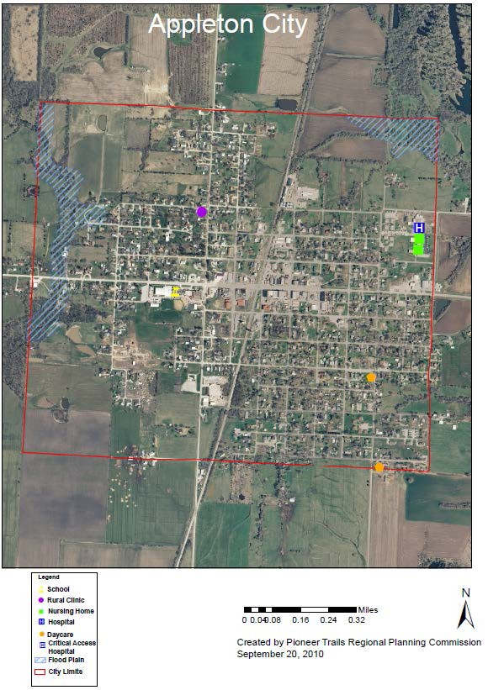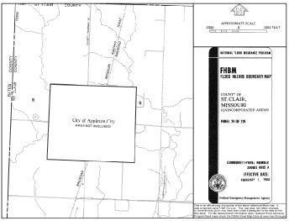

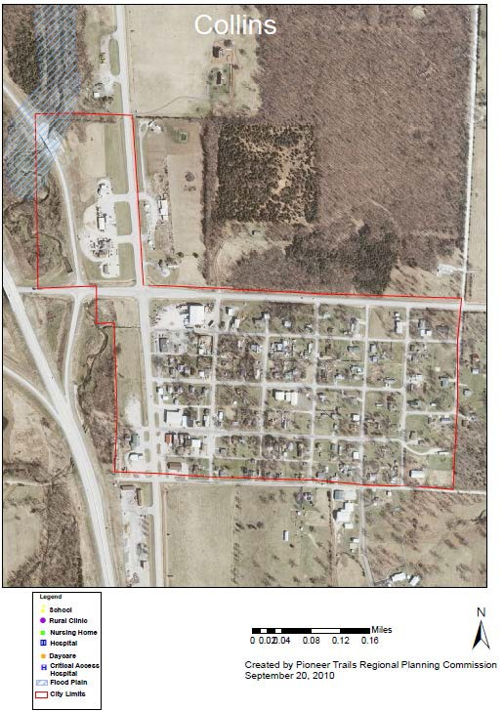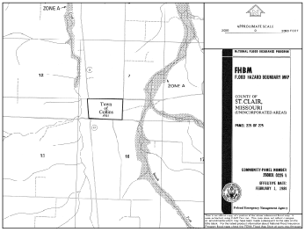

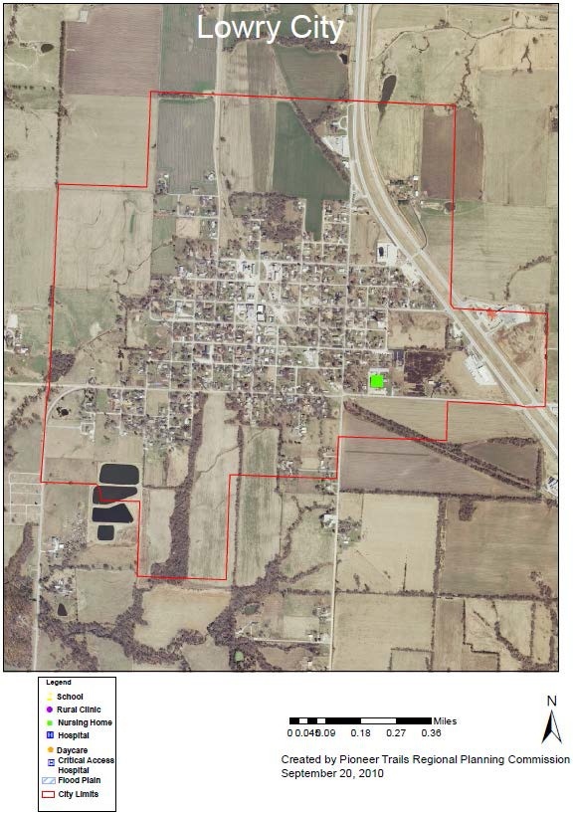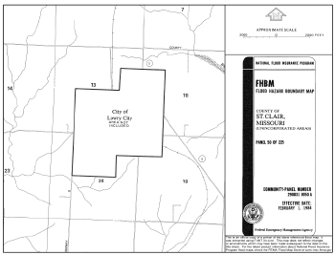

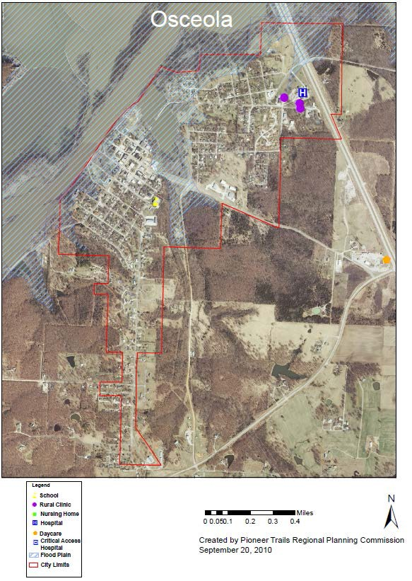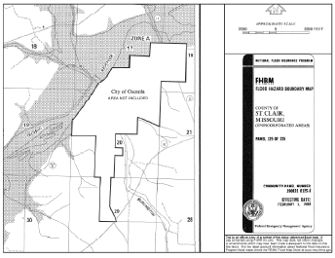

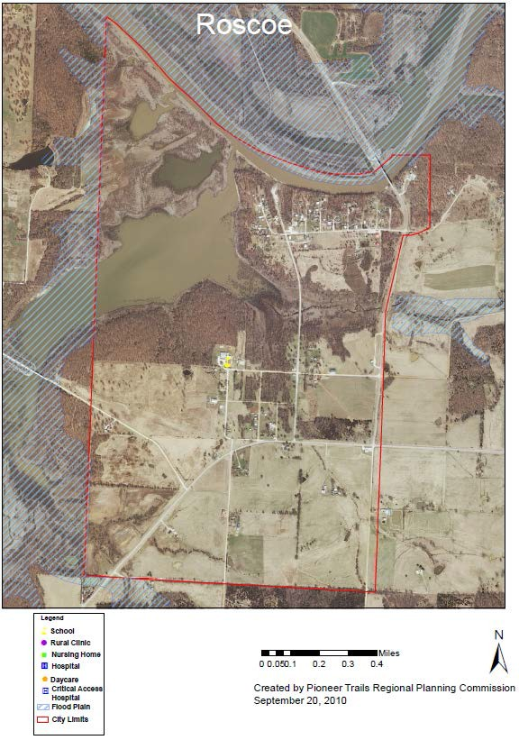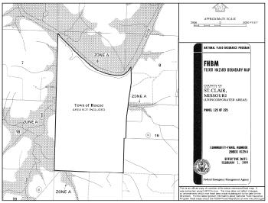

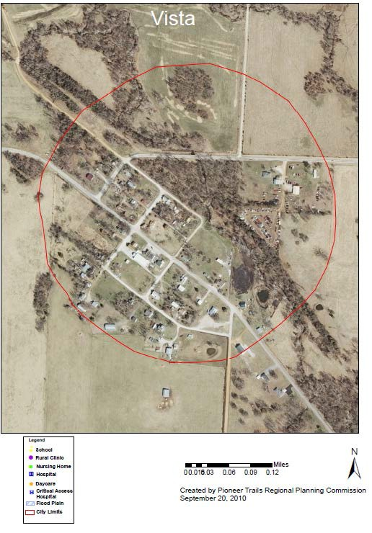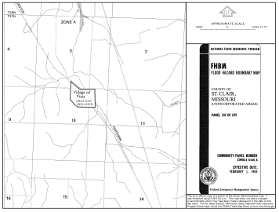

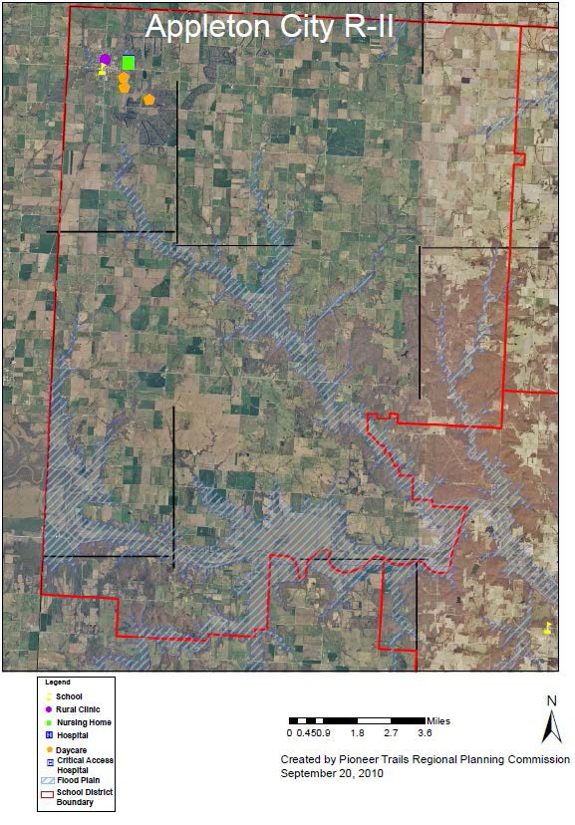

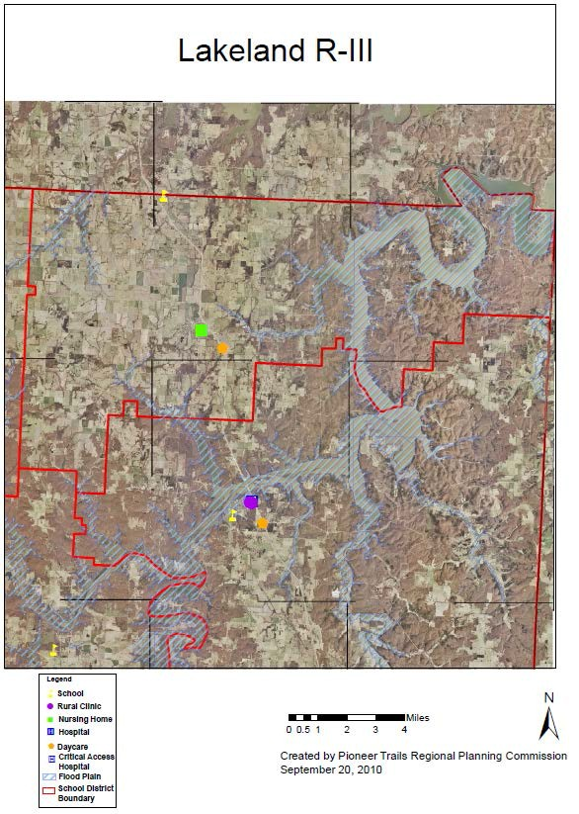

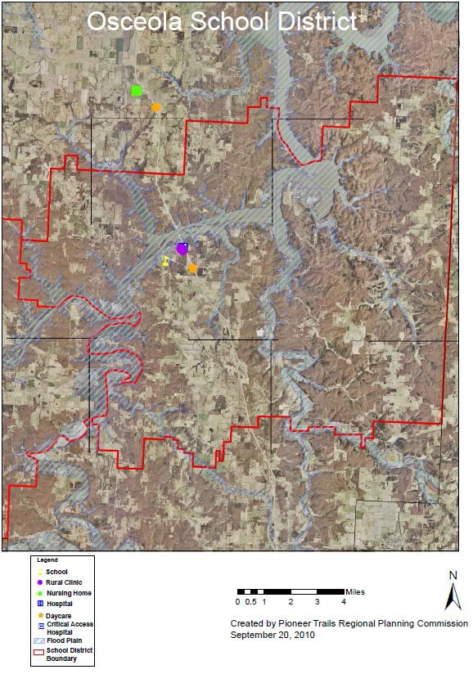

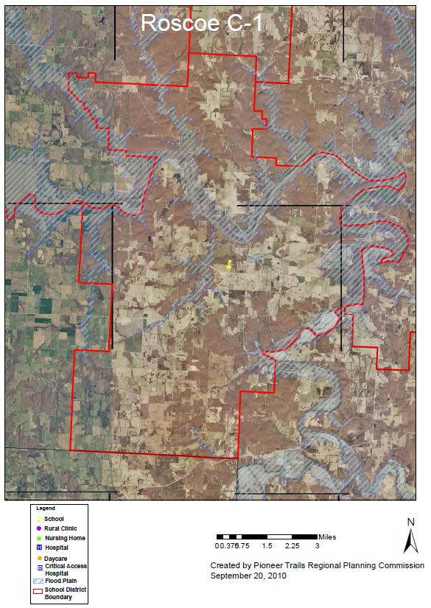

Statement of Future Probable Severity

According to SEMA’s Severity Ratings Table, the 1993 floods would qualify as critical. During the 1995 floods, some facilities were closed for 24 hours. Most other flood events had minimal impact on quality of life, no critical facilities or services were shut down for more than 24 hours, and property damage was less than 10%. Therefore, the probable severity of future floods could range from critical to negligible in the floodplain areas.

Statement of Future Probable Risk

Flooding causes widespread destruction disrupts businesses, and forces evacuation of 300,000 people in the United States annually. Direct flood losses are usually expressed in damage and death in a defined region. Indirect flood damage can include downtime for flooded industry and businesses, loss of production capability and income, disaster assistance and administration costs, costs due to lost power and communications, evacuation costs, and less tangible costs of psychological effects on flood victims.

The National Weather Service (NWS) is responsible for keeping records of major floods that have caused loss of life, major property damage, and major agricultural loss. Interpretation of flood-loss data is difficult, and estimates are not necessarily comparable due to differences in reporting in reporting flood losses, estimating personal vs. governmental outlays, and in adjusting dollar amounts. Because of these and other difficulties, flood damage data for most years is incomplete. However, the NWS reported $23,600,000 in property damage and
$7,200,000 in crop damage caused by 47 floods in the state between 1994 and 2009. Equivalent damage information is frequently not available for loss incurred from the multitude of smaller flood events that do not prompt federal response. Damage caused by flood events is therefore much more costly than NWS statistics indicate.

Many deaths caused by flooding are attributed to motorists who attempt to cross-swollen stream courses in automobile and are swept away by floodwaters. Low water bridges are particularly dangerous during flood events and periods of high water. Studies by FEMA show that 60 percent of flood fatalities occur in urban areas, 75% occur at night, and 49 % occur in cars. Motorists who underestimate the depth and velocity of floodwaters cause a high percentage of these. There have been 4 deaths in St. Clair County Due to flooding between the years of 1994 and 2009.

Statement of Next Disaster’s Likely Adverse Impact on the Community

Unless the next flood to hit the county is of greater magnitude than the floods of 1993, 1995, or 2002, the likely impact will be limited.

Without mitigations measures:

Life: Limited Property: Critical
Emotional: Catastrophic Financial: Critical
Comments: The above values assume conditions at the time of the 1993 floods.

With mitigation measures:
Life: Negligible Property: Limited Emotional: Critical Financial: Limited
Comments: Further mitigation measures should be directed at improving land use practices and elevating or redesigning vulnerable highways.

Statement of Next Disaster’s Likely Adverse Impact by Jurisdiction

Those jurisdictions which lie in the 100 year floodplain, specifically Appleton City, Osceola, Roscoe, Osceola School District and Roscoe C-1 District, are most susceptible to the potential damage from a flooding event. Since the passage of the original plan in 2004, no significant changes concerning building development or population shifts have taken place. Additionally, there have been no buyouts through NFIP.

Recommendation:

- Continue to provide an effective warning system to alert citizens in flood prone areas and on low-lying roads;
- Continue to encourage property owners, businesses, and occupants of flood-prone areas to participate in mitigation planning along with their public officials;
- Continue to provide emergency preparedness information and resources related to floods through active education and outreach programs.
- Work with SEMA to map non-federal levees and collect data related to levee failure in order to ensure best practices and create more effective mitigation strategies for levees.

Severe Winter Weather (Snow, Ice and Extreme Cold)

Like thunderstorms, severe winter weather events tend to occur over wide geographic areas, encompassing an entire county or a large group of counties. According to SEMA, severe winter weather events such as snow, ice storms and extreme cold can cause injuries, deaths and property damage in a variety of ways. Winter storms are considered deceptive killers because most deaths are not directly related to the storm. Causes of death range from traffic accidents during adverse driving conditions to heart attacks caused by overexertion while shoveling snow. Hypothermia or frostbite may be considered the most direct cause of death and injuries attributed to winter storms and/or severe cold. Economic costs are difficult to measure. Heavy accumulations of ice can bring down trees, electric power lines and poles, telephone lines, and communications towers. Such power outages also create an increased risk of fire as residents seek use of alternative fuel sources (wood or kerosene for heat, fuel burning lanterns or candles for emergency lighting). Crops, trees, and livestock can be killed or injured due to deep snow, ice, or severe cold. Buildings and automobiles may be damaged from falling tree limbs, power lines, and poles. Local governments, homeowners, business owners, and power companies can be faced with spending millions of dollars for restoration of services, debris removal, and landfill hauling.

Historical Statistics

Since 1995, according to the NCDC, severe winter weather in St. Clair County has:

- occurred primarily between December and March;
- caused 0 deaths and 0 injuries;
- damaged property valued at $8,295,000 and damaged crops valued at $105,000 and
- resulted in economic losses due to temporary business closings.

St. Clair County Severe Winter Weather: 1994 - 2010
Location | Date | Time | Type | Dth | Inj | PrD | CrD
St. Clair | 1/18/1995 | 1800 | Heavy Snow | 0 | 0 | 200,000 | 0
St. Clair | 11/11/1995 | 100 | Snow/ice | 0 | 0 | 0 | 0
St. Clair | 1/8/1997 | 1200 | Heavy Snow | 0 | 0 | 670,000 | 0
St. Clair | 12/20/1998 | 1400 | Winter Storm | 0 | 0 | 0 | 0
St. Clair | 1/1/1999 | 500 | Winter Storm | 0 | 0 | 2,800,000 | 0
St. Clair | 12/12/2000 | 2100 | Heavy Snow | 0 | 0 | 450,000 | 0
St. Clair | 1/28/2001 | 4:00 | Ice Storm | 0 | 0 | 0 | 0
St. Clair | 2/21/2001 | 1530 | Ice Storm | 0 | 0 | 25,000 | 0
St. Clair | 1/30/2002 | 500 | Ice Storm | 0 | 0 | 475,000 | 0
St. Clair | 3/2/2002 | 200 | Winter Storm | 0 | 0 | 0 | 0
St. Clair | 12/24/2002 | 400 | Winter Storm | 0 | 0 | 0 | 0
St. Clair | 1/2/2003 | 100 | Winter Storm | 0 | 0 | 0 | 0
St. Clair | 2/23/2003 | 1330 | Winter Storm | 0 | 0 | 0 | 0
St. Clair | 3/4/2003 | 2300 | Winter Storm | 0 | 0 | 0 | 0
St. Clair | 12/10/2003 | 100 | Heavy Snow | 0 | 0 | 0 | 0
St. Clair | 1/25/2004 | 200 | Ice Storm | 0 | 0 | 0 | 0
St. Clair | 11/30/2006 | 1200 | Winter Storm | 0 | 0 | 40,000 | 0
St. Clair | 1/12/2007 | 1800 | Ice Storm | 0 | 0 | 1,000,000 | 0
St. Clair | 1/20/2007 | 1900 | Winter Storm | 0 | 0 | 0 | 0
St. Clair | 12/9/2007 | 300 | Ice Storm | 0 | 0 | 2,500,000 | 0
St. Clair | 2/21/2008 | 700 | Ice Storm | 0 | 0 | 0 | 0
St. Clair | 1/26/2009 | 1500 | Ice Storm | 0 | 0 | 40,000 | 0
St. Clair | 1/26/2009 | 1500 | Winter Storm | 0 | 0 | 0 | 0
St. Clair | 12/12/2000 | 2400 | Extreme Cold | 0 | 0 | 125,000 | 105,000
St. Clair | 1/1/2001 | 2400 | Extreme Cold | 0 | 0 | 0 | 0
 |  |  | TOTALS | 0 | 0 | 8,125,000 | 105,000
Table 18 – Severe Winter Weather

Statement of Future Probably Severity

No deaths occurred in St. Clair County due to cold and ice storms. In 1997, a glaze/ice storm resulted in $670,000 in property damage. Two years later, in 1999, another ice storm caused
$2,800,000 in additional damage. In 2007, St. Clair County was subjected to a subsequent ice storm which devastated surrounding areas, resulting in $2,500,000 in property damages. Of 25 regional events, only eleven directly impacted the county. However, those eleven (extreme cold,

ice, and heavy snow) warrant ratings of critical for future probably severity. The following table shows snowfall extremes for St. Clair County between 1914 and 2008.

Historical Snowfall Climate Data
1971-2000 Averages

Element | JAN | FEB | MAR | APR | MAY | JUN | JUL | AUG | SEP | OCT | NOV | DEC | ANN
Snow(in) | 6.1 | 4.4 | 1.8 | 0.2 | 0.0 | 0.0 | 0.0 | 0.0 | 0.0 | 0.0 | 1.1 | 3.3 | 16.9

Period of Record: 1955-2001

Month | High (in) | Year | 1-Day | Date
JAN | 25.3 | 1979 | 8.5 | 01-21-1958
FEB | 14.0 | 1980 | 9.0 | 02-08-1980
MAR | 11.4 | 1960 | 9.0 | 03-06-1989
APR | 3.5 | 1973 | 3.5 | 04-09-1973
MAY | 0.0 | - | - | -
JUN | 0.0 | - | - | -
JUL | 0.0 | - | - | -
AUG | 0.0 | - | - | -
SEP | 0.0 | - | - | -
OCT | 0.5 | 1980 | 0.5 | 10-28-1980
NOV | 7.1 | 1975 | 7.0 | 11-26-1975
DEC | 14.0 | 2000 | 11.0 | 12-13-2000
Season (Jul-Jun) | 29.8 | 1978-1979 | 11.0 | 12-13-2000

*Annual/seasonal totals may differ from the sum of the monthly totals due to rounding.

Month | # Days Total ≥ 0.1" | # Days Total ≥ 1.0" | # Days Total ≥ 2.0" | # Days Total ≥ 5.0"
JAN | 3.5 | 2.5 | 1.4 | 0.2
FEB | 2.4 | 1.7 | 1.1 | 0.1
MAR | 1.0 | 0.6 | 0.3 | 0.1
APR | 0.1 | 0.1 | 0.1 | 0.0
MAY | 0.0 | 0.0 | 0.0 | 0.0
JUN | 0.0 | 0.0 | 0.0 | 0.0
JUL | 0.0 | 0.0 | 0.0 | 0.0
AUG | 0.0 | 0.0 | 0.0 | 0.0
SEP | 0.0 | 0.0 | 0.0 | 0.0
OCT | 0.0 | 0.0 | 0.0 | 0.0
NOV | 0.5 | 0.4 | 0.2 | 0.1
DEC | 1.6 | 1.0 | 0.6 | 0.2
Annual | 9.0 | 6.1 | 3.7 | 0.7

Excessive winter weather can prove devastating. Primary concerns include the potential loss of heat, power, telephone service, and a shortage of supplies if storm conditions continue for more then one day. Further, employees may be unable to get to work due to icy conditions, unplowed roadways, or facility damage.

Winter weather warnings are organized by stages of severity by the National Weather Service. These stages are shown below:

WINTER WEATHER ADVISORY:
Winter weather conditions are expected to cause significant inconveniences and may be hazardous. If caution is exercised, these situations should not become life-threatening. The greatest hazard is often to motorists.

WINTER STORM WATCH:
Severe winter conditions, such as heavy snow and/or ice, are possible within the next day or two.

WINTER STORM WARNING:
Severe winter conditions have begun or are about to begin in your area.

BLIZZARD WARNING:
Snow and strong winds will combine to produce a blinding snow (near zero visibility), deep drifts, and life-threatening wind chill. Seek refuge immediately.

FROST/FREEZE WARNING:
Below freezing temperatures are expected and may cause significant damage to plants, crops, or fruit trees. In areas unaccustomed to freezing temperatures, people who have homes without heat need to take added precautions.

In addition to snow, the effects of temperature and wind chill increase the severity of a winter storm. Wind blowing across exposed skin drives down the skin temperature and eventually the internal body temperature. The faster the wind blows, the faster the heat is carried away, the greater the heat loss and the colder it feels. Exposure to low wind chills can be life threatening to humans and animals.

A new Wind Chill Temperature Index took effect on November 1, 2001, replacing the original wind chill index that was devised in 1945. To determine the Wind Chill Temperature Index from the table below, locate the air temperature along the top of the table and the wind speed along the left side. The point where the two intersect is the wind chill temperature.

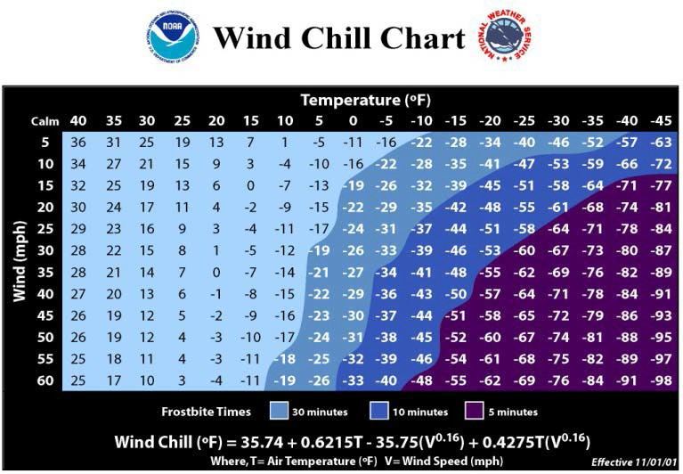

Figure 37

Based upon the county’s event history and the risk indicators discussed above, extreme cold events are likely the most dangerous for St. Clair County. The future probable severity for each category of winter event is shown below.

Winter event: Probable severity:
Heavy snow: limited
Ice event: limited
Extreme cold: critical
Blizzard: critical

Statement of Probable Risk

Overall, there is a highly likely risk of impacts due to winter weather, based upon the county’s history, snowfall summary and number of events by month of occurrence. These events are most likely to affect all jurisdictions which exist within the county due to their regional nature. History shows that snow events of at least three inches are highly likely. Ice events are likely. Periods of extremely cold temperature are also possible. Therefore, the risks for each type of severe winter weather are shown below.

Winter event: Probable risk:
Heavy snow likely
Ice event highly likely
Extreme Cold possible
Blizzard possible

Statement of Next Disaster’s Likely Adverse Impact on the Community

Based on recent history, the probably severity of future St. Clair County winter storm events is shown below:

Without mitigation measures:
Life: catastrophic
Property: critical Emotional: critical Financial: limited Comments: none

With mitigation measure:
Life: negligible
Property: limited Emotional: limited Financial: limited
Comments: A public awareness campaign regarding winter safety tips could help decrease the impact of winter storm events.

Statement of Next Disaster’s Likely Adverse Impact by Jurisdiction

All jurisdictions within the county are equally susceptible to damage stemming from severe winter weather, particularly snow and ice events. In the event of a severe winter storm, 50-100% of any given jurisdiction may be at risk for damage. Since the passage of the original plan in 2003, no significant changes concerning building development or population shifts have taken place. In the case of extreme cold temperatures, special consideration must be given to the potential impact upon the young and the elderly populations.

Recommendation:

- Work with MoDOT to monitor pavement and weather conditions so that they can be synchronized with snow removal machinery for more accurate, efficient, and timely snow removal.
- Maintain and expand distribution methods of severe weather alerts to the general public as the county’s needs change and new technology becomes available.
- Continue to provide emergency preparedness information and resources related to severe winter weather to the public through active education and outreach programs.

Drought

The impacts of drought are not limited to agriculture, but can extend to encompass the whole economy. Impacts can adversely affect a small town’s water supply, the corner grocery store, commodity markets and a big city’s tourism. According to the National Drought Mitigation Center, drought costs the U.S. economy an average of $7-9 billion a year. Losses from the Great Drought of 1988-89 were assessed at $39 billion. More recently, the University of Missouri estimated the drought losses of 2002 and 2003 farm production years. Economic impact to the Missouri economy due to agricultural losses was estimated at $461 million for 2002 and $575 million in 2003.

Drought’s impact on society results from the interplay between a natural event (less precipitation than expected resulting from natural climatic variability) and the demand development places on groundwater reservoirs. A drought situation often is exacerbated by development practices that decrease the percolation of surface water into groundwater reservoirs. Recent droughts in both developing and developed countries and the resulting economic and environmental impacts have underscored society’s vulnerability to this “natural” hazard. Like thunderstorms and severe winter weather, drought events tend to be regional in nature, encompassing all jurisdictions within the county.

The dictionary definition of drought is a period of prolonged dryness. The Missouri Drought Response Plan commonly distinguishes between five categories of drought:

- Agricultural Drought: defined by soil moisture deficiencies;
- Hydrological Drought: defined by declining surface water and groundwater supplies;
- Meteorological Drought: defined by precipitation deficiencies.
- Hydrological Drought and Land Use: defined as a meteorological drought in one area that has hydrological impacts in another area; and
- Socioeconomic Drought: defined as droughts that impact supply and demand of some economic commodity.

Agricultural and meteorological droughts are the most likely to wreak economic losses in St. Clair County.

The most commonly used indicator of drought and drought severity is the Palmer Drought Severity Index (PDSI) published jointly by NOAA and the United States Department of Agriculture. The PDSI measures the departure of water supply (in terms of precipitation and stored soil moisture) from demand (the amount of water required to recharge soil and keep rivers, lakes, and reservoirs at normal levels). The result is a scale from +4 to -4, ranging from an extremely moist spell to extreme drought. By relating the PDSI number to a regional index,
one can compile data that reflects long-term wet or dry tendencies. Regional indicators such as the PSDI are limited in that they respond slowly to deteriorating conditions. On the other hand, observing surface conditions and groundwater measurements may provide only a snapshot of a very small area. Therefore, the use of a variety of drought indicators is essential for effective assessment of drought conditions, with the PSDI being the primary drought severity indicator. The PDSI regions and severity scale are shown in the figure below.

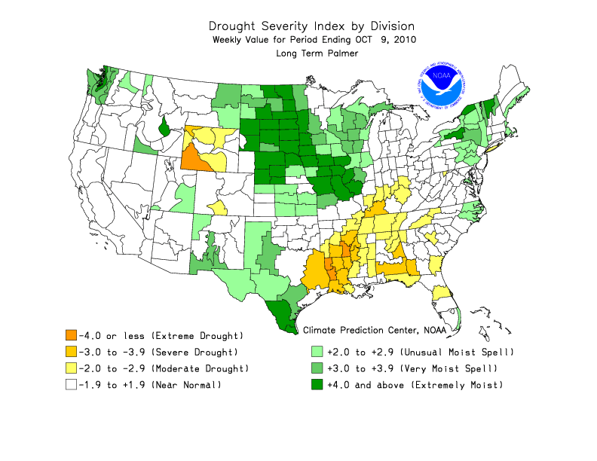

Historical Statistics
Figure 38

The counties of west-central Missouri have been subject to severe droughts over the past 10 years. In Missouri, the 1999-2000 droughts began in July of 1999 and developed rapidly into a widespread drought just three months later. The entire state was placed under a Phase I Drought Advisory level by DNR and the Governor declared an Agricultural Emergency. In October, the
U.S. Agriculture Secretary declared a federal disaster, making low-interest loans available to farmers in Missouri and neighboring states and altering the status of northern Missouri to Phase II Drought Advisory level. By May of 2000, twenty-seven northern Missouri counties were upgraded to Phase III Drought Advisory level (Conservation). Increased precipitation allowed for a return to near-normal conditions by July 2000 for northwest Missouri.

In Missouri, the 1999-2000 droughts began in July of 1999 and developed rapidly into a widespread drought just three months later. The entire state was placed under a Phase 1 Drought Advisory level by DNR and the Governor declared an Agricultural Emergency. In October the
U.S. Agriculture Secretary declared a federal disaster, making low-interest loans available to farmers in Missouri and neighboring states. By June of 2000, the entire state was under a Phase 2 Alert for drought conditions. Drought conditions put St. Clair County within the state’s Phase 2 Alert area for June, July, and August of 2000. Currently, according to the PSDI map, county conditions indicate near normal to very moist spells as of October of 2010.

Drought Occurances 2005 - 2010
Date | Phase | Condition
2/17/2006 | Phase 2 | Drought Alert
4/5/2006 | Phase 2 | Drought Alert
5/4/2006 | Phase 3 | Conservation
8/16/2006 | Phase 3 | Conservation
9/19/2006 | Phase 3 | Conservation
Table 19

Statement of Future Probable Severity

Crops are the first to show the impact of drought in St. Clair County. As drought increases, livestock water supplies become scarce and, finally, deep wells begin to fail. When good water becomes a scarce commodity and people must compete for the available supply, the importance of drought severity and duration increases dramatically. According to the Climate Prediction Center, the average annual precipitation for the St. Louis regional area is 39 inches and the state rates St. Clair County for moderate drought susceptibility. Precipitation related impacts on time scales ranging from a few days to a few months can include effects on wildfire danger, non- irrigated agriculture, topsoil moisture, pasture conditions, and unregulated stream flows. Lack of precipitation over a period of several months or years adversely affects reservoir stores, irrigated agriculture, groundwater levels, and well water depth. Groundwater resources in the county are adequate to meet domestic and municipal water needs, but due to required well depths, irrigation wells are very expensive.

The DNR’s drought response system has four phases. Phase 1 begins when water monitoring analysis indicates anticipated drought consequences. The situation moves into Phase 2 when the PDSI reads -1.0 to -2.0. At the same time, stream flow, reservoir levels and groundwater levels are below normal over a period of several months. Phase 3 is based on a PDSI between -2.0 to -
4.0 and various other factors. Phase 4, or activation of drought emergency procedures, generally begins when the PSDI exceeds -4. Therefore, using the DNR’s drought response system, the probable severity levels of a future drought could be:

Phase: Probable Severity:
Phase 1, Advisory: negligible
Phase 2, Alert: limited Phase 3, Conservation: critical Phase 4, Emergency: critical

Statement of Probable Risk

Overall, it is possible for St. Clair County to experience drought in any given year. Therefore, the risk of experiencing various levels of drought is shown below.

Phase: Probable Risk:
Phase 1, Advisory: likely
Phase 2, Alert: likely Phase 3, Conservation: possible Phase 4, Emergency: possible

Statement of Next Disaster’s Likely Adverse Impact on the Community

Based on recent history, the likely adverse impact of future St. Clair County droughts is shown below.

Without mitigation measures:
Life: negligible
Property: critical (crop damage) Emotional: critical
Financial: critical
Comments: none.

With mitigation measures:
Life: negligible
Property: limited (crop damage) Emotional: limited
Financial: limited
Comments: Educating farmers on the latest techniques for soil moisture maintenance, for example, could help stem the emotional impacts by reducing drought-related financial losses. Increased consolidation of small water structures also should be investigated.

Statement of Next Disaster’s Likely Adverse Impact by Jurisdiction

All jurisdictions within the county are equally susceptible to damage stemming from drought, particularly in phases 3 and 4. In the event of a severe drought, 100% of any given jurisdiction may be at risk for damage. Since the passage of the original plan in 2004, local agricultural producers have been encouraged to research and implement steps which reduce water usage in the event of a drought.

Recommendation:

- to discern and promote a set of best practices for drought-resistant farming;
- seek a cooperative effort with the home owners and contractors to promote best practices in storm water runoff and permeable surfaces.

Heat Wave

The dangers associated with extreme temperatures are often overlooked by the general public. According to NOAA, heat is the number two killer among natural hazards. Only the cold temperatures of winter take a greater toll. In contrast to the visible, destructive, and violent nature of floods, hurricanes, and tornadoes, a heat wave is a silent killer. Heat kills by overloading the human body’s capacity to cool itself. In the disastrous heat wave of 1980, more than 1,250 people died nationwide. In a normal year, about 175 Americans succumb to the bodily stresses of summer heat. As with previously identified hazards, heat waves tend to be regional in nature, placing all jurisdictions within the county at equal risk.

Air temperature is not the only factor to consider when assessing the likely effects of a heat wave. High humidity, which often accompanies heat in Missouri, can increase the harmful effects. Relative humidity must also be considered, along with exposure, wind, and activity. The Heat Index devised by the NWS combines air temperature and relative humidity. Also known as the apparent temperature, the Heat Index is a measure of how hot it really feels. For example, if the air temperature is 102 degrees and the relative humidity is 55% then it feels like 130 degrees; 28 degrees hotter than the actual ambient temperature. To find the Heat Index from Figure 2.10, find the air temperature along the left side of the table and the relative humidity along the top.
Where the two intersect is the Heat Index for any given time of day.

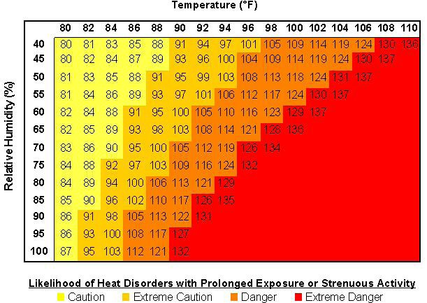

Figure 39

In addition, the NWS recently has devised a method to warn of advancing heat waves up to seven days in advance. The new Mean Heat Index is a measure of how hot the temperatures actually feel to a person over the course of a full 24 hours. It differs from the traditional Heat Index in that it is an average of the Heat Index from the hottest and coldest times of each day.

Historical Statistics

Seven heat events have directly impacted St. Clair County between 1994 and 2001. The most significant heat waves occurred in 1994, 1999, 2000, and 2001. These heat waves resulted in the following impacts:

- 16 deaths;
- 55 injuries; and
- crop damage valued at $50,000

Heat events affecting St. Clair County from 1994 to 2001 are noted in the table below.

Location or County | Date |  | Time | Type | Dth | Inj | PrD | CrD
St. Clair | 6/12/1994 |  | 0 | Heat | 4 | 55 | 0 | 50,000
St. Clair | 7/23/1999 | 6:00 AM |  | Excessive Heat | 6 | 0 | 0 | 0
St. Clair | 8/1/1999 |  | 12:00  AM | Excessive Heat | 2 | 0 | 0 | 0
St. Clair | 8/27/2000 | 4:00 AM |  | Excessive Heat | 1 | 0 | 0 | 0
St. Clair | 9/1/2000 |  | 12:00  AM | Excessive Heat | 0 | 0 | 0 | 0
St. Clair | 7/17/2001 |  | 12:00  PM | Excessive Heat | 1 | 0 | 0 | 0
St. Clair | 8/1/2001 |  | 12:00  AM | Excessive Heat | 2 | 0 | 0 | 0
 | TOTALS: |  |  |  | 16 | 55 | 0 | 50,000
Table 20 – Heat Events

Statement of Future Probable Severity

The levels of severity, by Heat Index apparent temperature, are:

- Extreme Danger (heat stroke or sunstroke highly likely at 130ºF or higher);
- Danger (sunstroke, muscle cramps, and/or heat exhaustion likely at 105ºF to 129ºF);
- Extreme Caution (sunstroke, muscle cramps, and/or heat exhaustion possible at 90ºF to 104ºF); and
- Caution (fatigue possible at less than 90ºF).

The NWS uses these levels in their weather warning messages to alert the public to the dangers of exposure to extended periods of heat, especially when high humidity acts along with the high temperatures to reduce the body’s ability to cool itself.

Although most heat-related deaths occur in cities, residents of rural areas are at risk due to factors that can include age, outdoor activities, or lack of air conditioning. While heat-related illness and death can occur due to exposure to intense heat in just one afternoon, heat stress on the body has a cumulative effect. The persistence of a heat wave increases the danger. Excessive heat can lead to illnesses and other stresses on people with prolonged exposure to these conditions.

In addition to the human toll, the Midwestern Climate Center notes other possible impacts such as electrical infrastructure damage and failure, highway damage, crop damage, water shortages, livestock deaths, fish kills, and lost productivity among outdoor-oriented businesses. The future probable severity for St. Clair County is shown below according to severity levels.

Index: Probable Severity:
Heat Index of 130ºF or higher: catastrophic Heat Index of 105ºF to 129ºF: critical Heat Index of 90ºF to 104ºF: limited Heat Index of less than 90ºF: negligible

Statement of Probable Risk:

In St. Clair County, days with temperatures of 90 degrees and above generally occur during the month of July. A review of the data for 1999-2008 shows the county could experience a brief heat wave every year. However, on average, only three instances could qualify as heat waves, dependent upon the relative humidity during those times. Based on NWS historical records, an actual extended heat wave may occur only once or twice per decade. The county’s risk of experiencing heat waves is shown below according to Heat Index severity levels.

Index: Probable Severity: Extreme Danger unlikely Danger possible Extreme Caution likely Caution highly likely

Statement of Next Disaster’s Likely Adverse Impact on the Community

The adverse impacts of future heat waves affecting St. Clair County at the “Extreme Caution” level are shown below.

Without mitigation measures:
Life: limited
Property: limited Emotional: limited Financial: limited Comments: None.

With mitigation measures:
Life: negligible
Property: negligible Emotional: negligible Financial: limited Comments: None

Statement of Next Disaster’s Likely Adverse Impact by Jurisdiction

All jurisdictions within the county are equally susceptible to damage stemming from a heat wave as these types of events tend to be regional in nature. In the event of a heat wave, 25% of any given jurisdiction may be at risk for damage. Since the passage of the original plan in 2003, no significant changes concerning building development or population shifts have taken place which may impact a heat wave. St. Clair County does include mitigation strategies which include the opening of cooling centers in case of a severe heat event. As with extreme cold temperatures, special consideration must be given to the potential impact upon the young and the elderly populations.

Recommendation

That the County initiates a mitigation activity to provide cooling centers or portable fans for the elderly and those populations without air conditioning during sustained high temperatures.

Earthquakes

According to the widely accepted plate tectonic theory, the earth’s outermost layer, the lithosphere, is a solid and brittle material. This layer consists of several large and fairly stable slabs of rigid rock called plates. These plates are in almost continuous motion relative to each other. This motion causes stresses to accumulate within the rocks resulting in deformation.
When the amount of stress exceeds the strength of the rocks, these rocks rupture and relative motion takes place along both sides of the rupture zone. This rupture zone is called a fault. If the motion or slippage along the fault zone happens abruptly, an earthquake will be generated. Thus earthquakes result from a sudden release of stress accumulated within the rocks over some period of time. The rupture and slippage processes generate seismic waves that radiate from the fault surface in all directions. If the energy of the seismic waves is high enough, people and structures along the earth surface will be affected.

The focus or hypocenter of an earthquake is the point within the earth where the initial rupture of the rock occurs and where the seismic waves from this point are first released. The majority of earthquakes in the central United States have shallow focal depths, generally 15 kilometers or less. Most of these earthquakes occur within the New Madrid Seismic Zone (NMSZ) (see next section). Almost all earthquake activity of the NMSZ occurs along ancient faults that are buried below the surface (from 0 to about 2 km) by thick alluvial sediments of the Mississippi and other rivers in the area. The epicenter of an earthquake is the point on the ground surface directly above the focus.

Most earthquakes such as those occurring in areas such as San Andreas Fault, Alaska, Japan, and Andes occur along the plate boundaries. In some cases, earthquake zones develop within the plate itself resulting in intraplate seismicity. The plate tectonics theory does not as easily explain this type of seismicity (Bolt, 1993). Such intraplate earthquakes must arise from a more localized system of forces perhaps associated with structural complexities from very ancient geological conditions or from variation of strength of the lithosphere. The New Madrid Seismic Zone is by far the most important example of intraplate seismicity in North America.

The New Madrid Fault System (NMFS) extends 120 miles southward from the area if Charleston, Missouri, and Cairo, Illinois, through New Madrid and Caruthersville, following Interstate 55 to Blytheville and on down to Marked Tree, Arkansas. It crosses five state lines and cuts across the Mississippi River in three places and the Ohio River in two places.

The fault is active, averaging more than 200 measured events per year (1.0 or more on the Richter scale), about 20 per month. Tremors large enough to be felt (2.5 – 3.0 on the Richter scale) are noted annually. Every 18 months the fault releases a shock of 4.0 or more, capable of local minor damage. Magnitudes of 5.0 or greater, occurring about once per decade, can do significant damage and be felt in several states.

The highest earthquake risk in the United States, outside the west coast, is along the NMFS. Damaging tremblers are not as frequent as in California, but when they do occur, the destruction covers over more than 20 times the area because of underlying geology.

A damaging earthquake in this area, 6.0, reoccurs about every 80 years (the last one in 1895). In 2002, the U.S.G.S. released new earthquake probabilities for the NMSZ. For a magnitude 6.0 –
7.5 or greater earthquake, there now is estimated to be a 25 – 40% chance in 50 years. The results would be serious damage to schools and masonry buildings from Memphis to St. Louis.

The earthquake risk to the St. Clair County is dominated by its proximity to the New Madrid Fault system. This fault system generates an annual rate of about 200 earthquakes per year. Even though St. Clair County is a considerable distance from the epicenters of the quakes on this fault system, there is a high probability that residents of the county would feel the effects of a major magnitude earthquake even from so far away.

During the process of fault rupture, energy radiates from the source area in the form of seismic waves. These waves travel in all directions and as they do, they cause the ground to vibrate or shake. In general, the amount of energy in these waves increases with an increase of the energy of the earthquake. Thus the severity of the ground motion is a function of the amount of energy in the seismic waves. Due to the fact that earth material is not perfectly elastic, energy in the seismic waves is absorbed (attenuated) as it travels through the earth. This explains the decrease in the amount of ground motion as the distance between the observation point and the causative fault or epicenter increases. Depending on the epicenter distance, faulting process and the type of material the waves travel through, the ground vibrates at a wide spectrum of frequencies. In general, the seismic waves range in frequency from less than 0.01 Hz to more than 50 Hz.

Earthquake motion and damage is the result of three basic types of elastic waves. Two of these waves propagate within the body of the earth, and are called body waves. The first of these body waves are called the primary or P waves. P waves, also called compressional or longitudinal waves, have a motion similar to that of sound wave in that, as they spread out, they alternately push (compress) and pull (dilate) the earth material. These waves are able to travel through both solid rock and liquid material. The second of the body waves are the shear waves, also called secondary or S waves. As S waves propagate, they shear the rock sideways at right angles to the direction of travel. S waves cannot propagate in the liquid parts of the earth, such as ocean or outer core.

The actual speed of P and S waves depends on the density and elastic properties of the rocks and soil through which they pass. In most earthquakes, the P waves are felt first. The effect is similar to a sonic boom that bumps and rattles windows (Bolt, 1993). The S waves arrive some seconds later, moving the ground up and down and side-to-side. The vertical and horizontal shaking of the ground by the S waves is the primary cause of structural damage.

The third general type of seismic waves is called surface waves. As their name indicates, these waves have their motion restricted to near the surface of the earth. Earthquakes usually generate two types of surface waves. The first type is called Love waves. The motion of Love waves is essentially the same as that of S waves that have no vertical displacement; they move the ground from side to side in a horizontal plane but at right angles to the direction of propagation. The horizontal shaking of Love wave is particularly damaging to the foundations of structures. The second type of surface waves is known as the Raleigh waves. These waves cause the ground to move in both vertically and horizontally in a vertical plane parallel to the direction in which the

wave is traveling. Surface waves travel more slowly than body waves and therefore arrive at a later time. Of the two surface waves, Love waves generally travel faster than Raleigh waves.

Ground Failure and Liquefaction

In areas where ground failure might occur, seismic intensity values may increase by one or two levels. Areas of likely ground failure, such as liquefaction and slope instability, are common in St. Clair County. Landslide and slope instability is discussed in detail in Chapter IV. Liquefaction occurs primarily in saturated, loose, and fine to medium-grained unconsolidated sediments in areas where the ground water table is 50 feet or less below the ground surface.
When these sediments are shaken, such as during an earthquake, a sudden increase in pore water pressure causes the soils to lose strength and behave as a liquid. Sand boils, sand blows or "sand volcanoes" are a common result. Liquefaction-related effects include loss of bearing strength, ground oscillations, lateral spreading, and flow-failures or slumping. Ground failure caused by liquefaction is expected to cause major earthquake damage throughout the embayment region.
Recent research conducted by the USGS and other institutions indicates that the 1811-1812 New Madrid earthquake series caused widespread ground failure and liquefaction throughout the region. Evidence of old liquefaction features indicates that several such events had taken place in the past.

A secondary hazard of earthquakes in cities is fire, which may be more devastating than the ground movement. Disruption of electric power lines and broken gas lines can start fires that are difficult to control because firefighting equipment may be damaged. At the same time, water lines also are broken, leaving no means to fight the fire effectively. Blocked and damaged roads often hamper access to fires. Terrible fires have accompanied earthquakes in Japan and the United States. In the great 1906 San Francisco earthquake, sometimes referred to as the “San Francisco fire,” about 80 percent of the damage was due to fire rather than simple building failure. Installing numerous valves in all water and fuel pipeline systems helps to combat these problems.

Historical Statistics

The New Madrid Seismic Zone, located in the northern part of the Mississippi Embayment, is one of the most seismically active regions of eastern North America. The 1811 - 1812 series of earthquakes, commonly known as the New Madrid earthquakes, produced damaging intensities over areas far greater than any historical earthquake in the conterminous United States. These and other historical earthquakes, as well as recent seismic activity, indicate that the New Madrid seismic zone has high potential for generating damaging earthquakes. Considering the isoseismic map for the 1811 - 1812 earthquake sequence, a conclusion is easily drawn that with the current distribution of population and infrastructure within the region, a repetition of the sequence similar to that in 1811-1812 would likely cause widespread destruction of property and loss of life.

Earthquake activity in the New Madrid seismic zone is considered to be a "high-risk, low- probability" phenomenon. The high risk in this region is associated with three main phenomena:
(1) the potential for a future, large-magnitude earthquake, (2) the efficient transmission of

seismic energy in the frequency range that is associated with structural damage, and (3) the population and infrastructure presently exist in the anticipated damage area. During the winter of 1811-12, a sequence of the three largest earthquakes in the history of this region occurred. The three main shocks, which occurred on December 16, 1811, January 23, 1812, and February 7, 1812, had epicenter Modified Mercalli intensities of XI, X-XI and XI-XII and estimated body- wave magnitudes (mb) of 7.2, 7.1, and 7.4 and estimated surface-wave magnitudes (Ms) of 8.5, 8.4, and 8.8, respectively.

Since 1812, only two large earthquakes of surface-wave magnitude greater than 6.0 have occurred in the central United States, both in the New Madrid Seismic Zone. The first earthquake, which struck on January 4, 1843, was centered in Arkansas at the extreme southern end of the Arkansas branch (near Marked Tree). It had a surface-wave magnitude of 6.3, and an area of Modified Mercalli intensity of VI or greater that encompassed about 60,000 square miles. The earthquake caused structural damage in Memphis, southwest Tennessee, northeast Arkansas, and the extreme northwest corner of Mississippi. The second large historic earthquake occurred near Charleston, Missouri, at the northern end of the New Madrid Seismic Zone in 1812. This earthquake had a surface-wave magnitude of 6.7 (Nuttli, 1990). Arkansas, Illinois, Missouri, and Tennessee are the most historically active states east of the Rocky Mountains.

The active portion of the New Madrid Seismic Zone is part of a larger complex of faults, the greater number of which extend in a northeasterly direction from the active zone and are exposed to the north of the Mississippi Embayment. Others extend in a northwest-southeast direction across southern Missouri and Illinois. Major faults of this system extend to the southwest from Caruthersville to Marked Tree, Arkansas. Some of these faults appear to be completely inactive, while others are sites of minor activity. The most widely accepted hypothesis for the generation of earthquakes in the New Madrid region is that they are responses to plate tectonic forces acting upon previously existing zones of weakness, which are favorably oriented with respect to the regional stress field.

Statement of Future Probable Severity

The possibility of a great earthquake occurring soon in the New Madrid seismic zone is small. Scientists believe that catastrophic events like those of the 1811-12 happen in the New Madrid region every 550-1200 years. This means there is roughly a 0.3-1.0% probability of an event greater than magnitude 8.0 within the next 15 years, and a 2.7-4.0% probability within 50 years. Even though the probabilities are small, there is no reason to be complacent, for there have been other damaging earthquakes in the region since 1811 and 1812.

A major earthquake, magnitude 7.0 or greater, occurs every 254-500 years and has a probability of five to nine percent within the next fifteen years, and a nineteen to twenty nine percent within the next fifty years. An earthquake of this size would be felt throughout much of the central and eastern United States. Damage could amount to several billion dollars.

A damaging earthquake in this area, magnitude 6.0 or greater, happens every seventy to ninety years and has a probability of 40- 63% within the next fifteen years, and 86-97% within the next

fifty years. An earthquake of this size would cause damage to older structures, especially those of masonry construction and mobile homes.

Earthquakes of 5.0 or less are also possible in many other parts of the central and eastern U.S., including Missouri. The following table lists the recurrence interval for different magnitude earthquakes in the NMSZ.

Recently the USGS published the following findings:

Scientists from the U.S. Geological Survey (USGS) scientists and the Center for Earthquake Research and Information at the University of Memphis have updated their expectations for earthquakes in the New Madrid Seismic Zone.

The new forecasts estimate a 7 to 10 percent chance, in the next 50 years, of a repeat of a major earthquake like those that occurred in 1811-1812, which likely had magnitudes of between 7.5 and 8.0.

There is a 25 to 40 percent chance, in a 50-year time span, of a magnitude 6.0 and greater earthquake.

The earthquake probabilities have changed considerably since the most commonly cited forecast published in 1985. The new probabilities show an increased chance of larger (7.5-8.0 magnitude) earthquakes and a lesser chance of magnitude 6.0 and greater earthquakes. Meanwhile, estimates of the hazard, or potential for damage caused by shaking, have changed much less. A fact sheet with the new information is available on the web at: http://pubs.usgs.gov/fs/fs-131-02/.

“More than fifteen years of research has given us the information to allow us to update our forecasts. But even though the chances of a mid-sized earthquake are reduced, the chances of a devastating earthquake in the region have risen,” said USGS scientist Eugene Schweig. “Given this new information, people should absolutely not drop their guard. The threat of an earthquake to Mid-America is still very real.”

The New Madrid seismic zone is an area of frequent small earthquakes that stretches along the lower Mississippi Valley from just west of Memphis, Tennessee into southern Illinois. It also was the location of a sequence of three or four major earthquakes in 1811 and 1812.

Major earthquakes in the range of magnitude 7.5 to 8.0 are capable of causing widespread damage over a large region. Magnitude 6.0 earthquakes can cause serious damage in areas close to the earthquake’s location because the hazard (chance of damage in a given area) depends not only on earthquake probabilities, but also on where the earthquakes occur and local soil conditions.

In Memphis and throughout the Mid-America region, the USGS is improving its earthquake monitoring and reporting capabilities through the Advanced National Seismic System (ANSS), a nation-wide network of modern strong motion seismometers that will provide emergency- response personnel with real-time "shaking" information within minutes of an earthquake.

ANSS stations will assist emergency responders within minutes of an event showing not only the magnitude and epicenter, but where damage is most likely to have occurred.

Ten new ANSS instruments were recently installed in the Memphis area, 20 have been installed across the mid-America region, and more than 175 have been installed in other vulnerable urban areas outside the central U.S. to provide real-time information on how the ground responds when a strong earthquake happens.

“The ultimate goal of ANSS is to save lives and ensure public safety,” said Dr. John Filson, U. S. Geological Survey (USGS) Earthquake Program Coordinator. “This information, already available in Southern California, is generated by data from seismic instruments installed in urban areas and has revolutionized the response time of emergency managers to an earthquake, but its success depends on further deployment of instruments in other vulnerable cities.”

In 1997, during the reauthorization of the National Earthquake Hazards Reduction Program, Congress asked for an assessment of the status and needs of earthquake monitoring. The result was the authorization of ANSS to be implemented by the USGS. The system, when implemented, would integrate all regional and national networks with 7,000 new seismic instruments, including 6,000 new strong-motion sensors in 26 at-risk urban areas. To date, approximately 350 instruments have been installed.

New USGS National Seismic Hazard Maps depict these hazard or likelihood of ground shaking. The USGS and its partners in universities and state geological surveys are preparing more detailed hazard maps for Memphis and other areas that include the effects of local soil conditions. For more information see http://geohazards.cr.usgs.gov/eq/.

The goal of USGS earthquake monitoring is to mitigate risk - using better instruments to understand the damage shaking causes and to provide information to help engineers create stronger and sounder structures that ensure vital infrastructures, utility, water, and communication networks keep operating safely and efficiently.

Earthquake frequencies in the New Madrid Seismic Zone

MAGNITUDE | RECURRENCE INTERVAL
4.0 | 14 months
5.0 | 10-12 years
6.0 | 70-90 years
7.0 | 254-500 years
8.0 | 550-1200 years

The most important direct earthquake hazard is ground shaking. Ground shaking affects structures close to the earthquake epicenter but can also affect those at great distances. NMSZ and possibly other faults in the region have the potential of generating earthquakes that will cause strong ground motion throughout Missouri. Ground motion at any given site can be characterized by three different parameters. These parameters are ground displacement, velocity, and acceleration. Each has its own usage and application. For engineering applications, ground acceleration, rather than velocity or displacement, is the primary consideration in design criteria. This is because acceleration is directly related to the dynamic forces that earthquakes induce on structures. Ground acceleration may be presented as a peak value or spectral value. Peak value represents the maximum predicted ground acceleration regardless of the frequency of the seismic waves. Spectral value, on the other hand, represents the maximum ground acceleration at a particular frequency (e.g., 1.0 Hz).

Seismologists and engineers are currently using computer-modeling schemes to predict ground acceleration. Input to this modeling process includes the maximum magnitude of an earthquake expected in the source areas, seismic wave attenuation equations, and site information. Even with fairly reliable models, it is still difficult to anticipate the damage sustained by different types of structures during an earthquake. This is because the response of structures to ground shaking depends on many parameters, including the amplitude and frequency content of the seismic waves, and the duration of shaking. The frequency content of the ground motion, in turn, depends on the rupture mechanism of the earthquake, the properties of the materials that attenuate the seismic energy, and the regional and local site conditions that may amplify, focus, or defocus the seismic waves arriving at the site of interest. In addition, different structures, because of differences in their natural frequencies and modes of vibration, respond differently to a given ground motion. For planning of critical facilities, therefore, it is often best to study the effects of the worst-case scenario, using as standard the maximum credible earthquake of the fault nearest to the site.

Earthquakes may occur at anytime and anywhere in the central United States including Missouri. However, it is most likely they will occur along the 120-mile New Madrid Seismic Zone.
Different from most other hazards, earthquakes are known to cause wide spread damage and human casualties (e.g. 1906 San Francisco earthquake, 1994 Northridge earthquake, 1995 Kobe, Japan, earthquake). A repetition of the 1811-1812 events or even magnitude 7.6 earthquake in the New Madrid Seismic Zone is expected to cause severe effects not just in Missouri, but throughout the central United States including, Arkansas, Illinois, Tennessee, Kentucky, and possibly Indiana and Mississippi. An earthquake of magnitude 6+ (similar to the 6.3 Marked Tree earthquakes of 1843) is expected to affect area of more than 60,000 square miles.

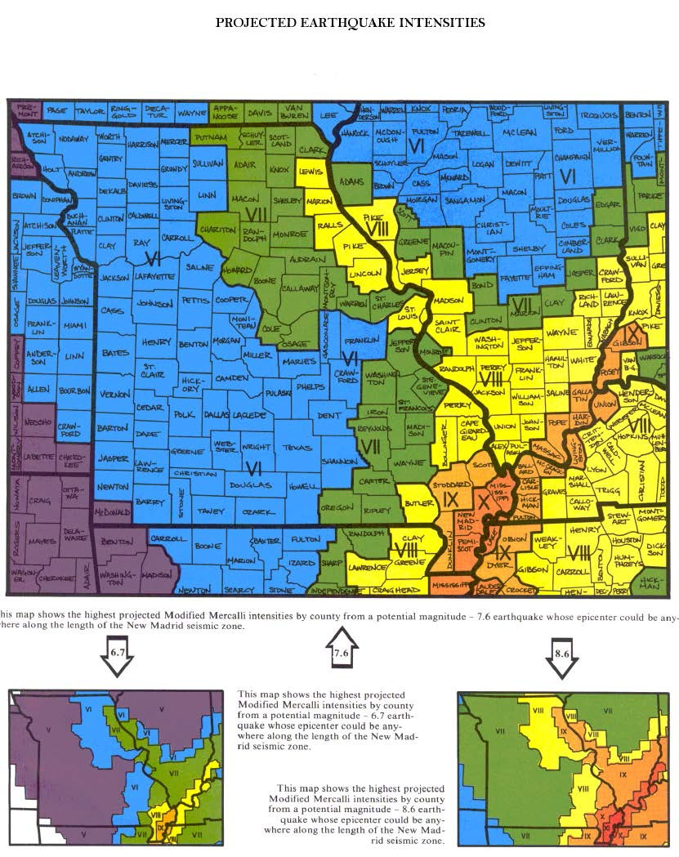

Figure 40

Statement of Probable Risk

Historic and recent earthquake activity in central United States, discussed in the Hazard Identification Section of this chapter, indicate that throughout this century, the region has not experienced a major earthquake that caused widespread damage or injuries. According to the magnitude-recurrence relation, the rate of earthquake activity for any particular seismic source usually remains stable for long periods of time (possibly thousands of years). Application of such a relation in the New Madrid Seismic Zone indicates that an earthquake of magnitude 6+ in the region is overdue.

The recurrence interval for a magnitude 6 earthquake is about 100 years. Many Midwestern communities are located near the New Madrid fault, an area with high seismic risk. Estimates of the recurrence intervals of the large 1811-1812 earthquakes are about 500 to 1000 years. Most residents are not aware of this risk because the last significant earthquake occurred in the early 19th century. However, small quakes along this fault continue to occur in Missouri about every 8 days.

Based on the history of the New Madrid Fault and the calculated earthquake frequencies, St. Clair County stands a good chance of experiencing an earthquake of magnitude 6.0. Since St. Clair County lies a good distance from the New Madrid Fault, small earthquakes usually are not noticeable. The more severe threat stems from an earthquake producing Modified Mercalli impact levels of VII-XIII.

Probable Risk of Modified Mercalli Levels:
I – V: likely (0-40% chance through year 2015)
VI: likely (40-63% chance through year 2015)
VII: possible
VII – XIII: possible

Statement of Next Disaster’s Likely Adverse Impact on the Community

The impact on the general public, small to medium size businesses, life-line services, and the infrastructure may be radically lessened if precautions are undertaken at multiple levels.
Increased education, concern and subsequent action can reduce the potential effects of earthquakes, and this can be done in conjunction with preparations for other natural hazards. A program that recognizes the risk of flooding, landslides and other dangers and which incorporates earthquake issues will be the most beneficial to St. Clair County citizens.

Individuals and all levels of government have roles in reducing earthquake hazards. Individuals can reduce their own vulnerability by taking some simple and inexpensive actions within their own households. Local government can take action to lower the threat through the proper regulation of poor sites, assuring that vital or important structures (police, fire, and school buildings) resist hazards, and developing infrastructure in a way that decreases risk. State agencies and the legislature can assist the other levels of action and provide incentives for minimizing hazards.

Based on the Projected Earthquake Intensities map, St. Clair County is most at risk for Modified Mercalli Level VI as likely adverse impacts. The possible effects at Level VI are shown below.

Without Mitigation Measures:
Life: limited
Property: limited Emotional: limited Financial: limited

With Mitigation Measures:
Life: negligible
Property: limited Emotional: negligible Financial: negligible
Comments: Education, building regulation enhancements, and infrastructure enhancements will help minimize building damage and injuries.

Statement of Next Disaster’s Likely Adverse Impact by Jurisdiction

All jurisdictions within the county are equally susceptible to damage stemming from an earthquake. In the event of an earthquake, 50% of any given jurisdiction may be at risk for damage. Since the passage of the original plan in 2004, no significant changes concerning building development have taken place. St. Clair County’s third-class status prevents mitigation actions based on zoning and building construction.

Recommendation

- initiates mitigation activities to encourage developers and building owners to institute appropriate earthquake safeguards to protect the lives of those using their buildings; and
- create a coordinated initiative to educate residents about precautions required by all the natural hazards in the county.

Dam Failure

Dam failure may also result in a flood event. A dam impounds water in the upstream area, referred to as the reservoir. The amount of water impounded is measured in acre-feet. An acre- foot of water is the volume that covers an acre of land to a depth of one foot. As a function of upstream topography, even a very small dam may impound or detain many acre-feet of water. Dam failures are not routine, but the results can be devastating. Two factors influence the potential severity of full or partial dam failure: the amount of water impounded, and the density, type, and value of development downstream.

A number of outside forces can cause Dam failures. Included in these are prolonged periods of rain or flooding, landslides into reservoirs, failure of dams upstream, and earthquakes. The most common cause of dam failure is prolonged rainfall that produces flooding. Failure due to events such as earthquakes or landslides, however, is significant because there is little to no advance warning. It is important to note that dam failures can result from natural events, human-induced events, or a combination. Improper design and maintenance, inadequate spillway capacity, or internal erosion or piping within a dam may also cause failure. People, property, and infrastructure downstream of dams are subject to devastating damage in the event of failure.

The National Dam Safety Program (NDSP) was established in 1996 with the Director of FEMA as coordinator. The purpose of the program is to reduce the risks to life and property from dam failure in the United States by bringing together the expertise and resources of the Federal and non-Federal communities in achieving national dam safety hazard reduction. The NDSP establishes a grant assistance program to the States to improve their dam safety programs; provides funds for research and training; creates a National Dam Safety Review Board to monitor the State assistance program; and funds the National Inventory of Dams (NID) under the United States Army Corps of Engineers.

St. Clair County Dam Failure Flood Hazard

According to the Missouri Department of Natural Resources, there are 15 dams in St. Clair County. Each dam listed is assigned a hazard classification (high, significant, or low hazard) based on potential of loss to life and property (exposure) should the dam fail. The hazard classification is not an indicator of the adequacy of the dam or its physical integrity. Hazard classification is updated continually based on development and changing demographics upstream and downstream. None of the damns within St. Clair County are classified as a high hazard dam because of the significant development downstream from it. The hazard rating is based on the contents of the downstream environment zone (permanent dwellings, public buildings, campgrounds, industrial buildings, etc). Dam failure can result in flood inundation areas significantly larger than the 100-year regulatory floodplain indicated on Federal Insurance Rate Maps (FIRM’s).

All federal agencies were recently required to develop Flood Emergency Plans for dams under their control. As part of these plans, flood inundation maps were prepared based upon selected emergency conditions. Preparation of these maps does not reflect on the safety, physical condition, or integrity of the dam. Conditions considered for the dams include: 1) occurrence of

the spillway design flood without failure (the flood for which the emergency spillway was designed), 2) failure of the dam (by piping, for example) concurrent with the spillway design flood, and 3) earthquake-induced failure (instantaneous, full-depth breach) of the dam at normal high pool. The possibility is extremely remote that any of these conditions will occur.

Frequency of flooding from dam failure is not maintained as a separate statistic. Dams or levees may fail during flood events that are documented by the National Weather Service as part of the damage assigned to flood events. Dam failures are often cited as secondary effects of natural disasters and are not named as the primary hazard that caused the disaster declaration. Although the frequency of dam failure is difficult to assess, dam failures have occurred in the United States, some failures with major loss of life. The frequency of dam failure will likely increase in the future, as more than 85% of the dams in the United States will be more than 50 years old (the design life of a dam) by the year 2020.

A dam is defined by the National Dam Safety Act as an artificial barrier which impounds or diverts water and (1) is at least 6 feet high and stores at least 50 acre-feet of water or (2) is at least 25 feet high and stores at least 15 acre-feet. Of the 80,000-plus dams in the United States, less than 5%are under the control of the federal government.

Missouri’s DNR regulates the design, construction and maintenance of 4,100 non-federal, non- agricultural dams that are at least 35 feet high. Dam owners have primary responsibility for the safe design, operation and maintenance of their dams.
They are responsible for providing early warning of problems at the dam, for developing an effective emergency action plan, and for coordinating that plan with local officials.
The state has ultimate responsibility for public safety and many states regulate construction, modification, maintenance, and operation of dams.

Oversight is extremely valuable to the owners as well as those people living downstream of the dam that could be flooded in the event the dam should fail. Dams can fail for many reasons. The most common are:

  - Piping: internal erosion caused by embankment leakage, foundation leakage and deterioration of pertinent structures appended to the dam.
  - Erosion: inadequate spillway capacity causing overtopping of the dam, flow erosion and inadequate slope protection.
  - Structure Failure: caused by an earthquake, slope instability or faulty construction. These failure types often are interrelated. For example, erosion, either on the surface or internal, may weaken the dam or lead to structural failure. Additionally, a structural failure may shorten the seepage path and lead to a piping failure.

Historical Statistics

Thousands of people have been injured, many killed, and billions of dollars in property damaged by dam failures in the United States. The problem of unsafe dams in Missouri was underscored by dam failures at Lawrenceton in 1968, Washington County in 1975, Fredericktown in 1977,

and a near failure in Franklin County in 1978. No records were found to indicate any dam failures in St. Clair County.

According to Missouri DNR’s Dam Safety Division in Rolla, St. Clair County now has 15 dams.

Table 21: St. Clair County Dams
Dam | Year Completed | Height | Length | Drainage Area (acre) | Lake Area (acre) | Hazard Class
Atkinson Lake Dam | 1962 | 28 | Unknown | 4800 | 355 | 3
Clary Lake Dam | 1967 | 25 | Unknown | 130 | 4 | 3
Colemans Valley Dam | 1958 | 30 | Unknown | 380 | 11 | 3
Corbin Lake Dam | 1964 | 25 | Unknown | 44 | 7 | 3
Ellliot Lake Dam | 1978 | 17 | Unknown | 170 | 9 | 3
Harvey Lake Dam-Sect 17 | 1955 | 25 | Unknown | 43 | 19 | 2
Haverland Lake Dam | 1800 | 25 | Unknown | 120 | 4 | 3
Keeton's Lake Dam | 1969 | 32 | Unknown | 70 | 7 | 3
Levee Number Three Dam | 1962 | 21 | Unknown | 1200 | 461 | 3
Mills Lake Dam | 1800 | 25 | Unknown | 120 | 3 | 3
Mononame 565 | 1959 | 15 | Unknown | 45 | 7 | 3
Mononame 514 | 1967 | 15 | Unknown | 80 | 2 | 3
Mononame 532 | 1952 | 20 | Unknown | 55 | 3 | 3
Roth Lake Dam | 1963 | 25 | Unknown | 75 | 4 | 3
Upp's Resort Lake Dam | 1800 | 25 | Unknown | 150 | 23 | 3

All St. Clair County dams are earthen construction. The mean dam height is 24 feet. The mean maximum storage capacity is 540 acre-feet. (An acre-foot is one acre of water that is one foot deep. For example, a 10-acre lake that is 10 feet deep would have a maximum storage capacity of 100 acre- feet.). All dams are less than 35 feet high and therefore not regulated by Missouri DNR. People living downstream of these smaller unregulated dams are virtually at the mercy of the dam owner’s construction and maintenance practices.

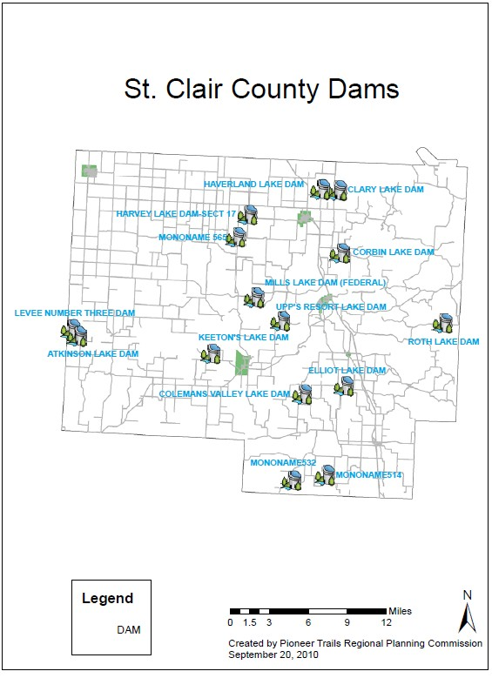Figure 41
Statement of Future Probable Severity

Missouri DNR has defined three levels of hazard potential –high, significant, and low -as accepted by the Interagency Committee on Dam Safety. The definitions are:

High: Failure or improper operation will probably cause loss of human life.
Significant: Failure or improper operation results in no probable loss of human life but can cause economic loss, environmental damage, disruption of lifeline facilities, or impact other concerns. Significant hazard potential classification dams are often located in predominantly rural or agricultural areas but could be located in areas with population and significant infrastructure.
Low: Failure or improper operation results in no probable loss of human life and low economic and/or environmental losses. Losses are principally limited to the owner’s property.

The future probable severity of a dam failure in St. Clair County is shown below according to DNR’s hazard potential levels.

Hazard Level Future Probable Severity
High catastrophic
Significant critical
Low negligible

Statement of Probable Risk

Of the total 15 dams, 0 are rated by Missouri DNR as “high” risk. One is rated as “significant”, and the rest are considered “low.” The “high” risk category is based on the following conditions

More than 30 years old;
High ratio of maximum storage to dam height; and/or,
High population density downstream.

These “high” risk dams represent the greatest risk of dam failure. The county’s risk of experiencing a dam failure is shown below according to DNR’s hazard levels.

Hazard Level Probable Risk
High highly likely
Significant possible
Low not likely

Statement of Next Disaster’s Likely Adverse Impact on the Community

.

The adverse impacts of future dam failures affecting St. Clair County at the high hazard level are shown below. The extent of hazard damage from dam failure was measured by first looking at the topography located around the dam to figure the direction of flow from a dam failure. Once flow was determined, the inundation area extent was determined by reflecting the size of the lake around the dam.

In the event of dam failure in St. Clair County, the following estimated impacted areas are as follows:

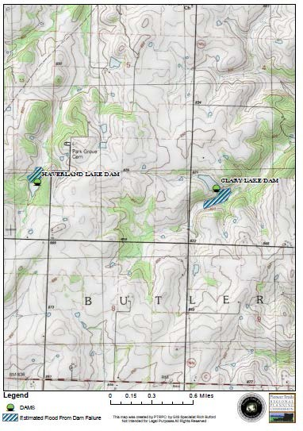

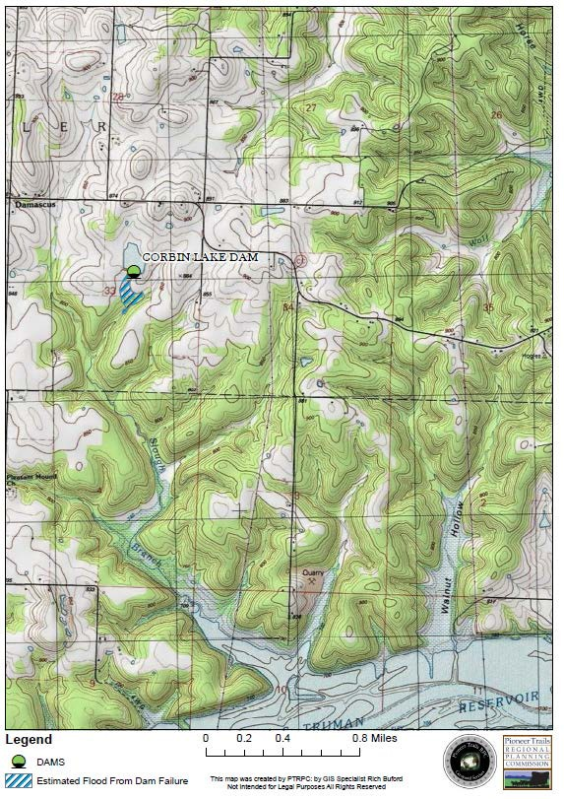

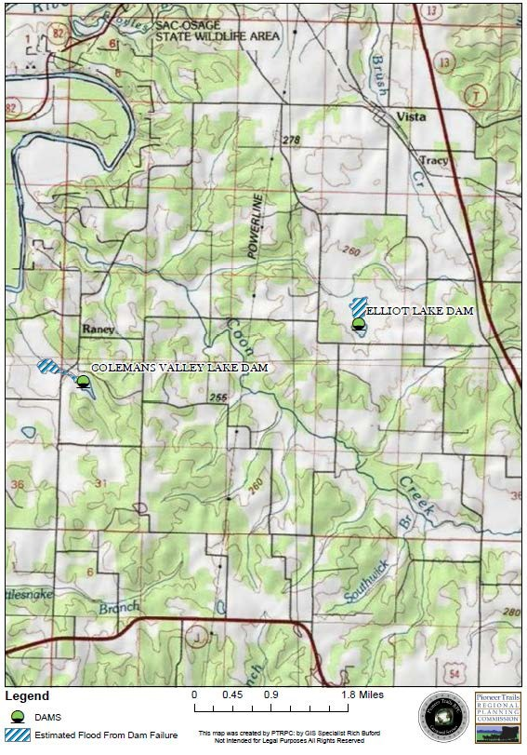

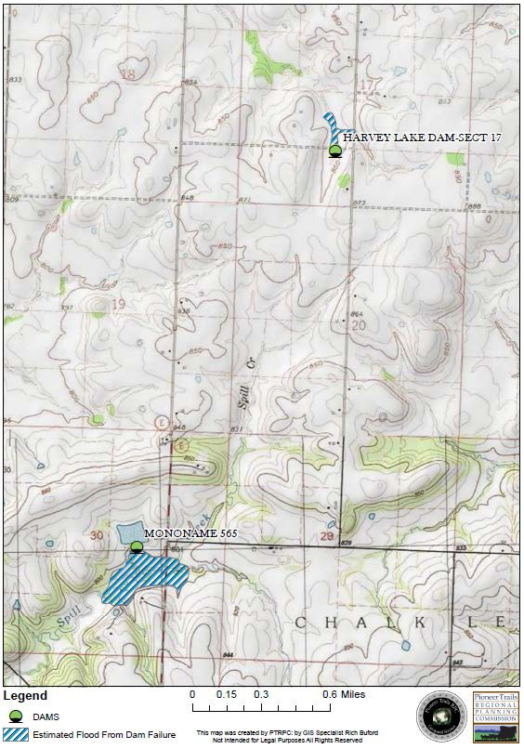

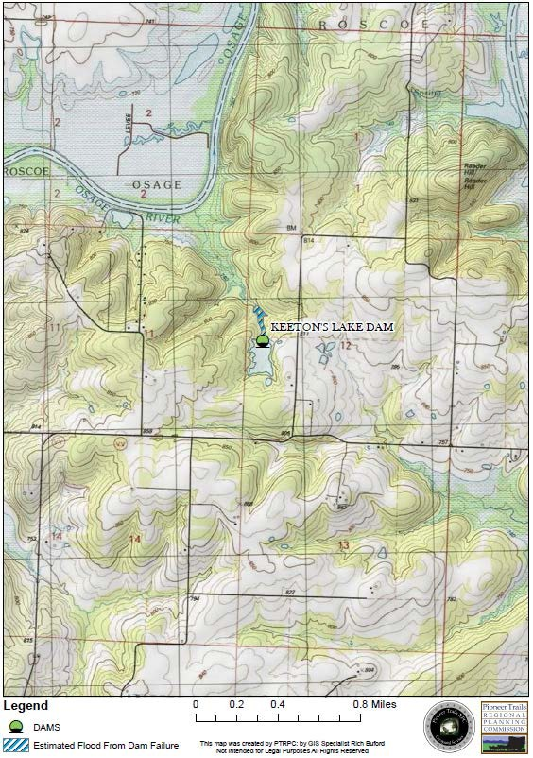

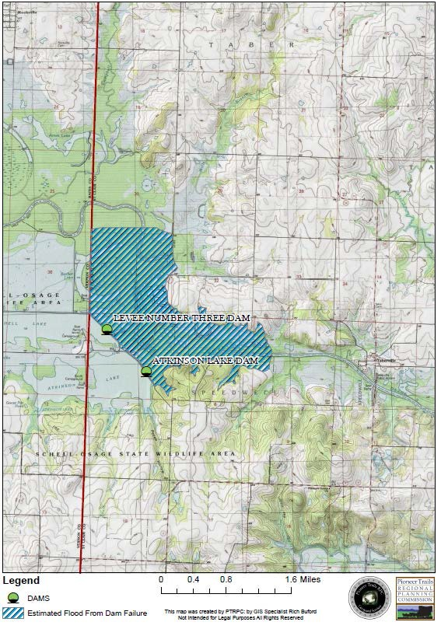

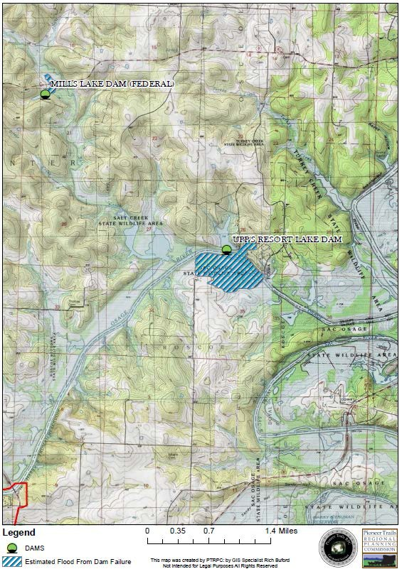

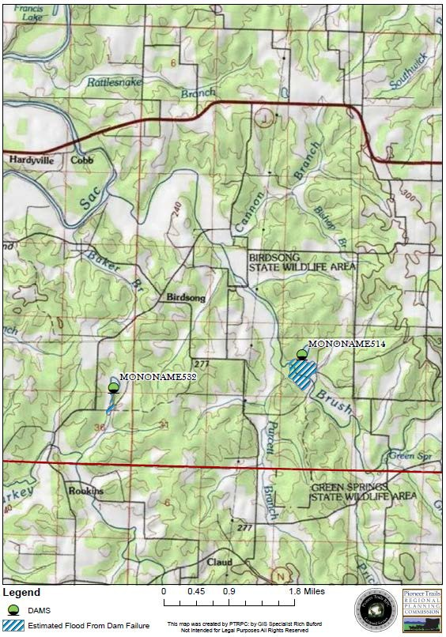

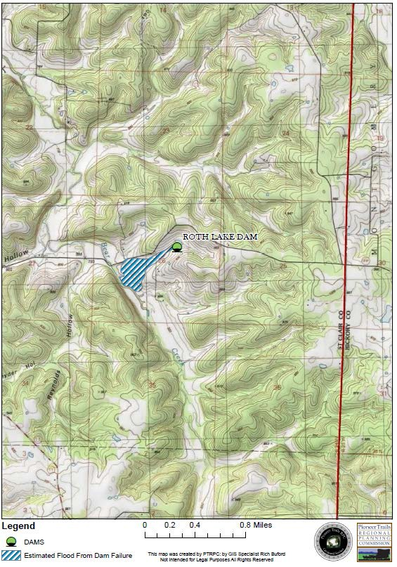

Without mitigation measures:
Life: limited
Property: limited Emotional: limited Financial: limited

With mitigation measures:
Life: negligible
Property: negligible Emotional: negligible Financial: negligible
Comments: If a mechanism for county inspections was instituted and deficiencies corrected, the risk of dam failure would be negligible.

Statement of Next Disaster’s Likely Adverse Impact by Jurisdiction

The assessment of a dam failure impact upon St. Clair County and its jurisdictions is a fairly small estimate. With 15 dams total in the county with no large scale dams that hold back a large volume of water, the impact of a dam failure remains fairly minimal.

Recommendation

That the County work with the DNR Dam Safety Program to identify appropriate mitigation measures and develop a comprehensive map of possible areas of inundation during a dam failure.

Wildfires

Each year, about 3,700 wildfires burn more than 55,000 acres of forest and grassland in our state. Unlike the Western states that have a summer fire season, Missouri’s period of highest vulnerability to wildfires comes in the spring and fall. Dead vegetation, combined with the low humidity and high winds typical of these seasons, makes the risk of wildfire greater at these times.

The majority of wildfires in the world are thought to be started by people. However, the greatest cause of wild land fires is lightning. Eight million lightning strikes occur worldwide each day. One percent of these strikes result in wild land fires. In fact, dry lightning is responsible for 80 percent of all fires in wild land areas. Dry lightning occurs during thunderstorms when the humidity levels are so low that rain evaporates before it reaches the ground. Even though the rain does not reach the ground, the lightning does.

Forest and grassland fires can and have occurred on any day throughout the year. The majority of the fires, however, and the greatest acreage loss will occur during the spring fire season which is normally between February 15 and May 10. The length and severity of this burning period depends on weather conditions. Spring is Missouri is noted for its low humidity and high winds. In addition, spring is the time of the year when rural residents normally burn their garden spots, brush piles, etc. Many landowners also still believe it is necessary to burn the woods in the spring of the year in order to get more grass, kill ticks, and get rid of the brush. These conditions, together with below normal precipitation and high temperatures, result in extremely high fire danger. Depending on weather conditions, a sizable number of fires also can occur between mid-October and late November.

According to SEMA’s 2000 Hazard analysis, wildfires are most common in the southern districts of the state. However, it is possible for wildfires to occur in St. Clair County due to drought, debris burning and incendiary fires. According to the MDC, humans cause at least 88% of Missouri fires. Debris burning is consistently the number one cause of wildfires. Incendiary fires, willfully set on another person’s property, continue to rank second in the number of wildfires each year. Fires caused by natural ignition, like lightning, are rare despite 50 to 70 thunderstorm days per year.
Table 22 – Fires by Ignition

Lightning | >1%
Camping | 1%
Smoking | 4%
Debris Burning | 58%
Arson | 20%
Equipment Use | 3%
Railroads | 1%
Children | 1%
Miscellaneous Causes | 12%

Table 23 Fire Danger Categories
Low Fire Danger | Open burning is usually safe with proper containers and precautions under low fire danger conditions. However, residents should always check on local ordinances that prohibit open burning under any conditions. Escaped fires are easy to extinguish. No fire crew staffing is planned for low fire danger conditions. | Burning index <20.
Moderate Fire Danger | Open burning is usually safe with the proper precautions under moderate fire danger conditions. Burning should be done in the early morning and late evening to avoid windier conditions at midday. Escaped fires can be contained with proper fire-fighting equipment. Partial fire crew staffing is planned for moderate fire danger. | Burning index = 21-30.
High Fire Danger | Any open burning is discouraged during high fire danger. Windy conditions, low humidity and dry fuels contribute to high fire danger. Fires escape control easily and containment is difficult, endangering human safety and property. Partial or full fire staffing is planned, depending on local burning conditions. | Burning index = 31-45.
Extreme Fire Danger | Open burning should not be attempted during extreme fire danger. Local authorities may impose burning bans. High winds and extended dry periods lead to extreme burning conditions. Open fires can quickly escape and are very difficult to control. Spot fires occur ahead of the main fire, and erratic burning conditions make fires difficult to control even for experienced fire fighters. Full fire crew staffing is planned for extreme burning conditions. | Burning index >45.

In the United States, about 2.5 million acres (1 acre = 1 football field, approximately) of developed lands and wild lands will burn every year. Often the carelessness of people leads to fires in wild lands, in which planned burns by farmers is the leading contributor. Campers who neglect to properly extinguish campfires cause some wild land fires, while others are the result of lit cigarettes tossed onto the dry ground. Arsonists can contribute to other occurrences.

In most instances, grass, brush, and forest fires are natural events that have occurred periodically throughout history. There are three major classes of wild land fires: ground fires, surface fires, and crown fires. Ground fires spread across the grass and low-lying vegetation. Surface fires burn the trunks of trees as well as the grass and low-lying vegetation. During crown fires, the flames move across the ground, up the trees, and across the tops of the trees. Crown fires are the most dangerous and destructive class of wild land fires.

Fire danger is based upon the burning index (BI). The burning index takes into account the fuel moisture, relative humidity, wind speed, temperature and recent precipitation. The burning index is the basis for fire suppression crew staffing levels. The Missouri Department of Conservation relies upon the local news media to help warn citizens of high fire danger. A set of standardized fire danger adjectives has been developed for fire warnings. These adjectives include a brief description of burning conditions, open burning suggestions for homeowners and fire crew staffing levels. Residents should always check with their local fire department or conservationist for local burning conditions.

Historical Statistics

No Missouri fires are listed among the significant wildfires in the U.S. since 1825. Fires covering more than 300 acres are considered large in Missouri. Missouri averages 3,500 fires a year with 45,000 acres burned, or an average fire size of 12 acres. The following map shows the distribution of forest and grassland across the county. St. Clair County has experienced two wildfires in the past 5 years. One of the forest fires caused $20,000 in property damage.

Table 24: St. Clair Wildfire Occurrences: 1994 - 2010

Location or County | Date | Time | Type | Mag | Dth | Inj | PrD | CrD
St. Clair | 11/18/1999 | 12:00 pm | Wild/forest Fire | N/A | 0 | 0 | 0 | 0
St. Clair | 03/08/2000 | 08:00 am | Wild/forest Fire | N/A | 0 | 0 | 20K | 0
TOTALS: |  |  |  |  | 0 | 0 | 20K | 0

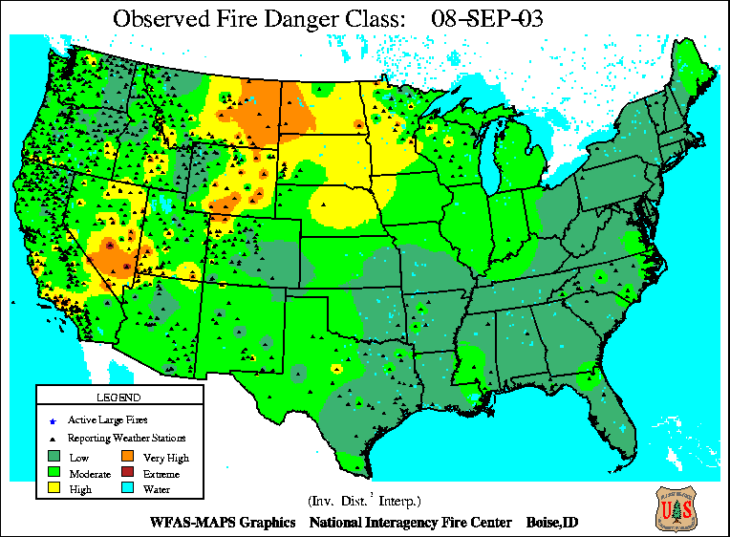

Figure 51

Statement of Future Probable Severity

In St. Clair County, according to local MDC agents, fires tend to be fairly frequent but small due to early detection and quick response. However, wildfires can flare out of control, often with catastrophic results. Grass grows back quickly with little damage, but fires in forests and croplands are costly. Grass and shrubs take one to five years to grow back. Trees, however, can take 20 to 100 years to return.

Additional losses occur in the buffer area between undeveloped and developed land. Even when they can respond immediately, fighters in rural areas may not be able to prevent large fires from destroying remote homes and property. The FEMA website points out that as residential areas expand into previously undeveloped areas; people living in these communities are increasingly threatened by forest fires. Protecting structures from fire in these buffer areas poses special problems, and can stretch firefighting resources to the limit. Propane tanks located near trees and vegetation can increase the risk of destruction in the event of fire. Fatalities occasionally can

result from wildfires, usually due to overexertion or heart attack. The MDC diagram below illustrates the possible severity of a fire’s progression.

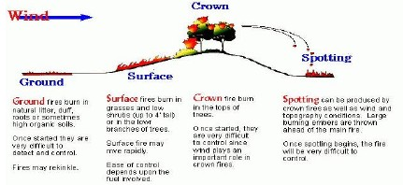

Figure 52

Wildfire fuel includes combustible material in the form of vegetation such as grass, leaves, ground litter, plants, shrubs and trees. The forested areas, combined with dry weather conditions and/or human error, represent the potential for a disastrous wildfire within the county. Based on the county’s ample supply of wildfire fuel and continuing new development near forest and grasslands, the future probable severity is shown below.

Buffer Areas: critical
Forests: critical
Croplands: critical

*Any Maps that were added after the plans approval from sema 05-2011 will be added to appendix E Maps

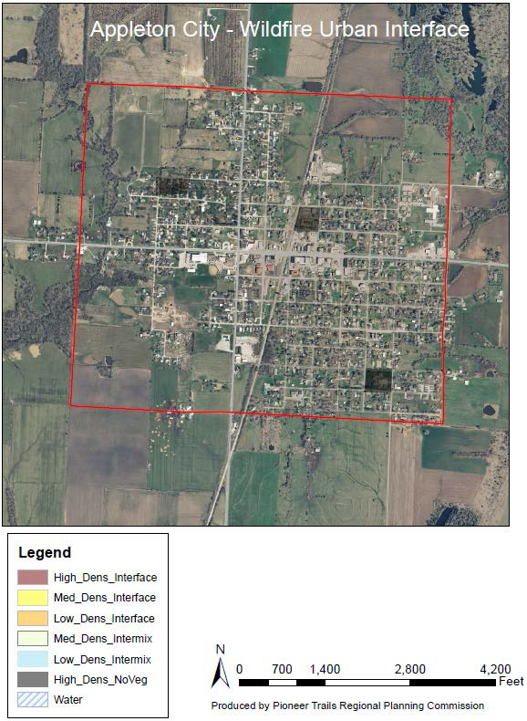

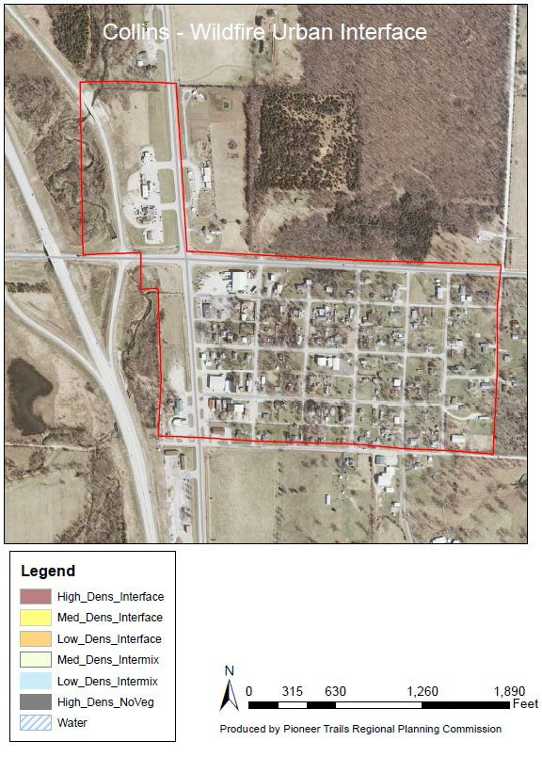

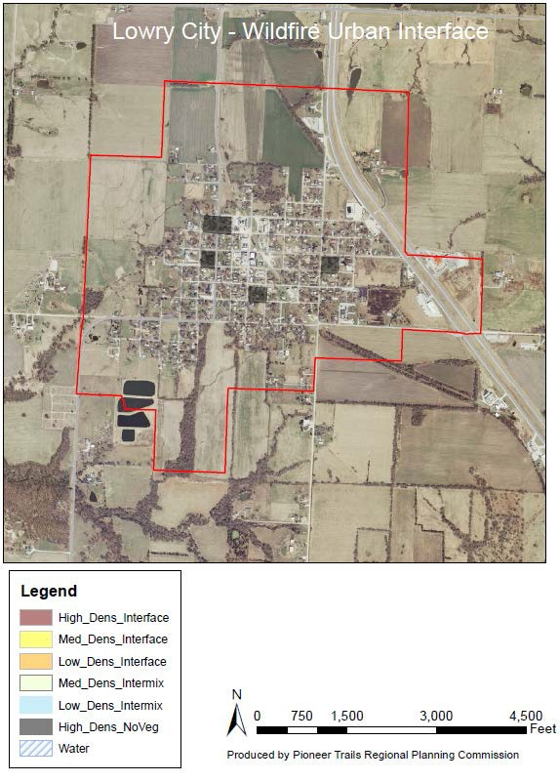

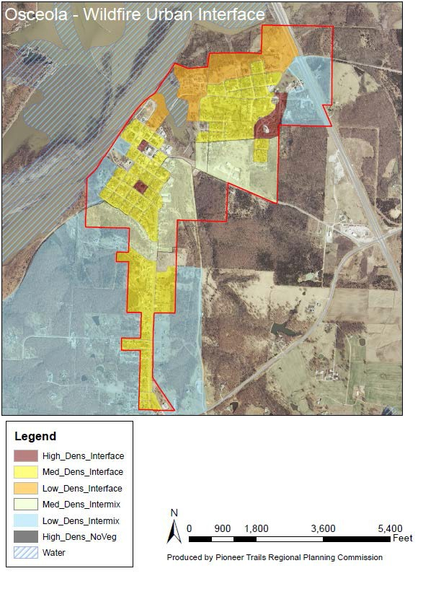

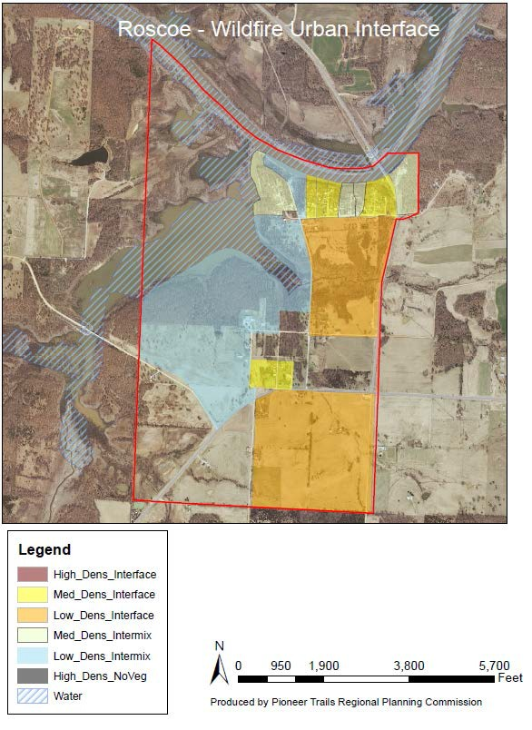

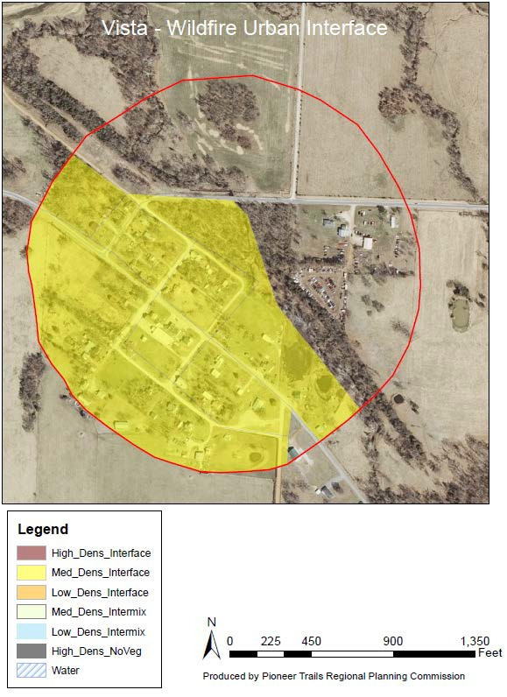

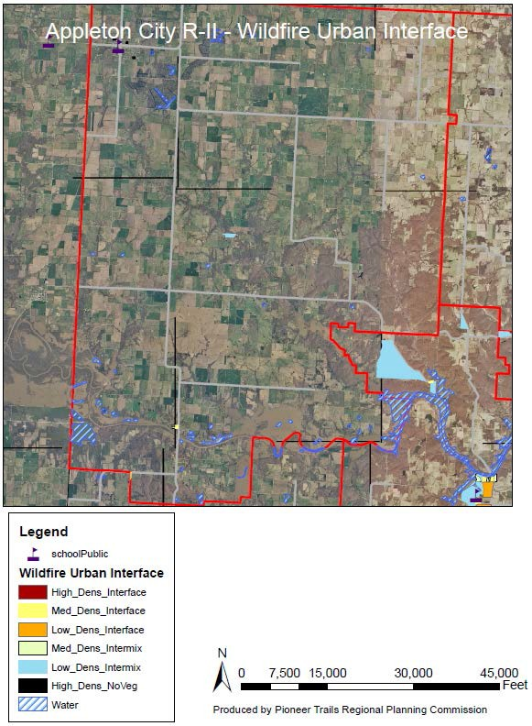

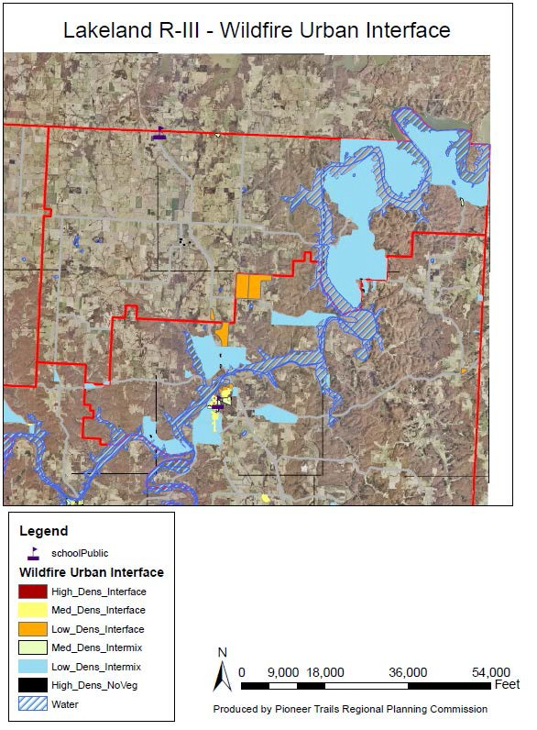

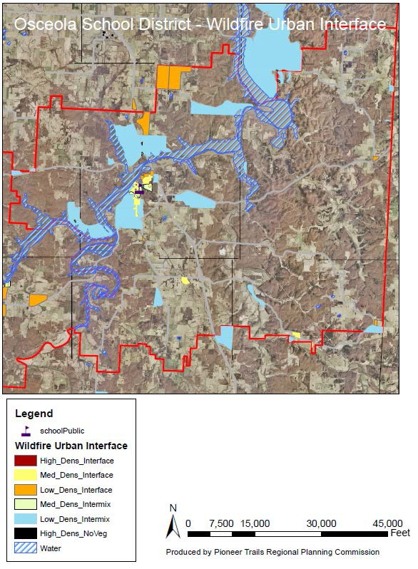

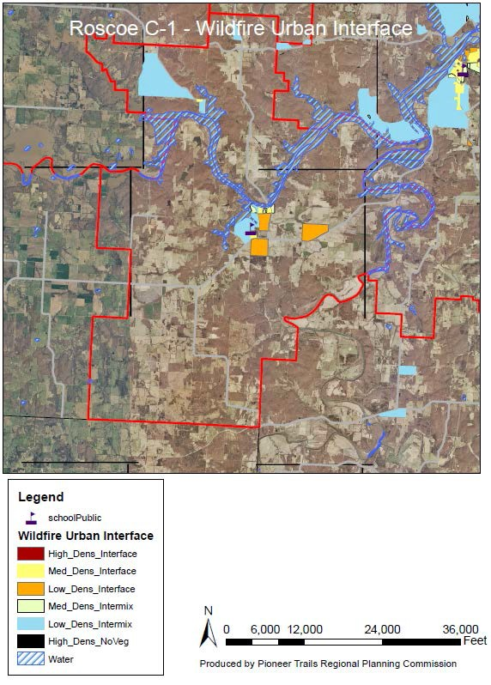

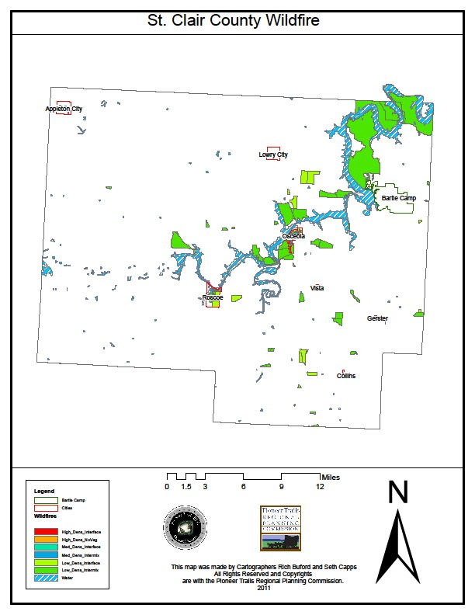

Statement of Probable Risk

Judging from the county’s lack of wildfires, a disastrous wildfire is not likely. Conversely, the absence of previous fires has contributed to an increasing supply of wildfire fuel within the county’s forested areas. The following fire danger index is used by MDC. The likeliness of a future occurrence, at each of the fire danger index levels is shown below.

Low Fire Danger: highly likely Moderate Fire Danger: highly likely High Fire Danger: likely
Extreme Fire Danger: possible

Statement of Next Disaster’s Likely Adverse Impact on the Community

A major wildfire could affect expensive homes built within the buffer area. In addition, timber harvesters would suffer great economic hardship. The likely adverse impact of a disastrous St. Clair County wildfire is shown below.

Without Mitigation Measures:
Life: limited
Property: critical Emotional: critical Financial: critical

With Mitigation Measures:
Life: negligible
Property: limited Emotional: limited Financial: limited
Comments: The practice of prescribed burning mimics nature’s way of reducing the accumulation of underbrush that provides quick fuel for a wildfire.

Statement of Next Disaster’s Likely Adverse Impact by Jurisdiction

All jurisdictions within the county are equally susceptible to damage stemming from wildfire. In the event of a wildfire, 25% of any given jurisdiction may be at risk for damage before the fire is contained due to surrounding agricultural land. The possibility for increased impact is further compounded with possible complications concerning drought.

Recommendation

- Continue to pursue mitigation activities to encourage citizens to keep vegetation clear from structures.
- Institutes an education initiative to reduce the risk of wild fires.

SINKHOLES

Much of the southeast St. Clair County rests on karst topography, and therefore the landscape is dotted with sinkholes. While there are no records of major structural damage caused by sinkholes in the St. Clair County, such incidents have occurred in other karst regions. Sinkholes are always challenging, however, as there is potential for direct groundwater contamination.

Karst is a distinctive topography in which the landscape is shaped by the dissolving action of water on carbonate bedrock (usually limestone, dolomite, or marble). Dissolution in this region may produce solution, collapse, and cover-collapse sinkholes.

Solution sinkholes form as the limestone dissolves, creating sunken areas in the land surface. Collapse sinkholes form when caves collapse and suddenly drop a portion of the land surface above. Damage to buildings commonly results from collapse of soil and/or rock material into an open void space near or beneath man-made structures.

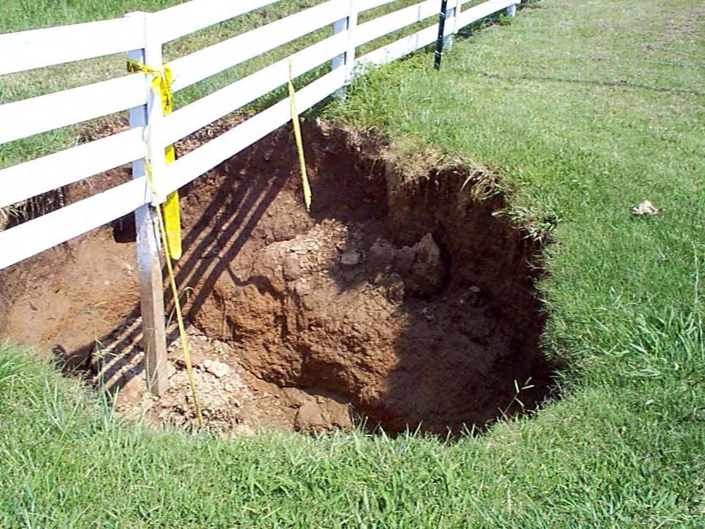

Figure 64

The formation of a sinkhole, into even a small opening, may be very costly if a structure sits on the overlying surface. Sinkhole collapses are often unpredicted and sudden, although they occur more frequently after heavy rainfall. Heavy rainfall increases the soils’ weight and decreases its

strength and stability. Construction can also trigger collapses by directing runoff into a vulnerable area, or weakening the cover of an incipient collapse. Finally, lowering of the water table by a nearby well or from quarry pumping can also trigger collapse when the buoyant effect of groundwater is removed.

The following figure demonstrates the karst features in Missouri with St. Clair County highlighted by the red square around it. The darker red indicates greater cave density, losing stream courses are shown in yellow, and blue spots indicate known natural springs.

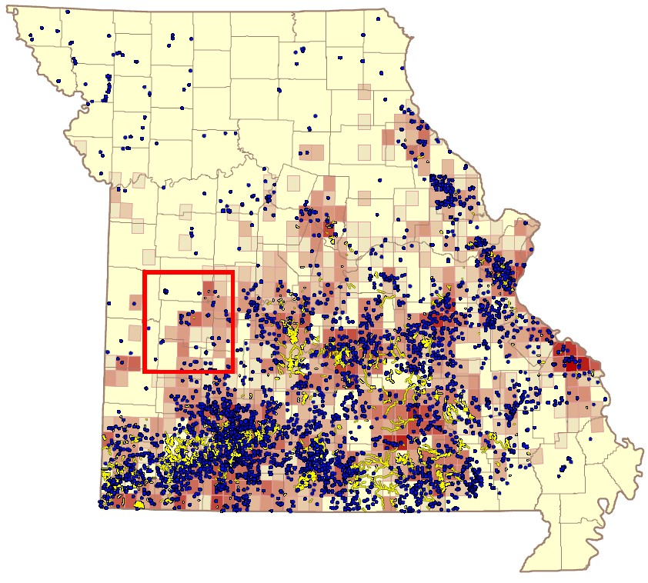

Figure 65

Most karst features and sinkholes in St. Clair County are found in the southeast portion of the county, closest to the Ozark Region.

Figure 66

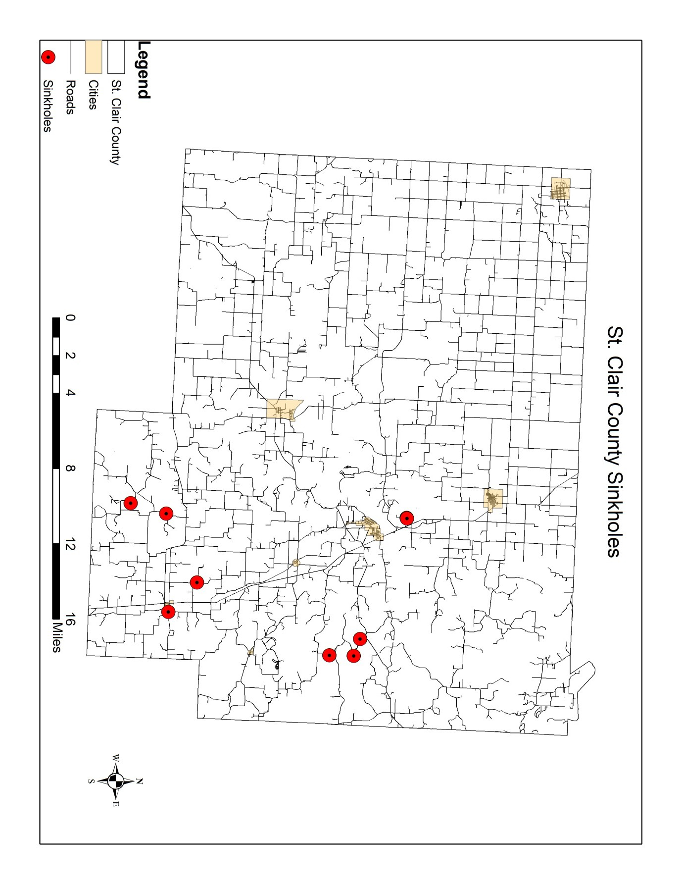St. Clair County consists of limestone, dolomite or other soluble rocks where karst may develop.

Karst is characterized by subsurface drainage systems, sinking or losing streams, sinkholes, springs and caves.

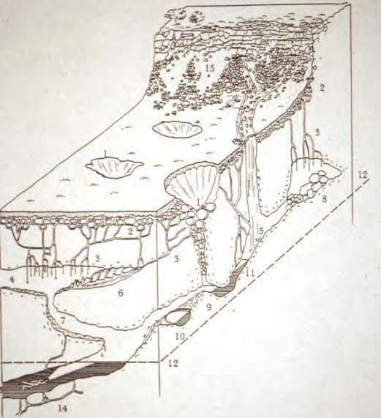

Figure 66

The principal event associated with karst is sinkholes, which may open up under structures such as a home. Sinkholes also literally open up a direct avenue for potential groundwater contamination, which can occur naturally through run-off or when people dump waste or dead animals into them. While fecal coliform has been found in 25-30% of wells in some areas, expensive dye tracing is necessary to trace paths from sinkholes, so no precise cases are known.

The risk of new sinkholes developing is highest during times of flooding or drought. In terms of structural damage, a new sinkhole would likely impact only one property.

Historical Statistics

Even though St. Clair County has one of the lesser concentrations of sinkholes in the region, major damage to property and lives is still possible, but extremely low. There is a high probability of sinkholes occurring, but a low risk is involved for damage.

Statement of Future Probable Severity

The probability of future occurrence of a sinkhole in Missouri is unlikely. History of events is greater than 10% but less than or equal to 20% likely per year. There have been eight sinkholes in St. Clair County over the last 50 years which means there is a 16% chance of a sinkhole occurrence over the next year.

Statement of Probable Risk

Sinkholes vary in size and location. The possible impacts are loss of a personal vehicle, a building collapse, damage to infrastructure such as roads, water, or sewer lines, and ground water contamination. The magnitude/severity of a sinkhole in St. Clair County is “limited”. 10% to 20% of property severely damaged; shutdown of facilities for more than a week; and/or injuries/illnesses treatable do not result in permanent disability.

Statement of Next Disaster’s Likely Adverse Impact on the Community Without mitigation measures:
Life: negligible
Property: critical Emotional: limited Financial: limited
Comments: Though sink holes can be dangerous and costly, usually building on the required topography is not allowed or is impossible.

With mitigation measures:
Life: negligible
Property: negligible Emotional: negligible Financial: negligible
Comments: If a mechanism for county inspections was instituted and deficiencies corrected, the risk of sinkhole damages would be negligible.

Statement of Next Disaster’s Likely Adverse Impact on the Jurisdiction Without mitigation measures:
Life: negligible
Property: critical Emotional: limited Financial: limited
Comments: Though sink holes can be dangerous and costly, usually building on the required topography is not allowed or is impossible.

With mitigation measures:
Life: negligible
Property: negligible Emotional: negligible Financial: negligible
Comments: If a mechanism for county inspections was instituted and deficiencies corrected, the risk of sinkhole damages would be negligible.

Recommendations

Additional mitigation opportunities are problematic in predominantly-karst jurisdictions.

A good GIS database would be useful. Storm water management ordinances may also be needed in some areas. Karst overlay zones with special studies and buffer requirements may be needed as well, including special warnings and/or education for landowners.

Multijurisdictional risk assessment in the county and municipalities

All municipalities and government subunits within St. Clair County participated in the creation of this hazard mitigation plan, and unless otherwise noted, the actions prescribed within pertain to all jurisdictions without bias. St. Clair County hazards strongly tend to be either geographically random or regional in scope, with exceptions in flood, levee failure, and dam failure. Using historical events and data compiled from the National Weather Service and United States Geological Survey (USGS), Hazard Profile Worksheets for each identified natural hazard affecting St. Clair County are included in the following pages. The county and most of the incorporated areas have experienced limited damage from winter storms, tornadoes, thunderstorms, heat waves, drought, dam failure, and wildfires. All location-specific vulnerabilities are noted in the following Hazard Profile Worksheets as well as the preceding pages.

The scaling system for potential severity in the Hazard Profile Worksheets is as follows: Catastrophic - More than 50% of area will be affected by hazard
Critical - 25% to 50 % of area will be affected by hazard Limited - 10% to 25% of area will be affected by hazard Negligible - Less than 10%

TORNADO HAZARD PROFILE WORKSHEET

POTENTIAL SEVERITY BY TORNADO TYPE:
EF0 - Negligible EF3 - Critical
EF1 - Limited EF4 - Catastrophic
EF2 - Limited EF5 - Catastrophic

FREQUENCY OF OCCURRENCE:
Highly Likely: Near 100% probability in next year.
χ Likely: Between 10 and 100% probability in next year, or at least one chance in 10 years.
Possible: Between 1 and 10% probability in next year, or at least one chance in next 100 years.
Unlikely: Less than 1% probability in next 100 years.

SEASONAL PATTERN:
Most St. Clair County tornadoes have occurred between April and August, but have known to stretch from March to November.
AREAS LIKELY TO BE AFFECTED MOST (BY SECTOR):
Any location in St. Clair County could be susceptible to a tornado.
PROBABLE DURATION:
St. Clair County’s tornadoes have ranged from F0 to F3. At these levels, most are usually on the ground for a few minutes.
POTENTIAL SPEED OF ONSET
(Probable amount of warning time):
χ Minimal (or no) warning.
6 to 12 hours warning.
12 to 24 hours warning. More than 24 hours warning.

EXISTING WARNING SYSTEMS:
St. Clair County has several tornado sirens in the incorporated communities, but most are outdated and are in need of replacement and the growth of each of the cities requires additional sirens to be installed.
COMPLETE VULNERABILITY ANALYSIS
Currently at risk (50% of the planning area); 4,826 people in 3,399 buildings.
SPECIAL VULNERABILITIES BY JURISDICTION
All Jurisdictions represented by this plan are equally vulnerable to tornadic activity.

SEVERE THUNDERSTORM HAZARD PROFILE WORKSHEET

POTENTIAL SEVERITY:
Catastrophic: More than 50%
χ Critical: 25 to 50%
Limited: 10 to 25%
Negligible: Less than 10%

FREQUENCY OF OCCURRENCE:
χ Highly Likely: Near 100% probability in next year.
Likely: Between 10 and 100% probability in next year, or at least one chance in 10 years. Possible: Between 1 and 10% probability in next year, or at least one chance in next 100 years. Unlikely: Less than 1% probability in next 100 years.

SEASONAL PATTERN:
Severe thunderstorms, hail, and high winds may occur at any time during the year, but tend to be most prevalent between March and October.
AREAS LIKELY TO BE AFFECTED MOST (BY SECTOR):
Any location in St. Clair County could be susceptible to severe storms.
PROBABLE DURATION:
Severe storms vary considerable in duration.
POTENTIAL SPEED OF ONSET
(Probable amount of warning time): Minimal (or no) warning.
χ 6 to 12 hours warning.
12 to 24 hours warning. More than 24 hours warning.

EXISTING WARNING SYSTEMS:
Most communities have siren systems and there are weather radio frequencies available for this area.
COMPLETE VULNERABILITY ANALYSIS
Currently at risk (50% of the planning area); 4,826 people in 3,399 buildings.
SPECIAL VULNERABILITIES BY JURISDICTION
All Jurisdictions represented by this plan are equally vulnerable to severe thunderstorm activity.

FLOOD HAZARD PROFILE WORKSHEET

POTENTIAL MAGNITUDE (Percentage of the jurisdiction that can be affected):
Catastrophic: More than 50%
Critical: 25 to 50%
X Limited: 10 to 25%
Negligible: Less than 10%

FREQUENCY OF OCCURRENCE:
Highly Likely: Near 100% probability in next year.
X Likely: Between 10 and 100% probability in next year, or at least one chance in 10 years.
Possible: Between 1 and 10% probability in next year, or at least one chance in next 100 years.
Unlikely: Less than 1% probability in next 100 years.

SEASONAL PATTERN:
Flooding occurs most often in the county during the months of May through August, but during the last 10 years flooding has occurred during all months but January, November, and December.
AREAS LIKELY TO BE AFFECTED MOST (BY SECTOR):
Any location, where topography allows, in St. Clair County could be susceptible to flooding.
PROBABLE DURATION:
Flash flooding can occur within minutes. Sustained flooding can last over several days, weeks, or months.
POTENTIAL SPEED OF ONSET
(Probable amount of warning time):
χ Minimal (or no) warning.
6 to 12 hours warning.
12 to 24 hours warning. More than 24 hours warning.

EXISTING WARNING SYSTEMS:
National Weather Service Watches and Warnings via TV, Radio, and Weather Radio.
COMPLETE VULNERABILITY ANALYSIS
Currently at risk (25% of the planning area); 2,413 people in 1,699 buildings.
SPECIAL VULNERABILITIES BY JURISDICTION
All Jurisdictions represented by this plan are equally vulnerable to flooding.

SEVERE WINTER WEATHER HAZARD PROFILE WORKSHEET

POTENTIAL SEVERITY:
Heavy Snow - Limited Ice Event - Limited Extreme Cold - Critical Blizzard - Critical

FREQUENCY OF OCCURRENCE:
χ Highly Likely: Near 100% probability in next year.
Likely: Between 10 and 100% probability in next year, or at least one chance in 10 years. Possible: Between 1 and 10% probability in next year, or at least one chance in next 100 years. Unlikely: Less than 1% probability in next 100 years.

SEASONAL PATTERN:
Severe winter weather in St. Clair County occurs most often in the county during the month of January.
AREAS LIKELY TO BE AFFECTED MOST (BY SECTOR):
Severe Winter Weather events tend to occur on a regional scale, thus likely to affect the entire county.
PROBABLE DURATION:
Dangerous conditions can occur within a few hours. Ice and/or snow can last over several days. Cascading effects (utility outages, for example) also can last several days.
POTENTIAL SPEED OF ONSET
(Probable amount of warning time): Minimal (or no) warning.
χ 6 to 12 hours warning.
12 to 24 hours warning. More than 24 hours warning.

EXISTING WARNING SYSTEMS:
National Weather Service Watches and Warnings via TV, Radio, and Weather Radio.
COMPLETE VULNERABILITY ANALYSIS
Currently at risk (50% of the planning area); 4,826 people in 3,399 buildings.
SPECIAL VULNERABILITIES BY JURISDICTION
All Jurisdictions represented by this plan are equally vulnerable to severe winter weather.

DROUGHT HAZARD PROFILE WORKSHEET
POTENTIAL SEVERITY:
Phase 1 - Negligible Phase 2 - Limited Phase 3 - Critical
Phase 4 - Critical
FREQUENCY OF OCCURRENCE:
Highly Likely: Near 100% probability in next year.
χ Likely: Between 10 and 100% probability in next year, or at least one chance in 10 years.
Possible: Between 1 and 10% probability in next year, or at least one chance in next 100 years.
Unlikely: Less than 1% probability in next 100 years.
SEASONAL PATTERN:
Drought alerts usually are issued in the summer months, however, economic impacts can extend year round.
AREAS LIKELY TO BE AFFECTED MOST (BY SECTOR):
Severe droughts tend to occur on a regional scale, thus likely to affect the entire county.
PROBABLE DURATION:
Drought conditions can last several months to several years.
POTENTIAL SPEED OF ONSET
(Probable amount of warning time): Minimal (or no) warning.
6 to 12 hours warning.
12 to 24 hours warning.
χ More than 24 hours warning.
EXISTING WARNING SYSTEMS:
MoDNR uses several indices to monitor precipitation and other drought factors. The PSDI is the main indicator.
COMPLETE VULNERABILITY ANALYSIS
Currently at risk (50% of the planning area); 4,826 people in 3,399 buildings.
SPECIAL VULNERABILITIES BY JURISDICTION
All Jurisdictions represented by this plan are equally vulnerable to drought.

HEAT WAVE HAZARD PROFILE WORKSHEET
POTENTIAL MAGNITUDE (Percentage of the jurisdiction that can be affected):
Heat Index of 130 Degrees (f) or higher - Catastrophic Heat Index of 105 to 129 Degrees (f) - Critical Heat Index of 90 to 104 Degrees (f) - Limited
Heat Index of less than 90 Degrees (f) - Negligible
FREQUENCY OF OCCURRENCE:
Highly Likely: Near 100% probability in next year.
χ Likely: Between 10 and 100% probability in next year, or at least one chance in 10 years.
Possible: Between 1 and 10% probability in next year, or at least one chance in next 100 years.
Unlikely: Less than 1% probability in next 100 years.
SEASONAL PATTERN:
Heat wave alerts usually are issued in the summer months, however, economic impacts can extend year round.
AREAS LIKELY TO BE AFFECTED MOST (BY SECTOR):
Severe droughts tend to occur on a regional scale, thus likely to affect the entire county.
PROBABLE DURATION:
Extreme heat conditions can last several days to weeks.
POTENTIAL SPEED OF ONSET
(Probable amount of warning time): Minimal (or no) warning.
6 to 12 hours warning.
12 to 24 hours warning.
χ More than 24 hours warning.
EXISTING WARNING SYSTEMS:
The National Weather Service uses the Heat Index to alert the public via TV, radio, and weather radio.
COMPLETE VULNERABILITY ANALYSIS
Currently at risk (25% of the planning area); 2,413 people in 1,699 buildings.
SPECIAL VULNERABILITIES BY JURISDICTION
All Jurisdictions represented by this plan are equally vulnerable to heat waves.

EARTHQUAKE HAZARD PROFILE WORKSHEET
POTENTIAL SEVERITY (Based on Mercalli Intensity Index):
FREQUENCY OF OCCURRENCE:
Highly Likely: Near 100% probability in next year.
Likely: Between 10 and 100% probability in next year, or at least one chance in 10 years.
χ Possible: Between 1 and 10% probability in next year, or at least one chance in next 100 years.
Unlikely: Less than 1% probability in next 100 years.
SEASONAL PATTERN:
Earthquakes are not affected by climatic conditions.
AREAS LIKELY TO BE AFFECTED MOST (BY SECTOR):
The impacts of an earthquake are felt on a regional scale, thus likely to affect the entire county.
PROBABLE DURATION:
Earthquakes last from a few to several minutes.
POTENTIAL SPEED OF ONSET
(Probable amount of warning time):
χ Minimal (or no) warning.
6 to 12 hours warning.
12 to 24 hours warning. More than 24 hours warning.
EXISTING WARNING SYSTEMS:
Earthquake prediction is far from accurate. There are no warning systems in place.
COMPLETE VULNERABILITY ANALYSIS
Currently at risk (50% of the planning area); 4,826 people in 3,399 buildings.
SPECIAL VULNERABILITIES BY JURISDICTION
All Jurisdictions represented by this plan are equally vulnerable to an earthquake.

MMI I – Negligible | MMI VI – Limited | MMI XI - Catastrophic
MMI II – Negligible | MMI VII – Critical | MMI XII - Catastrophic
MMI III – Negligible | MMI VIII – Critical
MMI IV – Limited | MMI IX - Critical
MMI V - Limited | MMI X - Catastrophic

DAM FAILURE HAZARD PROFILE WORKSHEET

POTENTIAL SEVERITY (Based on failure of dam by hazard class): High - Catastrophic
Significant - Critical Low - Negligible

FREQUENCY OF OCCURRENCE:
Highly Likely: Near 100% probability in next year.
Likely: Between 10 and 100% probability in next year, or at least one chance in 10 years.
χ Possible: Between 1 and 10% probability in next year, or at least one chance in next 100 years.
Unlikely: Less than 1% probability in next 100 years.

SEASONAL PATTERN:
Dam failure would most likely be caused by heavy rains. Therefore, the most likely risk might be May to June.
AREAS LIKELY TO BE AFFECTED MOST (BY SECTOR):
Larger, older dams pose significant risk to undeveloped areas of St. Clair County.
PROBABLE DURATION:
Dam failures usually last several minutes, depending on the severity of the failure and the acre-feet of water.
POTENTIAL SPEED OF ONSET
(Probable amount of warning time):
χ Minimal (or no) warning.
6 to 12 hours warning.
12 to 24 hours warning. More than 24 hours warning.

EXISTING WARNING SYSTEMS:
Some of the dams are regulated by MoDNR. All others are not regulated or inspected. Generally a dam could fail without warning.
COMPLETE VULNERABILITY ANALYSIS
Currently at risk (10% of the planning area); 965 people in 680 buildings.
SPECIAL VULNERABILITIES BY JURISDICTION
Sufficient data is not available to identify jurisdictions specifically at risk due to dam failure at this time.

WILDFIRE HAZARD PROFILE WORKSHEET

POTENTIALSEVERITY (By land vegetation type): Buffer Areas - Critical
Forests - Critical Croplands - Critical

FREQUENCY OF OCCURRENCE:
x Highly Likely: Near 100% probability in next year.
Likely: Between 10 and 100% probability in next year, or at least one chance in 10 years. Possible: Between 1 and 10% probability in next year, or at least one chance in next 100 years. Unlikely: Less than 1% probability in next 100 years.

SEASONAL PATTERN:
Wildfires are likely to occur from March to October.
AREAS LIKELY TO BE AFFECTED MOST (BY SECTOR):
Though forested areas along the transition are between urban and rural development and along the various river/lake banks are most likely to be affected, all jurisdictions are equally vulnerable to the possibility of wildfire due to agricultural surroundings.
PROBABLE DURATION:
Wildfires can last a few minutes to several weeks.
POTENTIAL SPEED OF ONSET
(Probable amount of warning time):
χ Minimal (or no) warning.
6 to 12 hours warning.
12 to 24 hours warning. More than 24 hours warning.

EXISTING WARNING SYSTEMS:
The Conservation Department relies on fire towers, air surveillance, and 911 call from the general public.
COMPLETE VULNERABILITY ANALYSIS
Currently at risk (25% of the planning area); 2,413 people in 1,699 buildings.
SPECIAL VULNERABILITIES BY JURISDICTION
All jurisdictions represented by this plan are equally vulnerable to wildfire as they are surrounded by agricultural land.

SINKHOLE HAZARD PROFILE WORKSHEET
POTENTIAL MAGNITUDE (Percentage of the jurisdiction that can be affected):
Catastrophic: More than 50%
Critical: 25 to 50%
Limited: 10 to 25%
X Negligible: Less than 10%
FREQUENCY OF OCCURRENCE:
Highly Likely: Near 100% probability in next year.
Likely: Between 10 and 100% probability in next year, or at least one chance in 10 years.
χ Possible: Between 1 and 10% probability in next year, or at least one chance in next 100 years.
Unlikely: Less than 1% probability in next 100 years.
SEASONAL PATTERN:
Sinkholes are not affected by climatic conditions.
AREAS LIKELY TO BE AFFECTED MOST (BY SECTOR):
Sinkholes occur where karst topography exists.
PROBABLE DURATION:
Effects of sinkholes could likely be permanent.
POTENTIAL SPEED OF ONSET
(Probable amount of warning time):
χ Minimal (or no) warning.
6 to 12 hours warning.
12 to 24 hours warning. More than 24 hours warning.
EXISTING WARNING SYSTEMS:
MoDNR keeps a listing of current sinkhole and regions with karst topography, but no warning systems exist.
COMPLETE VULNERABILITY ANALYSIS
Currently at risk (10% of the planning area); 965 people in 680 buildings.
SPECIAL VULNERABILITIES BY JURISDICTION
All jurisdictions that are constructed on karst topography can be affected.

Vulnerability Assessment worksheets are included on the following pages. These worksheets detail loss estimates for each hazard affecting the county. Loss estimates were calculated using a combination of information from the community profiles, historical loss data in the hazard profiles, and general knowledge of the jurisdiction as well as HAZUS data provided through the HAZUS-MH program provided by FEMA. Rough economic estimates were not included.

- The number of buildings was estimated by analysis shapefiles and attribute tables using GIS and 2009 HAZUS-MH
- The number of people was derived from population statistics in the 2000 US Census

As noted earlier, a vulnerability assessment for the Village of Gerster was not included due to their participation status in the St. Clair Hazard Mitigation Plan.

Vulnerability Assessment

The following vulnerability assessment for St. Clair County and all of the jurisdictions was done using past hazard data (frequency and damage) as well as public input and assessment. The vulnerability was based on two key factors:
  - Frequency of Hazard
  - Severity of Hazard’s Affect on an Area

These two factors were assigned a number value based on probability and severity:

Frequency of Hazard Scale:  Unlikely (Less than 1% probability in the next 100 years) | - 1
Possible (1 – 10% probability in the next year) | - 2
Likely (10 – 100% probability in the next year) | - 3
Highly Likely (Near 100% probability in the next year | - 4
Severity of Hazard Scale:
Negligible (Less than 10% of hazard area affected) | - 1
Limited (10 – 25% of hazard area affected) | - 2
Critical (25 – 50% of hazard area affected) | - 3
Catastrophic (50% or higher of hazard area affected) | - 4

Hazards were assigned the two values by jurisdiction. The values of probability and severity were added together to determine the overall vulnerability of a hazard by each jurisdiction (Probability + Severity = Overall Vulnerability). For instance:

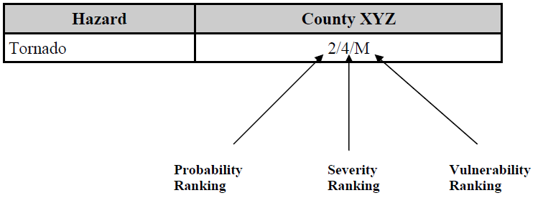
Overall Vulnerability (Probability + Severity) Scale:

Low | - 1-3
Medium | - 4-6
High | - 7-8

Vulnerability data and building damage counts were calculated using HAZUS-MH from the Federal Emergency Management Agency (FEMA) data for St. Clair County. Building damage for school districts and the buildings contained within them are included in the jurisdictional counts. With current data availability, the building counts derived from HAZUS-MH are the only anticipated damages reported in the plan.

*Overall County Vulnerability
Table 25:
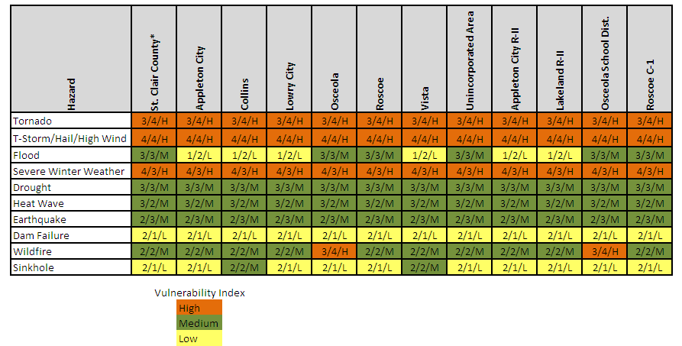Vulnerability Assessment By Jurisdiction

Base Count

Jurisdiction | Population | Residential | Commercial | Industrial | Agricultural | Religious | Government | Education*
Unincorporated Area | 6,432 | 3988 | 44 | 13 | 12 | 1 | 4 | 1
Appleton City | 1,314 | 947 | 39 | 6 | 3 | 7 | 3 | 3
Lowry City | 728 | 519 | 22 | 8 | 3 | 4 | 1 | 0
Osceola | 835 | 847 | 35 | 8 | 4 | 5 | 6 | 4
Roscoe | 112 | 96 | 3 | 1 | 1 | 0 | 1 | 1
Collins | 176 | 106 | 8 | 0 | 0 | 1 | 0 | 1
Vista | 55 | 41 | 0 | 0 | 0 | 0 | 0 | 0
St. Clair County Totals | 9,652 | 6544 | 151 | 36 | 23 | 18 | 15 | 10
Source: 2009 Hazus-MH

*Includes Private and Public Educational Institutions in jurisdictional counts

Tornado
Based on EF0 Tornado causing damage in 50% of the County (Critical Vulnerability)

Jurisdiction | Population | Residential | Commercial | Industrial | Agricultural | Religious | Government | Education
Appleton City | 657 | 474 | 20 | 3 | 2 | 4 | 2 | 2
Lowry City | 364 | 260 | 11 | 4 | 2 | 2 | 1 | -
Osceola | 418 | 424 | 18 | 4 | 2 | 3 | 3 | 2
Roscoe | 56 | 48 | 2 | 1 | 1 | - | 1 | 1
Collins | 88 | 53 | 4 | - | - | 1 | - | 1
Vista | 28 | 21 | - | - | - | - | - | -
Unincorporated Area | 3,216 | 1,994 | 22 | 7 | 6 | 1 | 2 | 1

Source: 2009 Hazus-MH

Severe Thunderstorms
Based on Severe Thunderstorm, Hail and High Wind Data causing damage in 50% of the County (High Vulnerability)

Jurisdiction | Population | Residential | Commercial | Industrial | Agricultural | Religious | Government | Education
Appleton City | 657 | 474 | 20 | 3 | 2 | 4 | 2 | 2
Lowry City | 364 | 260 | 11 | 4 | 2 | 2 | 1 | -
Osceola | 418 | 424 | 18 | 4 | 2 | 3 | 3 | 2
Roscoe | 56 | 48 | 2 | 1 | 1 | - | 1 | 1
Collins | 88 | 53 | 4 | - | - | 1 | - | 1
Vista | 28 | 21 | - | - | - | - | - | -
Unincorporated Area | 3,216 | 1,994 | 22 | 7 | 6 | 1 | 2 | 1

Source: 2009 Hazus-MH

Flood
Based on 100 Year Flood Data causing damage in 25% of the County (Medium Vulnerability)

Jurisdiction | Population | Residential | Commercial | Industrial | Agricultural | Religious | Government | Education
Appleton City | 329 | 237 | 10 | 2 | 1 | 2 | 1 | 1
Lowry City | 182 | 130 | 6 | 2 | 1 | 1 | 0 | 0
Osceola | 209 | 212 | 9 | 2 | 1 | 1 | 2 | 1
Roscoe | 28 | 24 | 1 | 0 | 0 | 0 | 0 | 0
Collins | 44 | 27 | 2 | 0 | 0 | 0 | 0 | 0
Vista | 14 | 10 | 0 | 0 | 0 | 0 | 0 | 0
Unincorporated Area | 1,608 | 997 | 11 | 3 | 3 | 0 | 1 | 0

Source: 2009 Hazus-MH

Severe Winter Weather
Based on Winter Weather Data causing damage in 50% of the County (High Vulnerability)

Jurisdiction | Population | Residential | Commercial | Industrial | Agricultural | Religious | Government | Education
Appleton City | 657 | 474 | 20 | 3 | 2 | 4 | 2 | 2
Lowry City | 364 | 260 | 11 | 4 | 2 | 2 | 1 | -
Osceola | 418 | 424 | 18 | 4 | 2 | 3 | 3 | 2
Roscoe | 56 | 48 | 2 | 1 | 1 | - | 1 | 1
Collins | 88 | 53 | 4 | - | - | 1 | - | 1
Vista | 28 | 21 | - | - | - | - | - | -
Unincorporated Area | 3,216 | 1,994 | 22 | 7 | 6 | 1 | 2 | 1

Source: 2009 Hazus-MH

Drought
Based on Drought Data causing damage in 50% of the County (High Vulnerability)

Jurisdiction | Population | Residential | Commercial | Industrial | Agricultural | Religious | Government | Education
Appleton City | 657 | 474 | 20 | 3 | 2 | 4 | 2 | 2
Lowry City | 364 | 260 | 11 | 4 | 2 | 2 | 1 | -
Osceola | 418 | 424 | 18 | 4 | 2 | 3 | 3 | 2
Roscoe | 56 | 48 | 2 | 1 | 1 | - | 1 | 1
Collins | 88 | 53 | 4 | - | - | 1 | - | 1
Vista | 28 | 21 | - | - | - | - | - | -
Unincorporated Area | 3,216 | 1,994 | 22 | 7 | 6 | 1 | 2 | 1

Source: 2009 Hazus-MH

Extreme Heat
Based on Heat Weather Data causing damage in 25% of the County (Medium Vulnerability)

Jurisdiction | Population | Residential | Commercial | Industrial | Agricultural | Religious | Government | Education
Appleton City | 329 | 237 | 10 | 2 | 1 | 2 | 1 | 1
Lowry City | 182 | 130 | 6 | 2 | 1 | 1 | 0 | 0
Osceola | 209 | 212 | 9 | 2 | 1 | 1 | 2 | 1
Roscoe | 28 | 24 | 1 | 0 | 0 | 0 | 0 | 0
Collins | 44 | 27 | 2 | 0 | 0 | 0 | 0 | 0
Vista | 14 | 10 | 0 | 0 | 0 | 0 | 0 | 0
Unincorporated Area | 1,608 | 997 | 11 | 3 | 3 | 0 | 1 | 0

Source: 2009 Hazus-MH

Earthquake
Based on Earthquake Data causing damage in 50% of the County (High Vulnerability)

Jurisdiction | Population | Residential | Commercial | Industrial | Agricultural | Religious | Government | Education
Appleton City | 657 | 474 | 20 | 3 | 2 | 4 | 2 | 2
Lowry City | 364 | 260 | 11 | 4 | 2 | 2 | 1 | -
Osceola | 418 | 424 | 18 | 4 | 2 | 3 | 3 | 2
Roscoe | 56 | 48 | 2 | 1 | 1 | - | 1 | 1
Collins | 88 | 53 | 4 | - | - | 1 | - | 1
Vista | 28 | 21 | - | - | - | - | - | -
Unincorporated Area | 3,216 | 1,994 | 22 | 7 | 6 | 1 | 2 | 1

Source: 2009 Hazus-MH

Dam Failure
Based on Dam Data causing damage in 10% of the County (Low Vulnerability)

Jurisdiction | Population | Residential | Commercial | Industrial | Agricultural | Religious | Government | Education
Appleton City | 131 | 95 | 4 | 1 | 0 | 1 | 0 | 0
Lowry City | 73 | 52 | 2 | 1 | 0 | 0 | 0 | -
Osceola | 84 | 85 | 4 | 1 | 0 | 1 | 1 | 0
Roscoe | 11 | 10 | 0 | 0 | 0 | - | 0 | 0
Collins | 18 | 11 | 1 | - | - | 0 | - | 0
Vista | 6 | 4 | - | - | - | - | - | -
Unincorporated Area | 643 | 399 | 4 | 1 | 1 | 0 | 0 | 0

Source: 2009 Hazus-MH

Wildfire
Based on Wildfire Data causing damage in 25% of the County (Low Vulnerability)

Jurisdiction | Population | Residential | Commercial | Industrial | Agricultural | Religious | Government | Education
Appleton City | 329 | 237 | 10 | 2 | 1 | 2 | 1 | 1
Lowry City | 182 | 130 | 6 | 2 | 1 | 1 | 0 | 0
Osceola | 209 | 212 | 9 | 2 | 1 | 1 | 2 | 1
Roscoe | 28 | 24 | 1 | 0 | 0 | 0 | 0 | 0
Collins | 44 | 27 | 2 | 0 | 0 | 0 | 0 | 0
Vista | 14 | 10 | 0 | 0 | 0 | 0 | 0 | 0
Unincorporated Area | 1,608 | 997 | 11 | 3 | 3 | 0 | 1 | 0

Source: 2009 Hazus-MH

Sinkhole
Based on Sinkhole Data causing damage in 10% of the County (Low Vulnerability)

Jurisdiction | Population | Residential | Commercial | Industrial | Agricultural | Religious | Government | Education
Appleton City | 131 | 95 | 4 | 1 | 0 | 1 | 0 | 0
Lowry City | 73 | 52 | 2 | 1 | 0 | 0 | 0 | -
Osceola | 84 | 85 | 4 | 1 | 0 | 1 | 1 | 0
Roscoe | 11 | 10 | 0 | 0 | 0 | - | 0 | 0
Collins | 18 | 11 | 1 | - | - | 0 | - | 0
Vista | 6 | 4 | - | - | - | - | - | -
Unincorporated Area | 643 | 399 | 4 | 1 | 1 | 0 | 0 | 0

Source: 2009 Hazus-MH

Section 3

Capability Assessment City/County Capability Assessment Mitigation management policies
The St. Clair County Emergency Management Director is charged with preparing for disasters. That duty includes advising the County Commission on mitigation measures and implementing those measures deemed appropriate by the Commission. In general, the county’s policies encourage cooperation between St. Clair County agencies as well as with similar agencies of neighboring jurisdictions.

Existing plans

The county’s Master Plan was revised in 2001 in order to better manage growth issues.
One of the main goals of the plan was to encourage development in and around already developed areas to provide more efficient access to adequate roadways, utilities, and emergency services. The Master Plan has not been updated since its drafting in 2001.

The county’s 2008 Emergency Operation Plan was approved by the County Commission and identifies facilities and resources that require special security during a disaster; promotes the development and maintenance of mutual aid agreements with nearby agencies; requires participation in drills and exercises; identifies vulnerabilities in county-administered road, water, and wastewater facilities; and includes an evacuation plan. The EOP includes all-hazard mitigation measures.

Mitigation programs

St. Clair County currently has no mitigation programs in place, and they do not participation in the administration of the National Floodplain Insurance Program.

Capabilities (organization, staffing, training, etc)

The capabilities of emergency management, fire protection, law enforcement, emergency medical services are detailed at the end of Section I.

The Emergency Operation Center (EOC) in Osceola meets FEMA EOC criteria for a place from which key officials can direct and control an emergency response. However, the EOC is not equipped for an emergency and there is not a backup facility.

The EOC has survivable communications from primary and other operating forces, the Emergency Alert System, commercial and public broadcast stations, SEMA, adjacent jurisdictions, and the incorporated areas within the county. The communications and warning

equipment are tested on a scheduled basis. Warning sirens are located in Appleton City, Lowry City, Osceola and the H. Roe Bartle Scout Reservation.

The cities and county have communication abilities, both fixed and mobile, to coordinate the scene of an emergency. However, the EMA has only a limited number of radios, and no mobile telecommunications devices such as cell phones.

Substantially adequate fire equipment and vehicles are available to city and county agencies. Equipment available for police, rescue, mass care, and information/communications is fairly adequate. The two hospitals within the county provide immediate care. The two ambulance districts serving the county provide substantial triage care.

The EMA director has completed the FEMA “Professional Development Series” training and the advanced series in 2007 along with MOCEM in 2010. Emergency response personnel have received substantial training in the past five years. Appropriate officials, and the EOC staff have had limited training on hazard mitigation.

Responsibilities and authorities

City and county governments have the following:

  - the legal basis for authorization to order an evacuation, redirect funds for emergency use, order a curfew, and commandeer facilities and/or equipment and materials;
  - authorized lines of succession for the chief elected officials with power to initiate necessary emergency activities;
  - substantially safeguarded vital records, although limited for records needed to reconstitute local government;
  - a substantial analysis of the possible impacts of potential disasters;
  - a multi-hazard emergency operations plan;
  - limited completion of mutual aid agreements with neighboring jurisdictions; and
  - substantial protection of people with special needs.

Intergovernmental and interagency coordination

The St. Clair County Emergency Management Director serves to maintain coordination among fire, law enforcement, emergency medical, public health officers from the county, incorporated areas, and adjacent jurisdictions.

Vulnerability Assessment of County Policies and Development Trends Commitments to a comprehensive mitigation program
St. Clair County maintains and regularly updates the Emergency Operation Plan that includes mitigation measures for all hazards, both natural and manmade.

County laws, regulations and policies related to development in hazard-prone areas

St. Clair County has no codes or regulations that prohibit structures being built in the flood plain. The only regulations currently in place are building codes in Appleton City and building codes and zoning ordinances in Osceola. No other laws, regulations, and policies to develop in hazard prone areas are known at this time.

County laws, regulations and policies related to hazard mitigation in general

No County laws, regulations, and policies related to hazard mitigation are currently in effect or can be enforced.

How local risk assessments are incorporated and prioritized into local planning

Local risk assessments are incorporated and prioritized into local planning on an “as needed” basis. Several initiatives will be implemented in incorporating the hazard mitigation plan into local planning:

  - Flood hazard maps and Wildfire Urban Interface maps will be utilized when dealing with placement of new critical facilities and residential areas.
  - Future comprehensive planning and/or zoning implementation will utilize the hazard mitigation plans resources and maps to look at areas within jurisdictions that are suitable for development in regards to hazard vulnerability.
  - School Districts will utilize the hazard maps provided in the plan in developing evacuation routes and emergency operations plans.
  - Businesses will also be encouraged to develop emergency operation plans using the County Hazard Mitigation Plan as a resource for information.
  - Future plans relating to health, transportation, and environmental issues will all utilize the hazard boundary maps and information in developing planning documents.
  - Goals and objectives will be reviewed during the planning processes to coincide hazard mitigation goals and objectives with those of local plans.

With no planning currently in place in St. Clair County or any jurisdiction, it becomes imperative to develop a system for developing plans and incorporating the hazard mitigation plan into said plans. In the beginning of local planning processes, officials will hold initial meetings to determine public sentiment on planning issues. Using data obtained from several resources, including the hazard mitigation plan, jurisdictions will be charged with planning future ordinances and development in relation to hazard data and mitigation goals and actions. All future plans will incorporate mitigation actions.

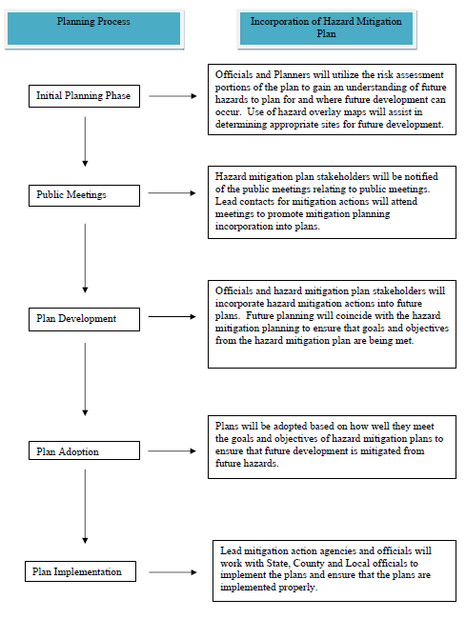

Current criteria used to prioritize mitigation funding

Mitigation funding is primarily based upon the combination of expected damage and death/injury impacts. Another facet of the county’s mitigation concerns is the intensity of development pressures. The master plan calls for concentrating new land use and economic development in and around higher-density areas to provide greater access to infrastructures and emergency measures.

Integration of hazard mitigation with the city/county department’s plans

The county EMD meets with representatives from fire districts, law enforcement, emergency medical and health organizations. The cities rely on the county’s EOP. The County Hazard Mitigation Plan will work in conjunction with the County EOP to provide residents and public officials with the proper information and resources to develop future plans. City and County department’s will utilize the plans mitigation actions to help develop new programs in hazard mitigation that focus on education, prevention, structural improvements and natural resource protection. Integration of hazard data will also provide useful information to City/County departments in understanding which hazards to help educate the public on and which hazards will need to be addressed in future emergency planning, especially for first responders and law enforcement officials.

How the county determines cost-effectiveness of mitigation programs

Cost-effectiveness is considered on a case-by-case basis, dependent upon the scope of damages, estimated savings in future hazard events, the type of mitigation project, and the probable hazard to human life in future events.

Mitigation funding options including current and potential sources of federal, state, local, private

The county and incorporated areas have historically relied upon federal disaster declarations in cases of heavy widespread damages. Sources have included FEMA, SEMA, the Missouri Department of Natural Resources and Department of Economic Development (DED), and various other grant programs. In addition, investments in infrastructures that have mitigating effects have been funded from sources such as local tax revenues. Other funding options being considered for the future include the grant sources identified in SEMA’s 2010 Missouri State Hazard Mitigation Plan, which include:

Pre-Disaster Mitigation Program

Program Summary: The Pre-Disaster Mitigation (PDM) program is a FEMA grant program. In 2009, Congress amended the Robert T. Stafford Disaster Relief and Emergency Assistance Act to reauthorize the pre-disaster mitigation program of FEMA. In addition, there is the Legislative Pre-Disaster Mitigation (L-PDM) program funded through the National Legislative Pre-Disaster Mitigation Fund. The purpose of PDM and L-PDM programs are to provide funds to states, territories, Indian tribal governments, and communities for hazard mitigation planning and the implementation of mitigation projects prior to a disaster event. Funding these plans and projects reduces overall risks to the population and structures, while also reducing reliance on funding from actual disaster declarations.

Project grants are available for voluntary acquisition of real property (i.e., structures and land, where necessary) for open space conversion; relocation of public or private structures; elevation of existing public or private structures to avoid flooding; structural and nonstructural retrofitting of existing public or private structures to meet/exceed applicable building codes; construction of safe rooms for public and private structures; vegetation management (e.g., for wildfire); protective measures for utilities, water and sanitary sewer systems, and infrastructure; storm water management projects; and localized flood control projects that are designed specifically to protect critical facilities and that do not constitute a section of a larger flood control system.
Planning grants are available for new plan development, plan upgrades, and comprehensive plan reviews and updates.

Amount: Congress appropriated $90 million for this program for fiscal year 2009 and $100 million for fiscal year 2010. Each State will receive at least $575,000 or the amount that is equal to one percent of the total funds appropriated to carry out this section for the fiscal year.
PDM grants are awarded on a competitive basis. Eligible sub-applications will compete nationally for PDM grant funds.

Eligibility: In Missouri, SEMA serves as the applicant for all PDM and L-PDM grants. State level agencies, including state institutions (e.g., state hospital or university); federally recognized Indian tribal governments; local governments (including state recognized Indian tribes and Missouri State Hazard Mitigation Plan FINAL 4.69 July 2010 authorized Indian tribal organizations); public colleges and universities; and Indian Tribal colleges and universities are eligible to apply to SEMA for assistance as sub-applicants. Private nonprofit organizations and private colleges and universities are not eligible to apply to the State, but an eligible, relevant state agency or local government may apply on their behalf. SEMA reviews and prioritizes sub- applications and submits the grant application with sub-applications to FEMA for review and approval.

All sub-applicants that have been identified through the NFIP as having a Special Flood Hazard Area and that have a Flood Hazard Boundary Map or a Flood Insurance Rate Map must be participating and in good standing in the NFIP. There is no NFIP participation requirement for PDM and HMGP project sub-applications for projects located outside of the SFHA. Also there are no NFIP participation requirements for PDM and HMGP hazard mitigation planning
sub-applications. The latest Hazard Mitigation Assistance Unified Guidance can also provide the

latest information.

For project grants, sub-applicants must have a FEMA-approved local mitigation plan. All activities submitted for consideration must be consistent with the local mitigation plan as well as the Missouri State Hazard Mitigation Plan.

Cost-Share Requirements: PDM and L-PDM grants are provided on a 75 percent federal/25 percent nonfederal cost share basis. Small and impoverished communities may be eligible for up to a 90 percent federal cost-share (see Section 5.3.3 Small and Impoverished Communities).

Requirements: Recipients of PDM and L-PDM planning grants must produce FEMA-approved hazard mitigation plans.

Flood Mitigation Assistance Program

Program Summary: The Flood Mitigation Assistance Program (FMA) is a program under FEMA’s NFIP. Its purpose is to implement cost-effective measures that reduce or eliminate the long-term risk of flood damage to buildings, manufactured homes, and other structures insured under the NFIP. The FMA provides planning grants for communities to assess their flood risk and identify actions to reduce it. Planning grants may be used to develop a new or update an existing flood mitigation plan (this also applies to the flood hazard portion of multi-hazard mitigation plans).

Project grants are available for acquisition, structure demolition, or structure relocation with the property deed restricted for open space uses in perpetuity; elevation of structures; dry
flood proofing of nonresidential structures; and minor structural flood control activities. Planning grants are available for flood mitigation planning activities.

Amount: For fiscal year 2009 (October 1, 2008-September 30, 2009), Congress appropriated
$35.7 million for the FMA and Missouri received $540,200 ($498,600 for projects and $41,600 for planning). For fiscal year 2010, Congress has appropriated $40 million.

Eligibility: In Missouri, SEMA serves as the applicant for all FMA grants. State-level agencies, federally recognized Indian tribal governments, and local governments (including state recognized Indian tribes and authorized Indian tribal organizations) are eligible to apply to SEMA for assistance as sub-applicants. Individuals and private nonprofit organizations are not eligible to apply to the State, but a relevant state agency or local community may apply on their behalf. SEMA reviews and prioritizes sub-applications by the applications that include mitigating repetitive loss properties. SEMA then submits the grant application with sub- applications to FEMA for review and approval.

All sub-applicants must be participating and in good standing in the NFIP. Also properties included in a project sub-application must be NFIP-insured at the time of the application submittal. For project grants, sub-applicants must have a FEMA-approved flood mitigation plan or multi-hazard mitigation plan that meets FMA planning requirements. All activities submitted for consideration must be consistent with the local mitigation plan as well as the Missouri State Hazard Mitigation Plan.

Cost-Share Requirements: FMA funds are provided on a 75 percent federal/25 percent nonfederal cost share basis. The recipient must provide the 25 percent match, only half of which may be in-kind contributions. For severe repetitive loss properties, FEMA will contribute up to 90 percent of the total eligible costs if the State has taken actions to reduce the number of severe repetitive loss properties and has an approved state mitigation plan that specifies how it intends to reduce the number of severe repetitive loss properties. Missouri State Hazard Mitigation Plan FINAL 4.71 July 2010

Requirements: Recipients of FMA planning grants must produce FEMA-approved flood mitigation plans.

Hazard Mitigation Grant Program

Program Summary: The Hazard Mitigation Grant Program (HMGP) is a FEMA program to provide funds to states, territories, Indian tribal governments, and communities to significantly reduce or permanently eliminate future risk to lives and property from natural hazards. HMGP funds projects in accordance with priorities identified in state, tribal, or local hazard mitigation plans, and enables mitigation measures to be implemented during the recovery from a disaster. HMGP funds can be used for projects to protect either public or private property, as long as the project fits within state and local government mitigation strategies to address areas of risk and complies with program guidelines. Examples of projects include acquiring and relocating structures from hazard-prone areas; retrofitting structures to protect them from floods, high winds, earthquakes, or other natural hazards; constructing certain types of minor and localized flood control projects; and constructing safe rooms inside schools or other buildings in tornado prone areas.

The State may set aside up to 7 percent of the HMGP funds received following a presidential disaster declaration to develop FEMA-approved mitigation plans. The State may also set aside up to 5 percent of the HMGP monies to fund the State 5% Initiative Projects (see Section 4.4.1: Actions (Projects) That Will Be Considered by the State of Missouri).
Amount: Federal funding under the HMGP is available following a major disaster declaration if requested by the governor. The amount of an HMGP grant will depend on the costs associated Missouri State Hazard Mitigation Plan FINAL 4.72 July 2010 with each individual disaster.
Since the Missouri State Hazard Mitigation Plan is an enhanced plan, the State is eligible for up to 20 percent of the total estimated federal assistance provided after a major disaster declaration. States with standard hazard mitigation plans are eligible for 15 percent for amounts not more than $2 billion, 10 percent for amounts of more than $2 billion and not more than $10 billion, and 7.5 percent on amounts more than $10 billion and not more than $35.3 billion.

Eligibility: HMGP funds are administered by SEMA. Local governments, eligible private nonprofit organizations or institutions, and Indian tribes or authorized tribal organizations are eligible to apply to SEMA for assistance as subapplicants. Individuals and businesses are not eligible to apply to the State, but eligible local governments or private non-profit organizations may apply on their behalf.

SEMA’s administrative plan for eight federal disasters starting with DR-1736 in December 2007, says that the Mitigation Section reviews the submitted HMGP subapplications documents.
Priority is given to flood mitigation, tornado/ severe wind, ice storm and earthquake mitigation projects located in the declared counties. If all available funds are not expended on these mitigation projects, consideration will be given to other types of mitigation projects in the declared counties prior to requesting proposals statewide. The subapplications are sent to FEMA for review and approval.

For project grants, subapplicants must have a FEMA-approved local mitigation plan. All activities submitted for consideration must be consistent with the local mitigation plan as well as the Missouri State Hazard Mitigation Plan.

Cost-Share Requirements: HMGP funds are provided on a 75 percent federal/25 percent nonfederal cost share basis. The nonfederal match does not does not need to be cash; in-kind services and/or materials may be used.

Repetitive Flood Claims Program

Program Summary: The Repetitive Flood Claims (RFC) Program is a FEMA program designed to reduce or eliminate the long-term risk of flood damage to structures insured under the NFIP that have had one or more claim payment(s) for flood damage. Project grants are available for voluntary property acquisition, structure demolition, structure elevation, dry flood proofing of structures, and minor localized flood reduction projects. If the structure is removed, the property is deeded to the community and restricted only to open-space use. The property can never be developed again. Planning grants and non-flood hazard mitigation activities are not available.

Amount: Historically, Congress appropriated $10 million for the RFC program for each fiscal year 2006-2010. RFC grants are awarded nationally without reference to state allocations, quotas, or other formula-based allocation(s) of funds.

Eligibility: RFC funds can only be used mitigate structures that are located within a state or community that cannot meet the requirements of the FMA for either cost share or capacity to manage the activities.

In Missouri, SEMA serves as the applicant for all RFC grants. State-level agencies, federally recognized Indian tribal governments, and local governments (including state-recognized Indian tribes and authorized Indian tribal organizations) are eligible to apply to SEMA for assistance as sub-applicants. Individuals and private nonprofit organizations are not eligible to apply to the State, but a relevant state agency or local community may apply on their behalf. SEMA reviews and prioritizes sub-applications and submits the grant application with subapplications to FEMA for review and approval. All sub-applicants must be participating and in good standing in the NFIP.

Cost-Share Requirements: All RFC grants are eligible for up to 100 percent federal assistance.

Severe Repetitive Loss Program

Program Summary: The Severe Repetitive Loss (SRL) program is a FEMA program with a purpose to reduce or eliminate the long-term risk of flood damage to severe repetitive loss residential properties and the associated drain on the National Flood Insurance Fund (NFIF) from such properties. FEMA defines SRL properties as residential properties that have at least four NFIP claim payments over $5,000 each, at least two of which occurred within any ten-year period, and the cumulative amount of such claims payments exceeds $20,000; or that have at least two separate claims payments (building payments only) where the total of the payments exceeds the value of the property, when two such claims have occurred within any ten-year period.

Project grants are available for flood mitigation activities such as acquisition, structure demolition, or structure relocation with the property deed restricted for open-space uses in perpetuity; elevation of structures; flood proofing of structures; minor physical localized flood control projects; and mitigation reconstruction. SEMA gives the highest priority to the
sub-applicant projects that demonstrate the greatest savings to the NFIF based on a benefit cost ratio.

Planning grants are not available.

Amount: The SRL program was authorized for up to $40 million for fiscal years 2006 and 2007. Then up to $80 million in fiscal years 2008 and 2009 and $70 million in fiscal year 2010. The SRL program is subject to the availability of appropriation funding, as well as any directive or restriction made with respect to such funds.

Eligibility: In Missouri, SEMA serves as the applicant for all SRL grants. State-level agencies, federally recognized Indian tribal governments, and local governments (including state recognized Indian tribes and authorized Indian tribal organizations) are eligible to apply to SEMA for assistance as sub-applicants. Individuals and private nonprofit organizations are not eligible to apply to the State, but a relevant state agency or local community may apply on their behalf. SEMA reviews and prioritizes sub-applications and submits the grant application with sub-applications to FEMA for review and approval.

All sub-applicants must be participating and in good standing in the NFIP and an approved local mitigation plan is required.

Cost-Share Requirements: SRL grants are provided on a 75 percent federal/25 percent nonfederal cost share basis. Up to 90 percent federal cost-share funding may be available for projects approved in states, territories, and federally recognized Indian Tribes with FEMA approved standard or enhanced mitigation plans or Indian tribal plans that include a repetitive loss strategy for mitigating existing and future SRL properties.

FEMA’s Public Assistance—Mitigation
Program Summary: Section 406 (Public Assistance) of the Stafford Act establishes the program for the repair, restoration, and replacement of facilities damaged as a result of a presidentially

declared disaster. These funds can also be used for hazard mitigation measures a state or local government determines to be necessary to meet a need for governmental services and functions in the area affected by the major disaster. Section 406 mitigation funds can only be used in the declared disaster areas (usually counties) and only in conjunction with identified, eligible disaster projects that will strengthen existing infrastructure and facilities to more effectively withstand the next disaster. One example would be replacing a blown out culvert with one designed to convey higher flows, instead of one that will be easily damaged in a flood again.

Eligibility: State-level agencies, federally recognized Indian tribal governments, and local governments (including state-recognized Indian tribes and authorized Indian tribal organizations) are eligible to apply to SEMA for assistance.

Cost-Share Requirements: Public Assistance grants are provided at not less than 75 percent federal/25 percent nonfederal cost share basis for emergency measures and permanent restoration. All projects approved under State disaster assistance grants will be subject to the cost sharing provisions established in the FEMA-State Agreement and the Stafford Act.

How county government meets requirements for hazard mitigation funding programs

Recommended improvements include expanded mutual aid agreements among neighboring jurisdictions, improve the capabilities of the EOC, additional warning sirens, adopt and implement storm-water regulations, educate the public concerning the link between storm- water runoff and flash floods, promote drought-resistant farming techniques and design recommendations to reduce impervious surfaces, work with DNR and USDA to promote dam maintenance, and generally increase education for public safety.
In addition, Missouri’s Structural Assessment and Visual Evaluation (SAVE) Coalition facilitates the use of volunteer engineers, architects and qualified building inspectors who perform damage assessments of homes following disasters such as earthquake, floods and tornadoes. The SAVE Coalition can provide sound advice to communities and citizens concerning the safety of reentering their homes following a disaster, with the added intent of minimizing the need for sheltering by keeping people in their homes as much as safely feasible. Missouri statute RSMO 44.023 provides immunity from liability for those working in disaster volunteer programs. St. Clair County emergency preparedness personnel remain active in the SAVE Coalition.
The Missouri Seismic Safety Commission (under Missouri statutes RSMO 44.227 44.229, 44.231, 44.233, 44.235, and 44.227) has developed a Strategic Plan for Earthquake Safety in Missouri that contains a number of recommendations for earthquake mitigation. The commission also sponsors Earthquake Awareness activities each year, including exhibitions at the St. Louis Science Center and the State Capitol.

City/Town/Village Policies and Development Trends

The table below shows the cities that have zoning, building regulations, storm water regulations, earthquake regulations, and floodplain regulations. All 3 cities are facing major growth pressures.

Jurisdiction | Master Plan | Zoning | Building Codes | Earthquake Design | Subdivision Regulations | Stormwater Regulations | Floodplain Regulations
Appleton City | NO | NO | YES | NO | NO | NO | NO
Collins | NO | NO | NO | NO | NO | NO | NO
Lowry City | NO | NO | NO | NO | NO | NO | NO
Osceola | NO | YES | YES | NO | NO | NO | NO
Roscoe | NO | NO | NO | NO | NO | NO | NO
Vista | NO | NO | NO | NO | NO | NO | NO
St. Clair County | YES | NO | NO | NO | NO | NO | NO
Table 37 – Jurisdictional Ordinances

Section 4 Mitigation Strategy

Mitigation

Mitigation is defined as “…sustained action that reduces or eliminates long-term risk to people and property from natural hazards and their effects.” It describes the ongoing effort at the Federal, State, local, and individual levels to lessen the impact of disasters upon our families, homes, communities and economy.
Mitigation includes not only avoiding the development of vulnerable sections of the community, but also making existing development in hazard-prone areas safer. For example, we can identify areas in our community that are susceptible to damage from natural hazards and take steps to make these areas less vulnerable, through flood buyouts for example.
We can also steer growth to less risky areas, through nonstructural measures such as avoiding construction in the most flood-prone areas for example. Keeping buildings and people out of harm’s way is the essence of mitigation. In fact, incorporating mitigation into decisions related to our community’s growth can result in a safer, more resilient community, and one that is more attractive to new families and businesses.
St. Clair County is subject to many types of natural hazards such as floods, tornadoes, winter storms, earthquakes, droughts, and occasionally, wild fires. Some, such as floods, can occur at many times of the year and almost anywhere in the county. All-hazard mitigation planning is what we call the process associated with devising strategies needed to mitigate the damages associated with this wide variety of potential disasters.

Categories of Mitigation

Mitigation measures may be grouped into five categories.

Prevention
- Property protection
- Natural resource protection
- Public education and awareness
- Structural projects

- Prevention Measures are intended to keep a hazard risk problem from getting worse. They insure that the future development does not increase hazard losses.

Communities can achieve significant progress toward hazard resistance through prevention measures. This is particularly true in areas that have not been developed or where capital investment has not been substantial.

Using prevention measures, future development can be guided away from hazards, while maintaining other community goals such as economic development and quality of life.

Planning and zoning Open space preservation
Land development regulations Storm water management

- Property protection measures are used to modify buildings subject to hazard risk, or their surroundings, rather than to prevent the hazard from occurring. A community may find these to be inexpensive measures because often they are implemented or cost-shared with property owners. These measures directly protect people and property at risk. (Protecting a building does not have to affect the building’s appearance and therefore a popular measure for historic and cultural sites.)

Some examples of property protection are:
  - Acquisition – public procurement and management of lands that are vulnerable to damage from hazards
  - Relocation – permanent evacuation of hazard-prone areas through movement of existing hazard-prone development and population to safer areas
  - Rebuilding – modifying structures to reduce damage by future hazard events
  - Flood proofing – protecting a flood-prone building using one or more of several different methods

- Natural resource protection measures are intended to reduce the intensity of hazard effects as well as to improve the quality of the environment and wildlife habitats. Parks, recreation, or conservation agencies or organizations usually implement these activities.

Examples of natural resource protection include:
  - Erosion and sediment control
  - Wetland protection

- Public information activities inform and remind people about hazardous areas and the measures necessary to avoid potential damage and injury.

Public information activities for mitigation are directed towards property owners, potential property owners, business owners, and visitors. A few examples of public information activities to achieve mitigation are.
  - Providing hazard maps and other hazard information.
  - Outreach programs that provide hazard and mitigation information to people when they have not asked for it.

How might outreach programs accomplish this?
    - Print media
    - Radio/T.V. spots and interviews
    - Videotape

    - Massing mailings
    - Notices to residents and property owners in a specific, hazard-prone area
    - Displays in widely used facilities such as public buildings and malls
    - Property owner handbooks
    - Presentations at meeting of neighborhood groups

  - Real estate disclosure
  - Information in the public library or a library developed specifically for mitigation information
  - Available technical assistance
  - School age and adult education

- Structural measures directly protect people and property at risk. They are called “structural” because they involve construction of man-made structures to control hazards.

Structural projects for flood control may include:
  - Reservoirs
  - Levees, floodwalls, and seawalls
  - Diversions
  - Channel modifications
  - Storm sewers

County Hazard Mitigation Goals, Objectives, Strategy and Coordination Plan Goals

Through the planning process of the hazard mitigation update, the County, goals, objectives, strategies and implementation policies were all re-examined for several key characteristics. Such items include:

  - Applicability of goal to current county and jurisdictional standing
  - Cost-Benefit analysis
  - Projected timeline of action
  - Priority Status
  - Funding Sources

All goals and objectives from the 2005 plan were reviewed by the St. Clair County Emergency Management Director, as well as several key County department heads. The goals were also reviewed at public meetings and discussed thoroughly. Each goal was analyzed for one of three actions:

Revision - Goal was updated and revised to meet current mitigation practice standards or to be more applicable to county and jurisdictional capabilities

Delete - The goal/objective was removed due because it no longer applied to the County’s mitigation planning effort or was not a reasonable mitigation action that could be successfully accomplished
New - The new goal/objective were put into place to enhance the mitigation efforts of the county

If the goals/objectives were not revised, deleted or new, then the goal/objective will be considered ongoing and was reviewed by members of the public and emergency preparedness personnel.

The following table displays the updates made to the goals and objectives for mitigation planning in St. Clair County:

St. Clair County Goals and Objectives Update
Goal | Action | Original | Updated | Purpose
1.2.3 | Revised | Partner with local radio stations to assure that appropriate warning is provided to county residents of impending disasters | Partner with regional radio station to assure that appropriate warning is provided to county residents of impending disasters | There is no local radio in St. Clair County. Broadcasting stations are generally located in the Kansas City and Springfield areas.
1.3.1 | Deleted | Tree trimming programs and dead tree removal | N/A | Not county or jurisdictional responsibility and left up to individual home owners
1.3.2 | New | N/A | Encourage construction of tornado safe rooms | Provide suitable shelter from tornados
1.3.3. | New | N/A | Promote safe room construction in businesses, schools and residences. | Businesses and schools must become aware of the hazard dangers in their environment and develop mitigation activities.
2.3.2 | Revised | Encourage local and county governments to develop and implement regulations for the securing of hazardous materials tanks and mobile homes | Encourage local and county governments to develop and implement regulations for the securing of mobile homes | No hazardous materials tanks located within the County
3.1.1 | Revised | Distribute SEMA brochures at public facilities and events | Distribute SEMA and Red Cross brochures at public facilities and events | County emergency personnel work with the Red Cross to provide information to residents

3.4.1 | Revised | Encourage county health department and local American Red Cross Chapter to use publicity campaigns that make residents aware of property measures to take during times of extreme heat or cost | Encourage county health department to use publicity campaigns that make residents aware of property measures to take during times of extreme heat or cost | While work is done with them, there is no local red cross in St.  Clair County.
5.1.1 | Revised | Encourage communities to budge for enhance warning systems | Encourage communities to find resources for enhanced warning systems. | Communities in the County currently lack financial assets to provide enhanced warning systems and must seek funding streams before they can budget.
5.2.1 | Deleted | Encourage local government to purchase properties in the floodplain as funds become available and convert that land into public/recreational space | N/A | Lack of financial resources and few regulations make this an unreasonable mitigation activity
2.2.2 | Deleted | Encourage communities to zone all areas in the floodplain as open space | N/A | Other than Osceola, there is no zoning or regulatory practices in St. Clair County.

Table 38

Goal 1: Reduce risks and vulnerabilities of people in hazard-prone areas

Objectives
  - Advise the public about health and safety precautions to guard against injury and loss of life from natural hazards.

Recommendation: Education program on personal emergency preparedness (turning off utilities, preparing emergency medical kits that include water, blankets, flashlights, etc). Recommendation: Promote development of emergency plans by businesses.

  - Use the latest technology to provide adequate warning, communication, and mitigation of hazard events.

Recommendation: Assist communities with securing funding for early warning systems, improved communications systems, county wide GIS systems and databases, county wide GPS capability, and mitigation projects.
Recommendation: Promote the purchase of weather radios by local residents to ensure advanced warning about threatening weather.
Recommendation: Partner with local radio stations to assure that appropriate warning is provided to county residents of impending disasters.

  - Reduce the danger to, and enhance protection of, dangerous areas during hazard events.

Recommendation: Tree trimming programs, dead tree removal program. Recommendation: Assist communities/county in securing funding for road and bridge improvements.
Recommendation: Assist county with securing quality GIS systems and databases for county wide mapping and analysis.

Goal 2: Reduce the potential impact of natural disasters on new and existing properties and infrastructure and the local economy.

Objectives
  - Implement cost-effective activities that assist in protecting lives by making homes, businesses, infrastructure, critical facilities, and other property more resistant to natural hazards.

Recommendation: Encourage a self-inspection program at critical facilities to assure that the building infrastructure is earthquake and tornado resistant.
Recommendation: Encourage businesses to develop emergency plans.

  - Discourage new development and encourage preventive measures for existing development in areas vulnerable to natural hazards, thereby reducing repetitive losses to the National Flood Insurance Program.

Recommendation: Educate residents about the dangers of floodplain development and the benefits of the National Flood Insurance Program

  - Use regulation to ensure that development will not put people in harm’s way or increase threats to existing properties.

Recommendation: Encourage minimum standards for building codes in all cities. Recommendation: Encourage local governments to develop and implement regulations for the securing of hazardous materials tanks and mobile homes to reduce hazards during flooding and high winds.
Recommendation: Encourage local and county governments to develop and implement zoning regulations.

Goal 3: Promote education, outreach, research and development programs to improve the knowledge and awareness among the citizens and industry about hazards they may face, their vulnerability to identified hazards, and hazard mitigation alternatives that can reduce their vulnerabilities.

Objectives
  - Heighten public awareness of the full range of natural hazards by developing education and outreach programs.

Recommendation: Distribute SEMA brochures at public facilities and events. Recommendation: Regular press releases from county and city EMD offices concerning hazards, where they strike, frequency and preparation.

  - Provide information on tools, partnership opportunities, and funding resources to assist in implementing mitigation activities.

Recommendation: Encourage local residents to purchase weather radios through press releases and brochures.
Recommendation: Ask SEMA mitigation specialists to present information to city councils, county commission, Kaysinger Basin Regional Planning Commission, St. Clair County Emergency Planning Committee.

  - Publicize and encourage the adoption of appropriate hazard mitigation measures by county and city governments.

Recommendation: Cities/county should continually re-evaluate hazard mitigation plan and merge with other community planning.
Recommendation: Press releases by cities/county regarding adopted mitigation measures to keep public abreast of changes and/or new regulations.

  - Educate the public on actions they can take to prevent or reduce the loss of life or property from all natural hazards.

Recommendation: Encourage county health department and local American Red Cross chapter to use publicity campaigns that make residents aware of proper measures to take during times of extreme heat or cold.
Recommendation: Publicize county or citywide drills.

Goal 4: Strengthen communication and coordinate participation between public agencies, citizens, non-profit organizations, business, and industry to create a widespread interest in mitigation.

Objectives
  - Build and support local partnerships to continuously become less vulnerable to hazards.

Recommendation: Encourage joint meetings of different organizations/agencies for emergency planning.
Recommendation: Joint training (or drills) between agencies, public & private entities (including schools/businesses).
Recommendation: Pool different agency resources to achieve widespread results. Recommendation: Encourage the development of Community Emergency Response Teams (CERT Program).

  - Encourage active participation and responsibility of chief elected officials in mitigation planning and activities.

Recommendation: Encourage meetings between EMD, city/county, and SEMA to familiarize officials with mitigation planning and implementation and budgeting for mitigation projects.

Goal 5: Establish priorities for reducing risks to the people and their property with emphasis on long-term and maximum benefits to the public rather than short-term benefit of special interests.

Objectives
  - Incorporate hazard mitigation into the long-range planning and development activities of the county and each jurisdiction.

Recommendation: Encourage communities to budget for enhanced warning system maintenance and updating.
Recommendation: Examine potential road and bridge upgrades that would reduce danger to residents during occurrences of natural disasters.
Recommendation: Encourage all communities to develop storm water management plans.
Recommendation: Coordinate and integrate hazard mitigation activities, where appropriate, with emergency operations plans and procedures.
Recommendation: Encourage cities to require contractor storm water management plans in all new development—both residential and commercial properties.

  - Promote beneficial uses of hazardous areas while expanding open space and recreational opportunities.

Recommendation: Encourage local government to purchase properties in the floodplain as funds become available and convert that land into public space/recreation area.
Recommendation: Encourage communities to zone all areas in floodplain as open space.

Goal 6: Secure resources for investment in hazard mitigation Objectives
  - Research the use of outside sources of funding

Recommendation: Work with SEMA Region I coordinator to learn about new mitigation funding opportunities.
Recommendation: Structure grant proposals for road/bridge upgrades so that hazard mitigation concerns are also met.
Recommendation: Work with state/local/federal agencies to include mitigation in all economic and community development projects.

  - Encourage participation of property owners in investing in hazard mitigation projects on their own property.

Recommendation: Encourage cities and counties to implement cost-share programs with private property owners for hazard mitigation projects that benefit the community as a whole.
Recommendation: Implement public awareness program about the benefits of hazard mitigation projects, both public and private.

  - In the event of a disaster declaration, be prepared to apply for hazard mitigation for prioritized projects.

Recommendation: Prioritize mitigation projects, based on cost-effectiveness and starting with those sites facing the greatest threat to life, health and property.

Workshop participants discussed suggestions and were in agreement that none of the objectives and recommendations needed to be eliminated. All goals, objectives and actions were evaluated using the criteria of STAPLEE. These criteria look at the social, technical, administrative, political, legal, economic, and environmental impact of a proposed course of action.

The following table represents the goals that are applicable to the county and jurisdictions within St. Clair County. Due to its low population and size, St. Clair County’s goals and objective tend to apply throughout the county.

Table Key: Hazards Addressed
T - Tornado
F - Flood
W - Severe Winter Weather D - Drought
H - Severe Winter Heat E - Earthquake
D - Dam Failure
WF - Wildfire Effect on Buildings:
- - New Buildings
- - Existing Buildings
- - New and Existing Buildings
- - Neither New or Existing Buildings

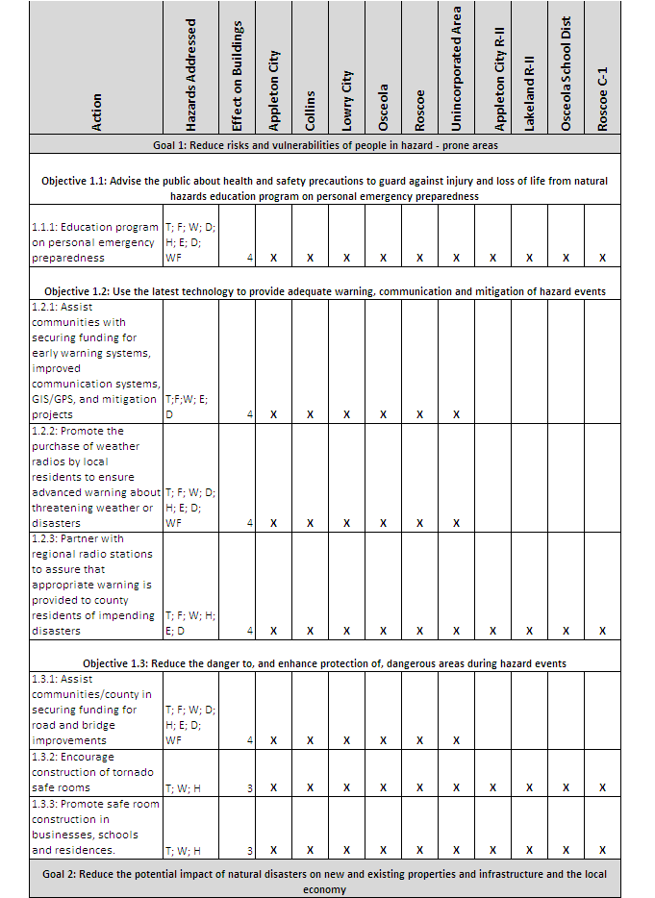

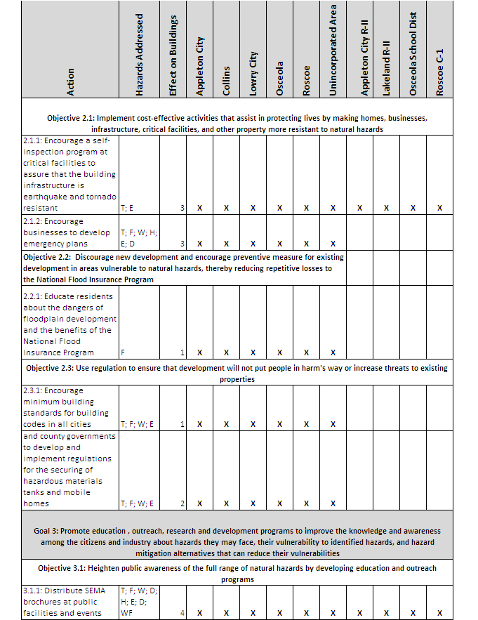

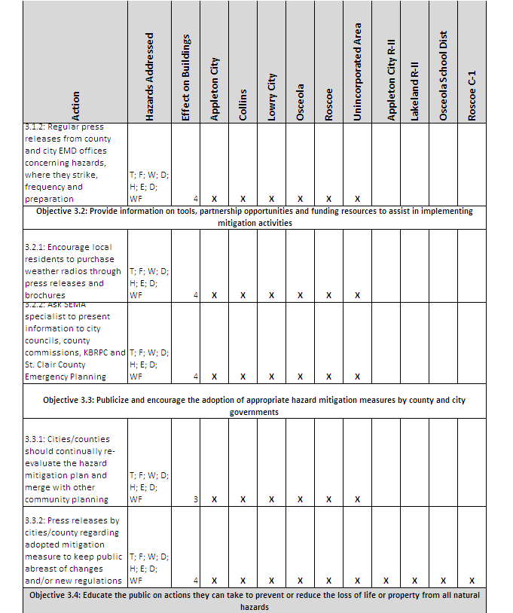

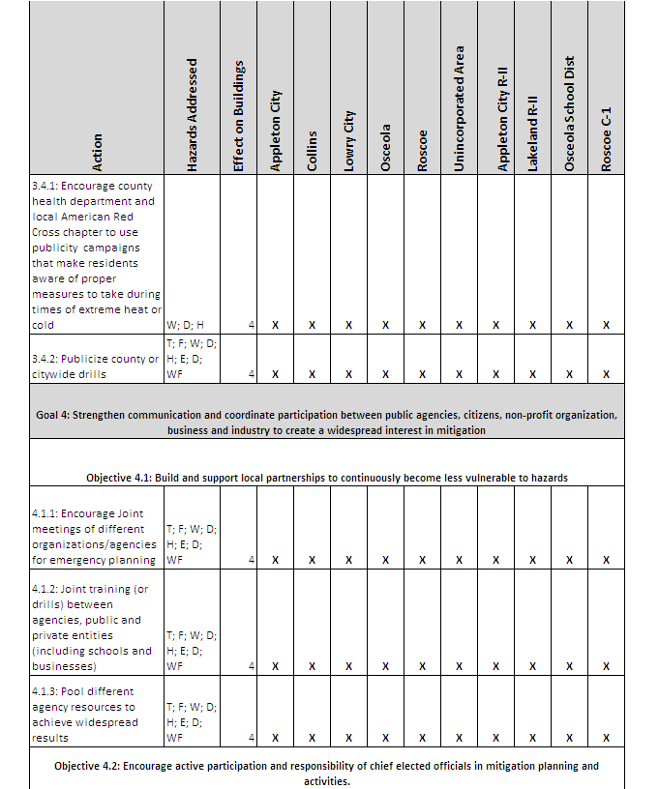

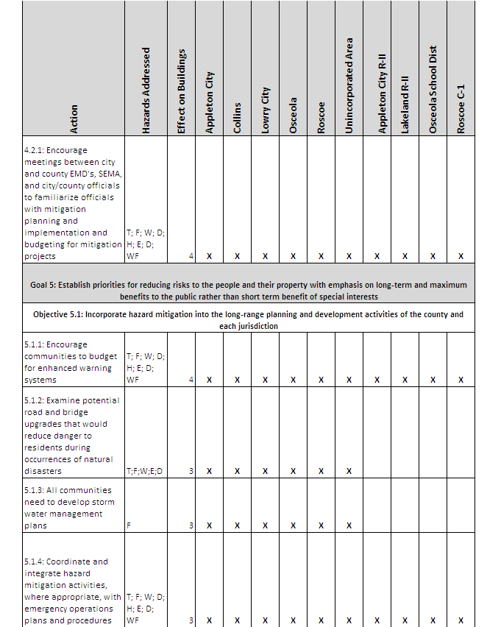

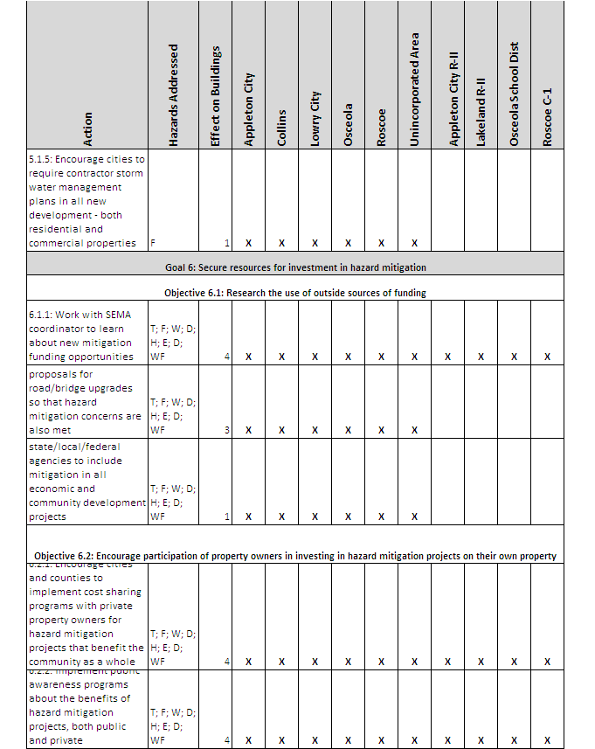

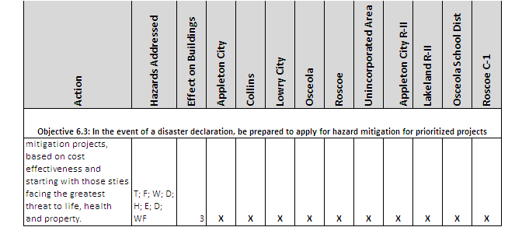

Table 39 – Goals/Objectives by Jurisdiction

Strategic implementation

The goals, objectives, and actions steer the plan toward group involvement such as individual communities, chambers of commerce, large employers, etc. All actions shown above were found to be cost-effective, environmentally sound, and technically feasible. The following set of underlying operating principles will improve fiscal and operational efficiency, help maintain a focus on the greater goal of overall community well-being, and help ensure implementation.

Each action will be implemented according to the following strategies.

  - Incorporate mitigation objectives into existing and future plans, regulations, programs and projects.
  - Promote and encourage collaboration between disparate agencies and departments to create a synergism that results in benefits that would not be possible through a single agency.
  - Employ sustainable principles and techniques in the implementation of each objective to attain maximum benefits. For example, watershed protection decreases the incidence and severity of flood.
  - Create and implement a prioritization process that includes monetary, environmental, and sociological considerations.

Overall, the County Emergency Management Director will oversee the majority of mitigation actions that will occur throughout the county as most goals are broad enough in scale that they affect the county as a whole.. Actions relating to hazard specific goals, such as flooding, will be implemented by the local emergency management director. If a jurisdiction does not have an emergency manager, the local elected officials will take the lead on project implementation.
School district implementation of action items will be led the Superintendent of the school district and support staff.

Ensure implementation through inclusion in adoption resolution

The county’s Natural Hazard Mitigation Plan will be implemented by the County Commission and its delegates. The implementation process will include coordination among county departments and coordinated with other relevant agencies or districts through the county’s Emergency Management Agency. The county will set up a system to monitor progress and evaluate the effectiveness of implemented actions with revisions as needed. As mandated by the Disaster Management Act of 2000, every five years, the county will review the plan and include any needed updates. The updated plan will be submitted for SEMA/FEMA approval.
Copies of the signed adoption resolutions are included in Appendix A. In addition, the plan will be reviewed for any necessary updates following any major disasters that occur within the county.

Analysis and prioritization of mitigation actions

St. Clair County’s mitigation actions promote and/or support the development of local hazard mitigation plans, projects and activities. The following matrix provides an analysis and prioritization of the county’s natural hazard mitigation goals, objectives and actions. The matrix also illustrates the relationship between the state’s identified hazards and the county’s mitigation actions. All actions will be coordinated, where applicable, with Missouri’s mitigation actions set forth in the Missouri Natural Hazard Mitigation Plan, 2010.

Mitigation actions were prioritized by St. Clair County officials and the public. Review of all goals, objectives and actions were reviewed item by item for relevance and priority status. Reviewers were provided with a simple scale to determine priority status. All mitigation actions were considered using the STAPLEE method to review the cost benefit ratio as well. Priority levels by jurisdictions for each action were determined on a timetable to mitigate hazards. The scales used are below:

Priority Level

Low - Long range mitigation action item with implementation within a ten year timeframe

Med - Mid range mitigation action item with implementation within a five year timeframe

High - Resources should be focused on mitigation action item with a one to five year timeframe

Mitigation actions were given a priority status of ‘Low’, ‘Medium’, or ‘High’ depending on their importance of completion for mitigating disaster in the County.

Cost Benefit Analysis

In order to help St. Clair County Hazard Mitigation stakeholders gain a better understanding of the Cost/Benefit Analysis of the plan update, the following scale was produced:

Low - None to minimal cost to jurisdiction involved. Minimal costs was defined as five percent of jurisdiction operating budget

Med - Moderate cost to jurisdiction that will likely be worked into the operating budget of the jurisdiction involved.

High - Excessive costs above a jurisdictions operating budget. Will require additional measures to secure funding for mitigation project in the jurisdiction involved.

Stakeholders were asked to apply a status of ‘Low’, ‘Medium’, or ‘High’ for all the mitigation actions that were reviewed as it pertains to their jurisdiction.

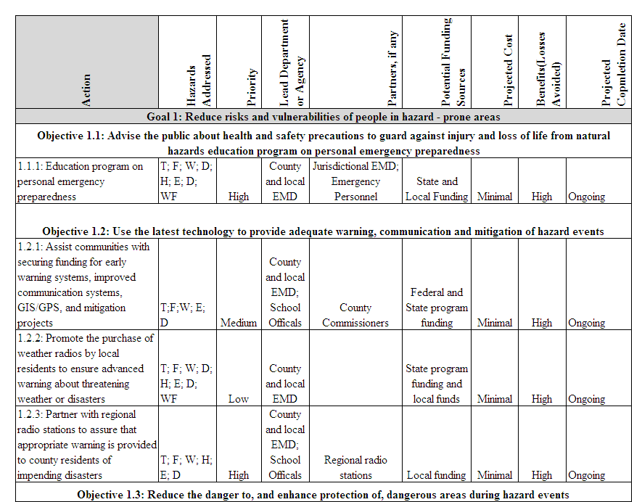

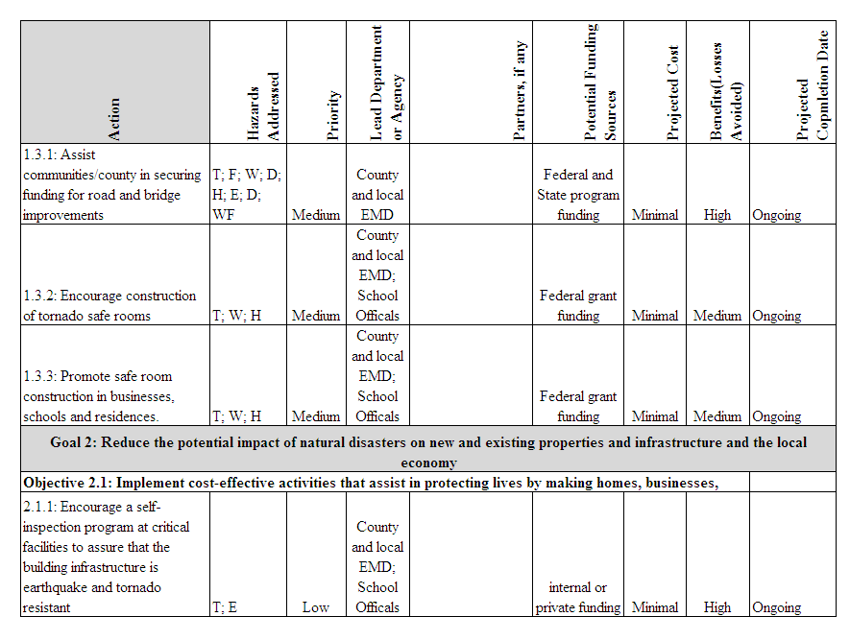

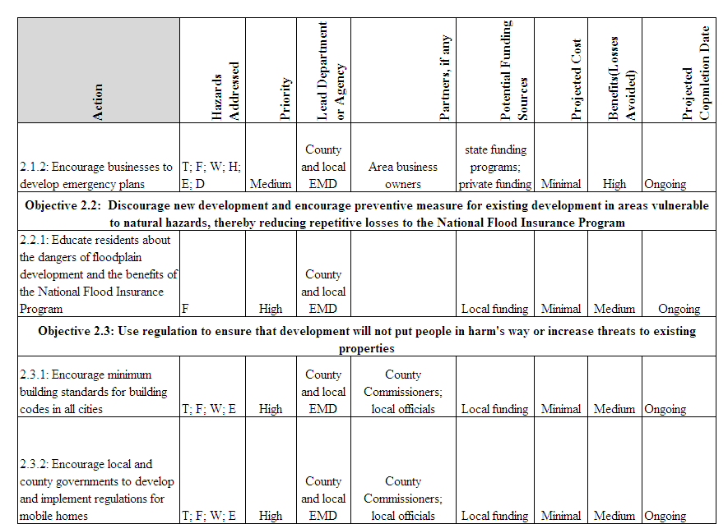

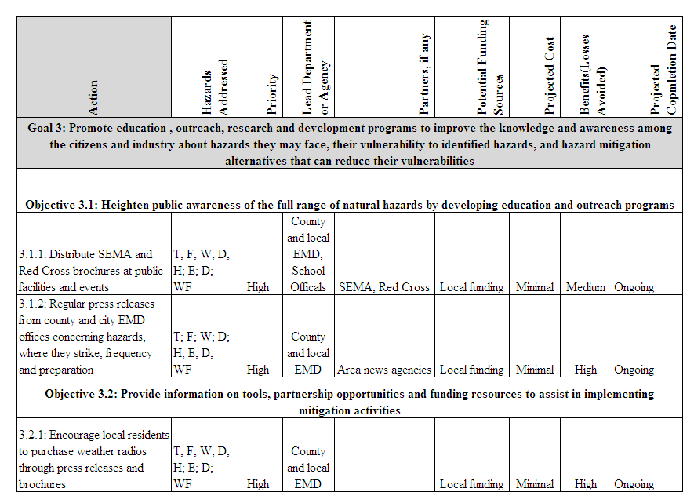

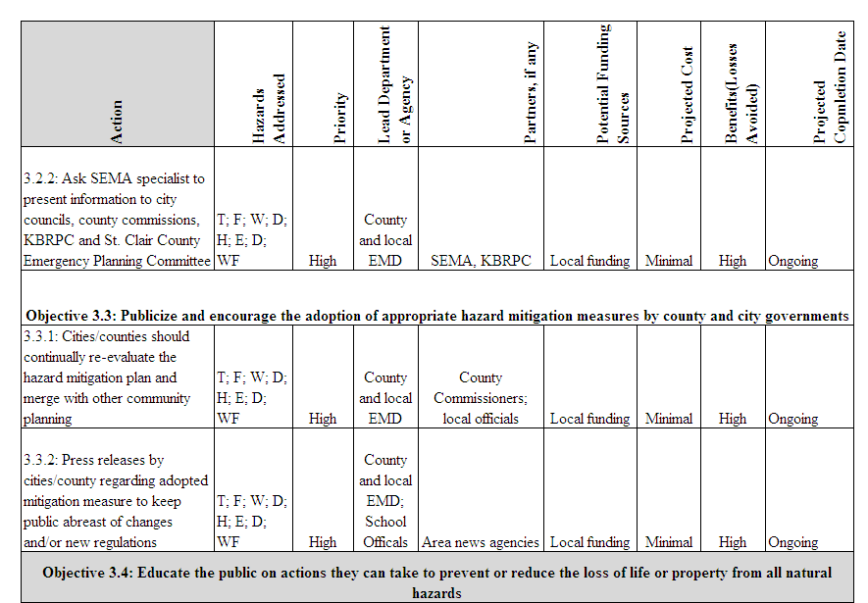

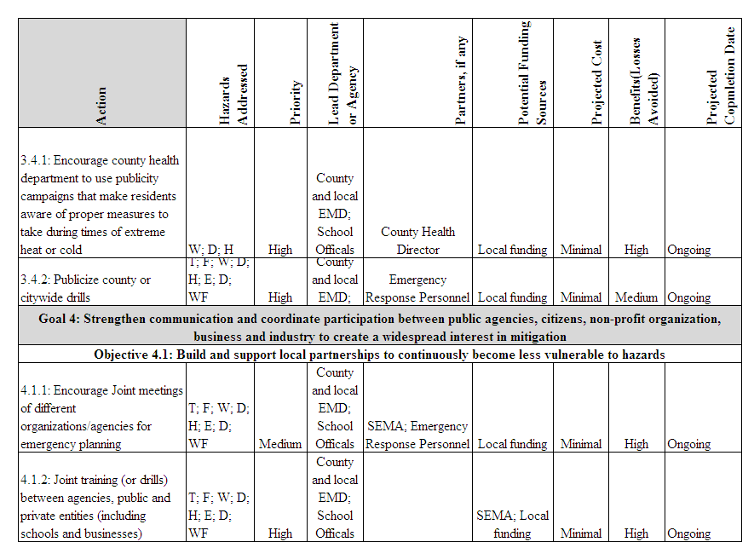

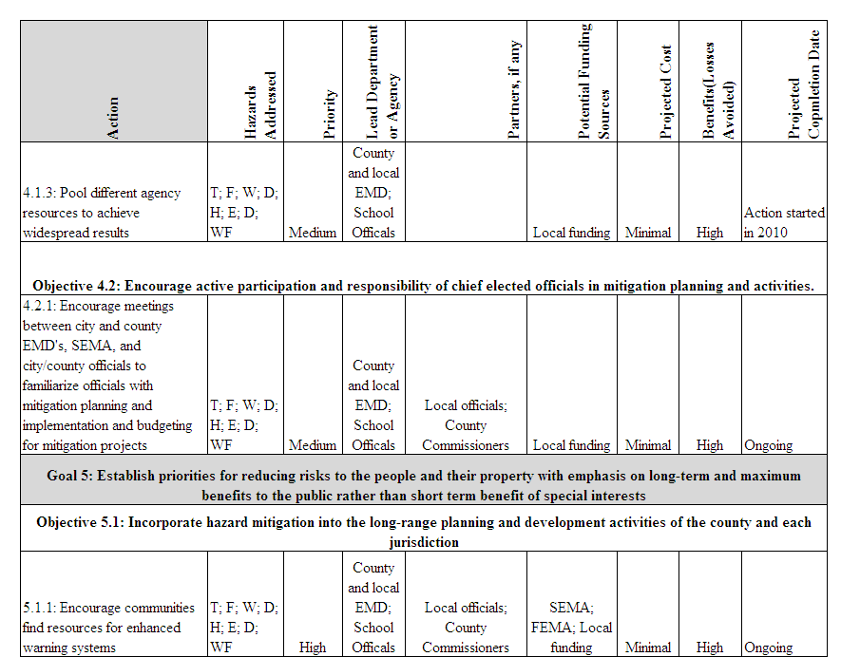

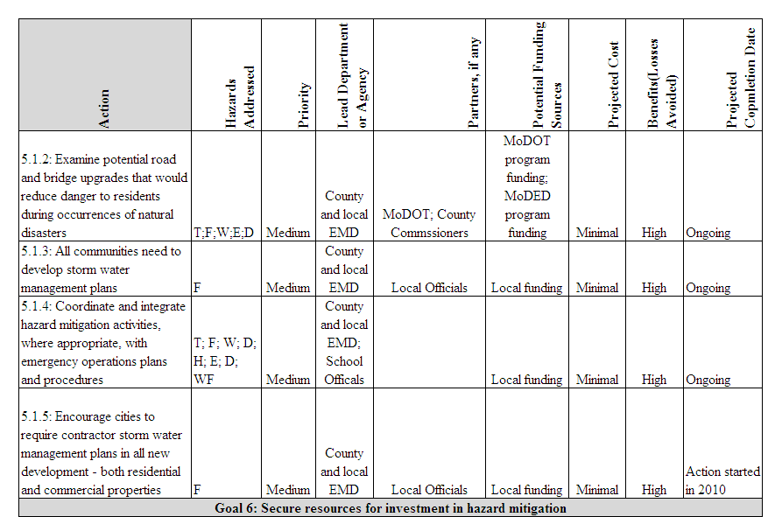

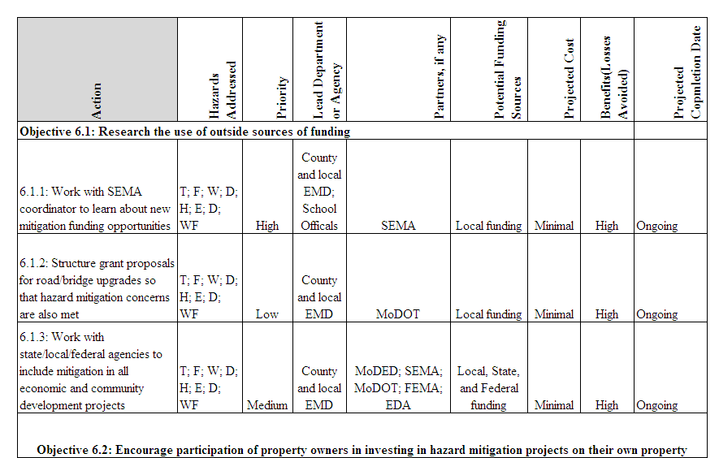

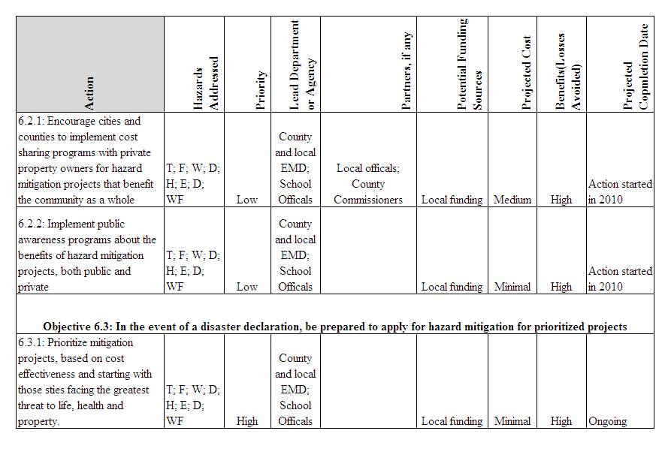

Monitoring, Evaluating, and Updating the Plan

St. Clair County has developed a method to ensure regular review and update of the Hazard Mitigation Plan. The County Commissioners, municipal public officials, members of the St. Clair County Emergency Management Committee (fire, law enforcement, emergency medical, and public health officers), and the County EMA director are responsible for various objectives in the plan,. Hazard mitigation objectives will be an agenda item, as needed, at monthly meetings of the St. Clair County Emergency Management Committee meetings. As planning begins the public will be encouraged to participate. The county will publicize the various objectives and the objective at hand by way of media coverage and published reminders.

The County EMA director is responsible for contacting all hazard mitigation stakeholders and organizing an annual meeting. The meeting will be held in the first half of each year, and committee members will be responsible for monitoring and evaluating the progress of the mitigation strategies in the plan. The committee will review each goal and objective to determine their relevance to changing situations in the county, as well as changes in State or Federal policy, and to ensure that they are addressing current and expected conditions. The committee also will review the risk assessment portion of the plan to determine if this information should be updated or modified. The parties responsible for the various implementation actions will report on the status of their projects and will include which implementation processes worked well, any difficulties encountered, how coordination efforts were proceeding, and which strategies should be revised.

The County EMA director will then have three months to update and make changes to the plan before submitting it to the committee members and the State Hazard Mitigation Officer. The plan will be posted with the St Clair County Emergency Operations Plan on the county EMA/LEPC web site (www.stclaircountyemalepc.com). If no changes are necessary, the State Hazard Mitigation Officer will be given a justification for this determination. The general public will be encouraged to attend Hazard Mitigation meetings through media coverage, published notices, reminders or announcements at civic meetings, and possibly public speaking engagements. Kaysinger Basin Regional Planning Commission will continue to host any hazard mitigation announcements or information, as well as a copy of the latest plan, on the KBRPC website (www.kaysinger.org).

Appendix A: Formal Adoption Resolution

Model Resolution for the St. Clair County Hazard Mitigation Plan
The following resolution was adopted by on , 2010. Resolution No.
A RESOLUTION OF INTENT TO PARTICIPATE IN NATURAL HAZARD MITIGATION AND TO WORK TOWARD BECOMING A SAFER COMMUNITY.

WHEREAS, the recognizes that no community is immune from natural hazards whether it be tornado/severe thunderstorm, flood, severe winter weather, drought, heat-wave, earthquake, dam failure, or wildfire, and recognizes the importance of enhancing its ability to withstand natural hazards as well as the importance of reducing the human suffering, property damage, interruption of public services and economic losses caused by those hazards; and

WHEREAS, the may have previously pursued measures such as building codes, fire codes, floodplain management regulations, zoning ordinance, and storm-water management regulations to minimize the impact of natural hazards; and

WHEREAS, the Federal Emergency Management Agency and the State Emergency Management Agency have developed a natural hazard mitigation program that assists communities in their efforts to become Disaster-Resistant Communities which are sustainable communities after a natural disaster that focus, not just on disaster relief, but also on recovery and reconstruction that brings the community to at least pre-disaster conditions in an accelerated, orderly, and preplanned manner; and

WHEREAS, by participating in the Natural Hazards Mitigation program, the will be eligible to apply for post-disaster mitigation funds; and

WHEREAS, the desires to commit to working with government partners and community partners to implement the Natural Hazards Mitigation Plan; and

WHEREAS, the will implement pertinent precepts of the mitigation plan by incorporation into other community plans and mechanisms where appropriate; and

WHEREAS, the will participate in the evaluation and review of the Plan after a disaster as well as complete mandated five-year update submitted to the State Emergency Management Agency and the Federal Emergency Management Agency for review and approval; and

NOW, THEREFORE, BE IT RESOLVED BY THE OF THE AS FOLLOWS:

The hereby adopts the St. Clair County Multi-Jurisdictional Natural Hazard Mitigation Plan attached hereto for the purpose of building a safer community by reducing natural hazard vulnerability.

Presiding Official Date

Secondary Official Date

Tertiary Official Date

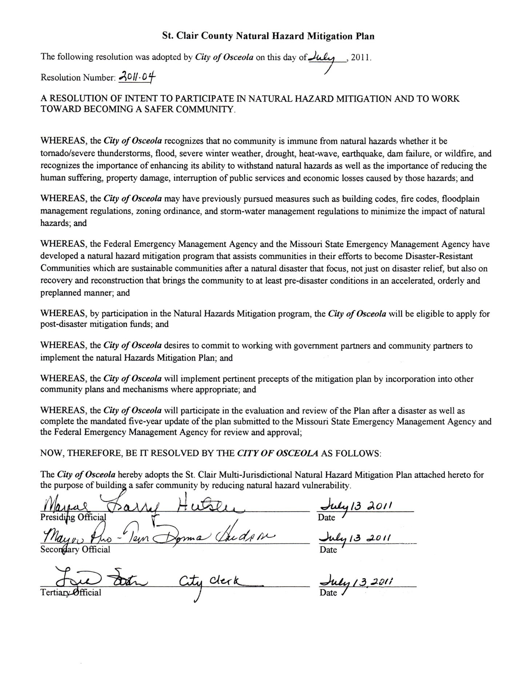

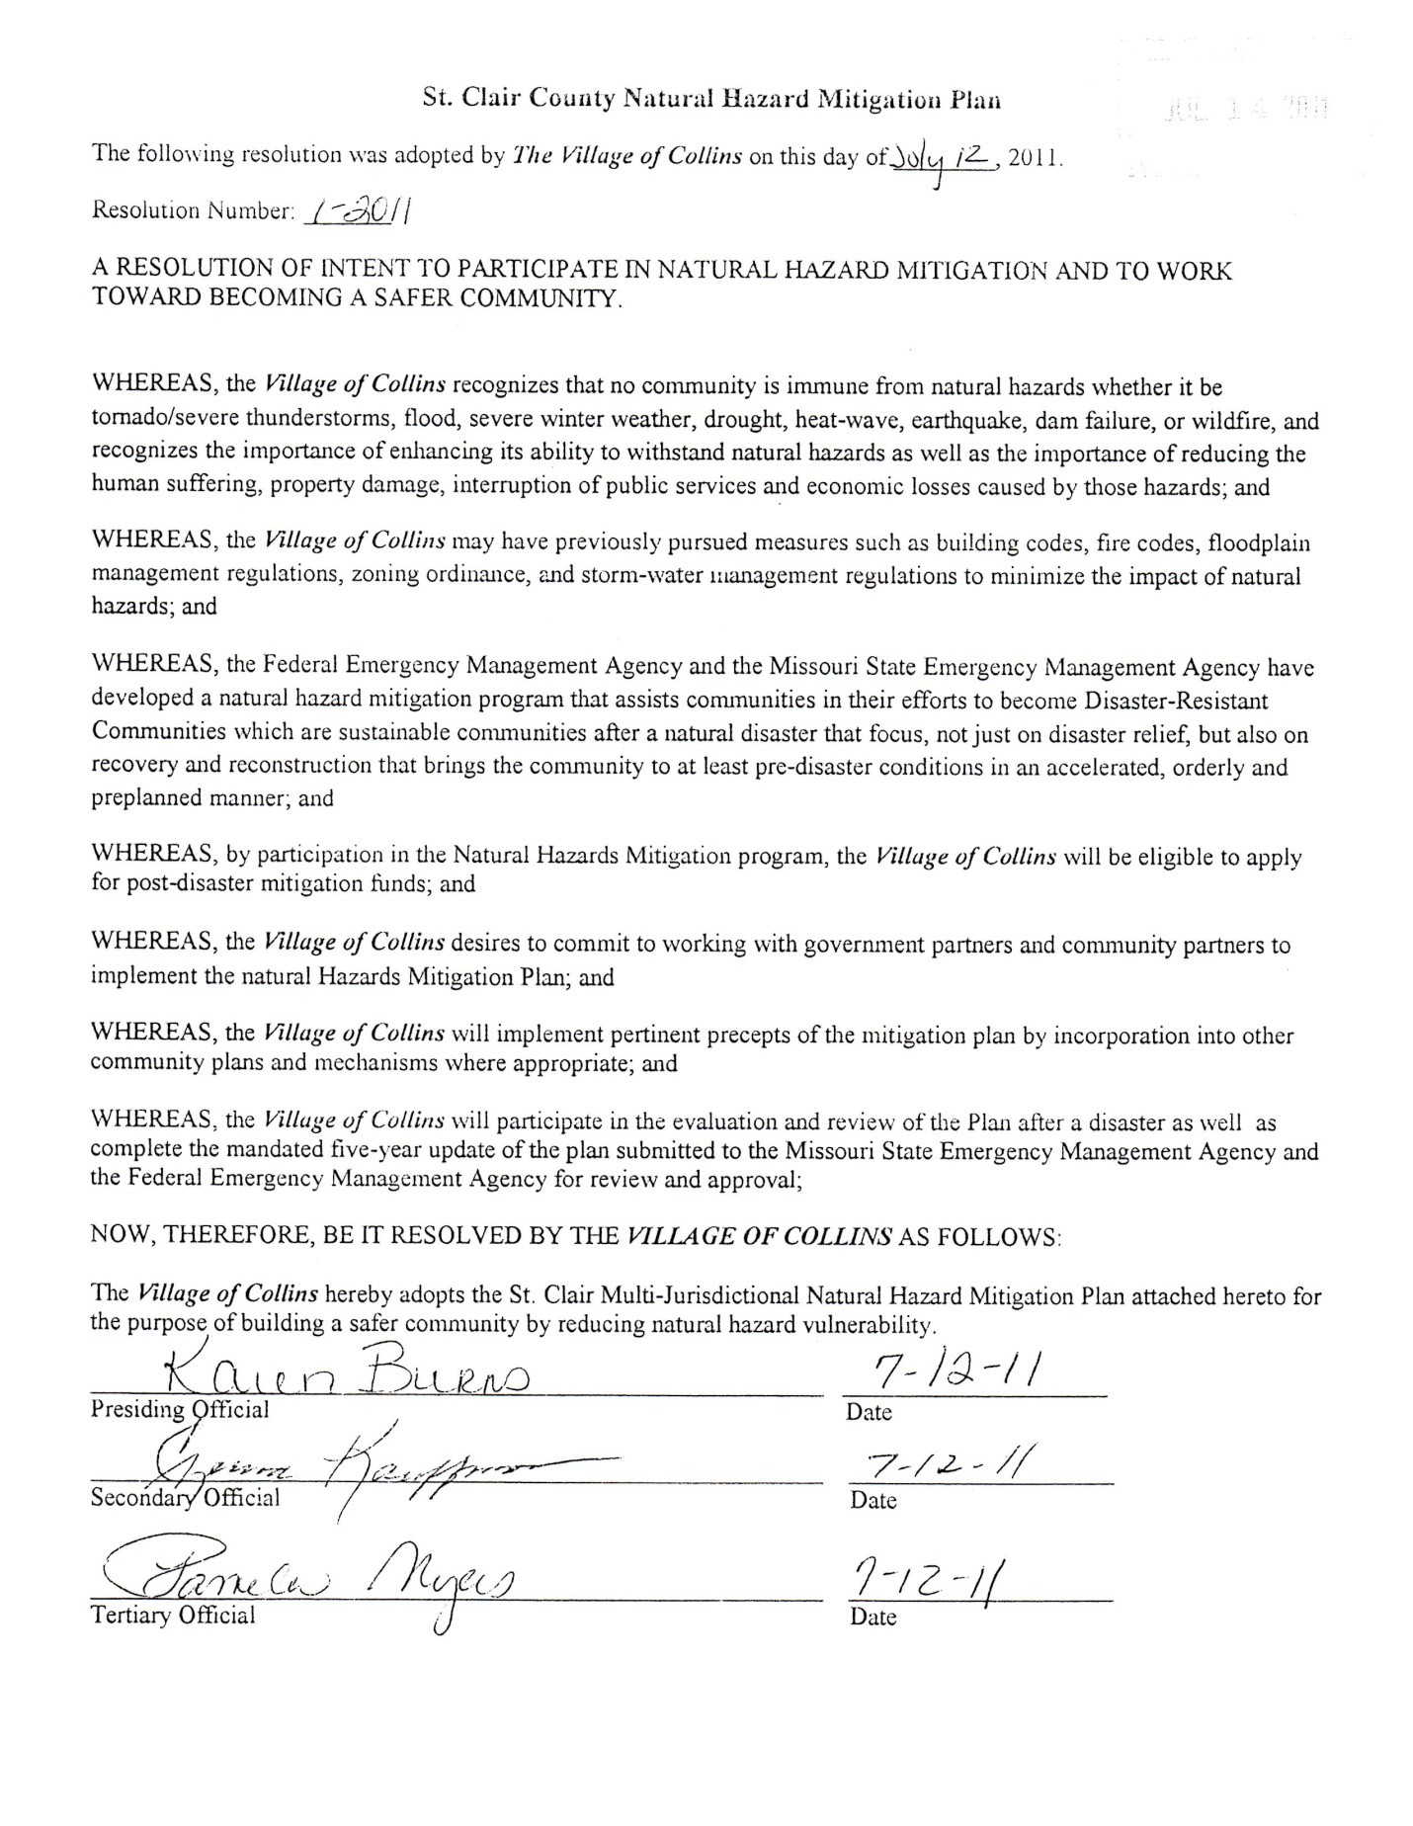

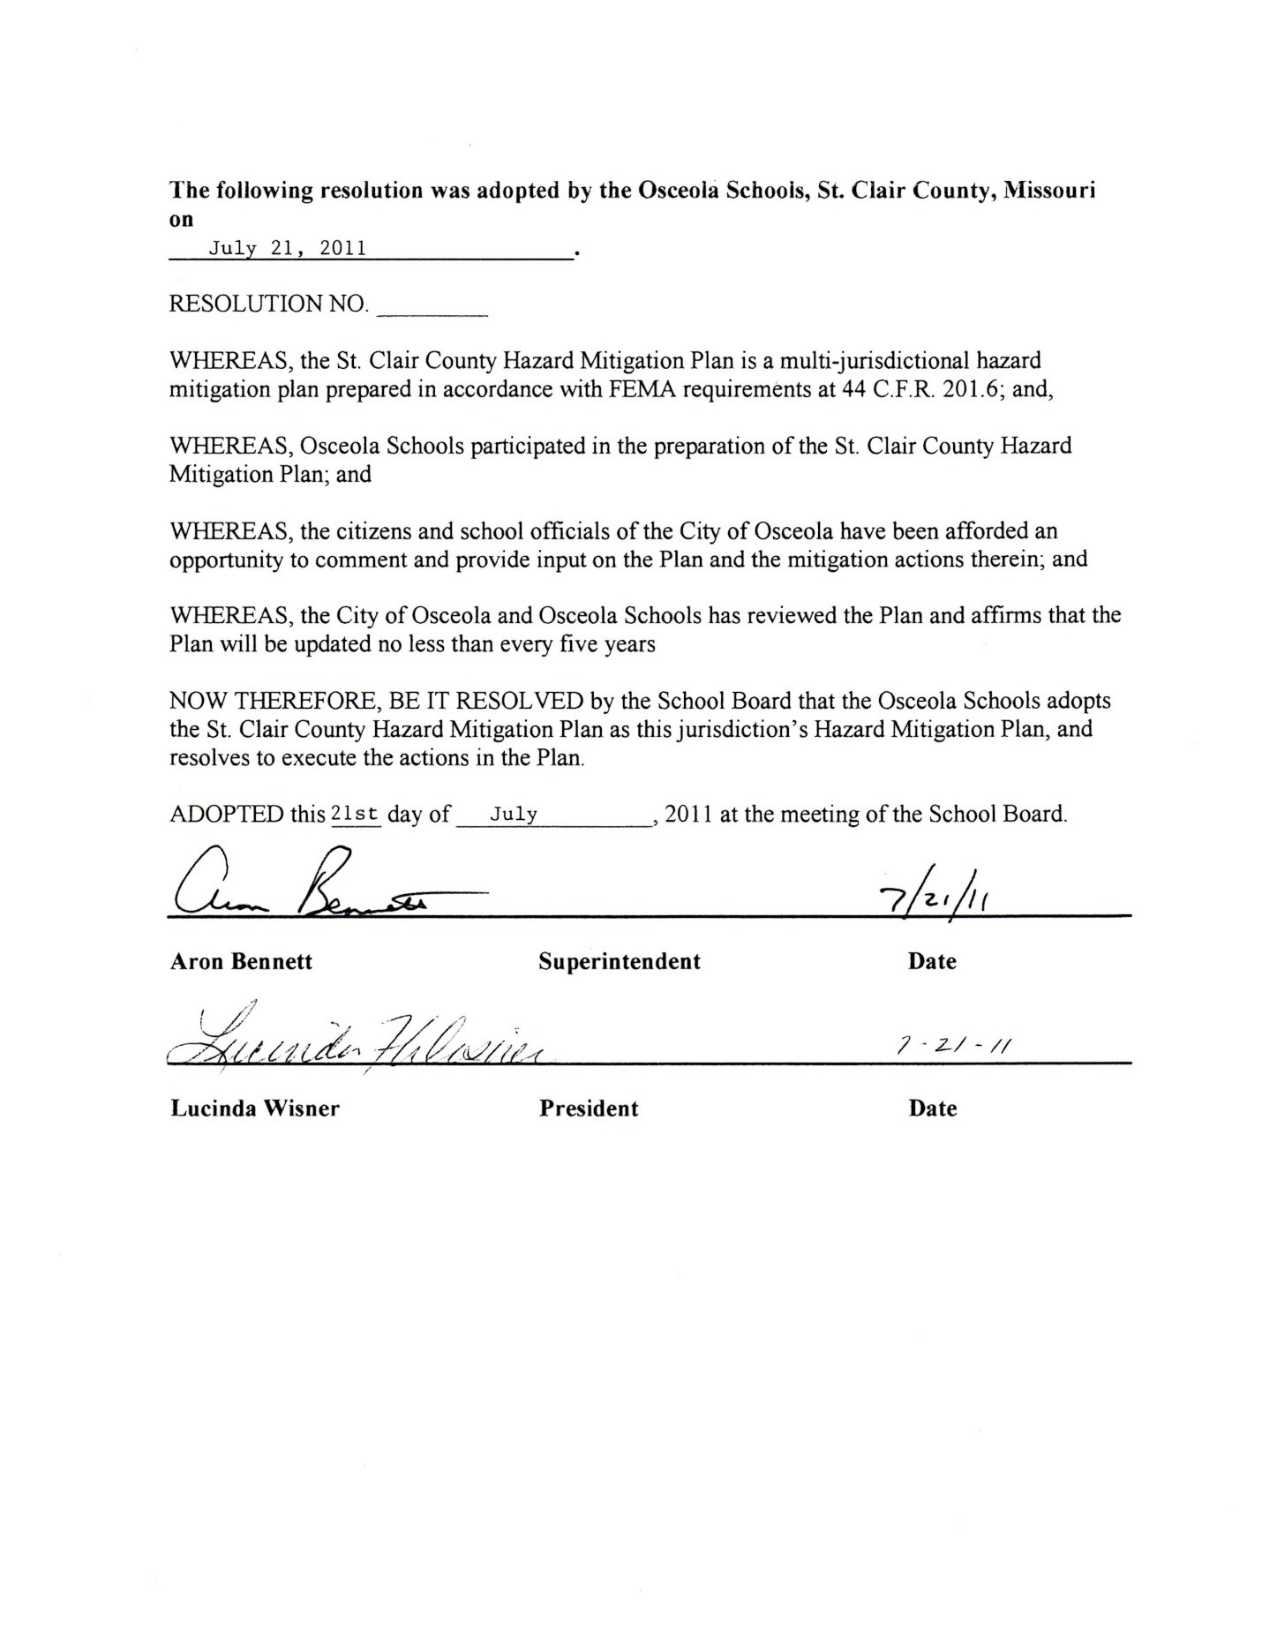

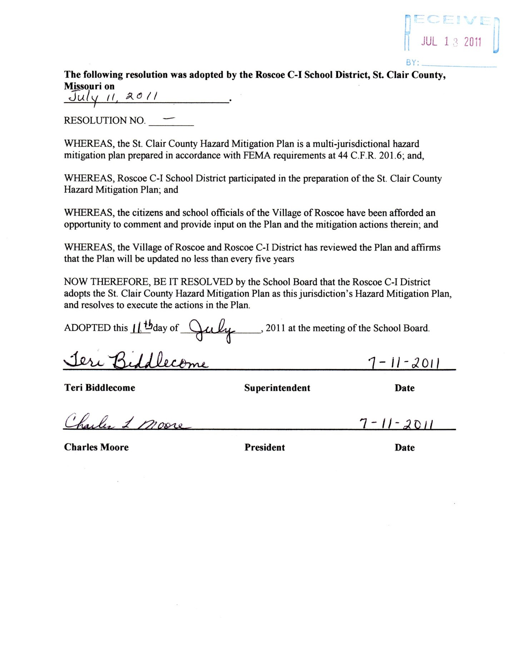

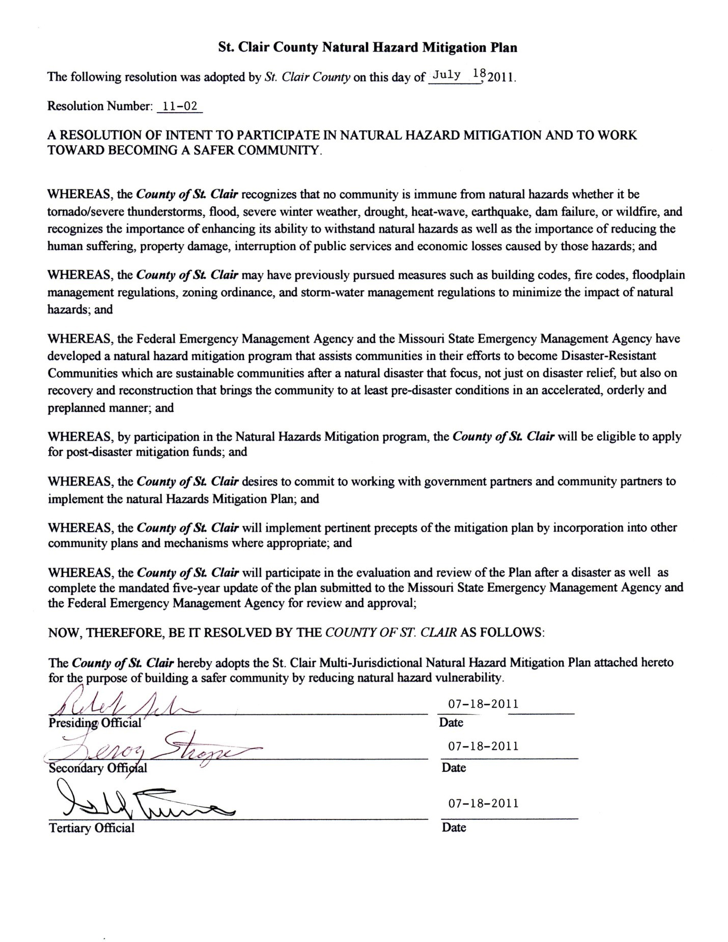

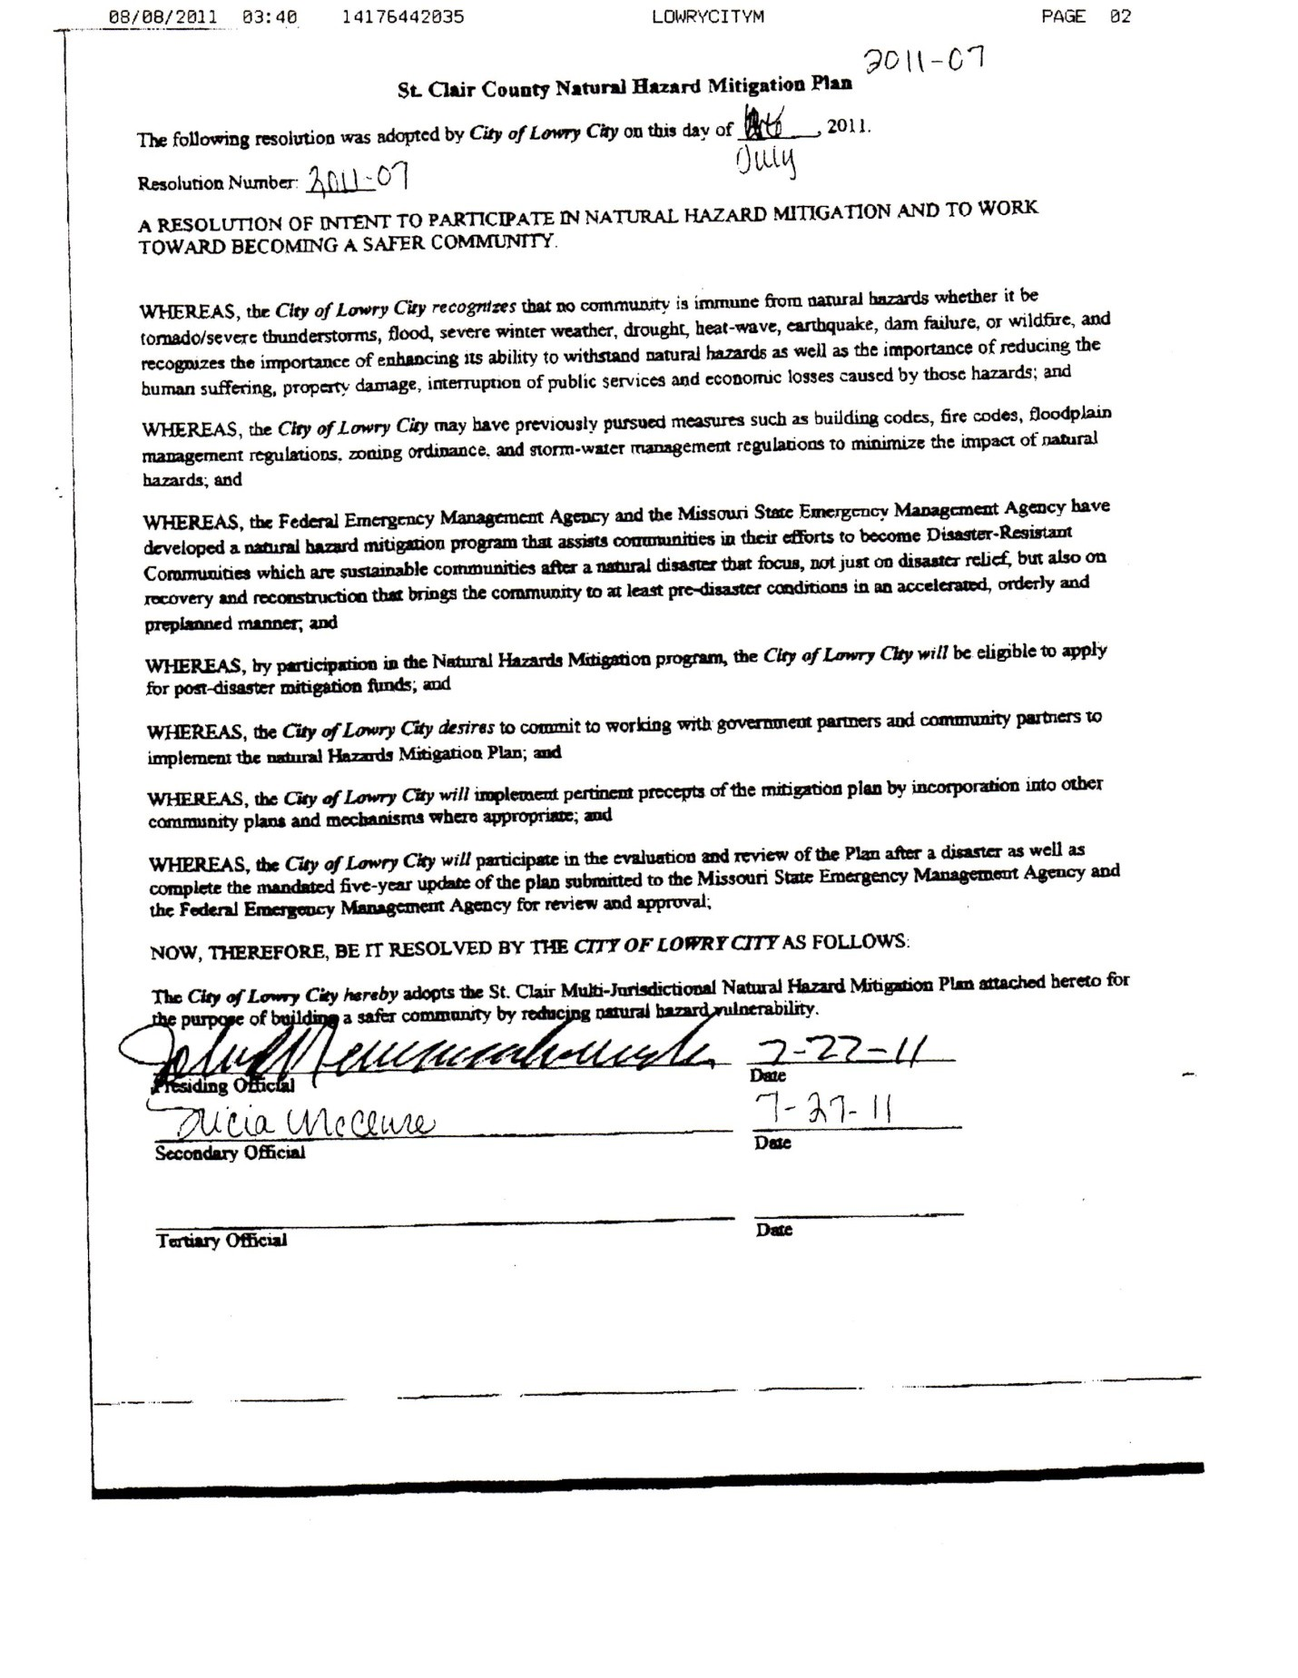

Appendix B: Websites

- http://www4.ncdc.noaa.gov/cgi-win/wwcgi.dll?wwevent~storms

- http://agebb.missouri.edu/mass/agrifact/St. Clair/narrative.htm

- http://outreach.missouri.edu/mowin/counties2/St. Clair.html

- http://members.aol.com/hrftx

- http://tacnet.missouri.org/history.state04.St. Clair.html

- http://cleora.uark.edu/State/Mira/pages/Ozark_Highland.htm

- http://www.nwk.usace.army.mil/harryst/whatwedo.htm

- http://www.pmg-lakeoftheozarks.com/lo.asp

- http://quickfacts.census.gov/qfd/states/29/29015.html

- http://www.fema.gov/

- Hazards Workshop Session Summary #16, Disasters, Diversity, and Equity.

- http://quickfacts.census.gov/qfd/states/29/29015.html

- http://fisher.lib.virginia.edu/cgi-local/cbpbin/post97/go.cgi

- http://eelink.net/EndSpp/endangeredspecies-definitions.html

- http://www.conservation.state.mo.us/nathis/endangered/index.htm

- http://cfpub.epa.gov/npdes/stormwater/endangerresult.cfm?state=MO&view=%27St. Clair%27&sort=sciname

- http://nationalregisterofhistoricplaces.com/mo/St. Clair/state.html

- http://quake.ualr.edu/HazardMitigation/armitig-plan/Tornadoes.htm

- http://www.fema.gov/mit/how2016.htm

- http://www.fema.gov/about/im_totip.htm

- http://www.fema.gov/library/tornadof.htm

- http://www.spc.noaa.gov/archive/tornadoes/index.html

- http://www.fema.gov/mit/hurrmit.htm

- http://www.fema.gov/fema/weathr.htm

- http://www.tornadoproject.com

- http://quake.ualr.edu/HazardMitigation/claymitg-plan/Floods.htm

- http://quake.ualr.edu/HazardMitigation/claymitg-plan/Earthquakes.htm

- www.stclaircountyhealth.net

- www.stclaircountyemalepc.com

Appendix C: Acronyms
- ASM Archaeological Survey of Missouri
- BFE Base Flood Elevation
- BLM Bureau of Land Management
- CDBG Community Development Block Grant
- CEDS Comprehensive Economic Development Strategy
- CERI Center for Earthquake Research and Information at the University of Memphis CFR Code of Federal Regulations
- CPC Climate Prediction Center
- CRS Community Rating System
- DMA 2000 Disaster Mitigation Act of 2000
- EDA Economic Development Administration
- EPA Environmental Protection Agency
- FEMA Federal Emergency Management Agency
- FIRM Flood Insurance Rate Map
- FMA Flood Mitigation Assistance (FEMA Program)
- FTE Full Time Equivalent
- GIS Geographic Information System
- HMGP Hazard Mitigation Grant Program
- HMST Hazard Mitigation Survey Team
- HUD Housing and Urban Development (United States, Department of)
- ICC Increased Cost of Compliance
- LMI Labor Market Information
- MACOG Missouri Association of Councils of Governments
- MCC Midwestern Climate Center
- MoDOT Missouri Department of Transportation
- MPA Missouri Press Association
- NCDC National Climate Data Center
- NEHRP National Earthquake Hazards Reduction Program
- NFIP National Flood Insurance Program
- NFPA National Fire Protection Association
- NHMP Natural Hazard Mitigation Plan
- NIBS National Institute of Building Sciences
- NIFC National Interagency Fire Center
- NOAA National Oceanic and Atmospheric Administration
- NRHP National Register of Historic Places
- NRCS Natural Resources Conservation Service
- NWS National Weather Service

- PDM Pre-Disaster Mitigation Program
- PDSI Palmer Drought Severity Index
- SBA Small Business Administration
- SEMA Missouri State Emergency Management Agency
- SHMO State Hazard Mitigation Officer
- SPC Storm Prediction Center
- USACE United States Army Corps of Engineers
- USDA United States Department of Agriculture
- USFA United States Fire Administration
- USFS United States Forest Service
- USFWS United States Fish and Wildlife Service
- USGS United States Geological Survey

Appendix D: Definitions

Base Flood Elevation (BFE):

An elevation, usually determined by an engineer, that represents the minimum elevation required for protection from flooding on a specific site.

Drought:

The dictionary definition of drought is a period of prolonged dryness. Current drought literature commonly distinguishes between three categories of drought:
  - Agricultural drought, defined by soil moisture deficiencies;
  - Hydrological drought, defined by declining surface water and groundwater supplies; and
  - Meteorological drought, defined by precipitation deficiencies.

Dam failure assessment levels:

  - High: Failure or mis-operation will probably cause loss of human life.
  - Significant: Failure or mis-operation results in no probable loss of human life but can cause economic loss, environmental damage, disruption of lifeline facilities, or impact other concerns. Significant hazard potential classification dams are often located in predominantly rural or agricultural areas but could be located in areas with population and significant infrastructure.
  - Low: Failure or mis-operation results in no probable loss of human life and low economic and/or environmental losses. Losses are principally limited to the owner’s property.

Mitigation:

According to FEMA’s “Report on Costs and Benefits of Natural Hazard Mitigation,” hazard mitigation is defined as “sustained action taken to reduce or eliminate the long-term risk to people and property from hazards and their effects.”

Sustainable:

Policies, projects or actions that “meet the needs of the present without compromising the ability of future generations to meet their needs.” (U.N. World Commission of Environment and Development)

Appendix E: Maps
  - St. Clair County Geology
  - St. Clair County Soils
  - St. Clair County Schools
  - St. Clair County Watersheds

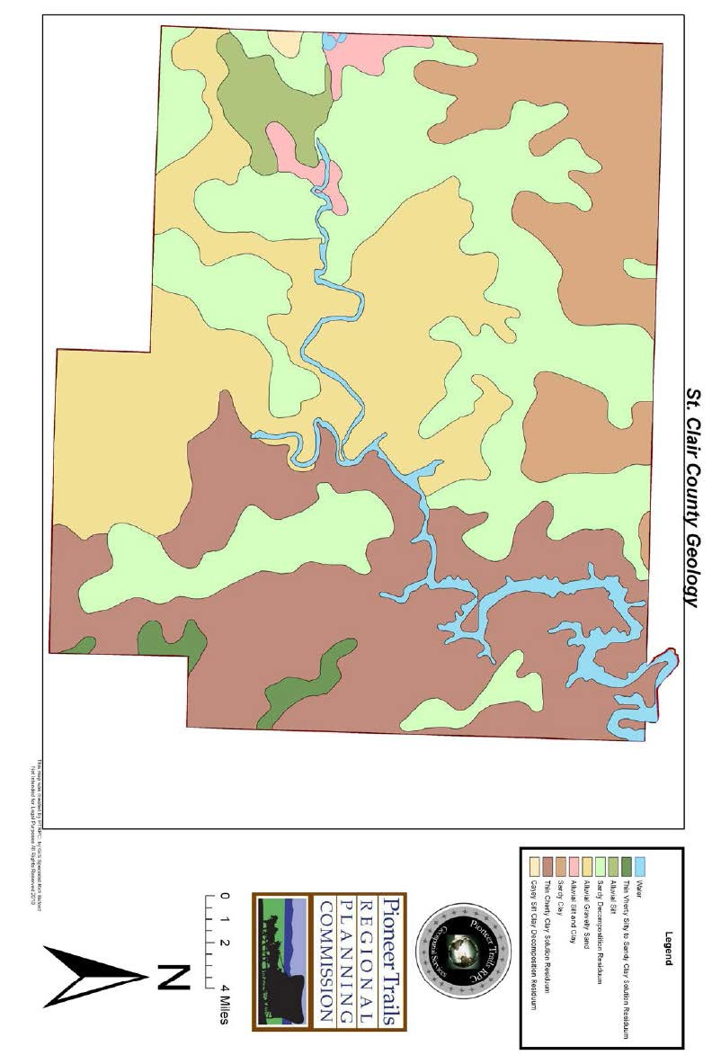

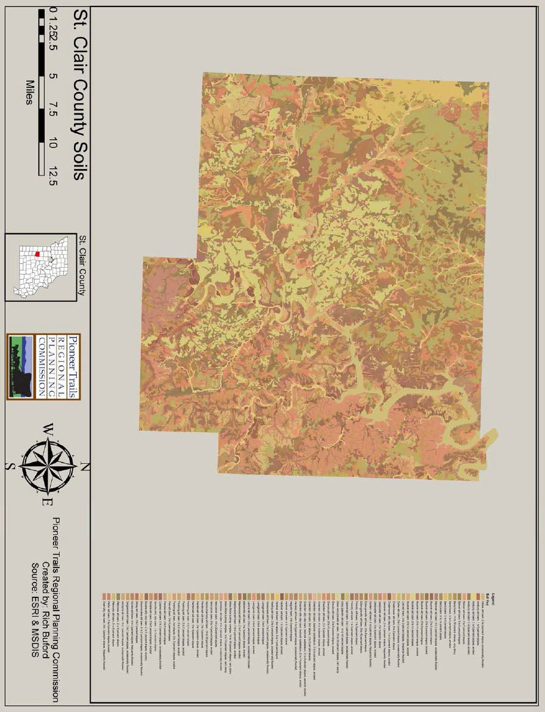

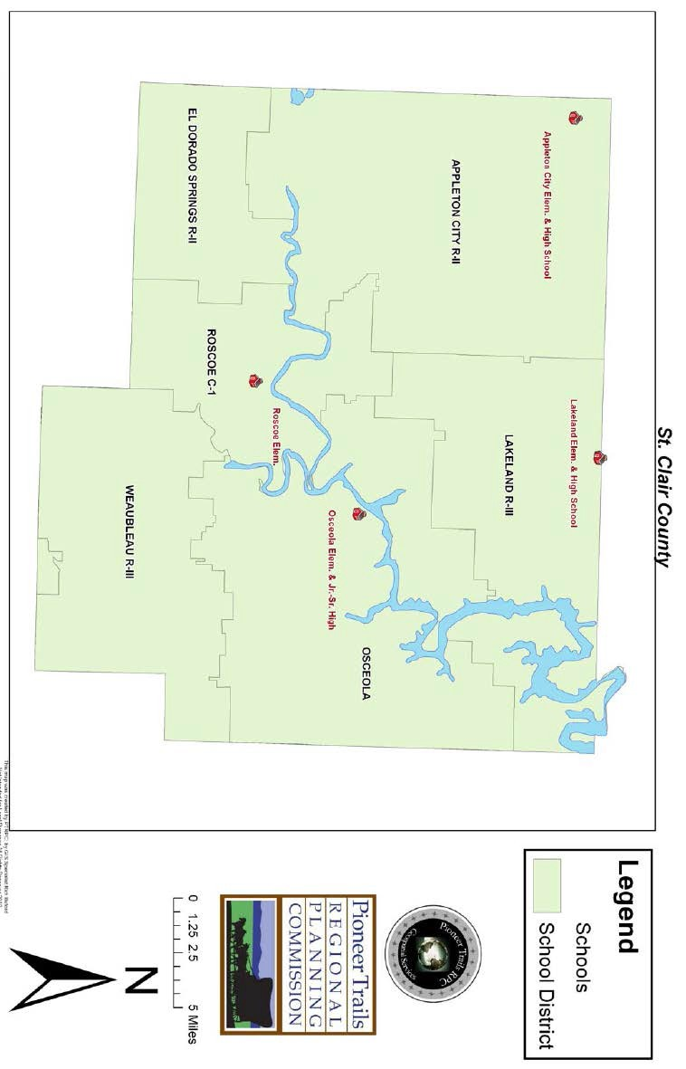

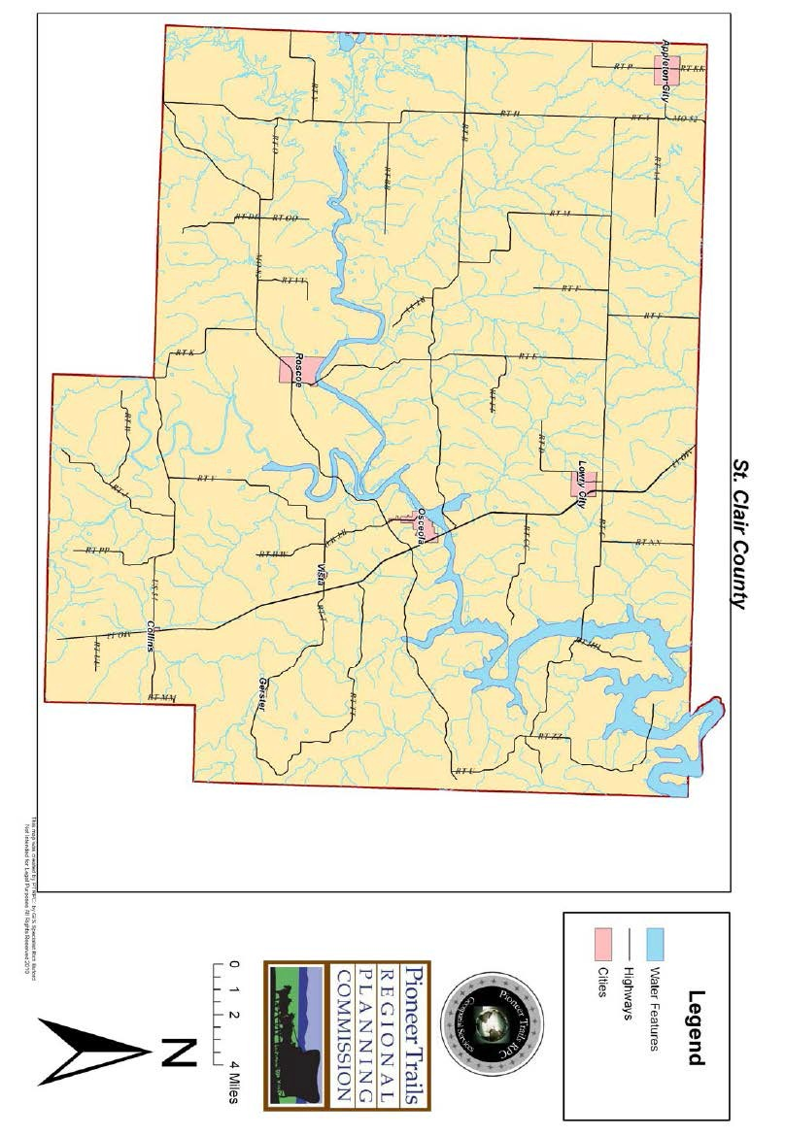

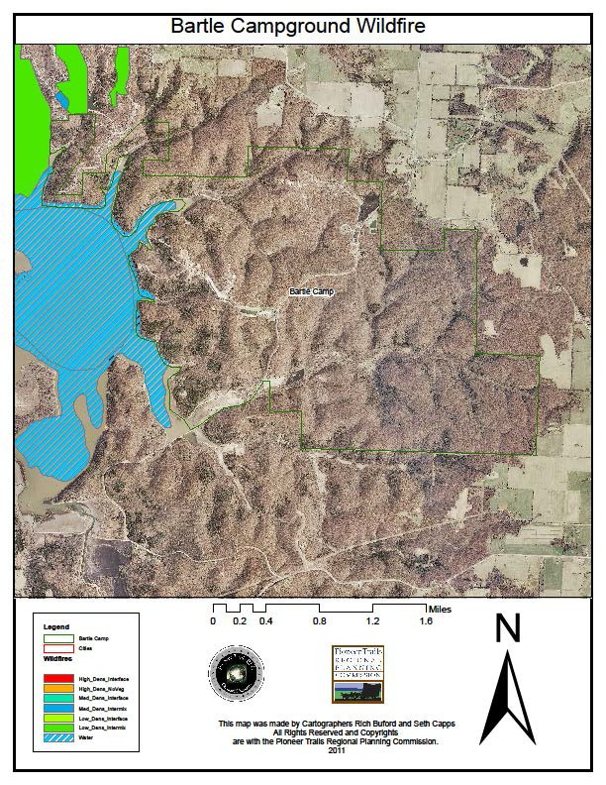

Appendix F: Public Participation Documents

